NAME ……………………………………..……………….. DATE …………………………………

INDEX NO. …………….……….……..…..… CANDIDATE’S SIGNATURE …………..…..………..

443/1
AGRICULTURE
PAPER 1 (THEORY)
OCTOBER/ NOVEMBER 2014
TIME: 2 HOURS

MBOONI EAST SUB – COUNTY FORM 4 ENTRANCE EXAMINATION, 2014

Kenya Certificate of Secondary Education

443/1
AGRICULTURE
PAPER 1 (THEORY)
TIME: 2 HOURS

INSTRUCTIONS TO CANDIDATES
- Write your name and index number in the spaces provided above.
- This paper has THREE sections: A , B and C
- Answer ALL the questions in section A and B and any TWO questions in section C
- ALL answers MUST be written in the spaces provided.
- Do not remove any pages from this booklet.
- This paper consists of 10 printed pages. Candidates should check to ensure that all pages are printed as indicated and no questions are missing

FOR EXAMINER’S USE ONLY

 | Questions | Maximum score | Candidate’s score
A | 01 - 16 | 30 marks
B | 16 - 20 | 20 marks
C | 21 - 23 | 40 marks
Total score |  | 90

© 2014, Mbooni East sub - County Form 4 entrance
443/1
Agriculture
Paper 1 (theory)
SECTION A
Answer all questions in the space provided
1. State four importance of treating water in the farm (2 marks)
………………………………………………………………………………………………………………………………………………………………………………………………………………………………………………………………………………………………………………………………………………………………………………………………………………………………………………………………
2. Explain the importance of the following layers when preparing compost manure.
- Well rotten manure (1 mark)
………………………………………………………………………………………………………………………………………………………………………………………………………………………………
- Wood ash (1 mark)
………………………………………………………………………………………………………………………………………………………………………………………………………………………………
- Top soil (1 mark)
………………………………………………………………………………………………………………………………………………………………………………………………………………………………
3. Give two ways in which pest can be categorized depending on their habitat. (1 mark)
………………………………………………………………………………………………………………………………………………………………………………………………………………………………………………………………………………………………………………………………………………………………………………………………………………………………………………………………
4. Explain how the following environmental factor affects the effectiveness of herbicides.
i) Wind (1 mark)
………………………………………………………………………………………………………………………………………………………………………………………………………………………………
ii) Temperature (1mark)
………………………………………………………………………………………………………………………………………………………………………………………………………………………………
iii) Rain (1 mark)
………………………………………………………………………………………………………………………………………………………………………………………………………………………………

5. Give the element whose its deficiency in plant is characterized by the following:-
- Blossom end rot in tomatoes (1 mark)
………………………………………………………………………………………………………………………………………………………………………………………………………………………………
- Intervenial chlorosis in leaves. (1 mark)
………………………………………………………………………………………………………………………………………………………………………………………………………………………………
- White bud formation and young leaves almost without chlorophyll (1mark)
………………………………………………………………………………………………………………………………………………………………………………………………………………………………
6. State three disadvantages of mulching (1½ marks)
………………………………………………………………………………………………………………………………………………………………………………………………………………………………………………………………………………………………………………………………………………………………………………………………………………………………………………………………
7. Differentiate between the following terms:
- Apiculture and aquaculture (1mark)
………………………………………………………………………………………………………………………………………………………………………………………………………………………………
- Olericulture and pomology (1mark)
………………………………………………………………………………………………………………………………………………………………………………………………………………………………
8. State four biotic factors negatively influencing agriculture (2 marks)
………………………………………………………………………………………………………………………………………………………………………………………………………………………………………………………………………………………………………………………………………………………………………………………………………………………………………………………………
9. Give the part in which each of the following crops is harvested
Coffee (½ mark)
………………………………………………………………………………………………………………………………………………………………………………………………………………………………

Tea (½mark)
………………………………………………………………………………………………………………………………………………………………………………………………………………………………Irish potato (½mark)
………………………………………………………………………………………………………………………………………………………………………………………………………………………………
10. State three negative effects of excess nitrogenous fertilizer in tomato production (1½ marks)
………………………………………………………………………………………………………………………………………………………………………………………………………………………………………………………………………………………………………………………………………………………………………………………………………………………………………………………………
11. State four biological /cultural control measure of soil erosion. (2 marks)
………………………………………………………………………………………………………………………………………………………………………………………………………………………………………………………………………………………………………………………………………………………………………………………………………………………………………………………………
12. Differentiate between the following terms
- Fragmentation and subdivision of land. (1mark)
………………………………………………………………………………………………………………………………………………………………………………………………………………………………
- Undersowing and oversowing (1 mark)
………………………………………………………………………………………………………………………………………………………………………………………………………………………………
13. State four ways in which soil pH can be modified (2 marks)
………………………………………………………………………………………………………………………………………………………………………………………………………………………………
14. Give four characteristics of productive soil. (2 marks)
………………………………………………………………………………………………………………………………………………………………………………………………………………………………
15. Give three factors that should be considered when choosing a seed rate. (1½ marks)
………………………………………………………………………………………………………………………………………………………………………………………………………………………………………………………………………………………………………………………………………………………………………………………………………………………………………………………………
SECTION B (20MARKS)
Answer all the questions in the space provided
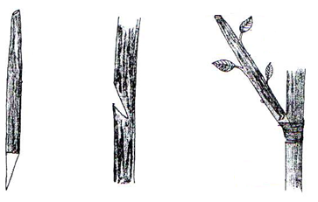
16. Below is a plant done for quality improvement of crops .Study it carefully and answer questions that follow.

- Identify the practice (1mark)
………………………………………………………………………………………………………………………………………………………………………………………………………………………………
- Other than the above type of practices ,Give other two types of the practice identified (2 marks)
………………………………………………………………………………………………………………………………………………………………………………………………………………………………
- Give any two importance of above practice (2 marks)
………………………………………………………………………………………………………………………………………………………………………………………………………………………………
17. Below is a practice used to investigate certain physical property of the soil in different soils. Study it carefully and answer the questions that follow.
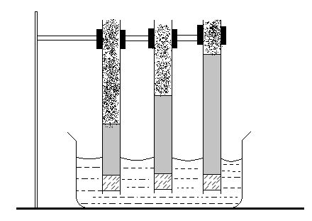
SOIL A
SOIL B
SOIL C
Water level
Water level
Water level
Trough
Water
Cotton wool

i) Identify the soil property being investigated (1 mark)
………………………………………………………………………………………………………………………………………………………………………………………………………………………………
- The set up was left for 24 hrs. and it was later observed that the water had risen up at different levels in different soils as shown above .Identify the soils labelled A,B and C (1½ marks)
A
……………………………………………………………………………………………………………..
B
……………………………………………………………………………………………………………..
C
……………………………………………………………………………….……………………………
- Which soil is suitable for paddy rice growing? (1 mark)
………………………………………………………………………………………………………………………………………………………………………………………………………………………………
- Other than above property of the soil being demonstrated ,State any other three properties of the soil (1½ marks)
………………………………………………………………………………………………………………………………………………………………………………………………………………………………
- The diagram below illustrates a maize cob attacked by a disease .Study it carefully and answer
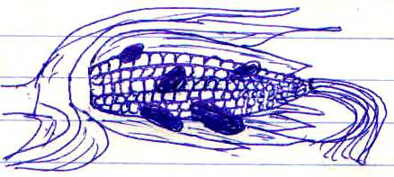
questions that follow.

- Identify the disease (1 mark)
………………………………………………………………………………………………………………………………………………………………………………………………………………………………
- Identify the causes of above disease (1mark)
………………………………………………………………………………………………………………………………………………………………………………………………………………………………
- Apart from maize .Give two other crops that may be attacked by the disease (1 mark)
………………………………………………………………………………………………………………………………………………………………………………………………………………………………
- State two ways in which the above disease can be controlled (2 marks)
………………………………………………………………………………………………………………………………………………………………………………………………………………………………

19. Below is a pump used to lift water in the farm .Study it carefully and answer the questions that follow
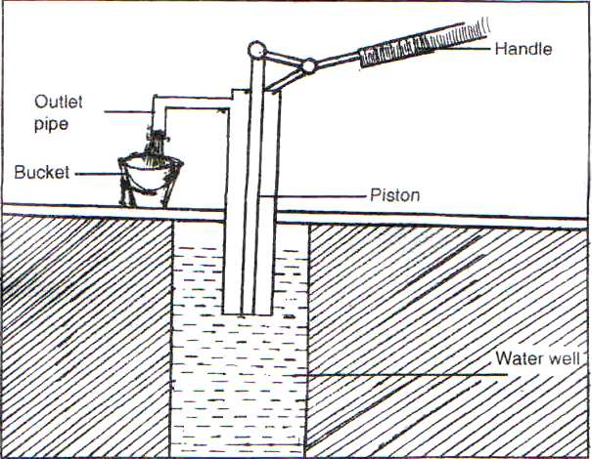

- Identify the type of pump illustrated (1 mark)
………………………………………………………………………………………………………………………………………………………………………………………………………………………………
- Other than type of pump identified in 19 (a) above ,state other two types of pumps used to lift water
in the farm (1 mark)
………………………………………………………………………………………………………………………………………………………………………………………………………………………………………………………………………………………………………………………………………………
- Give three ways in which water can be conveyed in the farm (1½ marks)
………………………………………………………………………………………………………………………………………………………………………………………………………………………………………………………………………………………………………………………………………………
- State three uses of water in the farm (1½ marks)
………………………………………………………………………………………………………………………………………………………………………………………………………………………………………………………………………………………………………………………………………………
SECTION C (40MARKS)
Answer only two questions in this section
20 (a) Give two main tenure systems (2 marks)
(b) Explain four advantages of communal categories land tenure system (4 marks)
(c) State and explain five ways in which herbicides work to kill weeds (10 marks)
(d) Explain four roles of trees in soil and water conservation (4 marks)

21 (a) Explain five negative effects of strong wind in crop production (5 marks)
(b) Explain four branches of agriculture (4 marks)
(c) Explain six reasons for doing land preparation (6 marks)
(d) Explain five reasons for carrying out minimum tillage (5 marks)

22 (a) Explain five factors to be considered when selecting the nursery site (5 marks)
(b) Explain five characteristic of a nitrogenous fertilizers (5 marks)
(c) State and explain factors determining spacing of a particular crop (10 marks)
………………………………………………………………………………………………………………………………………………………………………………………………………………………………………………………………………………………………………………………………………………………………………………………………………………………………………………………………………………………………………………………………………………………………………………………………………………………………………………………………………………………………………………………………………………………………………………………………………………………………………………………………………………………………………………………………………………………………………………………………………………………………………………………………………………………………………………………………………………………………………………………………………………………………………………………………………………………………………………………………………………………………………………………………………………………………………………………………………………………………………………………………………………………………………………………………………………………………………………………………………………………………………………………………………………………………………………………………………………………………………………………………………………………………………………………………………………………………………………………………………………………………………………………………………………………………………………………………………………………………………………………………………………………………………………………………………………………………………………………………………………………………………………………………………………………………………………………………………………………………………………………………………………………………………………………………………………………………………………………………………………………………………………………………………………………………………………………………………………………………………………………………………………………………………………………………………………………………………………………………………………………………………………………………………………………………………………………………………………………………………………………………………………………………………………………………………………………………………………………………………………………………………………………………………………………………………………………………………………………………………………………………………………………………………………………………………………………………………………………………………………………………………………………………………………………………………………………………………………………………………………………………………………………………………………………………………………………………………………………………………………………………………………………………………………………………………………………………………………………………………………………………………………………………………………………………………………………………………………………………………………………………………………………………………………………………………………………………………………………………………………………………………………………………………………………………………………………………………………………………………………………………………………………………………………………………………………………………………………………………………………………………………………………………………………………………………………………………………………………………………………………………………………………………………………………………………………………………………………………………………………………………………………………………………………………………………………………………………………………………………………………………………………………………………………………………………………………………………………………………………………………………………………………………………………………………………………………………………………………………………………………………………………………………………………………………………………………………………………………………………………………………………………………………………………………………………………………………………………………………………………………………………………………………………………………………………………………………………………………………………………………………………………………………………………………………………………………………………………………………………………………………………………………………………………………………………………………………………………………………………………………………………………………………………………………………………………………………………………………………………………………………………………………………………………………………………………………………………………………………………………………………………………………………………………………………………………………………………………………………………………………………………………………………………………………………………………………………………………………………………………………………………………………………………………………………………………………………………………………………………………………………………………………………………………………………………………………………………………………………………………………………………………………………………………………………………………………………………………………………………………………………………………………………………………………………………………………………………………………………………………………………………………………………………………………………………………………………………………………………………………………………………………………………………………………………………………………………………………………………………………………………………………………………………………………………………………………………………………………………………………………………………………………………………………………………………………………………………………………………………………………………………………………………………………………………………………………………………………………………………………………………………………………………………………………………………………………………………………………………………………………………………………………………………………………………………………………………………………………………………………………………………………………………………………………………………………………………………………………………………………………………………………………………………………………………………………………………………………………………………………………………………………………………………………………………………………………………………………………………………………………………………………………………………………………………………………………………………………………………………………………………………………………………………………………………………………………………………………………………………………………………………………………………………………………………………………………………………………………………………………………………………………………………………………………………………………………………………………………………………………………………………………………………………………………………………………………………………………………………………………………………………………………………………………………………………………………………………………………………………………………………………………………………………………………………………………………………………………………………………………………………………………………………………………………………………………………………………………………………………………………………………………………………………………………………………………………………………………………………………………………………………………………………………………………………………………………………………………………………………………………………………………………………………………………………………………………………………………………………………………………………………………………………………………………………………………………………………………………………………………………………………………

