NAME ……………………………………..……………….. DATE …………………………………

INDEX NO. …………….……….……..…..… CANDIDATE’S SIGNATURE …………..…..………..

443/2
AGRICULTURE
PAPER 2 (THEORY)
OCTOBER/NOVEMBER 2014
TIME: 2 HOURS

MBOONI EAST SUB – COUNTY FORM 4 ENTRANCE EXAMINATION, 2014

Kenya Certificate of Secondary Education

443/2
AGRICULTURE
PAPER 2 (THEORY)
TIME: 2 HOURS

INSTRUCTIONS TO CANDIDATES
- Write your name and index number in the spaces provided above.
- This paper has THREE sections: A , B and C
- Answer ALL the questions in section A and B and any TWO questions in section C
- ALL answers MUST be written in the spaces provided.
- Do not remove any pages from this booklet.
- This paper consists of 10 printed pages. Candidates should check to ensure that all pages are printed as indicated and no questions are missing

FOR EXAMINER’S USE ONLY

 | Questions | Maximum score | Candidate’s score
A | 01 - 18 | 30 marks
B | 19 - 22 | 20 marks
C | 23 - 25 | 40 marks
Total score |  | 90

© 2014, Mbooni East sub – County Form 4 Entrance Examination
443/2
Agriculture
Paper 2 (theory)
SECTION A (30MARKS)
Instructions: Answer all the questions in the space provided
1. State four factors to consider when siting farm structures. (2 marks)
...……………………………………………………………………………………………………………………………………………………………………………………………………………………………………………………………………………………………………………………………………………………………………………………………………………………………………………………………
2. State four reasons for keeping livestock healthy. (2 marks)
...……………………………………………………………………………………………………………………………………………………………………………………………………………………………………………………………………………………………………………………………………………………………………………………………………………………………………………………………
3. Name two breeds of goat kept for milk production originating from temperate regions. (1 mark)
...……………………………………………………………………………………………………………
………………………………………………………………………………………………………………………………………………………………………………………………………………………………
4. Name four examples of external parasites belonging to class insecta. (2 marks)
...……………………………………………………………………………………………………………………………………………………………………………………………………………………………………………………………………………………………………………………………………………………………………………………………………………………………………………………………
5. State four safety precautions to be observed when using workshop tools. (2 marks)
...……………………………………………………………………………………………………………………………………………………………………………………………………………………………………………………………………………………………………………………………………………………………………………………………………………………………………………………………
6. State four duties of a worker bee. (2 marks)
...……………………………………………………………………………………………………………………………………………………………………………………………………………………………………………………………………………………………………………………………………………………………………………………………………………………………………………………………
7. Distinguish between crutching and ringing as used in livestock production. (1 mark)
...……………………………………………………………………………………………………………………………………………………………………………………………………………………………
...……………………………………………………………………………………………………………
8. List four methods of preserving fish after harvesting. (2 marks)
...……………………………………………………………………………………………………………………………………………………………………………………………………………………………………………………………………………………………………………………………………………………………………………………………………………………………………………………………
9. State four factors that determine nutritional requirement of an animal. (2 marks)
...……………………………………………………………………………………………………………………………………………………………………………………………………………………………………………………………………………………………………………………………………………………………………………………………………………………………………………………………
10. Explain the functional difference between a rip saw and cross-cut saw. (1 mark)
...…………………………………………………………………………………………………………………………………………………………………………………………………………………………… ………………………………………………………………………………………………………………
11. State four signs of parturition in cattle. (2 marks)
...……………………………………………………………………………………………………………………………………………………………………………………………………………………………………………………………………………………………………………………………………………………………………………………………………………………………………………………………
12. Name four sources of energy concentrates (2 marks)
...……………………………………………………………………………………………………………………………………………………………………………………………………………………………………………………………………………………………………………………………………………………………………………………………………………………………………………………………
13. Identify four signs of heat in a rabbit. (2 marks)
...……………………………………………………………………………………………………………………………………………………………………………………………………………………………………………………………………………………………………………………………………………………………………………………………………………………………………………………………
14. State four predisposing factors of livestock diseases. (2 marks)
...……………………………………………………………………………………………………………………………………………………………………………………………………………………………………………………………………………………………………………………………………………………………………………………………………………………………………………………………
15. State four structures necessary for handling dairy animals. (2 marks)
...……………………………………………………………………………………………………………………………………………………………………………………………………………………………………………………………………………………………………………………………………………………………………………………………………………………………………………………………
16. State two ways in which underground water sources can be polluted. (1 mark)
...……………………………………………………………………………………………………………………………………………………………………………………………………………………………………………………………………………………………………………………………………………………………………………………………………………………………………………………………
17. State two ways that show good feeding help to control livestock diseases. (1 mark)
...…………………………………………………………………………………………………………………………………………………………………………………………………………………………… ………………………………………………………………………………………………………………
18. What is cropping to fish farming? (1 mark)
...……………………………………………………………………………………………………………………………………………………………………………………………………………………………………………………………………………………………………………………………………………………………………………………………………………………………………………………………
SECTION B (20MARKS)
Answer all questions in this section
19. A poultry farmer has maize containing 8 % DCP and soya bean containing 43% DCP .If the farmer wants to make 100kg of the feed using Pearsons square method .Calculate the proportions in which the two ingredients would have to be mixed to make a feedstuff containing 15% DCP.(Show your working) (5marks)

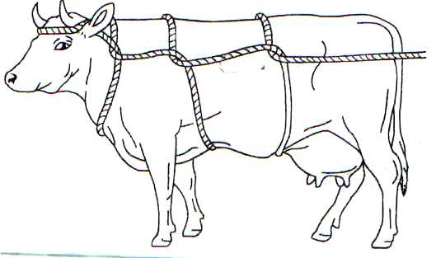
20. (a) Identify the practice demonstrated in the illustration below. (1 mark)

...……………………………………………………………………………………………………………………………………………………………………………………………………………………………
(b) Give four occasions when it may be necessary to carry out the practice above in livestock. (2 mark)
...……………………………………………………………………………………………………………………………………………………………………………………………………………………………………………………………………………………………………………………………………………………………………………………………………………………………………………………………
(c) Give two animal conditions under which the method cannot be used. (2 marks)
...…………………………………………………………………………………………………………… ………………………………………………………………………………………………………………
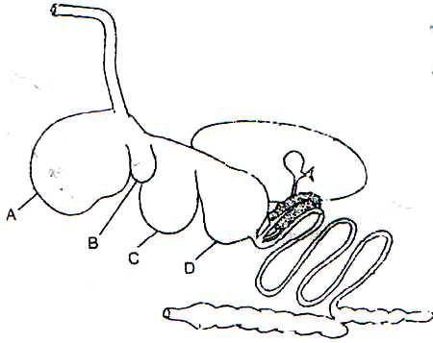
21. The following is an illustration of the digestive system of a ruminant.

- Name the parts labelled A, B, C and D. (2 marks)
...……………………………………………………………………………………………………………………………………………………………………………………………………………………………………………………………………………………………………………………………………………………………………………………………………………………………………………………………

(b) Name the part of the system where microbial activity takes place. (1 mark)
...…………………………………………………………………………………………………………… ………………………………………………………………………………………………………………
(c) State two microbial activities that take place in the part named in (b) above. (2 marks)
...……………………………………………………………………………………………………………………………………………………………………………………………………………………………
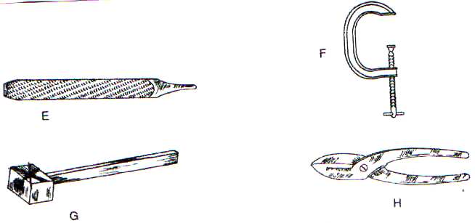
22. Identify the following workshop tools. (2 marks)

(b) State the use of each tool in the farm (2 marks)
E
………………………………………………………………………………………………………………
F
………………………………………………………………………………………………………………
G
………………………………………………………………………………………………………………
H
……………………………………………………………………………………………………………..
(c) How would a farmer maintain tool labelled F. (1 mark)
...……………………………………………………………………………………………………………………………………………………………………………………………………………………………………………………………………………………………………………………………………………

SECTION C (40MARKS)
Answer two questions in this section
23 (a) Explain the importance of fencing in the farm. (8 marks)
(b) Explain six functional requirements of a calf pen. (6 marks)
(c) Describe the procedure of harvesting honey. (6 marks)
24. (a) Explain six general methods of disease control. (12 marks)
(b) Describe the life cycle of two host tick. (5 marks)
(c) State three control measures of tapeworm. (3 marks)
25. (a) Explain eight characteristics of indigenous cattle breeds. (8 marks)
(b) Give four differences between the large white and land race breeds of pig. (4 marks)
(c) Describe the management during parturition in cattle. (8 marks)
...…………………………………………………………………………………………………………………………………………………………………………………………………………………………………………………………………………………………………………………………………………………………………………………………………………………………………………………………… ...…………………………………………………………………………………………………………………………………………………………………………………………………………………………………………………………………………………………………………………………………………………………………………………………………………………………………………………………… ...…………………………………………………………………………………………………………………………………………………………………………………………………………………………………………………………………………………………………………………………………………………………………………………………………………………………………………………………… ...…………………………………………………………………………………………………………………………………………………………………………………………………………………………………………………………………………………………………………………………………………………………………………………………………………………………………………………………… ...…………………………………………………………………………………………………………………………………………………………………………………………………………………………………………………………………………………………………………………………………………………………………………………………………………………………………………………………… ...…………………………………………………………………………………………………………………………………………………………………………………………………………………………………………………………………………………………………………………………………………………………………………………………………………………………………………………………… ...…………………………………………………………………………………………………………………………………………………………………………………………………………………………………………………………………………………………………………………………………………………………………………………………………………………………………………………………… ...…………………………………………………………………………………………………………………………………………………………………………………………………………………………………………………………………………………………………………………………………………………………………………………………………………………………………………………………… ...…………………………………………………………………………………………………………………………………………………………………………………………………………………………………………………………………………………………………………………………………………………………………………………………………………………………………………………………… ...…………………………………………………………………………………………………………………………………………………………………………………………………………………………………………………………………………………………………………………………………………………………………………………………………………………………………………………………… ...…………………………………………………………………………………………………………………………………………………………………………………………………………………………………………………………………………………………………………………………………………………………………………………………………………………………………………………………… ...…………………………………………………………………………………………………………………………………………………………………………………………………………………………………………………………………………………………………………………………………………………………………………………………………………………………………………………………… ...…………………………………………………………………………………………………………………………………………………………………………………………………………………………………………………………………………………………………………………………………………………………………………………………………………………………………………………………… ...…………………………………………………………………………………………………………………………………………………………………………………………………………………………………………………………………………………………………………………………………………………………………………………………………………………………………………………………… ...…………………………………………………………………………………………………………………………………………………………………………………………………………………………………………………………………………………………………………………………………………………………………………………………………………………………………………………………… ...…………………………………………………………………………………………………………………………………………………………………………………………………………………………………………………………………………………………………………………………………………………………………………………………………………………………………………………………… ...…………………………………………………………………………………………………………………………………………………………………………………………………………………………………………………………………………………………………………………………………………………………………………………………………………………………………………………………… ...…………………………………………………………………………………………………………………………………………………………………………………………………………………………………………………………………………………………………………………………………………………………………………………………………………………………………………………………… ...…………………………………………………………………………………………………………………………………………………………………………………………………………………………………………………………………………………………………………………………………………………………………………………………………………………………………………………………… ...…………………………………………………………………………………………………………………………………………………………………………………………………………………………………………………………………………………………………………………………………………………………………………………………………………………………………………………………… ...…………………………………………………………………………………………………………………………………………………………………………………………………………………………………………………………………………………………………………………………………………………………………………………………………………………………………………………………… ...…………………………………………………………………………………………………………………………………………………………………………………………………………………………………………………………………………………………………………………………………………………………………………………………………………………………………………………………… ...…………………………………………………………………………………………………………………………………………………………………………………………………………………………………………………………………………………………………………………………………………………………………………………………………………………………………………………………… ...…………………………………………………………………………………………………………………………………………………………………………………………………………………………………………………………………………………………………………………………………………………………………………………………………………………………………………………………… ...…………………………………………………………………………………………………………………………………………………………………………………………………………………………………………………………………………………………………………………………………………………………………………………………………………………………………………………………… ...…………………………………………………………………………………………………………………………………………………………………………………………………………………………………………………………………………………………………………………………………………………………………………………………………………………………………………………………… ...…………………………………………………………………………………………………………………………………………………………………………………………………………………………………………………………………………………………………………………………………………………………………………………………………………………………………………………………… ...…………………………………………………………………………………………………………………………………………………………………………………………………………………………………………………………………………………………………………………………………………………………………………………………………………………………………………………………… ...…………………………………………………………………………………………………………………………………………………………………………………………………………………………………………………………………………………………………………………………………………………………………………………………………………………………………………………………… ...…………………………………………………………………………………………………………………………………………………………………………………………………………………………………………………………………………………………………………………………………………………………………………………………………………………………………………………………… ...…………………………………………………………………………………………………………………………………………………………………………………………………………………………………………………………………………………………………………………………………………………………………………………………………………………………………………………………… ...…………………………………………………………………………………………………………………………………………………………………………………………………………………………………………………………………………………………………………………………………………………………………………………………………………………………………………………………… ...……………………………………………………………………………………………………………………………………………………………………………………………………………………………………………………………………………………………………………………………………………………………………………………………………………………………………………………………

