NAME…………………………..……………….. DATE …………………………

INDEX NO. ……….……….…………………...…..… SIGNATURE ……………..…………..

231/1
BIOLOGY
PAPER 1
OCTOBER /NOVEMBER 2014
(THEORY)
TIME: 2 HOURS

MBOONI EAST SUB - COUNTY FORM 4 ENTRANCE EXAMINATION, 2014
Kenya Certificate of Secondary Education

231/1
BIOLOGY
PAPER 1
(THEORY)
TIME: 2 HOURS

INSTRUCTIONS TO CANDIDATES.
- Write your name and index number in spaces provided above.
- Sign and write the date.
- Answer ALL the questions in the spaces provided.
- Answers must be written in the spaces provided in the question paper. Additional pages must not be inserted.
- This paper consists of 8 printed pages. Candidates should check to ensure that all pages are printed as indicated and no questions are missing

FOR EXAMINER’S USE ONLY.
Questions | Maximum score | Candidate’s score
1 - 27 | 80

© 2014, Mbooni East Sub- County Form 4 entrance examination
231/1
Biology Paper 1

- Name the tissues whose cells are thickened with:
- Cellulose and pectin (1 Mark)
…………………………………………………………………………………………………………..
- Lignin (1 Mark)
…………………………………………………………………………………………………………..
- The diagram below represents a fern.
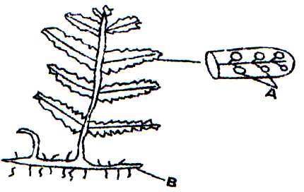

- Name parts labeled A and B (2 Marks)
A
…………………………………………………………………………………………………………..
B
…………………………………………………………………………………………………………..
- To which division does the plant belong? (1 Mark)
…………………………………………………………………………………………………………..
- State three measures that can be taken to control infection of man by protozoan parasites. (3 Marks)
…………………………………………………………………………………………………………..
…………………………………………………………………………………………………………..
…………………………………………………………………………………………………………..
…………………………………………………………………………………………………………..
- Explain how the following factors hinder self-pollination in plants:
(i) Protogyny (1 Mark)
…………………………………………………………………………………………………………..
…………………………………………………………………………………………………………..
…………………………………………………………………………………………………………..
(ii) Dioecism (1 Mark)
…………………………………………………………………………………………………………..
…………………………………………………………………………………………………………..
…………………………………………………………………………………………………………..

- Explain the likely effect on humans and other organisms of untreated sewage discharged into water body that supplies water for domestic use. (2 Marks)
…………………………………………………………………………………………………………..
…………………………………………………………………………………………………………..
…………………………………………………………………………………………………………..
- State the structural adaptation of the mitochondrion. (2 Marks)
…………………………………………………………………………………………………………..
…………………………………………………………………………………………………………..
…………………………………………………………………………………………………………..
- (a) Define the term immunity. (1 Mark)
…………………………………………………………………………………………………………..
…………………………………………………………………………………………………………..
(b) Distinguish between natural immunity and acquired immunity. (1 Mark)
…………………………………………………………………………………………………………..
…………………………………………………………………………………………………………..
…………………………………………………………………………………………………………..
…………………………………………………………………………………………………………..
…………………………………………………………………………………………………………..
…………………………………………………………………………………………………………..
- Identify one immunizable disease in Kenya. (1 Mark)
…………………………………………………………………………………………………………..
…………………………………………………………………………………………………………..
- State three differences between osmosis and active transport. (3 Marks)
…………………………………………………………………………………………………………..
…………………………………………………………………………………………………………..
…………………………………………………………………………………………………………..
…………………………………………………………………………………………………………..

- The diagram below illustrates part of a Nephron from a mammalian kidney.
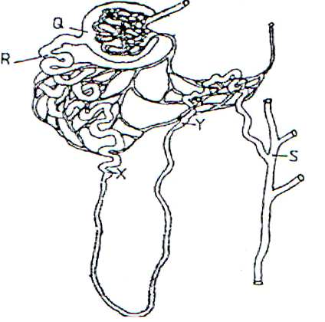

- Name the fluid found in the part labeled Q. (1 Mark)
…………………………………………………………………………………………………………..
…………………………………………………………………………………………………………..
- Identify the process responsible for the formation of the fluid named in (a) above. (1 Mark)
…………………………………………………………………………………………………………..
…………………………………………………………………………………………………………..
- Which two hormones exert their effect in the nephron? (2 Marks)
…………………………………………………………………………………………………………..
…………………………………………………………………………………………………………..
- State three characteristics of members of kingdom Monera that are not found in other kingdoms.
(3 Marks)
…………………………………………………………………………………………………………..
…………………………………………………………………………………………………………..
…………………………………………………………………………………………………………..
- What is meant by the following biological terms?
(i) Crenation (1 Mark)
…………………………………………………………………………………………………………..
…………………………………………………………………………………………………………..
(ii) Haemolysis (1 Mark)
…………………………………………………………………………………………………………..
…………………………………………………………………………………………………………..
(iii) Plasmolysis (1 Mark)
…………………………………………………………………………………………………………..
…………………………………………………………………………………………………………..

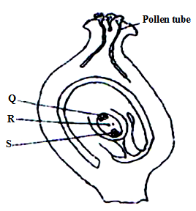
- The diagram below shows a stage during fertilization in flowering plant.

- Name the parts labeled Q, R and S. (3 Marks)
Q.………………………………………………..…………………………………………………..
R……………………………………………………………………………………………………..
S……………………………………………………………………………………………………..
- State the function of the pollen tube. (1 Mark)
…………………………………………………………………………………………………………..
…………………………………………………………………………………………………………..
- (a) State the major factor in the ‘Global warming’ experienced in the world today.
…………………………………………………………………………………………………………..
…………………………………………………………………………………………………………..
…………………………………………………………………………………………………………..
(b) Suggest two ways of reducing Global warming. (2 Marks)
…………………………………………………………………………………………………………..
…………………………………………………………………………………………………………..
…………………………………………………………………………………………………………..
- Explain how the spread of malaria is controlled by the following methods.
- Applying oil on stagnant water. (2 Marks)
…………………………………………………………………………………………………………..
…………………………………………………………………………………………………………..
- Replacing male anopheles mosquito with sterile males. (2 Marks)
…………………………………………………………………………………………………………..
…………………………………………………………………………………………………………..

- (a) Explain how the following adaptations of xerophytes assist them to survive in their habitat.
(i) Sunken stomata (1 Mark)
…………………………………………………………………………………………………………..
…………………………………………………………………………………………………………..
(ii) Thick cuticle (1 Mark)
…………………………………………………………………………………………………………..
…………………………………………………………………………………………………………..
(b) State the structural differences between the root system of the xerophytes and that of the hydrophytes
(2 Marks)
…………………………………………………………………………………………………………..
…………………………………………………………………………………………………………..
…………………………………………………………………………………………………………..
- (a) Name a protein and vitamin involved in blood clotting.
(i) Protein (1 Mark)
…………………………………………………………………………………………………………..
…………………………………………………………………………………………………………..
(ii) Vitamin (1 Mark)
…………………………………………………………………………………………………………..
…………………………………………………………………………………………………………..
(b) Explain why blood is not normally used for transfusion after one month. (1 Mark)
…………………………………………………………………………………………………………..
…………………………………………………………………………………………………………..
- The diagram below is a demonstration of breathing mechanism in man.
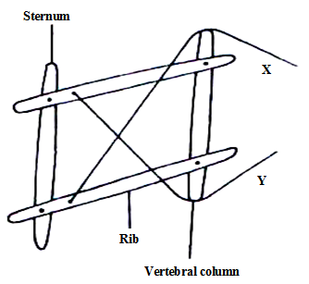

- What does the string X and Y represent (2 Marks)
…………………………………………………………………………………………………………..
…………………………………………………………………………………………………………..
- What is the effect of pulling string X (1 Mark)
…………………………………………………………………………………………………………..
…………………………………………………………………………………………………………..
- State two features in the insect pollinated flowers that encourage cross pollination. (2 Marks)
…………………………………………………………………………………………………………..
…………………………………………………………………………………………………………..
…………………………………………………………………………………………………………..
- The diagram below represents an experimental set up to investigate a certain scientific concept. The potted plant was first destarched by keeping it in dark for four days.
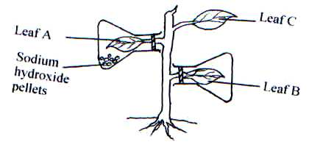

The set up was then placed in sunlight for five hours and leaves were tested for starch.
- What scientific concept was being investigated? (1 Mark)
…………………………………………………………………………………………………………..
…………………………………………………………………………………………………………..
- (i) Give the results likely to be obtained after starch test for A and B.
A………………………………………………………………………………………… (1 mark)
B………………………………………………………………………………………… (1 mark)
(ii) Account for the results in leaf A in b (i) above (1mark)
…………………………………………………………………………………………………………..
…………………………………………………………………………………………………………..
- Why was leaf C included in the set-up? (1 Mark)
…………………………………………………………………………………………………………..
…………………………………………………………………………………………………………..
…………………………………………………………………………………………………………..

- (a) Explain the importance of transport in plants. (2 Marks)
…………………………………………………………………………………………………………..
…………………………………………………………………………………………………………..
…………………………………………………………………………………………………………..
(b) What is the role of root hairs in plants? (1 Mark)
…………………………………………………………………………………………………………..
…………………………………………………………………………………………………………..
…………………………………………………………………………………………………………..

- (a) Identify the source of urea that is removed via the kidneys in healthy human being. (1 Mark)
…………………………………………………………………………………………………………..
…………………………………………………………………………………………………………..
…………………………………………………………………………………………………………..

(b) Explain why a pregnant woman excretes less urea compared to a woman who is non-pregnant
(2 Marks)
…………………………………………………………………………………………………………..
…………………………………………………………………………………………………………..
…………………………………………………………………………………………………………..
- Study the reaction below and answer the questions that follow.
+
A
B
X
Y
Glucose
Fructose

- What biological processes are represented by A and B
A.………………………………………………………………………………………………………..
B….……………………………………………………………………………………………………..
- Identify the product Y. (1 Mark)
…………………………………………………………………………………………………………..
…………………………………………………………………………………………………………..
- State the bond represented by X. (1 Mark)
…………………………………………………………………………………………………………..
…………………………………………………………………………………………………………..

- Explain the events of the light stage of photosynthesis (2 Marks)
…………………………………………………………………………………………………………..
…………………………………………………………………………………………………………..
…………………………………………………………………………………………………………..
…………………………………………………………………………………………………………..
- Explain what happens in humans when concentration of glucose in the blood rises above the normal level. (2 Marks)
…………………………………………………………………………………………………………..
…………………………………………………………………………………………………………..
…………………………………………………………………………………………………………..
…………………………………………………………………………………………………………..

- The diagram below shows a fruit specimen dispersed by a certain agent. Study the diagram carefully and then answer the questions that follow.
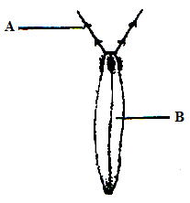

- What type of fruit represented by the diagram above? (1 Mark)
…………………………………………………………………………………………………………..
…………………………………………………………………………………………………………..
- Name each of the parts labeled A & B (2mark)
A………………………………………………………………………………………………………..
B………………………………………………………………………………………………………..
- Name the agent of dispersal of the fruit.
…………………………………………………………………………………………………………..
…………………………………………………………………………………………………………..

- In an experiment the shoot tip of a young tomato plant was decapitated as shown in the diagram below.
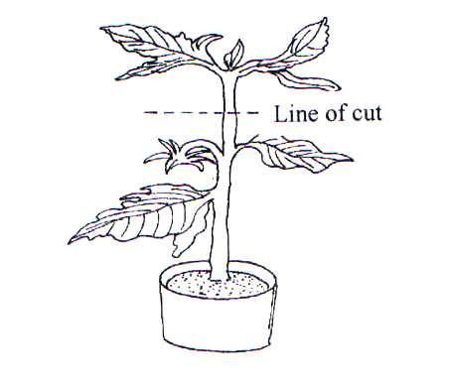

- State the expected results after 2 weeks (1 Mark)
…………………………………………………………………………………………………………..
…………………………………………………………………………………………………………..
- Give a reason for your answer in (a) above (1 Mark)
…………………………………………………………………………………………………………..
…………………………………………………………………………………………………………..

- Study the graph below and answer questions that follow.
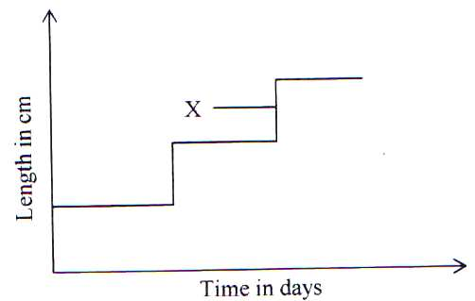

- What is the name given to the type of graph? (1 Mark)
…………………………………………………………………………………………………………..
- What is the name used to describe point X. (1 Mark)
…………………………………………………………………………………………………………..
- State the importance of part X (1 Mark)
…………………………………………………………………………………………………………..
…………………………………………………………………………………………………………..

