NAME..................................................................................ADM NO..................... STRM...................

ELERAI MCK GIRLS’ SECONDARY SCHOOL
P. O. BOX 435
SULTAN HAMUD
Motto “Discipline and Hard Work for Excellence”

FORM II
MATHEMATICS
CAT I
TERM III 2013

INSTRUCTION
- Answer ALL the questions in the spaces provided below each question
- Evaluate (3mks)
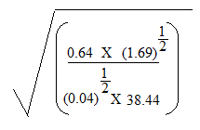
a)

b) aª – bª
b^{b} x aª if a =2 and b = -2 (2mks)

- Give that log y³ = log$∛$81, find y correct to 3 significant figures. (2mks)

- The volume of a sphere is given by v = 4$П$r³. Find the value of r if v = 311 and $П$= 3.14. (2mks)
3

- The corresponding lengths of two similar photographs are 12 cm and 30 cm. The area of the larger photograph is 750 cm². Find:
- The area scale factor (2mks)

- The area of the smaller photograph (2mks)

- Sophie has two balloons, one yellow and the other green. The radius of the yellow balloon is 7 cm while that of the green balloon is 21 cm. find the ratio of their surface areas. (2mks)

- What is the height of an equilateral triangle if one of its sides is 10 cm long? (2mks)

- A tree casts a shadow 20 m long. Find the height of the tree if the angle of elevation of the top of the tree from the tip of the shadow is 31⁰. (2mks)

- An aircraft flying into an airport calls out the control tower and says it is at height of 500 m above the tower. If its horizontal distance from the tower is 8 km, calculate its angle of elevation from the top of the tower. (2mks)

- In figure 1 below, AB = 16 cm and AC = 20 cm. Find:

- Sin ϴ (2mks)

- Cos ϴ (2mks)

- Simplify the following without using tables (use trigonometric ratios);
- 4cos45⁰sin60⁰ (2mks)

- 3cos30⁰ + cos60⁰ (2mks)

- An isosceles triangle is such that AB =AC = 8 cm. If the perpendicular distance from A to BC is 6 cm, find:
- The length of BC (2mks)

- Angle BAC (2mks)

- Evaluate 7cos50.2⁰
9.5sin60⁰ (2mks)

- In a triangle PQR, PQR = PRQ = 58⁰ and QR = 5.2 cm. Calculate the length of PQ. (2mks)

- A triangle has sides 10 cm, 7 cm and 9 cm. Find:
- Its area (2mks)

- The sizes of its angles (2mks)

- The figure below is a trapezium in which PS//QR, PS = 15 cm, QR = 20 cm, RS = 8 cm and QRS = 350. Calculate the area of the trapezium. (3mks)
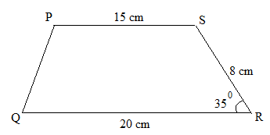

- ABCD is a parallelogram of area 120 cm². Its base is 10 cm and ABC = 30⁰. Find the length of the other side of the parallelogram (2mks)

- Find the area of a regular hexagon of side 4.8 cm. (2mks)

- The shaded region in the figure below shows the area swept out on a flat windscreen by a wiper. Calculate the area of this region. (2mks)
