NAME..................................................................................ADM NO..................... CLASS...................

ELERAI MCK GIRLS’ SECONDARY SCHOOL
P. O. BOX 435
SULTAN HAMUD
Motto “Discipline and Hard Work for Excellence”

FORM I
COMPUTER STUDIES
CAT I
TERM III 2013

INSTRUCTION
- Answer ALL the questions in the spaces provided below each question

- Name any two categories of keys found on a standard keyboard (2mks)

- Indicate the name of each of the following key symbols (3mks)
i)

ii)

iii)
ESC

- Explain the uses of the following keyboard keys (2mks)
- Shift key

- Backspace key

- Give any three types of mouse you know (3mks)

- Describe the flowing mouse techniques (3mks)
- Left click

- Drag and drop

- Double click

- State any two uses of a mouse (2mks)

- Giving an example, name two classifications of scanning devices (2mks)

- What is pixel in relation to monitors (1mk)

- What number does the following Abacus represent (2mks)
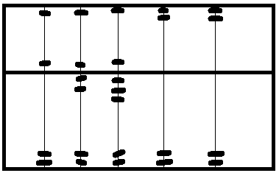

- Name any two output devices you know (2mks)

- Distinguish between a laser printer and a dot matrix printer (2mks)

- State any two advantages of a flat panel display over CRT monitors (2mks)

- Distinguish between softcopy and hardcopy devices (2mks)

- State an area where a plotter is used (1mk)

- A storage disk has a capacity of 40 GB, calculate the storage capacity in Megabytes (2mks)

- Name a standard unit used to measure the processor clock speed (1mk)

- List down any two types of optical disks you know (2mks)

- Explain any two precautions you will take to avoid the crashing of the hard disk (2mks)

- Distinguish between serial and parallel communication ports of a computer (2mks)

- State any two advantages of using a USB interface (2mks)

- A 32 bit computer word consist of how many Bytes (2mks)

- a) how many bytes would be required to store the following statement in a storage media (1mk)

ELERAI GIRLS’ SECONDARY

b) Calculate the number of bits required to store the above statement (2mks)

- List down any two buses found in the CPU (2mks)

- Give the correct name to each of the following port symbols (2mks)

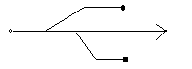
a)

b)
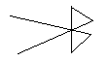

- Write USB in full (1mk)

