FORM 3
CHEMISTRY
MID TERM EXAM – JUNE 2016

NAME………………………………………….……ADM.NO………....CLASS............

80

- (a) Define a dehyquescent salt and give an example. (2 mks)
…………………………………………………………………………………………………..
…………………………………………………………………………………………………..
…………………………………………………………………………………………………..
- Starting with lead carbonate describe how a pure sample of lead (II) sulphate can be prepared in the laboratory given dilute sulphuric acid. (3 mks)

…………………………………………………………………………………………………..
…………………………………………………………………………………………………..
…………………………………………………………………………………………………..
…………………………………………………………………………………………………..
…………………………………………………………………………………………………..
…………………………………………………………………………………………………..
…………………………………………………………………………………………………..
…………………………………………………………………………………………………..
…………………………………………………………………………………………………..
…………………………………………………………………………………………………..
(c) Potassium carbonate reacts with nitric acid to form potassium nitrate. Write balanced ionic equations involved in the reaction. (1 mk)
…………………………………………………………………………………………………..
…………………………………………………………………………………………………..
(d) A green solid decomposed easily after heating to give a black residue and a gas formed a white precipitate with lime water. When nitric acid was added to the block residue a blue solution was obtained.
- What was the green solid? (1 mk)
…………………………………………………………………………………………………..
- What was the black residue? (1 mk)
…………………………………………………………………………………………………
- Write the equation for the decomposition reaction. (1 mk)

- An aqueous solution of copper (II) sulphate was electrolysed using inert electrodes as shown
in the set up below.
Gas T

CuSO_{4(aq)}

Inert electrodes

(a) Name:
(i) Gas T (1mk )
……………………………………………………………………………
(ii) A pair of electrode suitable for this experiment. (1mk)
………………………………………………………………………………………………
(b) Write ionic equation to show the reaction occurring on the Cathode. (1mk )

………………………………………………………………………………………………
………………………………………………………………………………………………
(c ) What happens to the pH of the electrolyte during electrolysis? Explain your answer.
(2mks)

………………………………………………………………………………………………
………………………………………………………………………………………………
………………………………………………………………………………………………
(d) What observations would be made on the electrodes if the inert electrodes were replaced
with copper electrodes in the above set up. (1mk)

………………………………………………………………………………………………
………………………………………………………………………………………………
………………………………………………………………………………………………

(e) A metal cup can be coated with silver by electrolysis. The cup must be very clean and
rotated during the process which is known as electroplating. The incomplete set up of the apparatus is shown below.

(i) Should the cup be anode or cathode? Explain. (1mk)

………………………………………………………………………………………………
………………………………………………………………………………………………
(ii) Suggest a suitable electrolyte that could be used to electroplate this cup. (1mk)

………………………………………………………………………………………………
(iii) Explain why the cup must be very clean and rotated during electrolysis. (1mk)

………………………………………………………………………………………………
………………………………………………………………………………………………
f) When a current of 0.82 amperes was passed for five hours through an aqueous solution of a salt of metal Z, 2.65g of the metal was deposited. Determine the charge on the ion of metal Z(1 Faraday = 96,500C, R.A.M of Z = 52) (3mks)

………………………………………………………………………………………………
………………………………………………………………………………………………
………………………………………………………………………………………………
………………………………………………………………………………………………
- Sodium hydroxide pellets were accidentally mixed with sodium chloride. 17.6g of the mixture were dissolved in water to make one litre of solution. 100cm³ of the solution was neutralized by 40 cm³ of 0.5M sulphuric acid.
- Write an equation for the reaction that took place. (1 mk)

………………………………………………………………………………………………
………………………………………………………………………………………………

- Calculate:
- Number of molar of the substance that reacted with sulphuric acid. (3 mks)

………………………………………………………………………………………………
………………………………………………………………………………………………
………………………………………………………………………………………………
………………………………………………………………………………………………
………………………………………………………………………………………………
………………………………………………………………………………………………
- Number of moles of the substance that would react with sulphuric acid in the one litre solution. (2 mks)

………………………………………………………………………………………………
………………………………………………………………………………………………
………………………………………………………………………………………………
………………………………………………………………………………………………
………………………………………………………………………………………………
- Mass of the unreacted substance in the one litre of solution. (2 mks)
H = 1, Na = 23 , cl = 35.5, O =16

………………………………………………………………………………………………
………………………………………………………………………………………………
………………………………………………………………………………………………
………………………………………………………………………………………………
………………………………………………………………………………………………
- When an hydrocarbon was completely burnt in oxygen., 4.2g of carbon (IV) oxide and 1.71g of water were formed. Determine the empirical formulae of hydrocarbon. (3 mks)

………………………………………………………………………………………………
………………………………………………………………………………………………
………………………………………………………………………………………………
………………………………………………………………………………………………
………………………………………………………………………………………………
………………………………………………………………………………………………
………………………………………………………………………………………………
- The molar masses of gases W and X are 16.0 and 44.0 respectively. If the rate of diffusion of W through a porpus material is 12 cm³ sec⁻¹. Calculate the rate of diffusion of X through the same material. (2 mks)

………………………………………………………………………………………………
………………………………………………………………………………………………
………………………………………………………………………………………………
………………………………………………………………………………………………
………………………………………………………………………………………………
- The grid below is part of the periodic table. The elements are not represented by their actual symbols. Use the information to answer the question that follow.

T |  |  |  |  |  | K | S
 | V |  | W | R |  |  |  | N
Q

- Name the family to which elements T and Q belongs. (1 mk)

………………………………………………………………………………………………
………………………………………………………………………………………………
- Write the formula of the compound formed when W reacts with S. (1 mk)

- Name the type of bond and structure formed when elements R and K react:
- Bond

- Structure

- Compare the atomic radii of T and Q. explain. (2 mks)

………………………………………………………………………………………………
………………………………………………………………………………………………
………………………………………………………………………………………………
………………………………………………………………………………………………
- Using dots (.) and crosses (x) to represent electrons draw a diagram to illustrate bonding in the sulphide of element V. (1 mk)

- State one use of element N. (1 mk)

………………………………………………………………………………………………
………………………………………………………………………………………………
- Write an equation for the burning of W in air. (1 mk)

- (a) What are isotopes? (1 mk)

………………………………………………………………………………………………
………………………………………………………………………………………………
………………………………………………………………………………………………

(b) An element Q consist of 3 isotopes of mass 28, 29, 30 and percentage abundance of 92.2
4.7, 3.1 respectively. Determine the relative atomic mass of the element. (3 mks)

………………………………………………………………………………………………
………………………………………………………………………………………………
………………………………………………………………………………………………
………………………………………………………………………………………………
………………………………………………………………………………………………
………………………………………………………………………………………………
………………………………………………………………………………………………
- The structure of methanoic acid is shown below.

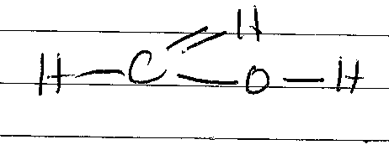
How many electrons are used in bonding? Explain. (2 mks)
…………………………………………………………………………………………………..
…………………………………………………………………………………………………..
…………………………………………………………………………………………………..
…………………………………………………………………………………………………..
- (a) Define the following terms. (1 ½ mks)
- Hydrocarbons

- catenation

- isomerism

(b) Draw the structure isomers of pentane and give their systematic names. (2 mks)

(c) Write the structure formula of: (2 mks)

- 2,2 – dimethylbutuna

- 2, 4 - dethyl – 2, 2 – demethlyheptane

- Study the reactions that follow and identify the processes involved:

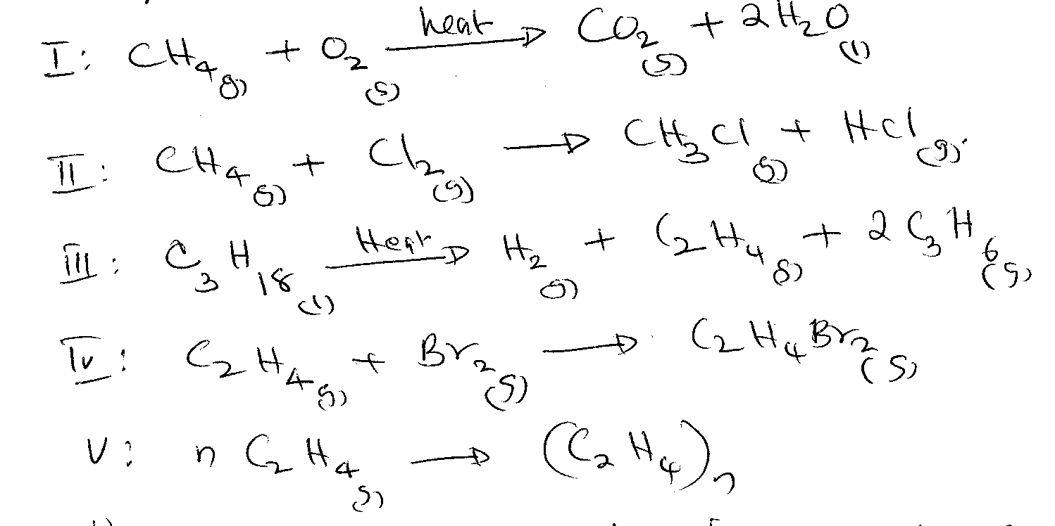
Name the process occurring in (d) above. (2 mks)

I.………………………………………… II.…………………………………..
III.………………………………………… IV.…………………………………
- Study the information in the table below and answer the question that follow.

Number o Carbon atoms per molecule | Relative molecular mars of hydrocarbon
2 | 28
3 | 42
4 | 56

- Write the general formula of the hydrocarbon in the table. (1 mk)

- Predict the relative molecular mass of the hydrocarbon with 5 carbon atoms. (1 mk)

- Determine the molecular formula of the hydrocarbon in (ii) above and draw its structural formula (H = 1, C = 12) (1mk)

- Study the following reaction scheme and answer the question that follow:

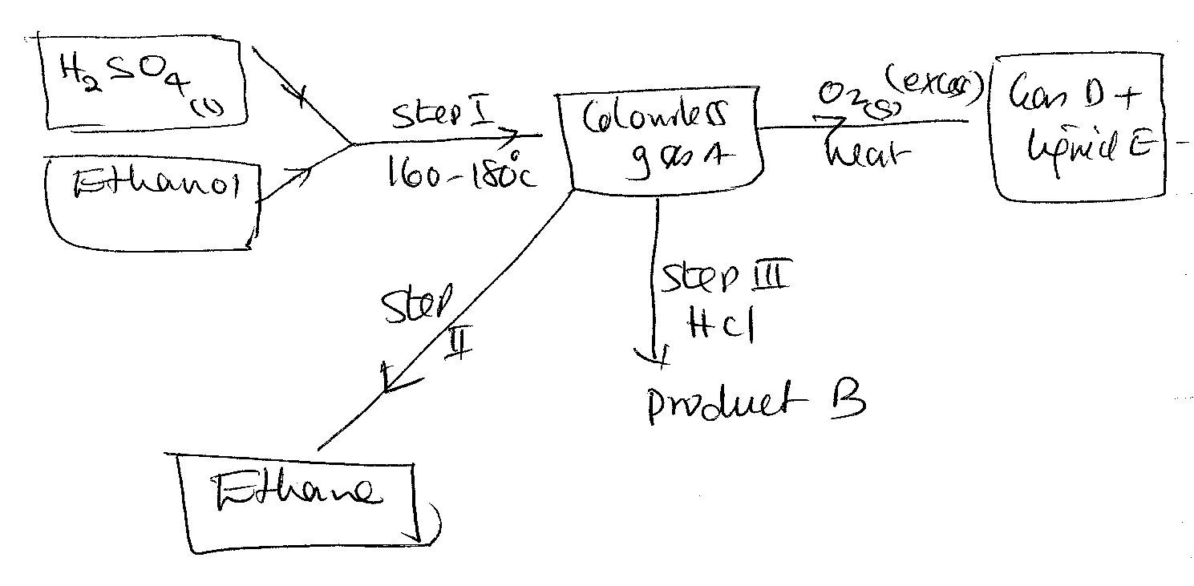
- Name: (2 mks)
- Colourless gas A
- Product B
- Gas D
- Liquid E
- Write balanced equations for each of the reactions forming the products in (a). (1 mk)

- Name the type of reactions taking place in step I and II. (1 mk)

…………………………………………………………………………………………………..
- State the importance of the reaction taking place in step II. (1 mk)

…………………………………………………………………………………………………..
…………………………………………………………………………………………………..
- Name the impurities found in steep I. (1 mk)

…………………………………………………………………………………………………..
- (a) Explain what happens when copper II oxide is mixed and heated with magnesium (1mk)

…………………………………………………………………………………………………..
…………………………………………………………………………………………………..
…………………………………………………………………………………………………..
(b) The apparatus below were used to determine the volume of oxygen in air.200cm3 of air
were passed repeatedly from syringe A to syringe B over heated copper turnings as
shown below.

B
A
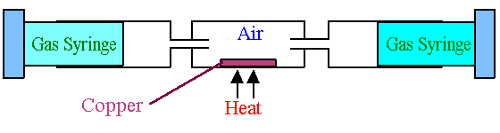
(i) After sometime the volume of air in syringe A was 150cm3 and syringe B 0cm3.
Calculate the percentage of oxygen in the initial sample of air. (2mks)
…………………………………………………………………………………………………..
…………………………………………………………………………………………………..
…………………………………………………………………………………………………..
…………………………………………………………………………………………………..
…………………………………………………………………………………………………..

(ii) Write down the chemical equation for the reaction that took place in the combustion
tube. (1mk)

…………………………………………………………………………………………………..
…………………………………………………………………………………………………..
(c) Explain why cars in coastal city of Mombasa rust faster than cars in Kisumu city. (1mk)
…………………………………………………………………………………………………..
…………………………………………………………………………………………………..
…………………………………………………………………………………………………..
(d) Sulphur was heated on deflagracting spoon until it began to burn. The components were then lowered into a jar of oxygen and observations were made. Then little water was added into the products and was shaken.
(i) Write the chemical equation when sulphur was burned (1mk)

(ii) Write a chemical equation when water was added to the product (1mk)
…………………………………………………………………………………………………..
…………………………………………………………………………………………………..
(e) State 2 uses of oxygen. (2 mks)
…………………………………………………………………………………………………..
…………………………………………………………………………………………………..
…………………………………………………………………………………………………..
…………………………………………………………………………………………………..

