FORM 3
GEOGRAPHY
MID TERM EXAM - JUNE 2016

NAME: …………………………………………………CLASS:………..ADM. NO:…………

Answer all the questions on separate full scarps.

A
6
7
8
TOTAL

SECTION A

Answer ALL the questions in this section.

- (a) Differentiate between the processes of the formation of plutonic rocks and volcanic
rocks. (2 mks)

………………………………………………………………………………………………
………………………………………………………………………………………………
………………………………………………………………………………………………
………………………………………………………………………………………………
(b) For each of the following sedimentary rocks, name the resultant rock that forms after
metamorphism:

- Sandstone …………………………………………………… (1 mk)

- Limestone …………………………………………………… (1 mk)

- Clay …………………………………………………… (1 mk)

- Use the diagram below to answer the questions that follow:

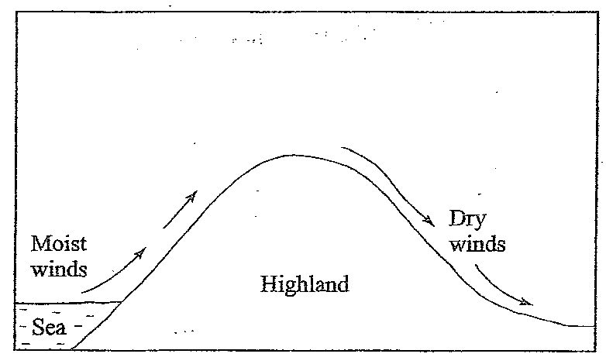

Outline the process through which the moist winds shown go through to eventually become dry winds. (5 mks)

…………………………………………………………………………………………………
…………………………………………………………………………………………………
…………………………………………………………………………………………………

- (a) What is a line of longitude? (2 mks)

………………………………………………………………………………………………
………………………………………………………………………………………………
(b) What is the local time at Alexandria 30⁰E when the local time at Malindi 40⁰E is 12.00
noon? (2 mks)

………………………………………………………………………………………………
………………………………………………………………………………………………
………………………………………………………………………………………………
- (a) Outline the steps followed when measuring humidity using a hygrometer. (3 mks)

………………………………………………………………………………………………
………………………………………………………………………………………………
………………………………………………………………………………………………
………………………………………………………………………………………………
………………………………………………………………………………………………
………………………………………………………………………………………………
(b) Give two factors that influence relative humidity. (2 mks)

………………………………………………………………………………………………
………………………………………………………………………………………………
- The diagram below shows some types of folds. Use it to answer questions (a).

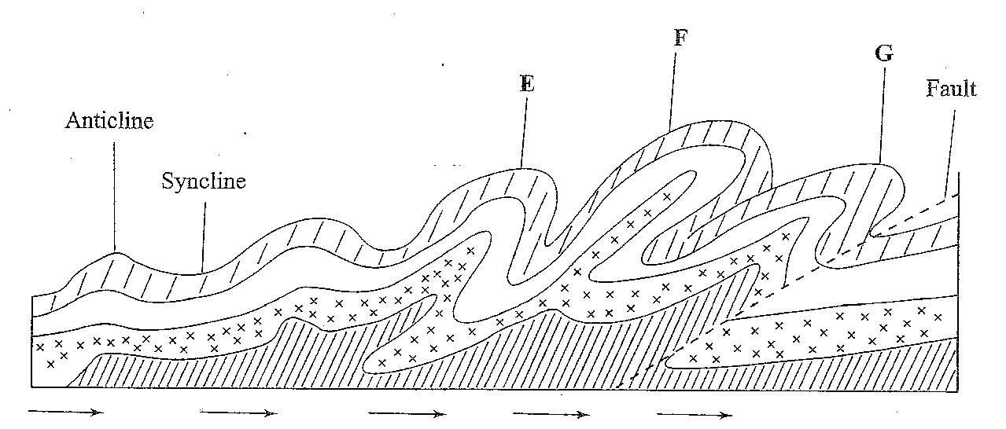

- Name the type of folds marked E, F and G. (3 mks)

………………………………………………………………………………………………
………………………………………………………………………………………………
………………………………………………………………………………………………
- In which countries are the following fold mountains found?
- Andes ……………………………………………… (1 mk)
- Cape Ranges ……………………………………………… (1 mk)
- Alps ……………………………………………… (1 mk)

SECTION B

- (a) (i) Give the approximate position of the school at Kamutungu by latitude and
longitude. (2 mks)

(ii) What is the magnetic variation of the map? (2 mks)

(iii) Give the six-figure grid reference for the junction of the roads D503 and D507. (2 mks)

- Name two methods used to represent relief on the map. (2 mks)

(b) (i) Using a vertical scale of 1cm to represent 100 metres, draw a cross section along
the line marked J – K. (2 mks)

(ii) On the section mark and label the following: (3 mks)
    - road
    - water pipeline
    - steep slope

(iii) Calculate the vertical exaggeration of the cross-section. (2 mks)

- Citing evidence from the map, give three economic activities carried out in the area covered on the map. (6 mks)

- Explain how relief has influenced distribution of settlement in the area covered by the map. (4 mks)

- (a) The diagram below represents features produced by wave action. Use it to answer the
following questions.

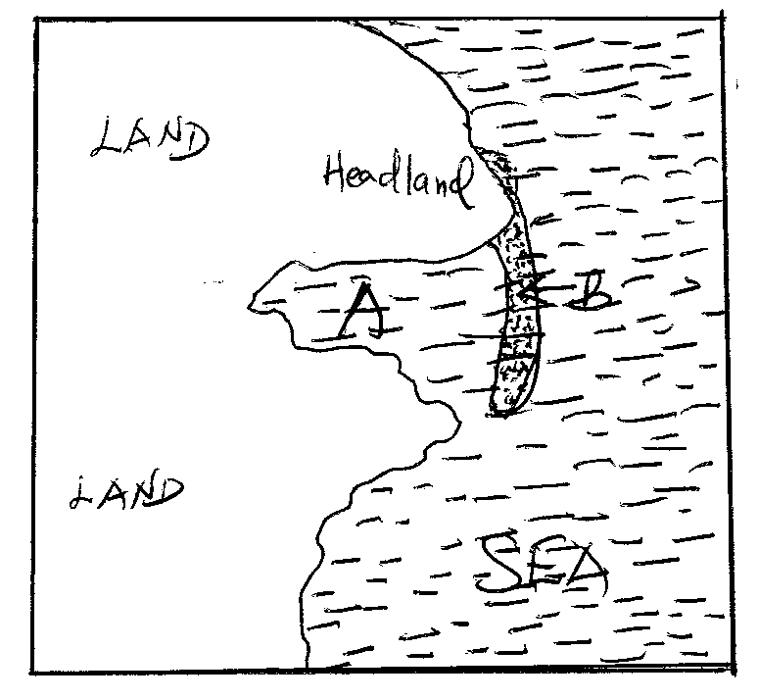

(i) Name features A and B. (2 mks)

(ii) Describe how feature B is farmed. (5 mks)

(b) (i) State four factors which influence wave deposition. (4 mks)

(ii) Explain four factors influencing the characteristics of coastlines. (4 mks)

(c) (i) State four conditions necessary for the growth of polyps. (4 mks)

(ii) Explain three positive significance of lakes to human activities.

- A form three class from Ushindi School carried out a field study in the country’s weather station and presented the data below:

Month | J | F | M | A | M | J | J | A | S | O | N | D
Temp | 30 | 31 | 31 | 31 | 30 | 29 | 28 | 28 | 29 | 29 | 29 | 30
Rainfall | 250 | 250 | 325 | 300 | 213 | 25 | 25 | 25 | 100 | 275 | 380 | 200

- Draw a suitable statistical graph to represent the above data they collected. Using
1 cm rep 2.5⁰C and 1 cm rep 50mm. (6 mks)

- Calculate:
- Annual rainfall (1 mk)

- Mean temperature (7 mks)

- (i) Describe how the data on rainfall was collected. (6 mks)

(ii) State 4 characteristics of ITCZ they found out. (4 mks)

- (i) Name three methods they used to collect the above date. (4 mks)

(ii) Give three advantages of having used fieldwork to study rainfall. (3 mks)

