KIDATO CHA TATU
KISWAHILI – JUNI 2016
MUDA: SAA 2 ½

SEHEMU | ALAMA | TUZO
UFAHAMU | 15
SARUFI | 30
ISIMU JAMII | 10
FASIHI SIMULIZI | 15
FASIHI ANDISHI | 30
JUMLA | 100

Maagizo
Jibu maswali yote katika nafasi uliozoachiwa. Makosa yote ya kisarufi yataadhibiwa.
KAZI
Ni muhimu kwanza mtu apate mafunzo Fulani ili awe na ujuzi aipendayo. Vijana
wanapomaliza shule na kutarajia kuajiriwa kazi katika makampuni makubwa, hawana
budi kutenda hivyo. Katika nyakati hizi za upungufu wa kazi, vijana wasijione duni
wakosapo kuajiriwa. Wasisahau kuwa kila kazi, hata iwe ndogo namna gani ina
thamani yake. Ukweli ni kuwa kila binadamu ana kipawa ambacho anaweza kukikuza
kufanya mambo mbalimbali, kwani akili ni nywele, kila mtu ana zake. Haifai, basi
kujikaliabure; kwani mgaagaa na upwa hali wali mkavu.
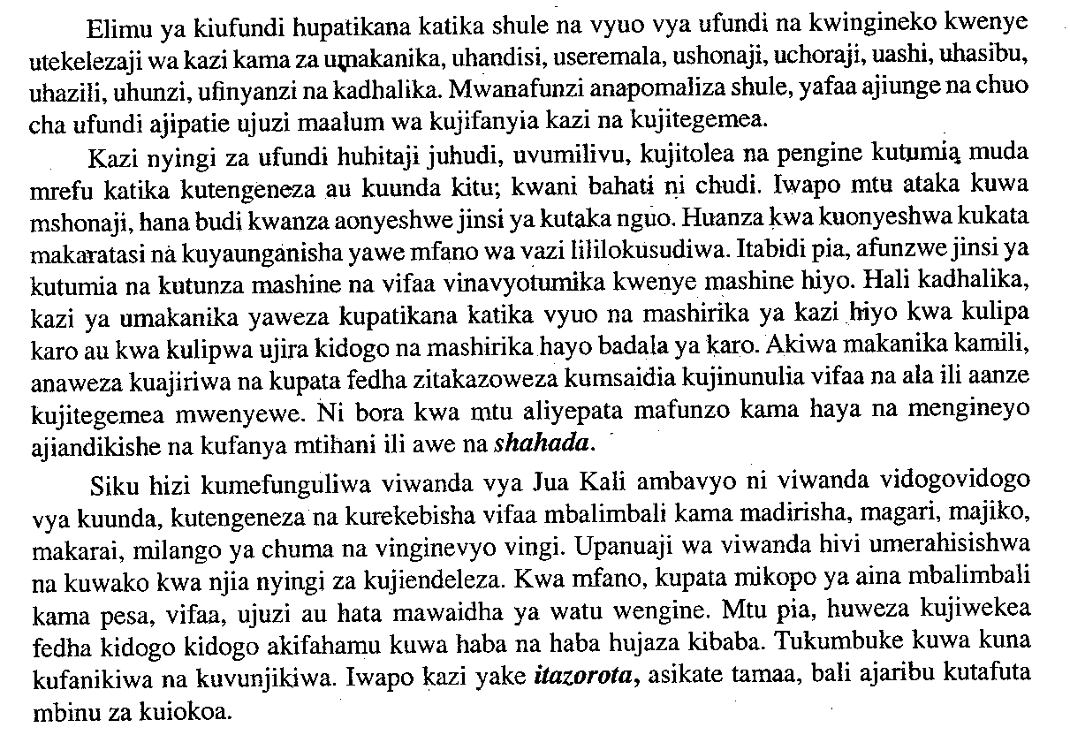
Fundi sharti awe na nidhamu; asiwe mzembe wala mdanganyifu. Yafaa awe
mwaminifu, afanye kazi kwa uthabiti na aionee fahari kazi yake ili kujenga imani ya
wateja wake.
Kwa jumla, mtu asidharau kazi ndogondogo ambazo zinaweza kumpa riziki na
kimwinua kimaisha. Kazi hizi za ufundi zitamsaidia mtu kukidhi matilaba yake nay a
wengine; atajitegemea.

- Wanafunzi wakikosa kupata kazi, wanashauriwa kufanya nini? Taja tatu (al 3)
...............................................................................................................................................................................................................................................................................................................................................................................................................................................................
- Ni ushauri gani unaoatolewa kwa mtu anayetaka kuanza kazi ya ufundi (al 2)
.................................................................................................................................................................................................................................................................................................................................................................................................................................................................
- Eleza wazi wazi mambo yanayofaa fundi anayetaka kufanikiwa katika kazi
yake (al 3)
.....................................................................................................................................................................................................................................................................................................................................................................................................................................................................................................................................................................................................................................................................................................................................................................................................................................................................................................................................................................
- Taja pingamizi tatu zinazoweza kumkumba mtu anayetaka kuanza kazi ya
ufundi ? (al 3)
................................................................................................................................................................................................................................................................................................................................................................................................................................................................................................................................................................................................................................................
- Kwa kurejelea taarifa eleza maana ya methali zifuatazo (al 2)
- Mgaagaa na upwa, hali wali mkavu
.........................................................................................................................................................................................................................................................................................................................Haba na haba hujaza kibaba
................................................................................................................................................................................................................................................................................................
- Toa maana za maneno yafuatayo kama yalivyotumiwa katika taarifa (al 2)
- Ujira
................................................................................................................................................ii) Matilaba
................................................................................................................................................
MATUMIZI YA LUGHA (AL 30)
- Onyesha sauti zifuatazo
- Kipasuo ghuna cha kaakaa laini (al $\frac{1}{2}$)
................................................................................................................................................................................................................................................................................................
- Nazali ya midomo (al $\frac{1}{2}$)
................................................................................................................................................................................................................................................................................................
- Tambua alama ya uakifishaji katika sentensi hii
- Ka –ra-ta-si (al $\frac{1}{2}$)
................................................................................................................................................................................................................................................................................................

- Timu ya mpira. (al $\frac{1}{2}$)
............................................................................................................................................................................................................................................................................................................3. Weka shadda katika sentensi zifuatazo
- Kijiko ki mezani (al $\frac{1}{2}$)
................................................................................................................................................
- Tunasoma (al $\frac{1}{2}$)
................................................................................................................................................
- Tumia vitate vifuatavyo katika sentensi kudhihirisha maana tofauti : (al 2)
Tata, Dada.
........................................................................................................................................................................................................................................................................................................................................................................................................................................................................................................................................................................................................................
- Tunga sentensi mbili kwa kutumia neneo ‘yule’kama kiwakilishii na kama
Kivumishi (al 2)
................................................................................................................................................................................................................................................................................................................................................................................................................................................................................................................................................................................................
- Ainisha vitenzi katika senteni ifuatayo (al 1)
Kijana yule alikuwa anacheza mpira
...........................................................................................................................................................................................................................................................................................................
- Bainisha maneno katika tungo ifuatayo (al 2)
Salaala! Dada na Kaka wanaenda wapi?
........................................................................................................................................................................................................................................................................................................................................................................................................................................................................................................................................................................................................................

- Eleza maana ya viambishi (al 1)
................................................................................................................................................................................................................................................................................................
- Onyesha viambishi katika neno lifuatalo. Wangelimtembelea (al 1)
................................................................................................................................................................................................................................................................................................................................................................................................................................................................................................................................................................................................
- Sahihisha sentensi ifuatayo (al 1)
Mzinga wa nyuki iliyoletwa imejaa asali
......................................................................................................................................................10. Ukitumia vitenzi na hali zilizoonyeshwa kwenye mabano kamilisha sentensi
Zifuatazo (al $\frac{1}{2}$)
- Kifaru ................................. majani (hali hu, kula) (al $\frac{1}{2}$)
- Wasichana hao ............................................sana (hali Me, Kasirirka) al $\frac{1}{2}$)
- Kamilisha sentensi zifuatazo ukitumia kinyume cha kitenzi kilichopigiwa mstari
- Dadangu aliukunjua mkeka asubuhi kisha ................................. majira ya alasiri
- Kwa nini ulivipangua vitabu vilivyokuwa ......................................vizuri hivyo?
- Onyesha tofauti kati ya sentensi zifuatazo (al 2)
- Mji wote umefurika maji
............................................................................................................................................................................................................................................................................................................
- Mji wowote umefurika maji
............................................................................................................................................................................................................................................................................................................
- Andika sentensi ifuatayo kwa usemi wa taarifa (al 2)
Dereva alisema, “Kesho nitawapeleka watalii Masai Mara
................................................................................................................................................................................................................................................................................................................................................................................................................................................
- Changanua sentensi ifuatayo kwa njia ya jedwali
Mwanafunzi stadi amenunua kitabu kizuri (al 3)
................................................................................................................................................................................................................................................................................................................................................................................................................................................................................................................................................................................................................................................................................................................................................................................................................................................................................................
- Yakinisha sentensi ifuatayo (al 1)
Padri hapendi uongo
...............................................................................................................................................................................................................................................................................................

- Unda nomino kutokana na vivumishi vifutavyo. (al 1)
- - fupi
................................................................................................................................................
- –rembo
................................................................................................................................................
- Unda sentensi ukitumia kivumishi kifuatacho kwa nomino. (al 1)
Pabaya
...............................................................................................................................................................................................................................................................................................
- a)Eleza maana ya shamirisho. (al 1)
................................................................................................................................................................................................................................................................................................
b)Tambua shamirisho katika sentensi ifuatayo
Mama alipikiwa ugali na mwanawe kwa jiko (al 3)
............................................................................................................................................................................................................................................................................................................

19. Bainisha virai katika sentensi ifutayo (al 1)
Wewe utapita mtihani
...........................................................................................................................................................................................................................................................................................................
ISIMU JAMIII (ALAMA 10)
Eleza maana ya istilahi zifuatazo
- Sajili (al 2)
........................................................................................................................................................................................................................................................................................................................2. Isimu jamii (al 2)
........................................................................................................................................................................................................................................................................................................................
- Lugha
............................................................................................................................................................................................................................................................................................................
- Isimu (al 2)
..........................................................................................................................................................................................................................................................................................................
- Lugha rasmi (al 2)
...........................................................................................................................................................................................................................................................................................................
FASIHI SIMULIZI (ALAMA 15)
- Tofautisha visasili na visakale (al 2)
................................................................................................................................................................................................................................................................................................................................................................................................................................................................................................................................................................................................
- Eleza sifa 3 za lakabu (al 3)
................................................................................................................................................................................................................................................................................................................................................................................................................................................................................................................................................................................................................................................................................................................................................................................................................................................................................................................................................................................................................................................
- Fafanua umuhimu wa vitanza ndimi (al 2)
................................................................................................................................................................................................................................................................................................................................................................................................................................................................................................................................................................................................
- Fafanua dhana hizi
a)Hodiya (al 1)
............................................................................................................................................................................................................................................................................................................b)sifo (al 1)
............................................................................................................................................................................................................................................................................................................c) Vivugo (al 1)
............................................................................................................................................................................................................................................................................................................
- Fafanua sifa 3 za ushairir simulizi (al 3)
.........................................................................................................................................................................................................................................................................................................................................................................................................................................................................................................................................................................................................................................................................................................................................................................................................................................................................................................................................................................................................................................................................................
Tina analia, Tina analia
Chozi lausaliti undani wake
Undani ambao ameuficha kwa miaka na mikaka
Undani ambaojapo anachelea kutangaza asije
Akaonekena apendaye chongo..................
- Huo ni utungo gani? (al 1)
............................................................................................................................................................................................................................................................................................................
- Taja sifa moja ya utungo uliotaja (al 1)
...........................................................................................................................................................................................................................................................................................................

FASIHI ANDISHI
SEHEMU A
KIDAGAA KIMEMWOZOEA na KEN WALIBORA.
- “Hata haramu huhalisishwa. Kuna wakati hata kupokonya ni halali, wakati mwingine kuua ni halali. Hutegemea mtendaji ni nanai na mtendwa ni nani..............”
- Eleza muktadha wa dondoo hili (al 4)
................................................................................................................................................................................................................................................................................................................................................................................................................................................................................................................................................................................................................................................................................................................................................................................................................................................................................................................................................................................................................................................................................................................................................................................................................................................................................................................................................................................................................................................................................................................................................................................................................................................
- Fafanua mbinu za lugha zinazojitokeza katika dondoo hili (al 4)
...............................................................................................................................................................................................................................................................................................................................................................................................................................................................................................................................................................................................................................................................................................................................................................................................................................................................................................................................................................................................................................................................................................................................................................................................................................................................................................................................................
- Kwa kurejelea kauli “haramu huhalalishwa thibitisha huku ukitoa mifano mwafaka riwayani (al 12)
................................................................................................................................................................................................................................................................................................................................................................................................................................................................................................................................................................................................................................................................................................................................................................................................................................................................................................................................................................................................................................................................................................................................................................................................................................................................................................................................................................................................................................................................................................................................................................................................................................................................................................................................................................................................................................................................................................................................................................................................................................................................................................................................................................................................................................................................................................................................................................................................................................................................................................................................................................................................................................................................................................................................................................................................................................................................................................................................................................................................................................................................................................................................................................................................................................................................................................................................................................................................................................................................................................................................................................................................................................................................................................................................................................................................................................................................................................................................................................................................................................................................................................................................................................................................................................................................................................................................................................................................................................................................................................................................................

SEHEMU B
DAMU NYEUSI na KEN WALIBORA na SAID A .MOHAMED
Hadithi ya Mke wangu –Muhammed Said Abdulla
- “Nitakushukuru kama utanipa talaka yangu”
- Eleza muktadha wa dondoo hili (al 4)
......................................................................................................................................................................................................................................................................................................................
...............................................................................................................................................................................................................................................................................................................................................................................................................................................................................................................................................................................................................................................................................................................................................................................................................................................................................................................................................................................................................................................................................................................................................................................................................................................................................................
- Fafanua sifa za msemaji (al 6)
.................................................................................................................................................................................................................................................................................................................................................................................................................................................................. ......................................................................................................................................................................................................................................................................................................................................................................................................................................................................................................................................................................................................................................................................................................................................................................................................................................................................................................................................................................................................................................................................................................................................................................................................................................................................................................................................................................................................
- Jadili kwa kina masuala yanayosababisha msemaji kuomba talaka (al 10)
................................................................................................................................................................................................................................................................................................................................................................................................................................................................................................................................................................................................................................................................................................................................................................................................................................................................................................................................................................................................................................................................................................................................................................................................................................................................................................................................................................................................................................................................................................................................................................................................................................................................................................................................................................................................................................................................................................................................................................................................................................................................................................................................................................................................................................................................................................................................................................................................................................................................................................................................................................................................................................................................................................................................................................................................................................................................................................................................................................................................................................................................................................................................................................................................................................................................................................................................................................................................................................................................................................................................................................................................................................................................................................................................................................................................................................................................................................................................................................................................................................................................................................................................................................................................................................................................................................................................................................................................................................................................................................................................................

