SUNSHINE SECONDARY SCHOOL

FORM 3
BUSINESS STUDIES
PAPER 1
END TERM EXAM – OCT 2015
TIME: 2 HOURS

NAME:…………………………………………………….ADM NO: ………CLASS:……….

INSTURCTIONS TO CANDIDATES

- Write your name and adm. no in the spaces provided above.
- Sign and write the date of examination in the spaces provided above.
- Answer ALL the questions.
- All answers should be written in the spaces provided in this booklet.
- This paper consists of 8 printed pages
- Candidates should check the question paper to ascertain that all the pages are printed as indicated and that no questions are missing.
- Candidates should answer all the questions in English

FOR EXAMINER’S USE ONLY

Question | 1 | 2 | 3 | 4 | 5 | 6 | 7 | 8 | 9 | 10 | 11 | 12 | 13 | 14
Candidate’s score

Question | 15 | 16 | 17 | 18 | 19 | 20 | 21
Candidate’s score
TOTAL MARKS

- List four advantages of a declining population. (4 mks)
- ………………………………………………………………………………………….
- ………………………………………………………………………………………….
- ………………………………………………………………………………………….
- ………………………………………………………………………………………….

- State four reasons why supermarkets are more popular in Kenya. (4 mks)

- ………………………………………………………………………………………….
- ………………………………………………………………………………………….
- ………………………………………………………………………………………….
- ………………………………………………………………………………………….

- Highlight four types of unemployment in an economy. (4 mks)

- ………………………………………………………………………………………….
- ………………………………………………………………………………………….
- ………………………………………………………………………………………….
- ………………………………………………………………………………………….

- Indicate whether the following resources are renewable or non-renewable. (4 mks)
Resource Classification
- Solar energy ……………………………………………………………….
- Natural gas ……………………………………………………………….
- Wood ……………………………………………………………….
- Gold ……………………………………………………………….

- Give four features of a public limited company. (4 mks)

- ………………………………………………………………………………………….
- ………………………………………………………………………………………….
- ………………………………………………………………………………………….
- ………………………………………………………………………………………….

- Mata had a car valued at sh 500,000 which he insured for sh 400,000. Later, the car was involved in an accident in which it was extensively damaged and written off.
- Calculate the amount that Mata is entitled to claim from the insurance company. (3 mks)

- Give a reason for your answer. (2 mks)
…………………………………………………………………………………………………..
…………………………………………………………………………………………………..
- Give four ways in which business ideas can be generated. (4 mks)

- ………………………………………………………………………………………….
- ………………………………………………………………………………………….
- ………………………………………………………………………………………….
- ………………………………………………………………………………………….
- For each of the following indicate the account to be debited or credited. (4 mks)

 | Transaction | A/C to Dr | A/C to Dr
(a) | Credit sales to Obonyo
(b) | Bought a furniture on credit
(c) | Bought goods on credit from Kwama.
(d) | Cash purchases from wafula.

- State four reasons why the government of Kenya encourages decentralization of industries. (4mks)

- ………………………………………………………………………………………….
………………………………………………………………………………………….
- ………………………………………………………………………………………….
………………………………………………………………………………………….
- ………………………………………………………………………………………….
………………………………………………………………………………………….
- ………………………………………………………………………………………….
………………………………………………………………………………………….

- The government has raised retirement age of civil servants from 55 years to 60 years. Highlight four effects of such a move. (4 mks)

- ………………………………………………………………………………………….
………………………………………………………………………………………….
- ………………………………………………………………………………………….
………………………………………………………………………………………….
- ………………………………………………………………………………………….
………………………………………………………………………………………….
- ………………………………………………………………………………………….
………………………………………………………………………………………….
- Highlight four features of a monopoly. (4 mks)
- ………………………………………………………………………………………….
- ………………………………………………………………………………………….
- ………………………………………………………………………………………….
- ………………………………………………………………………………………….

- Outline four measures that should be taken to ensure smooth functioning of the warehouse.
- mks)

- ………………………………………………………………………………………….
- ………………………………………………………………………………………….
- ………………………………………………………………………………………….
- ………………………………………………………………………………………….
- State four factors that are considered in determining premiums to be charged. (4 mks)
- ………………………………………………………………………………………….
- ………………………………………………………………………………………….
- ………………………………………………………………………………………….
- ………………………………………………………………………………………….
- State the type of advertisement described below. (4 mks)

- It is meant to promote the name of the business enterprise.
………………………………………………………………………………………….
- Aims at giving general information to consumers about the availability of a certain product.

………………………………………………………………………………………….
- Using famous persons in advertisement campaigns.
………………………………………………………………………………………….
- Aims at promoting the sales of a particular brand of a product.
………………………………………………………………………………………….

- Highlight four differences between the invoice and the proforma invoice. (4 mks)

 | The invoice |  | The proforma invoice
(a) |  | (a)
(b) |  | (b)
(c) |  | (c)
(d) |  | (d)

- State four methods of government involvement in business activities. (4 mks)

- ………………………………………………………………………………………….
- ………………………………………………………………………………………….
- ………………………………………………………………………………………….
- ………………………………………………………………………………………….

- Shakil started a business on 1st January 2013 with sh 15000 in cash and sh 130000 in bank. The following transactions took place during the month.

2013
Jan 2: | cash purchases sh 70,000
4: | Paid rent sh 10,000
10: | Cash sales paid direct into the bank sh 64,000
13: | Deposited sh 50,000 into the bank from cash till.
19: | Bought furniture for sh 36,000 paying sh 27,000 by cheque and the balance to be paid later
20: | Received sh 16,000 cash from a customer.
23: | Bought goods sh 190,000 by cheque.
28: | Received a loan of sh 210,000 from Musamali in cash.
30: | Deposited all cash into the bank except sh 8,000.

Prepare a two column cash book duly balanced on 31st January 2013. (6 mks)

- State four difficulties consumers face when satisfying human wants. (4 mks)

- ………………………………………………………………………………………….
- ………………………………………………………………………………………….
- ………………………………………………………………………………………….
- ………………………………………………………………………………………….
- The following account balances were obtained from the books of Obwogo Traders on 30th June 2008.
 | Shs
Machinery | 480,000
Current liabilities | 880,000
Land & buildings | 450,000
Current Assets | 620,000
Capital | 300,000

Prepare Obwogo Traders’ Trial balance as at 30th June 2008. (4 mks)

- State four circumstances under which sign language may be used in carrying business activities. (4 mks)

- ………………………………………………………………………………………….
- ………………………………………………………………………………………….
- ………………………………………………………………………………………….
- ………………………………………………………………………………………….
- State the type of error committed in each of the following. (4 mks)

 | Entry | Type of error
(a) | Purchases account was overcast by sh 35000 while sales account was also overcast by 35000.
(b) | Repairs on motor vehicle sh 20000 was debited on motor vehicle account.
(c) | Purchase of furniture on credit from Mboya sh 45000 was credited in Mboya’s account.
(d) | Credit sales of sh 130000 to Amina was recorded as  sh 310000 in both sales and Amina’s account.

- Outline four characteristics of underdevelopment. (4 mks)

- ………………………………………………………………………………………….
- ………………………………………………………………………………………….
- ………………………………………………………………………………………….
- ………………………………………………………………………………………….
- The diagram below shows a shift in the demand curve of a commodity from D₀D₀ to D₁D₁.
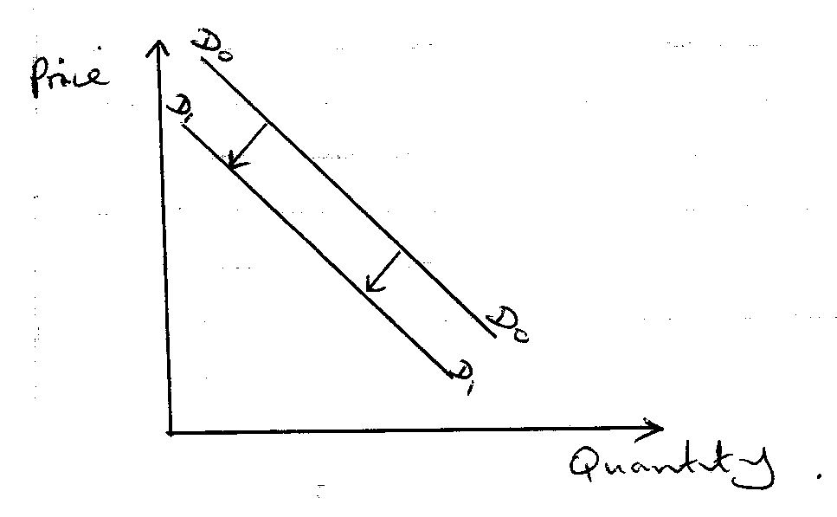
Outline four factors that may have contributed to the above shift.

- ………………………………………………………………………………………….
- ………………………………………………………………………………………….
- ………………………………………………………………………………………….
- ………………………………………………………………………………………….
- KL traders had the following information in its books of account on 1st Jan 2012.
 | Ksh
Bank overdraft | 38,000
Machinery | 500,000
Cash at bank | 40,000
Capital | 620,000
Cash at hand | 100,000
Stock | 30,000
Debtors | 38,000
Creditors | 50,000

For the year ended 31st Dec, 2012, the following information was available.
- Sold all the stock for Ksh 60000 and received the amount by cheque.
- Bought into the business cash from a private source sh 200000.

Required: Prepare a balance sheet as at 31st December, 2012. (5 mks)

- State four advantages of railway transport. (4 mks)

- ………………………………………………………………………………………….
- ………………………………………………………………………………………….
- ………………………………………………………………………………………….
- ………………………………………………………………………………………….
- Open the ledger account using the following information. (4 mks)
On 1st Jan 2012: Started business with Ksh 50,000 in cash
On 2nd Jan 2012: Bought goods on credit from Ms Traders with Ksh 5000.
On 3rd Jan 2012: Paid ML Ksh 3000 in cash
On 4th Jan 2012: Paid salaries Ksh 10,000 in cash.

