SUNSHINE SCHOOL

FORM 3
GEOGRAPHY
PAPER 1
END TERM EXAM – OCT. 2015
TIME: 2 ½ HRS

NAME: …………………………………………………CLASS:………..ADM. NO:…………

SECTION A
6
7
8
TOTAL

SECTION A

Answer all questions in this section.

- (a) Other than planets name two members of the solar system. (2 mks)

(b) Give three characteristics of planets. (3 mks)

- (a) What is forestry? (2 mks)

(b) State three factors that favour the growth of natural forests on the slopes of mt. Kenya.
(3 mks)

- (a) Name two features found on an emerged highland coast. (2 mks)

(b) State three factors that determine the type of a coast. (3 mks)

- (a) Name two zones of ground water. (2 mks)

(b) Give three characteristics of Karst scenery. (3 mks)

- (a) State two importance of soil water. (2 mks)

(b) Give three factors that influence development of soil catena. (3 mks)

SECTION B

Answer question 6 and any other two questions from this section.

- Study the map of Migwani (1:50,000) sheet 151/1 provided and answer the following questions.

- (i) Identify two natural features found in grid square 0479. (2 mks)

(ii) Convert the scale of the map to statement scale. (2 mks)

- (i) Measure the distance of the all weather road bound surface C94 to the North west
of the are covered by the map. (2 mks)

(ii) What is the bearing of the air photo principal point in grid square 0071 from the
air photo principle point in grid square 0567. (2 mks)

(iii) Calculate the area of part enclosed by the all weather road C94 and the dry
weather road D502 and south of Northing 80. (2 mks)

- (i) Citing evidence from the map give three social services offered at Mutitu (Ndooa)
shopping area. (3 mks)

(ii) State three indicators of low rainfall in the area covered by the map. (3 mks)

- (i) Reduce the area enclosed by easting 07 and 13 and Northing 68 and 73 to a half.
(1 mk)

(ii) On your reduced map mark and name the following:

- Dry weather road D 503 (1 mk)

- Ikoo river (1 mk)

- Water pipeline (1 mk)

(iii) What is the scale of the new map? (1 mk)

- Describe the relief of the area covered by the map. (4 mks)

- The diagram below represents zones of natural vegetation on a mountain in Africa. Use it to answer question (a) (i) and (ii).
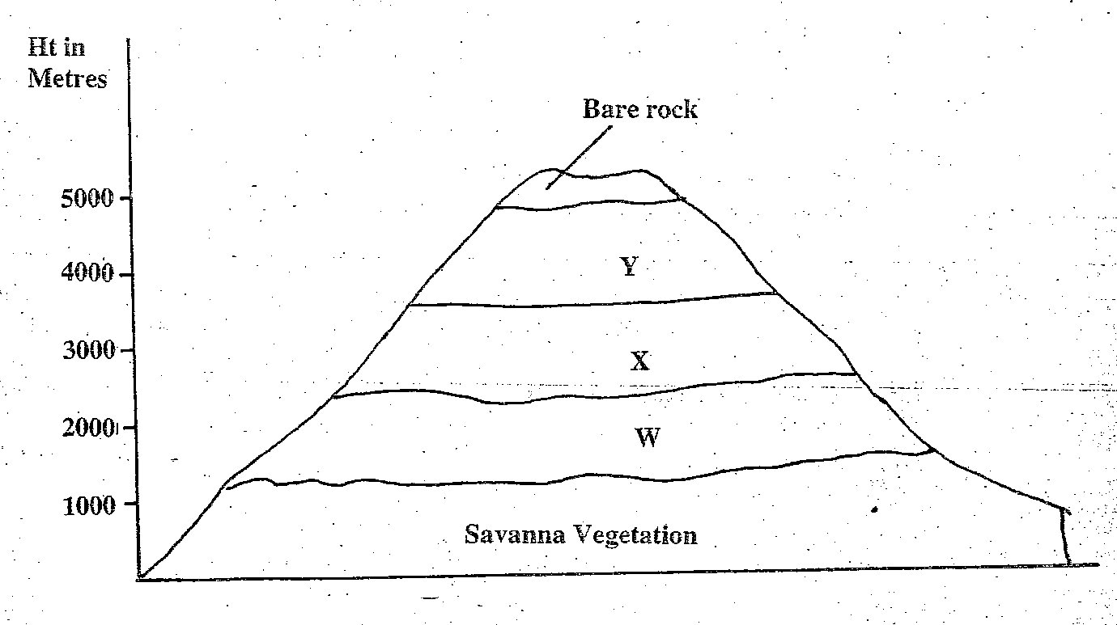

- (i) Name the vegetation zones marked W, X and Y. (3 mks)

(ii) Describe the characteristics of the Savanna vegetation. (6 mks)

(iii) Name the temperate grasslands found in the following countries:

- Canada (1 mk)

- Russia (1 mk)

- Australia (1 mk)

- Explain three causes of the decline of the areas under forests in Kenya. (6 mks)

- You are supposed to carry out a field study on the uses of vegetation in the area around your school.

- State three reasons why it would be necessary to visit the area before the day of the study. (3 mks)

- Give four uses of vegetation you are likely to identify during the study.(4 mks)

- (a) (i) Define the term aridity. (1 mk)

(ii) Name three types of desert landscapes. (3 mks)

(b) (i) State three natural factors that contribute to the development of deserts.
(3 mks)

(ii) Using well labelled diagrams, describe how the following features are formed. (6 mks)
- Zeugen

- Barchans (5 mks)

(c) Your class carried out a field study in arid areas.

- Name three features resulting form water action you are likely to identify.
(3 mks)

- State two reasons why they needed a route map. (2 mks)

- State two problems they are likely to encounter. (2 mks)

