SHULE YA UPILI YA SUNSHINE

KIDATO CHA TATU
KISWAHILI
KARATASI YA PILI
MUHULA WA PILI – OCT. 2015

JINA:………………………….……………………….…NAMBARI:……DARASA: ………

SWALI | ALAMA
UFAHAMU | 15
UFUPISHO | 15
SARUFI | 40
ISIMU JAMII | 10
JUMLA | 80

UFAHAMU
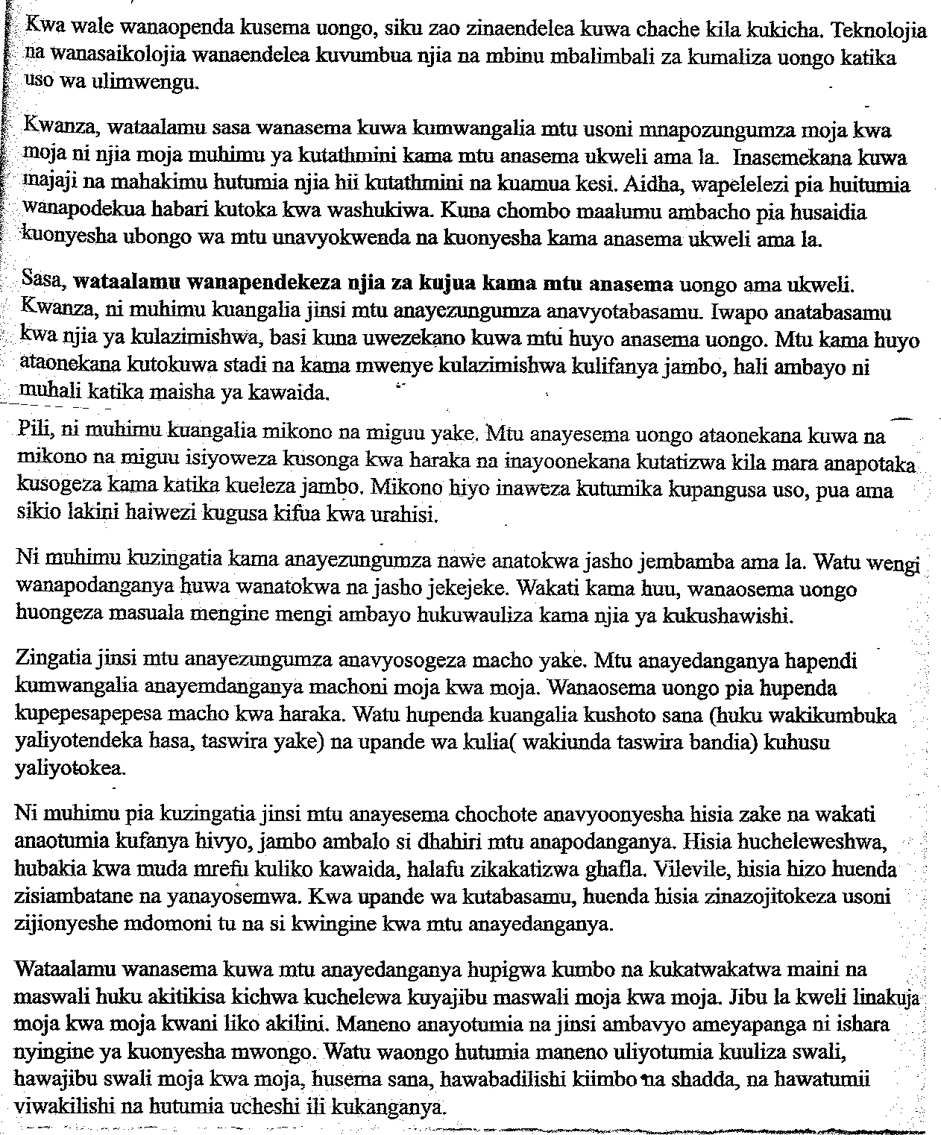
- Kwa nini mwandishi anasema kuwa dunia itakua ngumu kwa wanaopenda kudanganya? (al 2)

…………………………………………………………………………………………………..
…………………………………………………………………………………………………..
…………………………………………………………………………………………………..
…………………………………………………………………………………………………..
- Ni kwa nini uso wa mwongo ni njia rahisi ya kumshika? (al 4)
…………………………………………………………………………………………………..
…………………………………………………………………………………………………..
…………………………………………………………………………………………………..
…………………………………………………………………………………………………..
- Sehemu nyingine za mwili zinachangia nini katika kumshika anayesema uongo? (al 4)
…………………………………………………………………………………………………..
…………………………………………………………………………………………………..
…………………………………………………………………………………………………..
…………………………………………………………………………………………………..
- Wataalamu wanapendekeza nini kuhusu kutumia hisia za mtu anayesema uongo? (al 4)
…………………………………………………………………………………………………..
…………………………………………………………………………………………………..
…………………………………………………………………………………………………..
…………………………………………………………………………………………………..
…………………………………………………………………………………………………..
…………………………………………………………………………………………………..
…………………………………………………………………………………………………..…………………………………………………………………………………………………..
…………………………………………………………………………………………………..
…………………………………………………………………………………………………..
- Eleza maana ya msamiati huu kama ulivyotumiwa katika taarifa: (al 1)
- Muhali
…………………………………………………………………………………………………..
…………………………………………………………………………………………………..
- Hupigwa kumbo
…………………………………………………………………………………………………..
…………………………………………………………………………………………………..

UFUPISHO

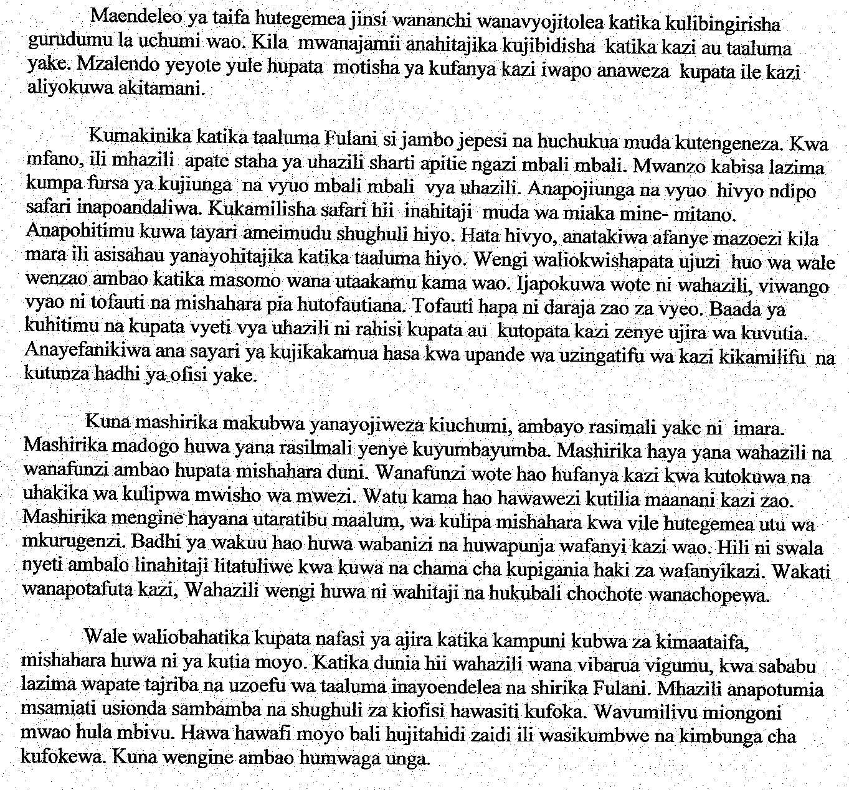

- Bila kupoteza maana iliyokusudiwa na mwandishi wa taarifa, fupisha aya ya kwanza na ya pili. (Maneno 60 – 70) (alama 1 kwa mtiririko) (al 7)

Matayarisho
…………………………………………………………………………………………………
…………………………………………………………………………………………………
…………………………………………………………………………………………………
…………………………………………………………………………………………………
…………………………………………………………………………………………………
…………………………………………………………………………………………………
…………………………………………………………………………………………………
…………………………………………………………………………………………………
…………………………………………………………………………………………………
Nakala safi:
…………………………………………………………………………………………………
…………………………………………………………………………………………………
…………………………………………………………………………………………………
…………………………………………………………………………………………………
…………………………………………………………………………………………………
…………………………………………………………………………………………………
…………………………………………………………………………………………………
…………………………………………………………………………………………………
- Kwa kuzingatia aya mbili za mwisho, eleza mambo muhimu yanayoshughulikiwa na mwandishi. (Maneno 60 – 70) (alama 2 kwa mtiririko) (al 8)

Matayarisho

…………………………………………………………………………………………………
…………………………………………………………………………………………………
…………………………………………………………………………………………………
…………………………………………………………………………………………………
…………………………………………………………………………………………………
…………………………………………………………………………………………………
…………………………………………………………………………………………………
Nakala safi

…………………………………………………………………………………………………
…………………………………………………………………………………………………
…………………………………………………………………………………………………
…………………………………………………………………………………………………
…………………………………………………………………………………………………
…………………………………………………………………………………………………
…………………………………………………………………………………………………
…………………………………………………………………………………………………

SARUFI

- Eleza sifa moja inayoitofautisha sauti za menoni. (al 2)

…………………………………………………………………………………………………..
…………………………………………………………………………………………………..
…………………………………………………………………………………………………..
- Nini maana ya silabi mwambatano. (Toa mfano). (al 3)

…………………………………………………………………………………………………..
…………………………………………………………………………………………………..
…………………………………………………………………………………………………..
…………………………………………………………………………………………………..
- Andika neno lenya muungano wa konsonanti, kieyusho na irabu. (al 1)

…………………………………………………………………………………………………..
- Eleza dhamira zinazokusudiwa na sentensi zifuatazo. (al 3)

- Ameshuka………………………………………………………………………………
…………………………………………………………………………………………..
- Ameshuka?……………………………………………………………………………..
…………………………………………………………………………………………..
- Ameshuka!……………………………………………………………………………..
………………………………………………………………………………………….
- Huku ukitoa mfano, eleza maana ya nomino ambatano. (al 3)

…………………………………………………………………………………………………..
…………………………………………………………………………………………………..
…………………………………………………………………………………………………..
…………………………………………………………………………………………………..
- Andika sentensi iliyo na nomoni milikishi. (al 2)

…………………………………………………………………………………………………..
…………………………………………………………………………………………………..
- Tunga sentensi kubainisha kiwakilishi kinachowakikisha nonimo katika ngeli ya ki-vi wingi ambacho kinaashiria. (al 2)

…………………………………………………………………………………………………..
…………………………………………………………………………………………………..

- Bainisha vivumishi katika sentensi ifuatayo na useme ni cha aina gani. (al 2)

“Ule mfuko ni wa mfanyibiashara”

…………………………………………………………………………………………………..
…………………………………………………………………………………………………..
…………………………………………………………………………………………………..
- Kilelezi kilichopigiwa mstari ni cha aina gani? (al 2)

“Watu wengi mashambani husariri kwa baiskeli”

…………………………………………………………………………………………………..
…………………………………………………………………………………………………..
…………………………………………………………………………………………………..
- Bainisha vitenzi katika sentensi ifuatayo. (al 2)

“Huenda akaja kwetu kesho”.

…………………………………………………………………………………………………..
…………………………………………………………………………………………………..
…………………………………………………………………………………………………..

- Onyesha viunganishi vya uteuzi katika sentensi ifuatayo. (al 2)

“Ama uamke mapema au ukose basi la kwenda Lamu.”

…………………………………………………………………………………………………..
…………………………………………………………………………………………………..
- Bainisha viambishi katika kitenzi kifuatacho. (al 3)

“Waliompokea”

…………………………………………………………………………………………………..
…………………………………………………………………………………………………..
…………………………………………………………………………………………………..
…………………………………………………………………………………………………..
…………………………………………………………………………………………………..
…………………………………………………………………………………………………..
- Bainisha dhana zinazojitokeza katika sentensi zifuatazo. (al 2)

…………………………………………………………………………………………………..
…………………………………………………………………………………………………..
- Tunga sentensi kuonyesha matumizi mawili ya alama ya kinyota. (al 2)

…………………………………………………………………………………………………..
…………………………………………………………………………………………………..
- Kirai ni nini? (al 2)

…………………………………………………………………………………………………..
…………………………………………………………………………………………………..
…………………………………………………………………………………………………..
…………………………………………………………………………………………………..
- Tambulisha kirai husishi katika sentensi ifuatayo. (al 1)

“Kikombe kiko juu ya meza.”

…………………………………………………………………………………………………..
…………………………………………………………………………………………………..

- Andika sifa zozote tatu za kishazi tegemezi. (al 3)

…………………………………………………………………………………………………..
…………………………………………………………………………………………………..
…………………………………………………………………………………………………..
…………………………………………………………………………………………………..
- Changamua sentensi ifuatayo kwa njia ya matawi. (al 3)

“Achelewaye huadhibiwa”.

ISIMU JAMII

- Eleza maana ya istilahi ziuatazo.

- Isimu jamii (al 1)
…………………………………………………………………………………………………
…………………………………………………………………………………………………
- Lahaja (al 1)
…………………………………………………………………………………………………
…………………………………………………………………………………………………
- Krioli (al 1)
…………………………………………………………………………………………………
…………………………………………………………………………………………………
- Pijini (al 1)
…………………………………………………………………………………………………
…………………………………………………………………………………………………
- Lingua franca (al 1)
…………………………………………………………………………………………………
…………………………………………………………………………………………………
- Lafudhi (al 1)
…………………………………………………………………………………………………
…………………………………………………………………………………………………
- Jamii (al 1)

…………………………………………………………………………………………………
…………………………………………………………………………………………………
- Eleza nadhara tatu zinazoeleza kuhusu chimbuko la Kiswahili. (al 3)

…………………………………………………………………………………………………
…………………………………………………………………………………………………
…………………………………………………………………………………………………
…………………………………………………………………………………………………
…………………………………………………………………………………………………
…………………………………………………………………………………………………
…………………………………………………………………………………………………

