SOUTH EASTERN KENYA UNIVERSITY

UNIVERSITY EXAMINATIONS 2016/2017

FIRST SEMESTER EXAMINATION FOR THE DEGREE OF BACHELOR

SCIENCE IN ELECTRONICS

ELC 300: ELECTROMECHANICAL CONTROL SYSTEMS

7TH DECEMBER, 2016

INSTRUCTIONS TO CANDIDATES

TIME: 4.00-6.00 P.M

·
·

Question one carries 30marks while the rest carry 20marks each
Answer Question One and any other two questions

Question One (30mks)
a) Explain what is meant by the following as used in electromechanical systems

(i) Process
(ii) System
(iii) Control
(iv) Actuators
b) State three variables that defines interactions in control systems
c) Highlight any four differences between open and closed loop systems
d) Briefly explain what is meant by BIBO Stability
e) What are the basic elements used for modeling mechanical translational system.
f) Explain how systems are classified depending on the value of damping?

SEKU/09-12/2016/2017

Page 1
(2mks)
(2mks)
(2mks)
(2mks)
(3mks)
(4mks)
(2mks)
(3mks)
(4mks)

g) (i) Explain the concept of frequency response
(ii) Give four advantages of frequency response analysis

Question Two (20mks)
a) (i) What is a closed loop control system?
(ii) State and explain the main elements of a closed control system.

b) (i) Explain what is meant by Transfer function

(2mks)
(4mks)

(2mks)
(10mks)

(2mks)

(ii)
Given the following system:

H (s) =

x(s) 3
u(s) 0.5s + 1

Find the differential equation from the transfer function hence draw a block diagram of the

system

Question Three (20mks)
a) The diagram below show a form of a speed governor for a steam engine.

(i) Explain how it controls the speed of the engine
(ii) Sketch a block diagram of all elements
b) Design an automatic water flushing system that can be used to for domestic use
c) The figure below shows an industrial production of sheets of metal

SEKU/09-12/2016/2017

(4mks)
(4mks)
(4mks)

Page 2
(6mks)
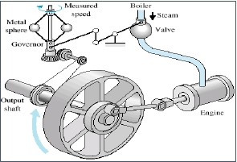

=

(i) Explain how it works in controlling the sheet thickness
(ii) Explain the all the elements of control depicted in the diagram

Question Four (20mks)
Indicate the basic and auxiliary functional elements of the device shown below in parts (a) to (b)

(4mks)
(4mks)

a) Diaphragm type liquid level gauge

b) A spring balance with electrical read out

c) Mechanical type of displacement measuring dial gauge

SEKU/09-12/2016/2017

Page 3

(6mks)

(7mks)

(7mks)
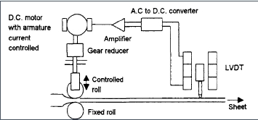

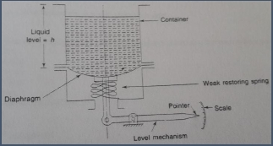

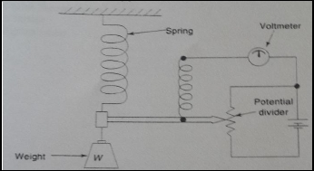

Question 5 (20 marks)
For the system with the block diagram shown below and taking 𝐾 = 200

-

K

+

u(t)

1
10𝐷

c(t)

Controller

Find the
a) The closed loop transfer function
b) Transient response for the unit step reference input 𝑟(𝑡)
c) Steady state error for the unit ramp reference input 𝑟(𝑡)
d) Steady state error for the unit step disturbance input 𝑢(𝑡)

SEKU/09-12/2016/2017

System

Page 4

(3mks)
(5mks)
(6mks)
(6mks)
