SOUTH EASTERN KENYA UNIVERSITY

UNIVERSITY EXAMINATIONS 2016/2017

FIRST SEMESTER EXAMINATION FOR THE DEGREE OF

BACHELOR SCIENCE IN ELECTRONICS

ELC 302: TRANSISTORS

8TH DECEMBER, 2016

INSTRUCTIONS TO CANDIDATES

TIME: 8.00-10.00 A.M

•
•
•

This paper consists of FIVE (5) questions.
Answer question ONE and any other TWO questions.
Question ONE carries 30 marks while the other TWO questions carry 20 marks
each.

QUESTION 1 (COMPULSORY) (30 MARKS)

a) By using circuit symbols, distinguish between bipolar junction transistors (BJTs) and
unipolar junction transistors (UJTs)
(4marks)

b)
The diagram below shows a transistor circuit.

Given that VBE = 0.7 and β= 100, determine:

i.
IB, IC, and IE
(6marks)

SEKU/09-12/2016/2017

Page 1

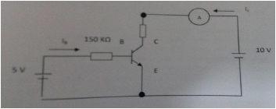

ii.
iii.

VCB
Plot schematic diagrams for the output characteristics

(2marks)
(4marks)

c) Name the three transistor configurations and draw simple circuit diagrams for each
(8marks)
d) Figure 2 below shows an inverting amplifier operated from a ±15 V supply.

i.
ii.

Calculate the voltage gain of the amplifier. (3marks)
A sinusoidal PD of 0.50 V RMS and frequency 1kHz is applied to the
input. Using the same axes showing suitable voltage and time scales,
sketch the variationwith time of the input PD and the output PD
(5marks)

e) Name different types of FET biasing .

(2marks)

QUESTION TWO (20 MARKS)

a) (i) Draw a well labelled circuit diagram that can be used to determine the input

characteristics for common emitter configuration of a transistor
(5marks)

(ii) By using appropriate graphs, discuss the input characteristics for different values
of VCE for the circuit in (i) above stating any special features. (5marks)

b) In the circuit below the input resistor is varied between 1 kΩ and 10 kΩ.

SEKU/09-12/2016/2017

Page 2
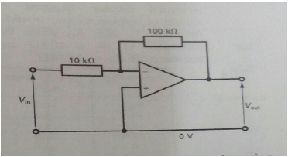

If the voltage Vbe is 2V and the current gain hfe = 100, calculate:

i.
ii.
iii.
iv.

The voltage across the input resistor Ri
The maximum and minimum currents through the base Ib
The minimum and maximum current Ic
The emitter current Ie when Ri = 5 kΩ

(2marks)
(2marks)
(2marks)
(4marks)

QUESTION THREE (20 MARKS)

a) The circuit diagram in figure 3 below shows how a transistor can be used to amplify
small voltage change.

i.Briefly explain how a small alternating PD applied at the input can be amplified
(5marks)

ii.
If the characteristics of the transistor are such that in the absence of an input
signal the steady collector current IC = 2 mA, the collector emitter voltage VCE

SEKU/09-12/2016/2017

Page 3
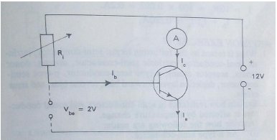

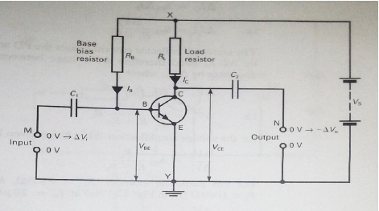

= 4 V and the supply PD = 9V. Given that when collector current IC = 2 mA,
the base current IB = 20µA and at this current VBE = 0.8 V, calculate

I.
the value of the load resistor RL

(2marks)

II.
III.
IV.
the value of the biasing resistor RB
the voltage amplification
the power amplification
(2marks)
(5marks)
(2marks)

b) A JFET has parameters of VGS(off) = -40V, and IDSS = 15 mA. Calculate the drain current

in this resistor if the gate source voltage VGS = 12 V.
(4marks)

QUESTION 4 (20 MARKS)

a) Define the h – parameters for the common base and common collector transistor
configurations and compare them with the general parameters (10marks)
b) The circuit diagram below can act as a switching circuit.

By drawing a graph of the variation of Vo against Vi, Explain how the switching

mechanism is achieved.
(10marks)

QUESTION 5 (20 MARKS)

a) (i) Draw a circuit diagram for an amplifier as an astable multivibrator and sketch the
corresponding waveform of output voltage against time. (8marks)

(ii) Show that the period of the corresponding waveform is given by

SEKU/09-12/2016/2017

Page 4
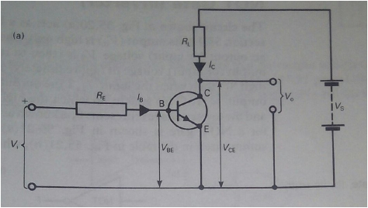

⎛
⎝

⎟

(6marks)

b) An amplifier having a gain of 500 without feedback has an overall negative feedback
applied which reduces the gain to 100

i.Calculate the fraction of the output voltage fed back
(3marks)

ii.
If due to the aging of components, the gain without feedback falls by 20%,
calculate the percentage fall in gain without feedback and with feedback
(3marks)

SEKU/09-12/2016/2017

Page 5
T = 2CR log e ⎜⎜1 +
2R2 ⎞
R1 ⎟⎠

