Name: …………………………………………………………… Index No …......…................................

Candidate’s Sign …………………………………. Date: …………………………………

443/2
AGRICULTURE
Paper 2
OCT/NOV 2013
Time: 2 Hours

Kenya Certificate of Secondary Education (K.C.S.E)

Agriculture
Paper 2
2 Hours

INSTRUCTIONS TO CANDIDATES:

- Write your name, index number and school in the spaces provided.
- Sign and write the date of the examination in the spaces provided.
- This paper consists of three sections; A, B and C.
- Answer all questions in section A and B.
- In section C answer any two questions in the spaces provided
- All answers must be written in the spaces provided.

For Examiner’s Use Only;
SECTION | QUESTION | MAXIMUM SCORE | CANDIDATES’ SCORE
A | 1 - 20 | 30
B | 16 – 19 | 20
C |  | 20
 |  | 20
 | Total | 90
This paper consists of 8 printed pages. Candidates should check the question paper to ascertain that all pages are printed as indicated and that no questions are missing

SECTION A (30 MARKS)
Answer all the questions in this section in the spaces provided.
1. What characteristics of gizzard of a cork enable it to digest food? (1mk)
…………………………………………………………………………………………………………..
…………………………………………………………………………………………………………..
2. Differentiate between an essex saddle back and Wessex saddle back (1mk)
…………………………………………………………………………………………………………..
…………………………………………………………………………………………………………..
3. State four factors that determine quality of honey (2mks)
…………………………………………………………………………………………………………..
…………………………………………………………………………………………………………..
…………………………………………………………………………………………………………..
…………………………………………………………………………………………………………..
4. (a) Give fours ways of restoring a sick animal to good health (2mks)
…………………………………………………………………………………………………………..
…………………………………………………………………………………………………………..
…………………………………………………………………………………………………………..
…………………………………………………………………………………………………………..
(b) Differentiate between pen and daft camping in sheep management (2mks)
…………………………………………………………………………………………………………..
…………………………………………………………………………………………………………..
5. What the difference between making gauge and mortise gauge (1mk)
…………………………………………………………………………………………………………..
…………………………………………………………………………………………………………..
6. Give two examples of light breeds of poulrty (1mk)
…………………………………………………………………………………………………………..
…………………………………………………………………………………………………………..
7. (a) State four signs of heat in pigs (2mks)
…………………………………………………………………………………………………………..
…………………………………………………………………………………………………………..
…………………………………………………………………………………………………………..
…………………………………………………………………………………………………………..
(b) Give two reasons why teaser rams are introduced to a flock of ewes some weeks before tupping (1mk)
…………………………………………………………………………………………………………..
…………………………………………………………………………………………………………..
8. Name two livestock diseases controlled through artificial insemination (1mk)
…………………………………………………………………………………………………………..
…………………………………………………………………………………………………………..
9. State two factors which determine amount of feeds given to an animal (1mk)
…………………………………………………………………………………………………………..
…………………………………………………………………………………………………………..
10. Name the tool used together with each of the following tools
(a) Canula
…………………………………………………………………………………………………………..
(b) Brace
…………………………………………………………………………………………………………..
(c) Elastrator
…………………………………………………………………………………………………………..
11. Name four plumbing tools used for installing galvanized water pipes (2mks)
…………………………………………………………………………………………………………..
…………………………………………………………………………………………………………..
…………………………………………………………………………………………………………..
…………………………………………………………………………………………………………..
12. Give two reasons for seasoning timber before it is used for construction (1mk)
…………………………………………………………………………………………………………..
…………………………………………………………………………………………………………..
13. State two factors that lower quality of concrete (1mk)
…………………………………………………………………………………………………………..
…………………………………………………………………………………………………………..
14. Give two maintenance practices in a green house (1mk)
…………………………………………………………………………………………………………..
…………………………………………………………………………………………………………..
15. Highlight three functions of ventilation in an animal house (1 ½ mks)
…………………………………………………………………………………………………………..
…………………………………………………………………………………………………………..
…………………………………………………………………………………………………………..
16. Name the type of breeding system represented below
(a) Ayrshire sue x Boran Dam F1 heifer x Hereford ( ½ mk)
…………………………………………………………………………………………………………..
(b) Outline two characteristics of livestock that are used in mass selection (1mk)
…………………………………………………………………………………………………………..
…………………………………………………………………………………………………………..
17 (a) Name four properties of a good vaccine (2mks)
…………………………………………………………………………………………………………..
…………………………………………………………………………………………………………..
…………………………………………………………………………………………………………..
…………………………………………………………………………………………………………..
(b) What is the function of spillway in a fish pond? (1mk)
…………………………………………………………………………………………………………..
SECTION B (20MARKS)
Answer all the questions in the spaces provided
18. Below is a diagram of a farm structure it to answer the questions that follow
A
B
C
D
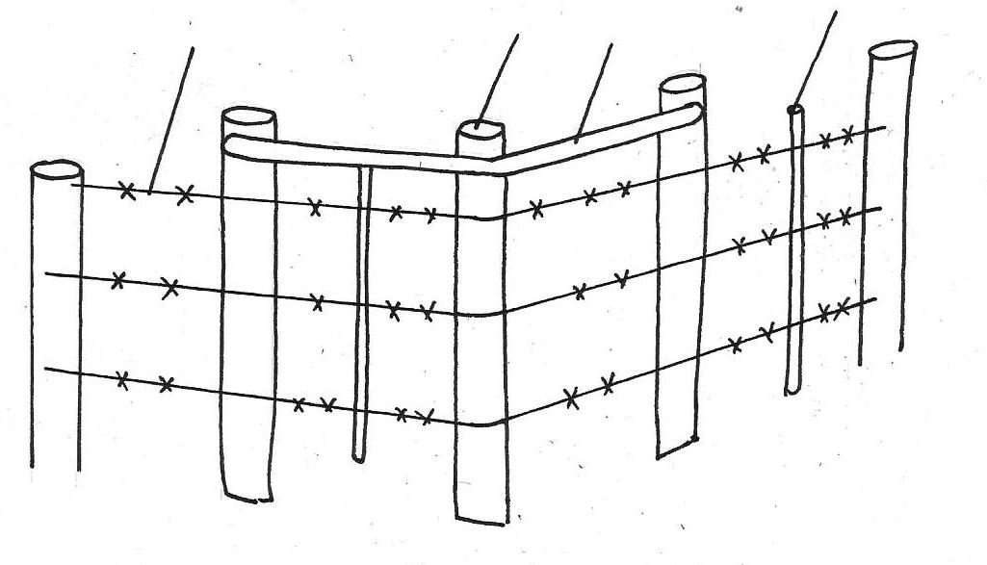

(a) Identify the structure ( ½ mk)
…………………………………………………………………………………………………………..
(b) Name the parts labeled B,C,D,E and F (2 ½ mks)
…………………………………………………………………………………………………………..
…………………………………………………………………………………………………………..
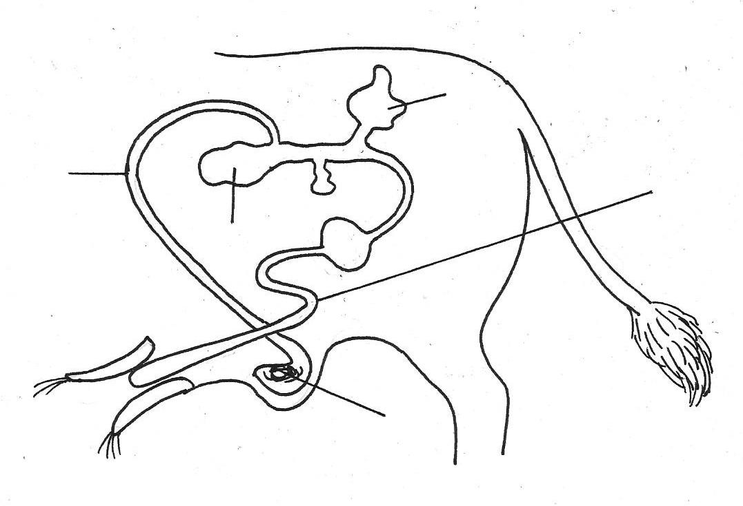
19. Study the illustration below and use to to answer the questions below
Urethra
A
C
D
B

(a) Label the parts
A…………………….
B……………………..
C……………………
D…………………
(b) Give the functions of parts B and C (2mks)
B……………………………………………………………………………………………….
C…………………………………………………………………………………………………
(c) Give the name of the part in the animal affected when the animal is attacked by brucellosis(1mk)
…………………………………………………………………………………………………………..
20. Diagram G,H and J illustrate some livestock parasites
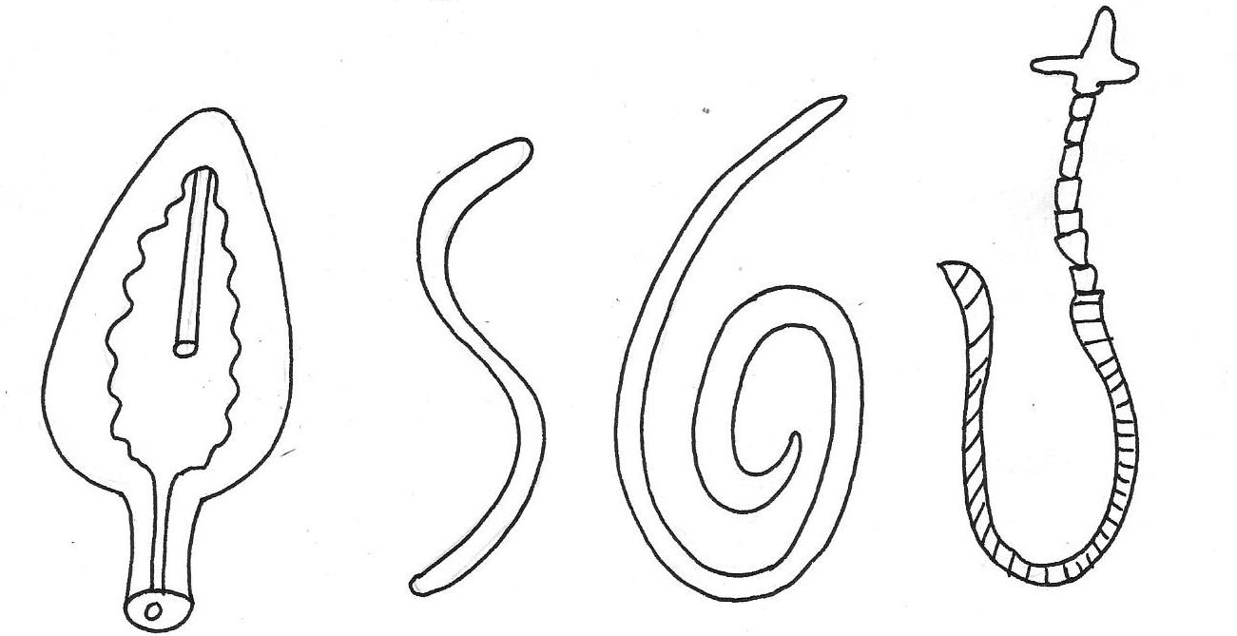

G
H
J

(a) Identify parasites G,H and J ( 1 ½ mks)
…………………………………………………………………………………………………………..

(b) State the category of parasites G, H and J (1 ½ mks)
…………………………………………………………………………………………………………..
…………………………………………………………………………………………………………..
(c) Name the parts of the hosts body where parasites G and J are found (2mks)
…………………………………………………………………………………………………………..
(d) Name the intermediate horsts of parasites G and H (1mk)
…………………………………………………………………………………………………………..
21. Below is a breeding cycle of an ewe in relation to feeding region accompanying it it.
TUPPING
LAMBING
WEANING
iii
i
ii

(a) Which stages are represented by:-
(i) ……………………………………
(ii)…………………………………….
(iii)…………………………………….
(b) Give two importance of (i) (2mks)
…………………………………………………………………………………………………………..
…………………………………………………………………………………………………………..
22. Below are farm tools, study them and answer the questions below

O
N
M
L

(a) Identify the tools M, N (1mk)
M …………………………………………………………………………………………………………..

N …………………………………………………………………………………………………………..
(b) Give one functional advantage of O over tool L (1mk)
…………………………………………………………………………………………………………..
SECTION C: (40MARKS)
Answer TWO questions from this section.
23. (a)Describe five design requirement of a calf pen (10mks)
(b) Describe milk fever disease under the following sub-headings
(i) Animals affected (2mks)
(ii) Symptoms (5mks)
(iii) Control and treatment (3mks)
24. Give the routine practices and explain an appropriate method of handling livestock during the routine practice (20mks)
25. (a) Describe the digestion of grass in the rumen of a ruminant (6mks)
(b) Describe the life-cycle of a three host tick (7mks)
(c) Which precautions should be observed when using farm tools and equipment (6mks)
…………………………………………………………………………………………………………..
…………………………………………………………………………………………………………..
…………………………………………………………………………………………………………..
…………………………………………………………………………………………………………..
…………………………………………………………………………………………………………..
…………………………………………………………………………………………………………..
…………………………………………………………………………………………………………..
…………………………………………………………………………………………………………..
…………………………………………………………………………………………………………..
…………………………………………………………………………………………………………..
…………………………………………………………………………………………………………..
…………………………………………………………………………………………………………..
…………………………………………………………………………………………………………..
…………………………………………………………………………………………………………..
…………………………………………………………………………………………………………..
…………………………………………………………………………………………………………..
…………………………………………………………………………………………………………..
…………………………………………………………………………………………………………..
…………………………………………………………………………………………………………..
…………………………………………………………………………………………………………..
…………………………………………………………………………………………………………..
…………………………………………………………………………………………………………..
…………………………………………………………………………………………………………..
…………………………………………………………………………………………………………..
…………………………………………………………………………………………………………..
…………………………………………………………………………………………………………..
…………………………………………………………………………………………………………..
…………………………………………………………………………………………………………..
…………………………………………………………………………………………………………..
…………………………………………………………………………………………………………..
…………………………………………………………………………………………………………..
…………………………………………………………………………………………………………..
…………………………………………………………………………………………………………..
…………………………………………………………………………………………………………..
…………………………………………………………………………………………………………..
…………………………………………………………………………………………………………..
…………………………………………………………………………………………………………..
…………………………………………………………………………………………………………..
…………………………………………………………………………………………………………..
…………………………………………………………………………………………………………..
…………………………………………………………………………………………………………..
…………………………………………………………………………………………………………..
…………………………………………………………………………………………………………..
…………………………………………………………………………………………………………..
…………………………………………………………………………………………………………..
…………………………………………………………………………………………………………..
…………………………………………………………………………………………………………..
…………………………………………………………………………………………………………..
…………………………………………………………………………………………………………..
…………………………………………………………………………………………………………..
…………………………………………………………………………………………………………..
…………………………………………………………………………………………………………..
…………………………………………………………………………………………………………..
…………………………………………………………………………………………………………..
…………………………………………………………………………………………………………..
…………………………………………………………………………………………………………..
…………………………………………………………………………………………………………..
…………………………………………………………………………………………………………..
…………………………………………………………………………………………………………..
…………………………………………………………………………………………………………..

