312/1
GEOGRAPHY
PAPER 1
OCT /NOV - 2013
TIME: 2 ¾ HOURS

Kenya Certificate of Secondary Education (K.C.S.E)

Geography
Paper 1
TIME: 2 ¾ hours

INSTRUCTIONS TO CANDIDATES:
- This paper consists of two sections A and B.
- Answer all the questions in section A. In section B, answer question 6 and any other two questions.
- All answers must be written in the answer booklet provided.

This paper consists of 4.printed pages. Candidates should check to ascertain that all pages are printed as indicated and that no questions are missing.

SECTION A

1. (a) Distinguish between an orbit and an axis. (2 mks)
(b) State three proofs that the interior of the earth is hot. (3 mks)

2. (a) What is a spring? (1 mk)
(b)State four ways in which a spring may develop. (4 mks)

3. (a) The diagram below represents zones of natural vegetation on a mountain within the tropical
region.
Study it and answer questions that follow:

Savannah grassland
1000
0
2000
3000
4000
5000
Bare rock
Height in metres
X
Y

(a) Name the vegetation zones marked X and Y. (2 mks)
(b) State three characteristics of Mediterranean types of vegetation. (3 mks)

4. (a) Give two processes of slow mass wasting. (2 mks)
(b) State three physical conditions that may influence landslides. (3 mks)

5. (a) State two ways through which rivers transport its loads. (2 mks)
(b) The diagram below represents a river captive.
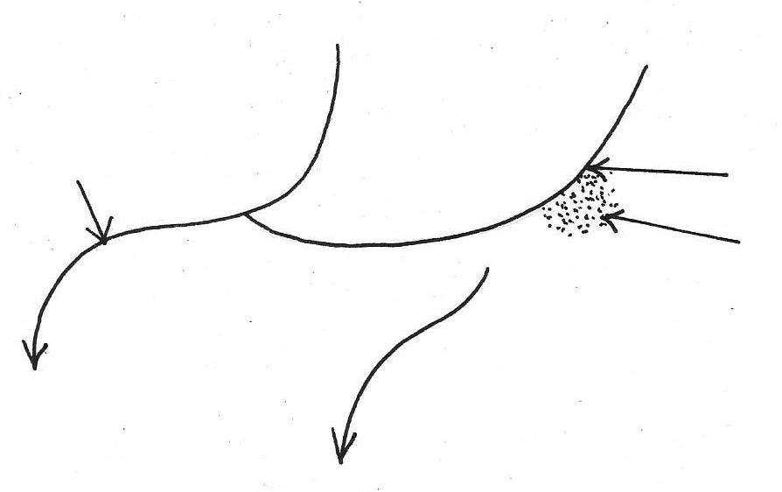

C
A
B

Name the parts marked A, B and C. (3 mks)

A ......................................................................................................
B .......................................................................................................
C .......................................................................................................

SECTION B.
Answer question 6 and any other two questions in this section.

6. Study the map of Kitale ( 1: 50,000) sheet 75/3 provided and answer the following
questions.
a) (i) Name the relief feature found in grid square 2823. (1 mk)
(ii) Determine the distance of road B 10/2 from Knight’s corner junction with
Road C 637 to Kitale. (2 mks)
(iii) Find the area of Kiptaberr Forest. (2 mks)
b) (i)Calculate the gradient of the slope between point M and N. (2 mks)
ii) Identify the highest point in the area covered by the map. (2 mks)
c) Farmers at Delgany Farm carried out a study at their colleagues’ farm of Longleat
Estate.
(i) State two reasons why they would need the map of Kitale. (2 mks)
(ii) Mention two methods they would use to collect data. (2 mks)
(iii) Identify three data /information they would collect. (3 mks)
d) (i) Describe the distribution of settlement in area covered by the map. (4 mks)
(ii) Citing evidence from the map; identify two factors which have influenced the
growth of forests in Kitale area. (2 mks)
(iii) State three functions of Kitale town. (3 mks)

7. a) (i) What is a rock? (2 mks)
(ii) Explain the process of formation of mechanically formed sedimentary rocks. (5 mks)
b) Explain three ways in which rocks are significant to the economy of Kenya. (6 mks)
c) Student from your school carried out a field study on the types of Rocks.
One of the rock samples they collected was coral.
(i) Give three uses of coral rock. (3 mks)
(ii) Give three reasons why it was important for them to conduct reconnaissance. (3 mks)
(iii) State three problems they are likely to have encountered during the field study. (3 mks)

8. a) (i) What are Earthquakes? (2 mks)
(ii) Name three types of Earthquake waves. (3 mks)
(iii) State five ways in which the Earth crust is affected by Earthquakes. (5 mks)
b) (i) With the aid of a well-labelled diagram describe how the rift valley is formed by
tensional forces. (8 mks)
(ii) State four effects of faulting to human activities. (4 mks)
(iii) Give two advantages of studying faulted landscape through field work. (2 mks)

9. a) Name three types of desert surfaces. (3 mks)
b) Explain the following process of wind erosion
(i) Abrasion (2 mks)
(ii) Deflation (2 mks)
(iii)Attrition (2 mks)
c) With the aid of a diagram, describe how a rock pedestal is formed. (6 mks)
d) Draw a diagram of an overhead view of a desert basin. On it mark and name the
following features resulting from water action.
(i) Alluvial
(ii) Pedimoment
(iii) Playa
(iv) Bajada (5 mks)

10. a) (i) What is climate? (2 mks)
(ii) Explain two effects of climate change on the physical environment. (4 mks)
b) (i) State five characteristics of Inter Tropical Convergence Zone. (ITCZ) (5 mks)
(ii) Describe how convectional rainfall is formed. (7 mks) (iii) State three problems associated with convectional rainfall in the lake region of
Kenya. (3 mks)

