Name: ………………………………………………………….. Index No. ……………………………………

Date: …………………………………………………………. Candidate’s Sign. …………................................

443/1
AGRICULTURE
Paper 1
OCT/NOV 2013
Time: 2 Hours

Kenya Certificate of Secondary Education (K.C.S.E.)
FORM THREE

INSTRUCTIONS TO THE CANDIDATES:
- Write your name, index number and school in the spaces provided above.
- Sign and write the date of examination in the spaces provided.
- This paper consists of Three Sections: A, B and C.
- Answer ALL the questions in section A and B and any TWO questions from section C.
- Answers should be written in the spaces provided.
- This paper consists of 11printed pages.
- Candidates should check the questions paper to ascertain that all the pages are printed as indicated and that no questions are missing.

For Examiners’ Use Only
SECTION | QUESTIONS | MAXIMUM SCORE | CANDIDATE’S SCORE
A | 1-17 | 30
B | 18-23 | 20
C 24-26 |  | 20
 |  | 20
 |  | 90

This paper consists of 11 printed pages. Candidates should check to ascertain that all pages are printed as indicated and that no questions are missing.

SECTION A (30 MARKS)
Answer ALL the questions in this section in the spaces provided
1. State four advantages of practicing shifting cultivation (2mks)
…………………………………………………………………………………………………………
…………………………………………………………………………………………………………
…………………………………………………………………………………………………………
…………………………………………………………………………………………………………
2. State four factors that determine the stage of which a crop is harvested (2mks)
…………………………………………………………………………………………………………
…………………………………………………………………………………………………………
…………………………………………………………………………………………………………
…………………………………………………………………………………………………………
3. Give five disadvantages of weeds in crop production (2 ½ mks)
…………………………………………………………………………………………………………
…………………………………………………………………………………………………………
…………………………………………………………………………………………………………
…………………………………………………………………………………………………………
…………………………………………………………………………………………………………
4. Give three ways in which pastures are classified ( 1 ½ mks)
…………………………………………………………………………………………………………
…………………………………………………………………………………………………………
…………………………………………………………………………………………………………
5. Give three ways in which pastures are classified ( 1 ½ mks)
…………………………………………………………………………………………………………
…………………………………………………………………………………………………………
…………………………………………………………………………………………………………
6. State the conditions underwhich the opportunity cost is zero in a farming enterprise. (1 ½ mks)
…………………………………………………………………………………………………………
…………………………………………………………………………………………………………
7. Give two example for each of the following categories of water pipes
(a) Metal pipes (1mk)
…………………………………………………………………………………………………………
(b) Horse pipes (1mk)
…………………………………………………………………………………………………………
8. State five factors that can encourage soil erosion (2 ½ mks)
…………………………………………………………………………………………………………
…………………………………………………………………………………………………………
…………………………………………………………………………………………………………
…………………………………………………………………………………………………………
…………………………………………………………………………………………………………
9. Name one vegetative material used to propagate each of the following crops
(a) Banana ( ½ mk)
…………………………………………………………………………………………………………
(b)Pineapples ( ½ mk)
…………………………………………………………………………………………………………
(c) Irish potatoes ( ½ mk)
…………………………………………………………………………………………………………
(d) Pyrethrum ( ½ mk)
…………………………………………………………………………………………………………
10. List four implements used in secondary tillage (2mks)
…………………………………………………………………………………………………………
…………………………………………………………………………………………………………
…………………………………………………………………………………………………………
…………………………………………………………………………………………………………
11. State four ways of controlling bean anthracnose disease (2mks)
…………………………………………………………………………………………………………
…………………………………………………………………………………………………………
…………………………………………………………………………………………………………
…………………………………………………………………………………………………………
12 State two mechanical methods of separating soil particles according to size during soil analysis(1mk)
…………………………………………………………………………………………………………
…………………………………………………………………………………………………………
13. List four factors that should be considered when classifying crop pests (2mks)
…………………………………………………………………………………………………………
…………………………………………………………………………………………………………
…………………………………………………………………………………………………………
…………………………………………………………………………………………………………
14. State three efforts of excessive application of Nitrogenous fertilizer on crop growth (1 ½ mks)
…………………………………………………………………………………………………………
…………………………………………………………………………………………………………
…………………………………………………………………………………………………………
15. Give fours ways in which burning of vegetation may lead to loss of soil fertility (1 ½ mks)
…………………………………………………………………………………………………………
…………………………………………………………………………………………………………
…………………………………………………………………………………………………………
…………………………………………………………………………………………………………
16. Give two methods of land reforms practiced in Kenya. (1 ½ mks)
…………………………………………………………………………………………………………
…………………………………………………………………………………………………………
17. List three methods of budding used in the propagate of plants (1 ½ mks)
…………………………………………………………………………………………………………
…………………………………………………………………………………………………………
…………………………………………………………………………………………………………
SECTION B (20 MARKS)
Answer ALL the questions in this section in the spaces provided.

18. The diagram below illustrates on investigation on a property of soil using soil samples labeled

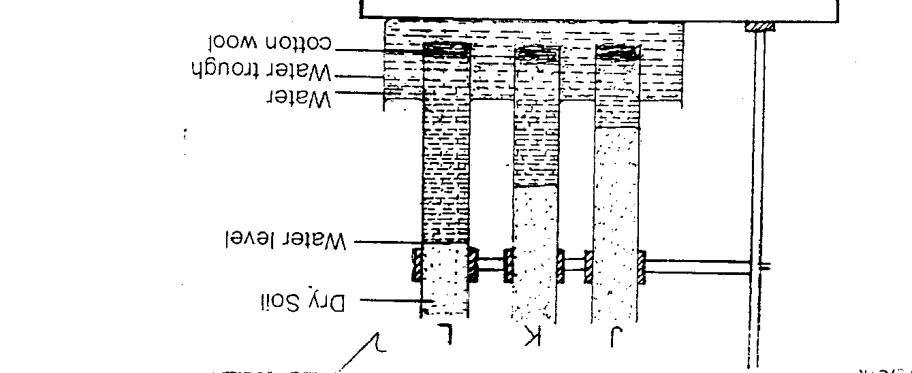

(a) If the levels of water shown in the diagram were observed after three hours, name the property of soil being investigated . (1mk)
…………………………………………………………………………………………………………
(b) What is the relationship between the soil property named in (a) above and the size of soil particles (1mk)
…………………………………………………………………………………………………………
(c) Which soil sample would be suitable fro growing paddy rice. (1mk)
…………………………………………………………………………………………………………

19. The figure below shows a field pest. Study it and answer the questions that follows

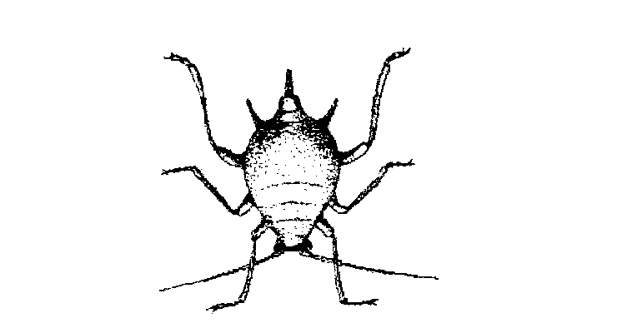

\
(a) Identify the pest shown above (1mk)
…………………………………………………………………………………………………………
(b) Give two measures that can be used to control the pest named above (1mk)
…………………………………………………………………………………………………………
…………………………………………………………………………………………………………
20. Below are diagrams labeled A1 A2 A3 and B illustrating methods and material of vegetative propagation. Study them and answer the questions that follow.

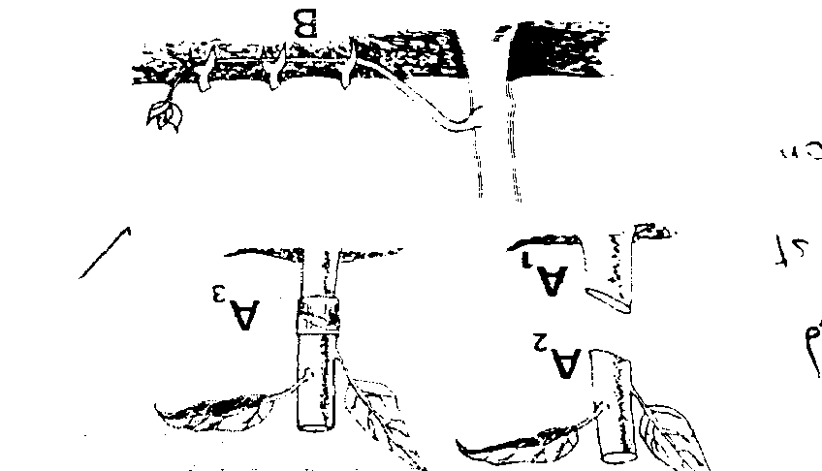

(a) Name the parts labeled
A₁……………………………………………………
A₂……………………………………………………
(b) Name the methods of propagation illustrated in diagrams A3 and B (2mks)
A₃………………………………………………………
B…………………………………………………………
(c) State two factors to consider when siting a nursery bed (1mk)
…………………………………………………………………………………………………………
…………………………………………………………………………………………………………
21. The illustration below shows a structure used for controlling soil erosion. Study if carefully and use it to answer the questions that follow.

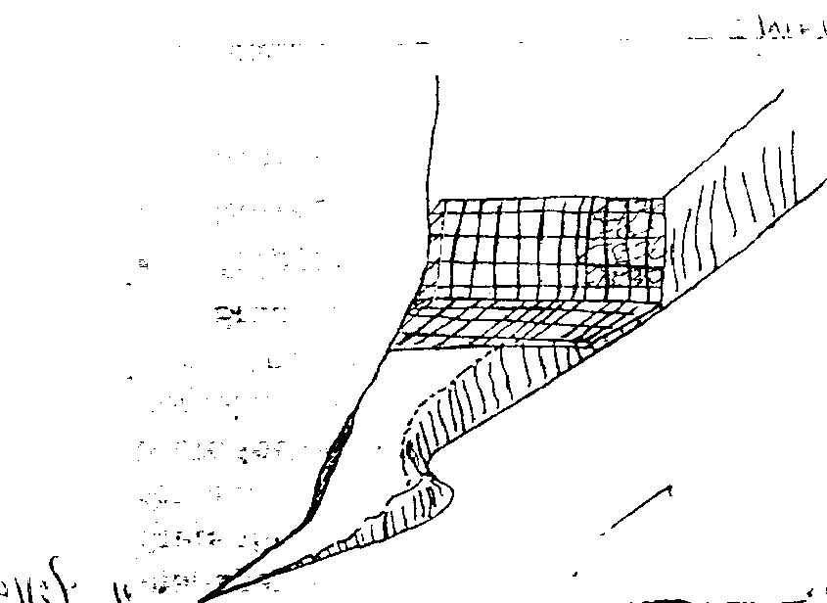

(a) Identify the structure
…………………………………………………………………………………………………………
(b) Explain two ways in which the structure helps to control soil erosion (2mks)
…………………………………………………………………………………………………………
…………………………………………………………………………………………………………
22. Below is a diagram illustrating a method of draining excess water from water logged soils.

(a) Identify the above method of drainage (1mk)
…………………………………………………………………………………………………………
(b) Name the features
X……………………………………………………………………………………………….( ½ mks)
Y……………………………………………………………………………………………….( ½ mks)
(c) State other two methods of draining excess water logged soils (1mk)
…………………………………………………………………………………………………………
…………………………………………………………………………………………………………

23. The diagrams below represent two ways in which a crop was pruned. Study them and answer the questions that follow
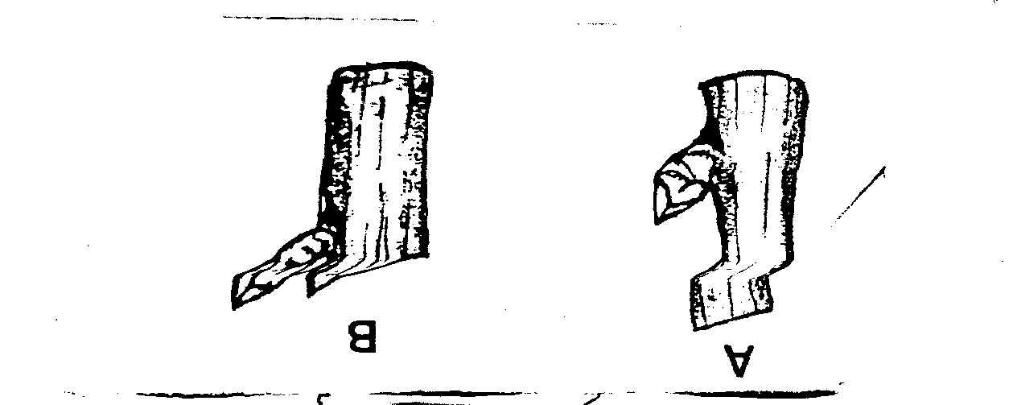

(i) Identify the diagram showing the correct way of pruning ( ½ mk)
…………………………………………………………………………………………………………
(ii) State a reason for your answer in (i) above ( ½ mk)
…………………………………………………………………………………………………………
(iii) State two ways in which pruning helps in controlling crop diseases (2mks)
…………………………………………………………………………………………………………
…………………………………………………………………………………………………………

SECTION C (40 MARKS)
Answer any two questions in this section in the spaces provided at the end of the section.
24. (a) Describe the field production of dry beans under the following sub-headings
(i) Varieties common in Kenya (2mks)
(ii) Selection and proportion of planting materials (4mks)
(iii) Planting and weeding (4mks)
(b) Explain the importance of irrigation in crop production (5mks)
(c) Describe five limitations of broadcasting method of planting in crop production (5mks
25. (a)Outline five management practices carried out in pastures (5mks)
(b) Explain ten importance of keeping records of activities in a farm enterprise (10mks)
(c) Discuss five benefits a farmer is likely to get by using vegetative propagation in the production of oranges (5mks)
26. (a) Outline five various methods of harvesting water in the farm (5mks)
(b) Outline five activities that may be undertaken in organic farming (5mks)
(c) Describe the transplanting of tomato seedlings (10mks)

…………………………………………………………………………………………………………
…………………………………………………………………………………………………………
…………………………………………………………………………………………………………
…………………………………………………………………………………………………………
…………………………………………………………………………………………………………
…………………………………………………………………………………………………………
…………………………………………………………………………………………………………
…………………………………………………………………………………………………………
…………………………………………………………………………………………………………
…………………………………………………………………………………………………………
…………………………………………………………………………………………………………
…………………………………………………………………………………………………………
…………………………………………………………………………………………………………
…………………………………………………………………………………………………………
…………………………………………………………………………………………………………
…………………………………………………………………………………………………………
…………………………………………………………………………………………………………
…………………………………………………………………………………………………………
…………………………………………………………………………………………………………
…………………………………………………………………………………………………………
…………………………………………………………………………………………………………
…………………………………………………………………………………………………………
…………………………………………………………………………………………………………
…………………………………………………………………………………………………………
…………………………………………………………………………………………………………
…………………………………………………………………………………………………………
…………………………………………………………………………………………………………
…………………………………………………………………………………………………………
…………………………………………………………………………………………………………
…………………………………………………………………………………………………………
…………………………………………………………………………………………………………
…………………………………………………………………………………………………………
…………………………………………………………………………………………………………
…………………………………………………………………………………………………………
…………………………………………………………………………………………………………
…………………………………………………………………………………………………………
…………………………………………………………………………………………………………
…………………………………………………………………………………………………………
…………………………………………………………………………………………………………
…………………………………………………………………………………………………………
…………………………………………………………………………………………………………
…………………………………………………………………………………………………………
…………………………………………………………………………………………………………
…………………………………………………………………………………………………………
…………………………………………………………………………………………………………
…………………………………………………………………………………………………………
…………………………………………………………………………………………………………
…………………………………………………………………………………………………………
…………………………………………………………………………………………………………
…………………………………………………………………………………………………………
…………………………………………………………………………………………………………
…………………………………………………………………………………………………………
…………………………………………………………………………………………………………
…………………………………………………………………………………………………………
…………………………………………………………………………………………………………
…………………………………………………………………………………………………………
…………………………………………………………………………………………………………
…………………………………………………………………………………………………………
…………………………………………………………………………………………………………
…………………………………………………………………………………………………………
…………………………………………………………………………………………………………
…………………………………………………………………………………………………………
…………………………………………………………………………………………………………
…………………………………………………………………………………………………………
…………………………………………………………………………………………………………
…………………………………………………………………………………………………………
…………………………………………………………………………………………………………
…………………………………………………………………………………………………………
…………………………………………………………………………………………………………
…………………………………………………………………………………………………………
…………………………………………………………………………………………………………
…………………………………………………………………………………………………………

