Name: …………………………………………………………… Index No …......…................................

Candidate’s Sign ………………………………….

Date: …………………………………

443/2
AGRICULTURE
Paper 2
OCT/NOV 2013
Time: 2 Hours

Kenya Certificate of Secondary Education (K.C.S.E)
FORM THREE

INSTRUCTIONS TO CANDIDATES:

- Write your name, index number and school in the spaces provided.
- Sign and write the date of the examination in the spaces provided.
- This paper consists of three sections; A, B and C.
- Answer all questions in section A and B.
- In section C answer any two questions in the spaces provided
- All answers must be written in the spaces provided.

For Examiner’s Use Only;
SECTION | QUESTION | MAXIMUM SCORE | CANDIDATES’ SCORE
A | 1 - 20 | 30
B | 16 – 19 | 20
C |  | 20
 |  | 20
 | Total | 90
This paper consists of 8 printed pages. Candidates should check the question paper to ascertain that all pages are printed as indicated and that no questions are missing

SECTION A (30 MARKS)
Answer all the questions in this section in the spaces provided.
1. Name three tools used for plumbing operations in the farm ( 1 ½ mks)
………………………………………………………………………………………………………….
………………………………………………………………………………………………………….
………………………………………………………………………………………………………….
2. Give two characteristics of the Bactrian camel (1mk)
………………………………………………………………………………………………………….
………………………………………………………………………………………………………….
3. List four breeds of exotic goats suitable for milk production. (2mks)
………………………………………………………………………………………………………….
………………………………………………………………………………………………………….
………………………………………………………………………………………………………….
………………………………………………………………………………………………………….
4. Mention five factors that may predispose an animal to certain diseases. (2 ½ mks)
………………………………………………………………………………………………………….
………………………………………………………………………………………………………….
………………………………………………………………………………………………………….
………………………………………………………………………………………………………….
………………………………………………………………………………………………………….
5. Name two diseases controlled by use of blanthrax vaccine. (1mk)
………………………………………………………………………………………………………….
………………………………………………………………………………………………………….
6. Differentiate between a one-host tick and a three-host tick (1mk)
………………………………………………………………………………………………………….
7. Give six effects of parasites on livestock (3mks)
………………………………………………………………………………………………………….
………………………………………………………………………………………………………….
………………………………………………………………………………………………………….
………………………………………………………………………………………………………….
………………………………………………………………………………………………………….
………………………………………………………………………………………………………….
8. Give one function of each of the following vitamins
Vitamin C (Ascorbic Acid)
………………………………………………………………………………………………………….
Vitamin E ………………………………………………………………………………………………………….
9. State two functions of reticulum (1mk)
………………………………………………………………………………………………………….
………………………………………………………………………………………………………….
10. State four factors which may affect maintenance requirement of an animal (2mks)
………………………………………………………………………………………………………….
………………………………………………………………………………………………………….
………………………………………………………………………………………………………….
………………………………………………………………………………………………………….
11. What are the disadvantages of embryo transplant? (1 ½ mks)
………………………………………………………………………………………………………….
………………………………………………………………………………………………………….
12. Give three signs of lambing in sheep (1 ½ mks)
………………………………………………………………………………………………………….
………………………………………………………………………………………………………….
………………………………………………………………………………………………………….
13. What are the four reasons for castration in livestock? (2mks)
………………………………………………………………………………………………………….
………………………………………………………………………………………………………….
………………………………………………………………………………………………………….
………………………………………………………………………………………………………….
14. List the four equipment a farmer may use in harvesting of honey (2mks)
………………………………………………………………………………………………………….
………………………………………………………………………………………………………….
………………………………………………………………………………………………………….
………………………………………………………………………………………………………….
15. What are the structural requirements of a good pig house (2mks)
………………………………………………………………………………………………………….
………………………………………………………………………………………………………….

16. List five symptoms of cocciodiosis in poultry in poultry (2 ½ mks)
………………………………………………………………………………………………………….
………………………………………………………………………………………………………….
………………………………………………………………………………………………………….
………………………………………………………………………………………………………….
………………………………………………………………………………………………………….
SECTION B (20MARKS)
Answer all the questions in the spaces provided

17. (a) Identify the tools illustrated below

M…………………………………………………………………………………………………
N………………………………………………………………………………………………….
(b) State one use for each of the above tools (2mks)
M…………………………………………………………………………………………………
N………………………………………………………………………………………………….
(c) State two safety measures when using saws (2mks)
………………………………………………………………………………………………………….
………………………………………………………………………………………………………….
18. The diagram below shows the female reproductive system of a cow. Use it to answer the questions that follow.
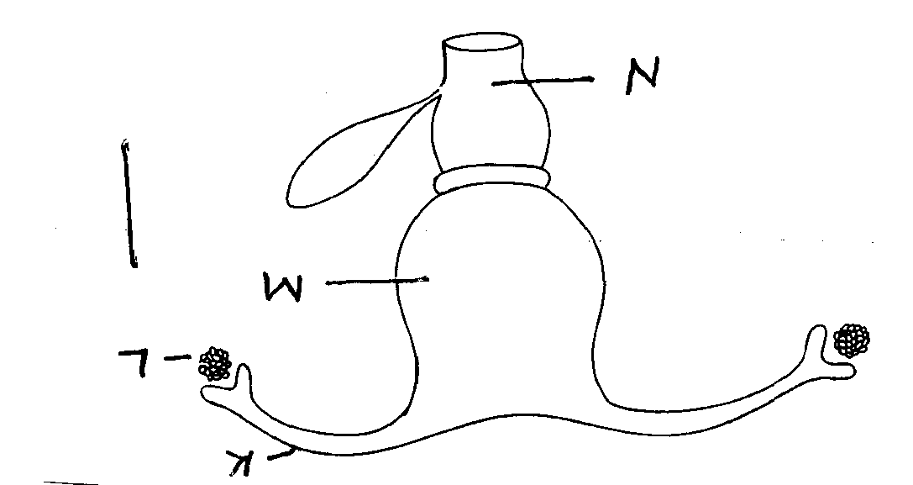

(a) Name the parts labeled K,L,M and N
K……………………………………….
L………………………………………..
M……………………………………….
N………………………………………
(b) State one function of each of the parts labeled K,L,M and N. (3mks)
K…………………………………………………………………………………………………
L…………………………………………………………………………………………………
M…………………………………………………………………………………………………
19. The following diagram shows parts of a roof. Study it carefully and answer the questions that follow

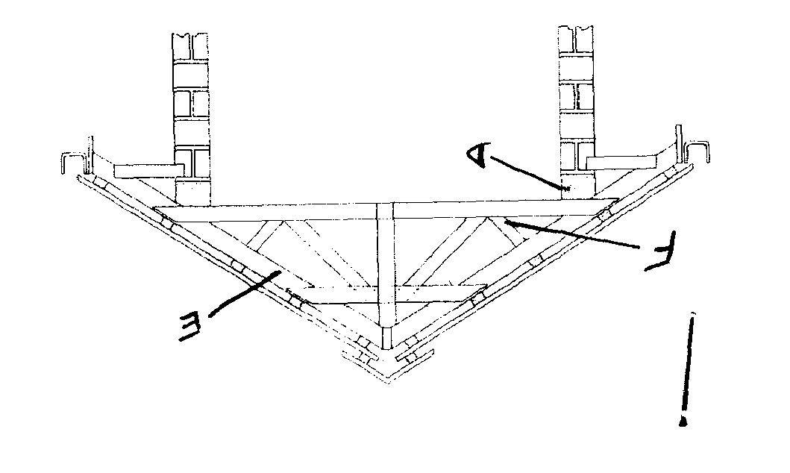

(a) Name the parts labeled D, E and F (1 ½ mks)
D……………………………………..
E…………………………………….
F…………………………………….
(b) State the functions of each of the parts. (3mks)
D…………………………………………………………………………………………………
E…………………………………………………………………………………………………
F…………………………………………………………………………………………………
(c) Give three reasons for treating timber before use in the construction of a farm structure.(1 ½ mks)
………………………………………………………………………………………………………….
………………………………………………………………………………………………………….
………………………………………………………………………………………………………….
20. The diagram below represents poultry attacked by a disease. Study it carefully and answer the questions that follow.

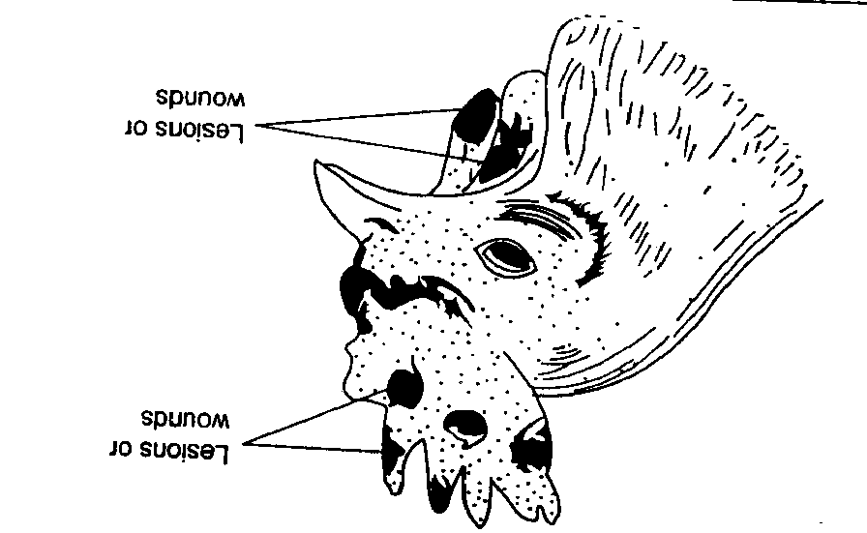

(a) Name the disease ( ½ mk)
………………………………………………………………………………………………………….
(b) Give two predisposing factors of the disease (2mks)
………………………………………………………………………………………………………….
………………………………………………………………………………………………………….
(c) Suggest two control measures for the disease. (2mks)
………………………………………………………………………………………………………….
………………………………………………………………………………………………………….
SECTION C: (40MARKS)
Answer TWO questions from this section.
21. (a) State six maintenance practices carried out on a knapsack sprayer (6mks)
(b) Outline the properties of a good vaccine. (6mks)
(c) A 100kg pig ration containing 18% crude protein was to be made from wheat bran (3% crude protein). Using Pearsons square method, Calculate the amount of each feedstuff needed to prepare the ration. (8mks)
22. (a) State the management practices that would enable maximum harvest of fish in a fish pond (8mks)
(b) Explain at least six factors to be considered when siting farm structures (12mks)
23. (a) List the symptoms that indicate an animal is infested with internal parasites. (10mks)
(b) Outline the procedure for harvesting honey from a top bar hive (10mks)

………………………………………………………………………………………………………….
………………………………………………………………………………………………………….
………………………………………………………………………………………………………….
………………………………………………………………………………………………………….
………………………………………………………………………………………………………….
………………………………………………………………………………………………………….
………………………………………………………………………………………………………….
………………………………………………………………………………………………………….
………………………………………………………………………………………………………….
………………………………………………………………………………………………………….
………………………………………………………………………………………………………….
………………………………………………………………………………………………………….
………………………………………………………………………………………………………….
………………………………………………………………………………………………………….
………………………………………………………………………………………………………….
………………………………………………………………………………………………………….
………………………………………………………………………………………………………….
………………………………………………………………………………………………………….
………………………………………………………………………………………………………….
………………………………………………………………………………………………………….
………………………………………………………………………………………………………….
………………………………………………………………………………………………………….
………………………………………………………………………………………………………….
………………………………………………………………………………………………………….
………………………………………………………………………………………………………….
………………………………………………………………………………………………………….
………………………………………………………………………………………………………….
………………………………………………………………………………………………………….
………………………………………………………………………………………………………….
………………………………………………………………………………………………………….
………………………………………………………………………………………………………….
………………………………………………………………………………………………………….
………………………………………………………………………………………………………….
………………………………………………………………………………………………………….
………………………………………………………………………………………………………….
………………………………………………………………………………………………………….
………………………………………………………………………………………………………….
………………………………………………………………………………………………………….
………………………………………………………………………………………………………….
………………………………………………………………………………………………………….
………………………………………………………………………………………………………….
………………………………………………………………………………………………………….
………………………………………………………………………………………………………….
………………………………………………………………………………………………………….
………………………………………………………………………………………………………….
………………………………………………………………………………………………………….
………………………………………………………………………………………………………….
………………………………………………………………………………………………………….
………………………………………………………………………………………………………….
………………………………………………………………………………………………………….
………………………………………………………………………………………………………….
………………………………………………………………………………………………………….
………………………………………………………………………………………………………….
………………………………………………………………………………………………………….
………………………………………………………………………………………………………….
………………………………………………………………………………………………………….
………………………………………………………………………………………………………….
………………………………………………………………………………………………………….
………………………………………………………………………………………………………….
………………………………………………………………………………………………………….
………………………………………………………………………………………………………….

