Name: …………………………………………………………… Index No ……..…...................................

School: ……………………………………………………....…. Candidate’s sign ……………………....

Date: ……………………………………………………………

442/1

ART AND DESIGN

Paper 1

OCT/NOV 2013

Time: 1 ½ Hours

Kenya Certificate of Secondary Education (K.C.S.E.)

ART AND DESIGN

Paper 1

July/August 2013

Time: 1 ½ Hours

INSTRUCTIONS TO CANDIDATES:
- This paper contains three sections.
- Answer all questions in section A and B.
- Answer any one question from section C.
- All answers should be written in the spaces provided.
- Where drawings and diagrams are appropriate, they should be included within the text of your answer

INSTRUCTIONS TO CANDIDATES:
SECTION | QUESTIONS | SCORE
A | 1
B | 2
 | 3
 | 4
 | 5
 | 6
C
 | Total

This paper consists of 6 printed pages. Candidates should check to ascertain that all pages are printed as indicated and that no questions are missing.

SECTION A (20 MARKS)
1. (a) Define form (1mk)
…………………………………………………………………………………………………………..
…………………………………………………………………………………………………………..
(b) Explain symmetrical balance (1mk)
…………………………………………………………………………………………………………..
(c) Define the term slip and state its use in pottery (1 ½ mks)
…………………………………………………………………………………………………………..
…………………………………………………………………………………………………………..
(d) In the space provided below draw a Tjanting a label it (1 ½ mks)
…………………………………………………………………………………………………………..
…………………………………………………………………………………………………………..
(e) State why newsprint paper is unsuitable material for ink drawing (1mk)
…………………………………………………………………………………………………………..
(f) Identify the advantages of grog in pottery (1mk)
…………………………………………………………………………………………………………..
(g) The illustration below represents a fabric decoration technique

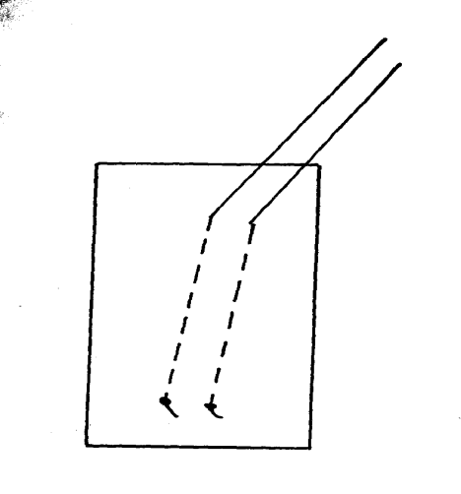

Identify the technique (1mk)
…………………………………………………………………………………………………………..
(h) Explain the main difference between solids and voids in sculpture (1mk)
…………………………………………………………………………………………………………..
(i) Explain the following terms
(i) Complementary colours ( ½ mk)
…………………………………………………………………………………………………………..
(ii) Intensity of colour ( ½ mk)
…………………………………………………………………………………………………………..
(iii) Chiaroscuro ( ½ mk) …………………………………………………………………………………………………………..
(j) Abstruct painting is the style in which elements are not based in the world of nature. Name two variations of abstract painting (1mk)
…………………………………………………………………………………………………………..
(k) In the space provided below, construct an ogee and use it to produce a half-drop repeat pattern (1 ½ mks) …………………………………………………………………………………………………………..
(l) Differentiate between Asceaders and Descenders in graphic design (1mk)
…………………………………………………………………………………………………………..
(m) Define a squeegee (1mk)
…………………………………………………………………………………………………………..
(n) Identify a logo from a trademark (1mk)
…………………………………………………………………………………………………………..
(o) What is the importance of priming in painting (1mk)
…………………………………………………………………………………………………………..
(p) State two shading techniques in drawing (1mk)
…………………………………………………………………………………………………………..
(q) Define the term “texture” (1mk)
…………………………………………………………………………………………………………..
(r) The illustration below represents a tool for the production of a work of art

(i) Name the tool (1mk)
…………………………………………………………………………………………………………..
SECTION B (25MKS)
2. Using illustrations, show the difference between a slit and a dove-tail tapestry weaves (3mks)
…………………………………………………………………………………………………………..
…………………………………………………………………………………………………………..
…………………………………………………………………………………………………………..
3. Explain the following terms as used in pottery (4mks)
(i) Bisque
…………………………………………………………………………………………………………..
(ii) Grog
…………………………………………………………………………………………………………..
(iii) Pyrometric cones
…………………………………………………………………………………………………………..
(iv) Pugmill
…………………………………………………………………………………………………………..
4. Describe four characteristics of African sculpture (4mks)
…………………………………………………………………………………………………………..
…………………………………………………………………………………………………………..
…………………………………………………………………………………………………………..
…………………………………………………………………………………………………………..
5. State the functions of the following in screen printing (4mks)
(i) Brown-gummed paper
…………………………………………………………………………………………………………..
(ii) Staple gun
…………………………………………………………………………………………………………..
(iii) masking tape
…………………………………………………………………………………………………………..
(iv) Shellac
…………………………………………………………………………………………………………..
6. Differentiate between a press mould and a slip mould (2mks)
…………………………………………………………………………………………………………..
7. Explain between a press mould and a slip mould (2mks)
(i) frottage
…………………………………………………………………………………………………………..
(ii) marbling
…………………………………………………………………………………………………………..
(iii) visual symbol
…………………………………………………………………………………………………………..
8. (a) Define ornaments (2mks)
…………………………………………………………………………………………………………..
…………………………………………………………………………………………………………..
(b) Which are considered in making ornaments (3mks)
…………………………………………………………………………………………………………..
…………………………………………………………………………………………………………..
…………………………………………………………………………………………………………..
SECTION C ( 15 MARKS)
Answer only one question from this section

9. (a) Define the term ceramics (2mks)
(b) State two classifications off clay (2mks)
(c) Explain four handbuilding methods in pottery (4mks)
(d) State and explain the three qualities of a good clay (3mks)
(e) Briefly describe the Bonfired kiln and an electric kiln (4mks)
10. (a) Define fabric decoration (2mks)
(b) Explain the functions of the following tools
(i) Tjap
(ii) Tjanting (2mks)
(c) State and explain four methods of fire and dye (4mks)
(d) Explain the following terms in fabric decoration (3mks)
(i) Paste resist
(ii) Batik
(iii) Block printing
(e) State and explain four functions of decorated fabric (4mks)

