NAME: …………………………………………………… INDEX NO……………………..……………
SCHOOL………………………………………………… CANDIDATE’S SIGNATURE………………
DATE: ……………….…………………………………..…

231/2
BIOLOGY
PAPER 2 (Theory)
OCT/NOV2013
Time: Hours

Kenya Certificate of Secondary Education
FORM THREE

BIOLOGY
Paper 2
Time: 2 Hours

INSTRUCTIONS TO THE CANDIDATES
- Write your name and index number in the spaces provided above.
- Sign and write the date of examination in the spaces provided above.
- This paper consists of two sections; A and B.
- Answer all the questions in Section A in the spaces provided.
- In section B, answer question 6(compulsory) and either question 7 or 8 in the spaces provided after question 8.

For Examiner’s Use Only:-
SECTION | QUESTION | MAXIMUM SCORE | CANDIDATES SCORE
A | 1  2  3  4  5 | 8  8  8  8  8
B | 6  7 or  8 | 20  20  20
TOTAL SCORE |  | 80

This paper consists of 8 printed pages. Candidates should check to ascertain that all papers are printed as indicated and that no questions are missing
SECTION A ( 40 MARKS)
Answer all the Questions in this section in the spaces provided
- The data below represents concentration of ions in the cell sap of glasswort plants and of water in a pond in which if it grew.
 | Na⁺ | K⁺ | Mg²⁺ | Ca²⁺ | Cl⁻ | SO₄²⁻
Cell sap | 50 | 49 | 11 | 13 | 101 | 13
Pond Water | 1.2 | 0.5 | 3.0 | 1.3 | 1.0 | 0.67
- Name a process by which this plant could absorb ions from water in pond. (1mk)
………………………………………………………………………………………………
………………………………………………………………………………………………
- What Effect could the following changes have on this process
- Reduced Oxygen supply in water ( 1mk)
………………………………………………………………………………………………
………………………………………………………………………………………………
- Increased concentration of glucose (1mk)
………………………………………………………………………………………………
………………………………………………………………………………………………
- The structures below represents specialized cells

Z
X
Y

- Identify structures X, Y, Z
X …………………………………………
Y …………………………………………
Z …………………………………………
- Give reasons for your identity for X and Y (2mks)
X …………………………………………
Y …………………………………………

- The diagram below shown part of the respiratory system of a certain animal
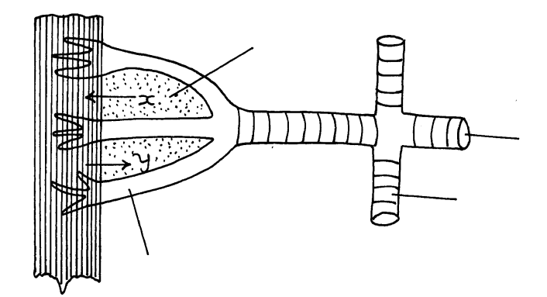
Water film

C
C
B

- Name the Structures labeled A to C (3mks)
A …………………………………………………………………
B …………………………………………………………………
C …………………………………………………………………
- Give the functions of ring around structure B. (1mk)
…………………………………………………………………………………………………
…………………………………………………………………….……………………………
c) State the role of water film (1mk)
…………………………………………………………………………………………………
…………………………………………………………………….……………………………
d) Identify the respiratory gases labeled x,y (2mks)
x …………………………………………………….
y……………………………………………………
e) State an example of group of organism with similar respiratory structures (1mk)
…………………………………………………………………………………………………
…………………………………………………………………….……………………………
- a) Explain what happens to excess amino acids in the liver of humans. (3mks)
…………………………………………………………………………………………………
…………………………………………………………………….……………………………
b)What would happen if a person produced less anti duratic hormone? (1mk)
…………………………………………………………………………………………………
…………………………………………………………………….……………………………
c) What term is given to the condition in (b) above (1mk)
…………………………………………………………………………………………………
…………………………………………………………………….……………………………

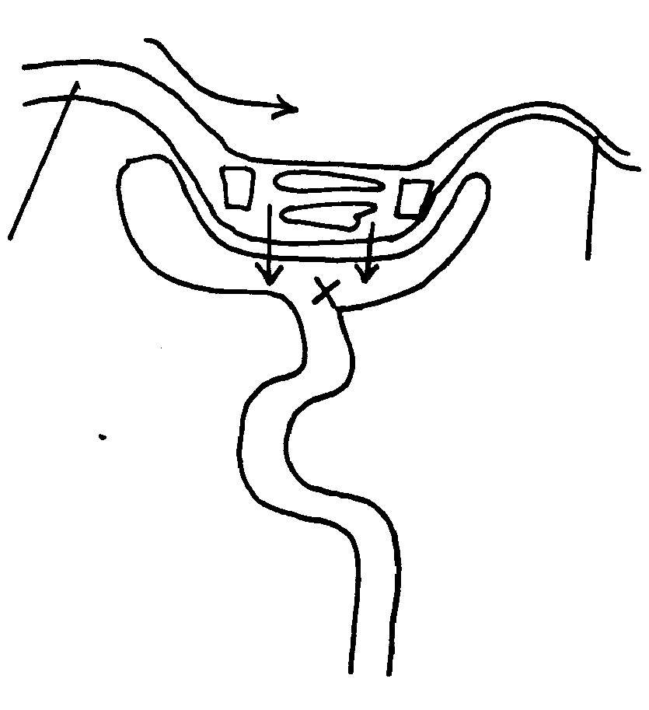
d) The diagram below illustrate a section of kidney nephron
Direction of blow flow

Aa
B

- Identify structures (2mks)
A ………………………………………………..
B ………………………………………………...
- Name the substance found in structure labeled x (1mk)
…………………………………………………………………………………………………
…………………………………………………………………….……………………………
- A student observed feeding relationship while on a tour in a coastal island.
Eagles feed on small fish
Small fish feed on sea grass
Insect larvae and molluses feed on sea grass
Insect larvae feed on by small fish
Crabs feed on insect larvae and molluses
- From the above information construct a food web ( 3mks)
…………………………………………………………………………………………………
…………………………………………………………………….……………………………
…………………………………………………………………….……………………………
- In which trophic level is small fish. (1mk)
…………………………………………………………………………………………………
- Extract food chain where the eagle is a tertiary consumer. (1mk)
…………………………………………………………………………………………………
- Suppose all crabs were poisoned. What would be immediate Effect in the Ecosystem. Give a reason
(2mks)
…………………………………………………………………………………………………
…………………………………………………………………….……………………………
- Give a reason why pyramid of biomass is better representation of energy flow in an Ecosystem than pyramid of number. (1mk)
…………………………………………………………………………………………………
…………………………………………………………………….……………………………

SECTION B (40 MARKS)
Answer Question 6 and Either Question 7 or 8in the spaces provided
6. In an Experiment to investigate certain processes in a given plant species, the rate of carbon (IV) oxide
released and intake were measured over along period of time. The results of the investigations were as
shown.
Time of the day(Hours) | 6 | 8 | 10 | 12 | 14 | 16 | 18 | 20 | 22 | 24
Volume of Carbon (IV) Oxide Consumed ( mm³/min) | 10 | 43 | 69 | 91 | 91 | 50 | 18 | 0 | 0 | 0
Volume of carbon (IV) oxide released mm³/min | 38 | 22 | 10 | 3 | 3 | 6 | 31 | 48 | 48 | 48

- On the same axes draw graphs of volume of carbon IV oxide consumed and released against time.
(7mks)

- Name the chemical processes represented by:
- Carbin (IV) oxide consumed
…………………………………………………………………………………………………
…………………………………………………………………….……………………………
- Carbon (IV) oxide (2mks)
…………………………………………………………………………………………………
…………………………………………………………………….……………………………
- Account for the shape of the curve for
(i) Carbon IV oxide consumed ( 3mks)
…………………………………………………………………………………………………
…………………………………………………………………….……………………………
(ii) carbon IV oxide released (3mks)
…………………………………………………………………………………………………
…………………………………………………………………….……………………………
- (i) What is meant by compensation point (1mk)
…………………………………………………………………………………………………
…………………………………………………………………….……………………………
(ii)From the graph, find the time of the day when the plant attained compensation point. (2mks)
…………………………………………………………………………………………………
…………………………………………………………………….……………………………
- Explain how temperature affects the rate of carbon IV oxide consumption in the plant. (2mks)
…………………………………………………………………………………………………
…………………………………………………………………….……………………………
7. (a) Outline roles of bile in digestion of food. (4mks)
(b) State an explain adaptation of ileum to its Functions (16mks)
8. Discuss adaptations of various seed and fruits to their mode of disperhal. (20mks)
…………………………………………………………………………….……………………………
…………………………………………………………………………….……………………………
…………………………………………………………………………….……………………………
…………………………………………………………………………….……………………………
…………………………………………………………………………….……………………………
…………………………………………………………………………….……………………………
…………………………………………………………………………….……………………………
…………………………………………………………………………….……………………………
…………………………………………………………………………….……………………………
…………………………………………………………………………….……………………………
…………………………………………………………………………….……………………………
…………………………………………………………………………….……………………………
…………………………………………………………………………….……………………………
…………………………………………………………………………….……………………………
…………………………………………………………………………….……………………………
…………………………………………………………………………….……………………………
…………………………………………………………………………….……………………………
…………………………………………………………………………….……………………………
…………………………………………………………………………….……………………………
…………………………………………………………………………….……………………………
…………………………………………………………………………….……………………………
…………………………………………………………………………….……………………………
…………………………………………………………………………….……………………………
…………………………………………………………………………….……………………………
…………………………………………………………………………….……………………………
…………………………………………………………………………….……………………………
…………………………………………………………………………….……………………………
…………………………………………………………………………….……………………………
…………………………………………………………………………….……………………………
…………………………………………………………………………….……………………………
…………………………………………………………………………….……………………………
…………………………………………………………………………….……………………………
…………………………………………………………………………….……………………………
…………………………………………………………………………….……………………………
…………………………………………………………………………….……………………………
…………………………………………………………………………….……………………………
…………………………………………………………………………….……………………………
…………………………………………………………………………….……………………………
…………………………………………………………………………….……………………………
…………………………………………………………………………….……………………………
…………………………………………………………………………….……………………………
…………………………………………………………………………….……………………………
…………………………………………………………………………….……………………………
…………………………………………………………………………….……………………………
…………………………………………………………………………….……………………………
…………………………………………………………………………….……………………………
…………………………………………………………………………….……………………………
…………………………………………………………………………….……………………………
…………………………………………………………………………….……………………………
…………………………………………………………………………….……………………………
…………………………………………………………………………….……………………………
…………………………………………………………………………….……………………………
…………………………………………………………………………….……………………………
…………………………………………………………………………….……………………………
…………………………………………………………………………….……………………………
…………………………………………………………………………….……………………………
…………………………………………………………………………….……………………………
…………………………………………………………………………….……………………………
…………………………………………………………………………….……………………………
…………………………………………………………………………….……………………………
…………………………………………………………………………….……………………………
…………………………………………………………………………….……………………………
…………………………………………………………………………….……………………………
…………………………………………………………………………….……………………………
…………………………………………………………………………….……………………………
…………………………………………………………………………….……………………………
…………………………………………………………………………….……………………………
…………………………………………………………………………….……………………………
…………………………………………………………………………….……………………………
…………………………………………………………………………….……………………………
…………………………………………………………………………….……………………………
…………………………………………………………………………….……………………………
…………………………………………………………………………….……………………………
…………………………………………………………………………….……………………………
…………………………………………………………………………….……………………………
…………………………………………………………………………….……………………………
…………………………………………………………………………….……………………………
…………………………………………………………………………….……………………………
…………………………………………………………………………….……………………………
…………………………………………………………………………….……………………………
…………………………………………………………………………….……………………………
…………………………………………………………………………….……………………………

