Name: ………………………………………………………… Index No. …………………………………..

Date: ………………………………………………………… Candidate’s Sign. ………….............................

233/1
CHEMISTRY
Paper 1
(Theory)
OCT/NOV 2013
Time: 2 Hours

Kenya Certificate of Secondary Education (K.C.S.E.)
FORM THREE

INSTRUCTIONS TO THE CANDIDATES:
- Write your name, admission numbers in the spaces provided above.
- Answer ALL the questions in the spaces provided.
- All working MUST be clearly shown where necessary.
- Mathematical tables and electrical calculators may be used.

For Examiners’ Use Only
QUESTIONS | MAXIMUM SCORE | CANDIDATE’S SCORE
1-27 | 80

This paper consists of 8 printed pages. Candidates should check to ascertain that all pages are printed as indicated and that no questions are missing.

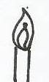
1. The diagram below shows a Bunsen burner when in use
D
C
Burnsen burner

Name the regions labeled C and D (2mks)
……………………………………………………………………………………………………..
2. Dry Carbon (II) Oxide gas reacts with heated Lead (ii) Oxide as shown in the equation below
PbO(s) + CO(g) CO2(g) + Pb(s)
(a) Name the process undergone by the Lead (ii) Oxide (1mk)
……………………………………………………………………………………………………..
(b) Give a reason for your answer in (a) above (1mk)
……………………………………………………………………………………………………..
(c)Name another gas that can be used to perfoam the same function as Carbon (II) Oxide in the above reaction (1mk)
……………………………………………………………………………………………………..
3. Ammonia gas was passed into water as shown below
Dry ammonia gas
Inverted funnel

(a) When a red litmus paper was dropped into the resulting solution, it turned blue. Give a reason for this observation. (1mk)
……………………………………………………………………………………………………..
(b) What is the function of the funnel (1mk)
……………………………………………………………………………………………………..
4. The table below gives elements represented by letters T, U,V,W,X,Y and their atomic numbers

Elements | T | U | V | W | X | Y
Atomic numbers | 12 | 13 | 14 | 15 | 16 | 17
Electronic arrangement

Use the information in the table to answer the questions below
(a) Complete the above table giving the electronic arrangement of each of the element (1 ½ mks)
(b) What type of bonding will be present in a compound formed between T and Y? Explain(1 ½ mks)
……………………………………………………………………………………………………..

5.
6. 0.25g of hydrocarbon burns in a stream of Oxygen to form 0.786g of Carbon (iv) Oxide and 0.321 of water vapour. Determine its empirical formula. (C=12,H=1) (2mks)
……………………………………………………………………………………………………..
……………………………………………………………………………………………………..
……………………………………………………………………………………………………..
7. Use the scheme below to answer the questions

Heat
Solid H
Solid J
Carbon (iv) Oxide
H₂O_{(l)}
Ca(OH)_{2(aq)}

(a) Identify the solids H and J. (2mks)
……………………………………………………………………………………………………..
(b) State one commercial used of solid J. (1mk)
……………………………………………………………………………………………………..
8. A student wanted to prepare Carbon (iv) Oxide in the Laboratory by the reaction between a metal Carbonate and an acid. He mixed a dilute mineral acid Q with Lead Carbonate but there was no significant reaction. Give a possible reason why the reaction failed and give possible identities of acid Q (2mks)
……………………………………………………………………………………………………..
……………………………………………………………………………………………………..
9. (a) State the Graham’s law of diffusion. (1mk)
……………………………………………………………………………………………………..
(b) The molar masses of gases W and X are 16.0 and 44.0 respectively. If the rate of diffusion of W through a porous material is 12cm3S-1. Calculate the rate of diffusion of X through the same material (2mks)
……………………………………………………………………………………………………..
……………………………………………………………………………………………………..
10. Study the chart below and answer the questions that follows

Sodaline
Step 1
N
Na₂CO₃
Excess Cl2(g)
u.v
step 2
CCl₄

P

(a) Identify N and P (2mks)
……………………………………………………………………………………………………..
(b) What name is given to the type reaction (1mk)
……………………………………………………………………………………………………..
11. Under certain conditions, chlorine gas reacts with sodium hydroxide to form sodium hypochlorite.
(a) Name the conditions under which Sodium Hydroxide reacts with chlorine to form sodium Hypochlorite (1mk)
……………………………………………………………………………………………………..
(b) State two uses of sodium Hypochlorite (2mks)
……………………………………………………………………………………………………..
……………………………………………………………………………………………………..
12. Compound “Q” is a solid with a giant ionic structure. What forms would the compound conduct an electric current. Explain (2mks)
……………………………………………………………………………………………………..
……………………………………………………………………………………………………..
13. Metal P reacts with an oxide of Oxide of metal Q but metal R does not. Metal P can remove Oxygen from an oxide of S but metal Q cannot. Arrange the metals in order of their reactivity starting with the most reactive. (2mks)
……………………………………………………………………………………………………..
……………………………………………………………………………………………………..
14. Silicon and Chlorine gas reacts together to form a liquid. The liquid fumes when exposed to air. Explain these observations. (2mks)
……………………………………………………………………………………………………..
……………………………………………………………………………………………………..
15. 22.2cm3 of Sodium hydroxide solution containing 4.0 per litre were required for complete Neutralization of 0.1g of a dibasic acid. Calculate the relative formula mass of the dibasic acid
(Na=23, H=1, O=16) (3mks)
……………………………………………………………………………………………………..
……………………………………………………………………………………………………..
……………………………………………………………………………………………………..
16. When Magnesium was burnt in air, a solud mixture was formed. On addition of water to the mixture a gas W which turned moist red litmus paper blue was evolved. Explain these observation.(2mks)
……………………………………………………………………………………………………..
……………………………………………………………………………………………………..
17. Hydrogen Sulphide is a highly toxic and flammable gas. It is normally prepared in a fume chamber.
(a) Name two reagents that can be used to prepare hydrogen sulphide in the Laboratory. (1mk)
……………………………………………………………………………………………………..
(b) One of the uses of Hydrogen sulphide is to produce Sulphur as shown in the following equation;
2H2S(g) + SO2(g) 3S(s) +2H2O(l)
Identify the reducing agent in this reaction and give a reason for your answer (1mk)
……………………………………………………………………………………………………..
(c) Other than production of Sulphuric (vi) acid state one commercial use of Sulphur. (1mk)
……………………………………………………………………………………………………..
18. Study the scheme below and answer the questions that follow
Salt X (mixture of two salts)

Add Pb(NO₃)₂
Boil
Step II
NH_{3(aq)}
Step III
Add dilute HNO₃
Step IV
Step 1
Add water and filter
Pale blue solution
A white ppt soluble in excess
Black solid
Colourless solution
White ppt insoluble in boiling

(a) Name
(i) Cations present in the salt (1mk)
……………………………………………………………………………………………………..
(ii) Anions present in the colourless solution (1mk)
……………………………………………………………………………………………………..
(b) Write an equation of how the white precipitate in step (III) dissolves (1mk)
……………………………………………………………………………………………………..
19. Atomic numbers of Phosphorous, sulphur and Potassium are 15,16 and 19 respectively. The formulae of their ions are P3-, S2- and K+. these ions have the same number of electrons.
(a) Write the electron arrangement for the ions (1mk)
……………………………………………………………………………………………………..
(b) Explain how the size of P3- and S2- compare (2mks)
……………………………………………………………………………………………………..
20. The table below gives some properties of gas K and L. study it and answer the question that follow.

Gas | Density | Effect of water
K | Heavier than air | Not affected
L | Lighter | Dissolves

(a) Describe how you would obtain a pure sample of K from the mixture of L and K (2mks)
……………………………………………………………………………………………………..
(b) Name one method in which gas L can be collected in the Laboratory (1mk)
……………………………………………………………………………………………………..
21. (a) Fill in the table below showing the colours of the given indicators in basic and acidic solutions

INDICATOR | ACID | BASE
Phenolphalein | Colourless
Methylorange |  | Yellow
(1mk)

(b) Anti acid tablets are always taken to relieve stomach upset conditions. Write a general equation for the reaction leading to the relief. (1mk)
……………………………………………………………………………………………………..
(c) State one condition where the use of a universal indicator may be opted for inserted of other
acid –base (1mk)
……………………………………………………………………………………………………..
22. Draw the structures and give the names of three alkenes having molecular formula C₅H₁₀(3mks)

(i) Name each (2mks)
A……………………………..
B……………………………
(ii) How can A be changed to B? (1mk)
……………………………………………………………………………………………………..
24. The melting point of Phosporous (III) chloride is 90oC while that of magnesium chloride is 715ºC in terms of structure and bonding. Explain the differences in their melting points (3mks)
……………………………………………………………………………………………………..
……………………………………………………………………………………………………..
25. Dilute hydrochloric acid and sodium sulphite were reacted as shown in the set up below
Flask
Sodium
sulphite
Delivery tube
Card board
Gas jar
Dilute hydrochloric acid
Thistle funnel
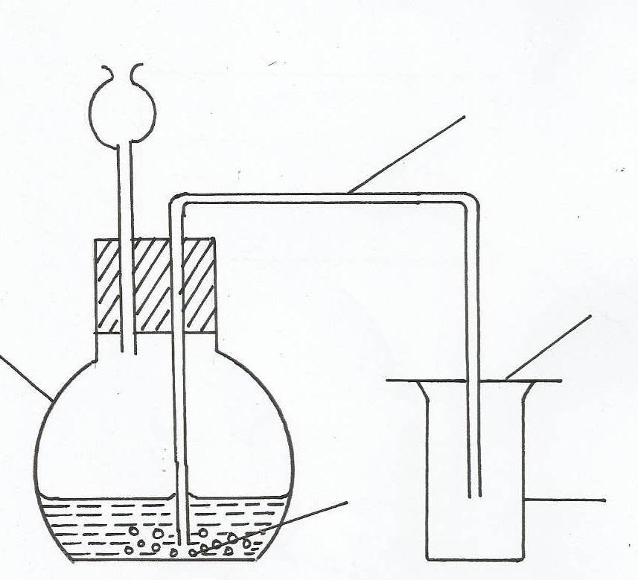

(a) Name the gas produced in the flask (1mk)
……………………………………………………………………………………………………..
(b) Give two reasons why no gas was collcted in the gas jar. (2mks)
……………………………………………………………………………………………………..
……………………………………………………………………………………………………..
26. An element X forms a bromide which is a liquid at room temperature with the formulae XBr₃. Neither element X not bromine conduct electricity.
(i) In which group of the periodic table is X likely too be found. (1mk)
……………………………………………………………………………………………………..
(ii) Give two reasons why liquid XBr3 is likely to have a molecular structure. (2mks)
……………………………………………………………………………………………………..
……………………………………………………………………………………………………..
(iii) How many outer electrons are there in atom of X and Bromine. (1mk)
……………………………………………………………………………………………………..
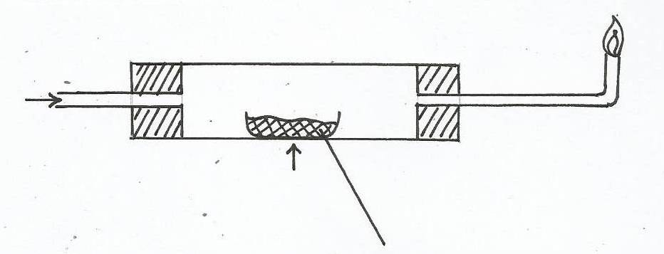
27. Hydrogen gas was passed over hated Copper (II) Oxide as shown below
Copper (II) Oxide
Excess burning
Dry hydrogen
gas
Heat

(a) State the observations that would be made in the combustion tube during the experiment (1mk)
……………………………………………………………………………………………………..
(b) Write the equation for the reaction taking place at the end of glass tube (1mk)
……………………………………………………………………………………………………..
……………………………………………………………………………………………………..
(c) A stream of hydrogen gas was passed through the combustion tube for sometime after heating was stopped. Give a reason. (1mk)
……………………………………………………………………………………………………..
28. A gas occupies 30cm³ at a temperature of OºC and a pressure of 10atm pressure. What would be its volume at 27ºC and 1 atm pressure.
……………………………………………………………………………………………………..
……………………………………………………………………………………………………..
29. An atom Q formed two isotopes of masses 42 and 44. If the relative atomic mass (RAM) of Q was found to be 42.6. determine the relative abundance isotope with a mass of 44 (2mks)
……………………………………………………………………………………………………..
……………………………………………………………………………………………………..

