Name: …………………………………………………………… Index No. ……………………………
Date: ………………………………............................................ Candidate’s Sign. …………..............

233/2
CHEMISTRY
PAPER 2
OCT/NOV 2013
TIME: 2 HOURS

Kenya Certificate of Secondary Education (K.C.S.E.)

Chemistry
Paper 2

INSTRUCTIONS TO CANDIDATES:
- Write your name and index number in the spaces provided above
- Sign and write the date of examination in the spaces provided.
- Answer all the questions in the spaces provided.
- All working must be clearly shown where necessary.
- Mathematical tables and electronic calculators can be used.

For Examiners Use Only
Question | Maximum score | Candidate’s score
1 | 11
2 | 10
3 | 10
4 | 10
5 | 7
6 | 10
7 | 12
8 | 10
Total | 80
This paper consists of 8 printed pages. Candidates should check to ascertain that all pages are printed as indicated and that no questions are missing.

1. (a) Candle wax is mainly a compound of two elements. Name the two elements. (1mk)
……………………………………………………………………………………………………………
(b) The set up below was used to investigate the burning of a candle. Study it and answer the questions that follow.
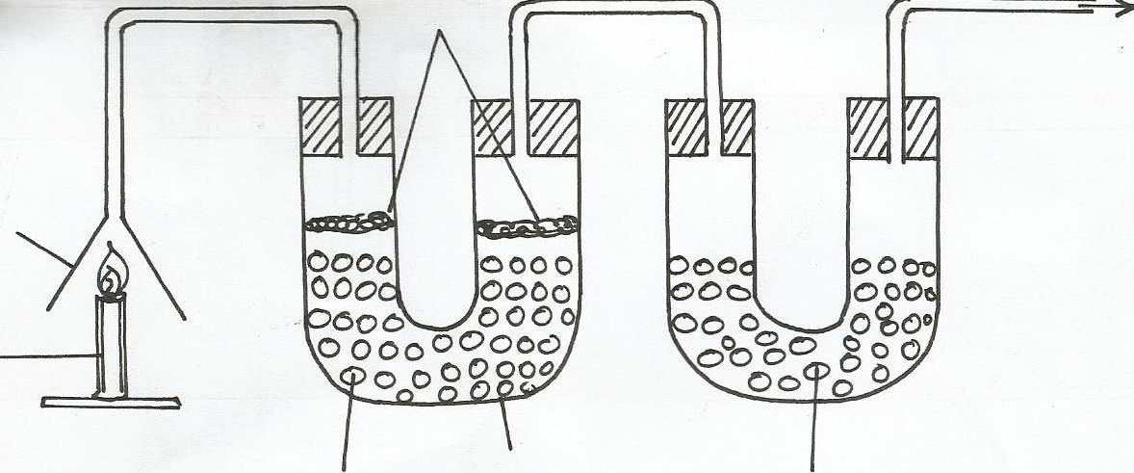
Funnel
Cotton wool
Calcium oxide
Tube N
To sunction pump
Sodium calcium chloride

Burning candle

(i) What would happen to the burning candle if the pump was turned off? Explain (2mks)
…………………………………………………………………………………………………………………
…………………………………………………………………………………………………………………
(ii) State and explain the changes in mass that occurs in tube N by the experiment (3mks)
…………………………………………………………………………………………………………………
…………………………………………………………………………………………………………………
…………………………………………………………………………………………………………………
(iii) State and explain the changes in mass that occurs in tube N by the end of the experiment. (3mks)
…………………………………………………………………………………………………………………
…………………………………………………………………………………………………………………
…………………………………………………………………………………………………………………
(iv) Name other substances that could be used in stead of
(i) Calcium Chloride (1mk)
…………………………………………………………………………………………………………………
(ii) Candle
…………………………………………………………………………………………………………………

(c) (i) Give the name of two reagents which when reacted with concentrated hydrochloric acid produces chlorine gas. (1mk)
…………………………………………………………………………………………………………………
(ii) State and explain the observations made when chlorine gas is bubbled through acqueous Pottassium Bromide. (2mks)
…………………………………………………………………………………………………………………
…………………………………………………………………………………………………………………
(iii) A liquid is suspected to contain chloride ions. Describe how you would confirm that the solid contains chloride ions. (2mks)
…………………………………………………………………………………………………………………
…………………………………………………………………………………………………………………
2. Study the data below and answer the questions. The letters are not actual symbols of the elements
Element No. of Protons Boiling point ºC
A 3 1333
B 13 2470
C 16 445
D 18 -186
E 19 774
(a) Select the elements that belong to the same
(i) group ………………………………………………………………………………………………………
(ii) period………………………………………………………………………………………………………
(b) Which element
(i) is a gas at 25.0oC. Explain (2mks)
…………………………………………………………………………………………………………………
…………………………………………………………………………………………………………………
(ii)does not form an oxide (2mks)
…………………………………………………………………………………………………………………
(c) Write the
(i) Formula of the Sulphate of element B (1mk)
…………………………………………………………………………………………………………………
(ii) Equation for the reaction between elements A and C (1mk)
…………………………………………………………………………………………………………………
(d) State and explain the bonding type that exists in the compound when elements C and B react (2mks)
…………………………………………………………………………………………………………………
(e) Select the most electropositive element. Explain (2mks)
…………………………………………………………………………………………………………………
…………………………………………………………………………………………………………………
3. (a) Distinguish between solid state and liquid state in terms of intermolecular forces (2mks)
…………………………………………………………………………………………………………………
…………………………………………………………………………………………………………………

(b) The sketch below shows the graph obtained when a gas is cooled

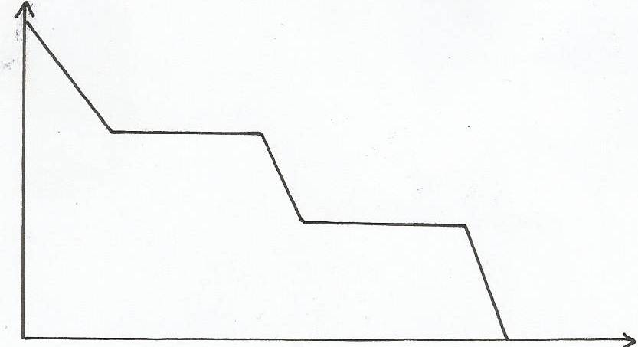
J
Temp ºC
K
L
M
N
T
Time (minutes)

(i) Name the state of the substance between K and L (1mk)
…………………………………………………………………………………………………………………
(ii) In terms of kinetic theory of matter, explain what happens between
I. L and M
…………………………………………………………………………………………………………………
II. M and N
…………………………………………………………………………………………………………………
(c) The scheme below shows the change in state that substance P undergoes
Process I
Solid Gas
Process II

(i) Name process I (1mk)
…………………………………………………………………………………………………………………
(ii) Name one substance that undergoes the change shown above (1mk)
…………………………………………………………………………………………………………………
(d) State the criteria for determining the purity of a solid substance. (1mk)
…………………………………………………………………………………………………………………
4. Study the table below and answer the questions that follow
Formula of hydrocarbon boiling point (K)
C2H4 169.4
C3H6 225.9
C4H8 266.9
C5H10 303.0
C6H12 336.5
(i) What name is given to a series of organic compounds like the ones in the table above? (1mk)
…………………………………………………………………………………………………………………
(ii) Select one hydrocarbon that would be a gas at 278K? Explain. (2mks)
…………………………………………………………………………………………………………………
…………………………………………………………………………………………………………………
(iii) Give the formula of the seventh member of the above series (1mk)
…………………………………………………………………………………………………………………
…………………………………………………………………………………………………………………
(iv) Explain the relationship between boiling points and the relative masses of the Hydrocarbons in the table above? (2mks)
…………………………………………………………………………………………………………………
…………………………………………………………………………………………………………………
(b) State and explain the observations made when a few drops of acidified Potassium Manganate (VII) was reacted with any of the above Hydrocarbons. (2mks)
…………………………………………………………………………………………………………………
…………………………………………………………………………………………………………………
(c) Excess Carbon (II) oxide gas was passed over heated sample of an oxide of Iron as shown below

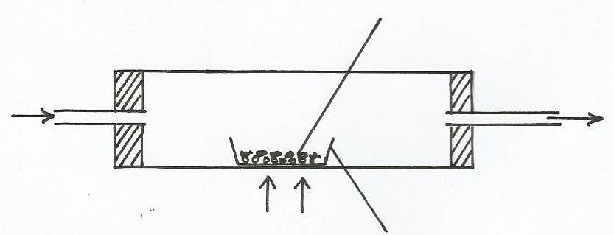
Dry Carbon (II) oxide
Heat
Dish
Oxide of iron
To fume chamber

Mass of empty dish = 10.98g
Mass of empty dish + oxide=13.30g
Mass of empty dish + residue = 12.66g
(i) Determine the formula of the oxide of iron (Metal oxide = 232, Fe=56,O=16) (3mks)
…………………………………………………………………………………………………………………
…………………………………………………………………………………………………………………
…………………………………………………………………………………………………………………
(ii) Write an equation for the reaction which took place in the dish. (1mk)
…………………………………………………………………………………………………………………
…………………………………………………………………………………………………………………

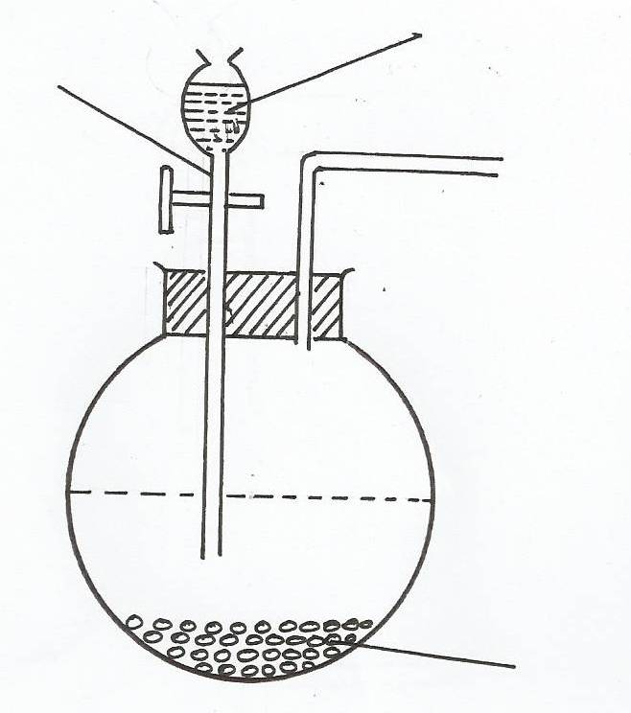
5. Oxygen can be prepared in the laboratory using the set-up shown below
P
Hydrogen peroxide

Solid R

(a) Name the following
i. Apparatus P ……………………….. (1mk)
ii. Solis R……………………………. (1mk)
(b) What is the use of solid R (1mk)
…………………………………………………………………………………………………………………
(c) Complete the diagram to show how dry oxygen gas can be collected. (2mks)
…………………………………………………………………………………………………………………
…………………………………………………………………………………………………………………
(d) Write chemical equation to show Oxygen gas is produced (1mk)
…………………………………………………………………………………………………………………
(e) State two physical properties of Oxygen gas (2mks)
…………………………………………………………………………………………………………………
…………………………………………………………………………………………………………………
(f) Give two uses of Oxygen gas (2mks)
…………………………………………………………………………………………………………………
…………………………………………………………………………………………………………………
6. (a) Sulphur is mined using frasch process which uses Super heated water at 170oC and hot compressed air.
(i) Name any other ore from which Sulphur can be obtained. (1mk)
…………………………………………………………………………………………………………………
(ii) What is the role of Superheated water? (1mk)
…………………………………………………………………………………………………………………
(iii) State the role of hot compressed air. (1mk)
…………………………………………………………………………………………………………………
(b) Give two large scale uses of Sulphur (1mk)
…………………………………………………………………………………………………………………
…………………………………………………………………………………………………………………
(c) In an experiment 3.63g of Sulpur were obtained by reacting hydrogen Sulpiide and Sulpur (iv) Oxide as shown below
2H₂S_{(aq)}+SO_{2(g)} 2H₂O_{(l)} + 3S_{(s)}
Given that the yield of Sulphur is 75%. Calculate the volume of sulpur (iv) Oxide used at r.t.p (H=1,S=32,O=16) and molar gas volume = 24dm³ (3mks)
…………………………………………………………………………………………………………………
…………………………………………………………………………………………………………………
…………………………………………………………………………………………………………………
(d) Study the flow chart below and answer the question that follow

Air
Pure
SO_{2(g)}
Water
Purifier

Solid A
Air
Solution L(Air)

Excess NaOH

White precipitate

Solution M
Barium nitrate

(i) Other than Sulphur, Name a possible identity of solid A (1mk)
…………………………………………………………………………………………………………………
(ii) Write an ionic equation for the formation of the white Precipitate (1mk)
…………………………………………………………………………………………………………………

(iii) State and explain the observation made when red and blue litmus papers were dipped into solution L(2mks)
…………………………………………………………………………………………………………………
…………………………………………………………………………………………………………………
(iv) State and explain the observation made whne dilute Hydrochloric acid is added tro the white precipitate. (2mks)
…………………………………………………………………………………………………………………
…………………………………………………………………………………………………………………

7. (a) Name the by-products that are recycled into the Solvay process (2mks)
…………………………………………………………………………………………………………………
…………………………………………………………………………………………………………………
(b) State one by-product in the Solvay process that is a waste and give one of its uses elsewhere. (2mks)
…………………………………………………………………………………………………………………
…………………………………………………………………………………………………………………
(c) Discuss a simple chemical test that can be used to distinguish between Carbon (II) oxide and Carbon (IV) oxide (2mks)
…………………………………………………………………………………………………………………
…………………………………………………………………………………………………………………
(d) When Sodium Carbonate solution is mixed with aluminium Chloride effervescence was produced. Explain this observation. (2mks)
…………………………………………………………………………………………………………………
…………………………………………………………………………………………………………………
(e) Write an ionic equation for observation in (d) above (1mk)
…………………………………………………………………………………………………………………

