**Name ………………………..…………………………Index No. ..………………..……….**

232/2

**PHYSICS**

Paper 2

July / August - 2013

**Time: 2 Hours**

**SIAYA DISTRICT JOINT EVALUATION TESTS - 2013**

***Kenya Certificate of Secondary Education (K.C.S.E)***

232/2

**PHYSICS**

Paper 2

November - 2013

**Time: 2 Hours**

**INSTRUCTION TO CANDIDATES**

* Write your name and index number in the space provided above.
* Answer ALL questions in the spaces provided in the question paper.
* Mathematical tables and electronic calculators may be used.

**FOR EXAMINER’S USE ONLY**

|  |  |  |  |
| --- | --- | --- | --- |
| **SECTION** | **QUESTIONS** | **MAXIMUM SCORE** | **CANDIDATE’S SCORE** |
| **I** | **1 - 11** | **25** |  |
| **II** | **12 - 20** | **55** |  |
| **TOTAL SCORE** | |  |  |

*This paper consists of 10 printed pages.*

*Candidates should check the question paper to ascertain that all the*

*Pages are printed as indicated and no questions are missing*

**SECTION I (25 Marks)**

**Answer all questions in the spaces provided**

1. Draw the electric field pattern around the charges shown below.

(2 mks)

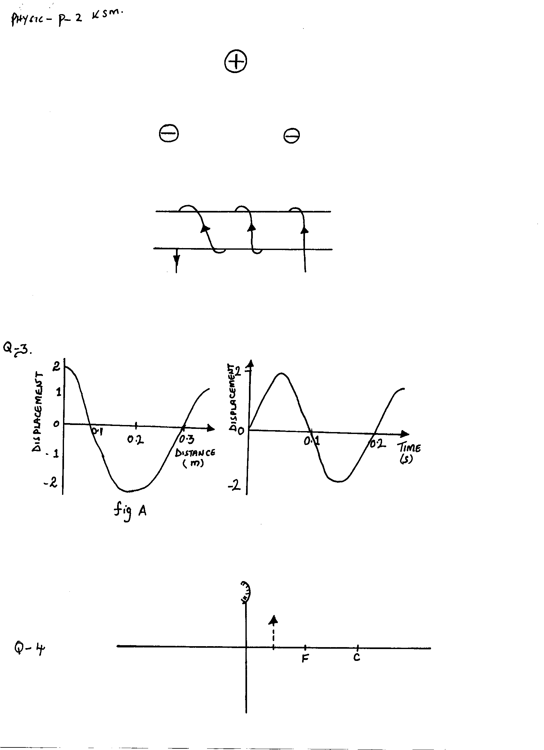

2. Sketch the magnetic field for a conductor shown in the figure below. (2 mks)



3. The graphs in the figure below represent the same wave.

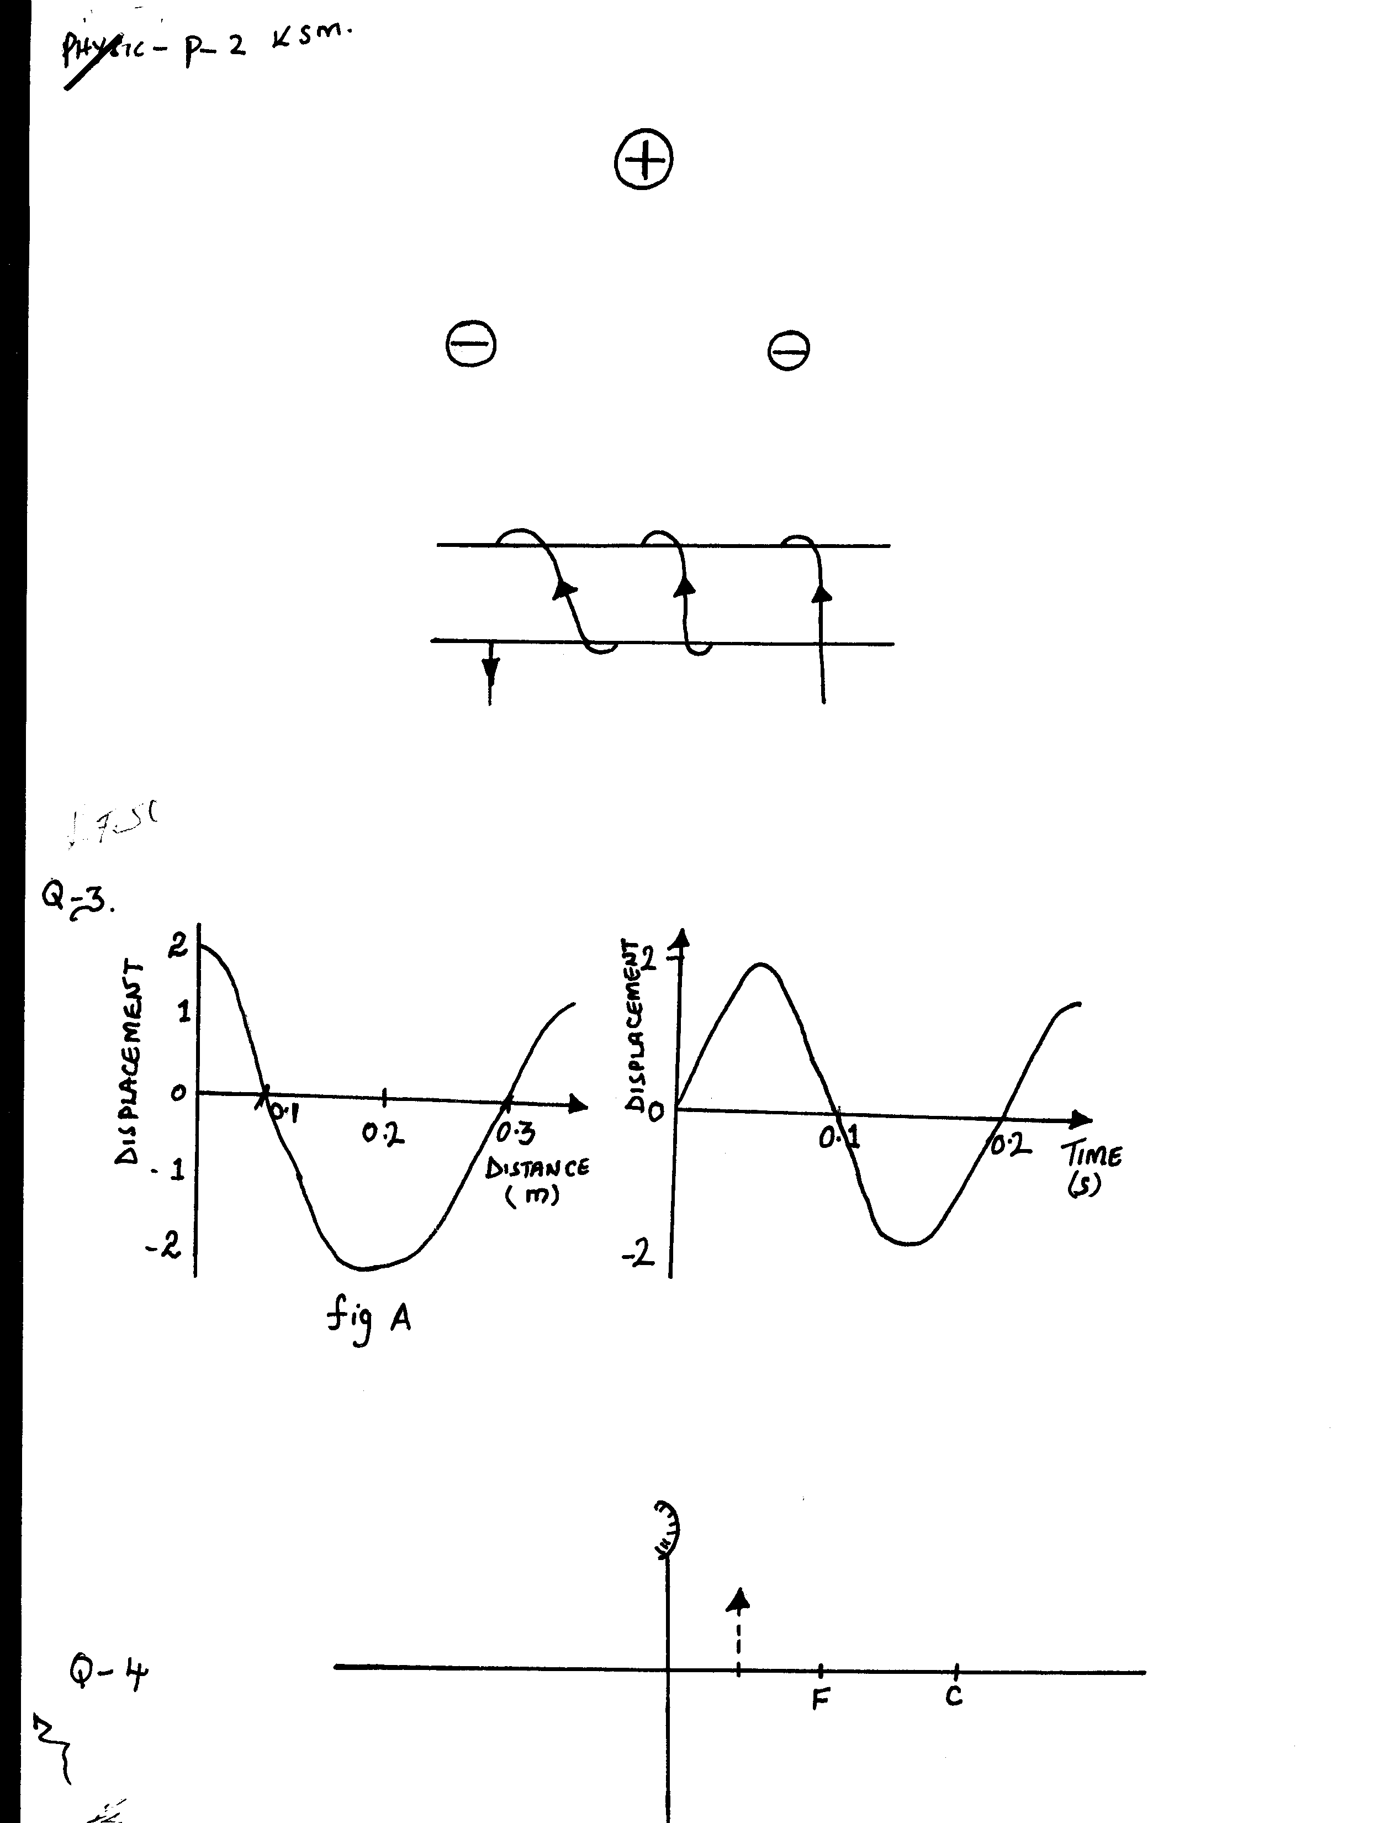

Determine the velocity of the wave. (3 mks)

4. a) The figure below shows the image I, formed in a convex mirror. Complete the ray diagram to show the position of the object. (2 mks)

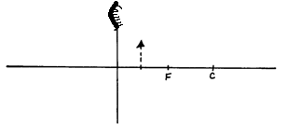

**I**

b) Describe images formed by convex mirrors. (2mks)

5. The figure below shows the set – up for a simple cell.

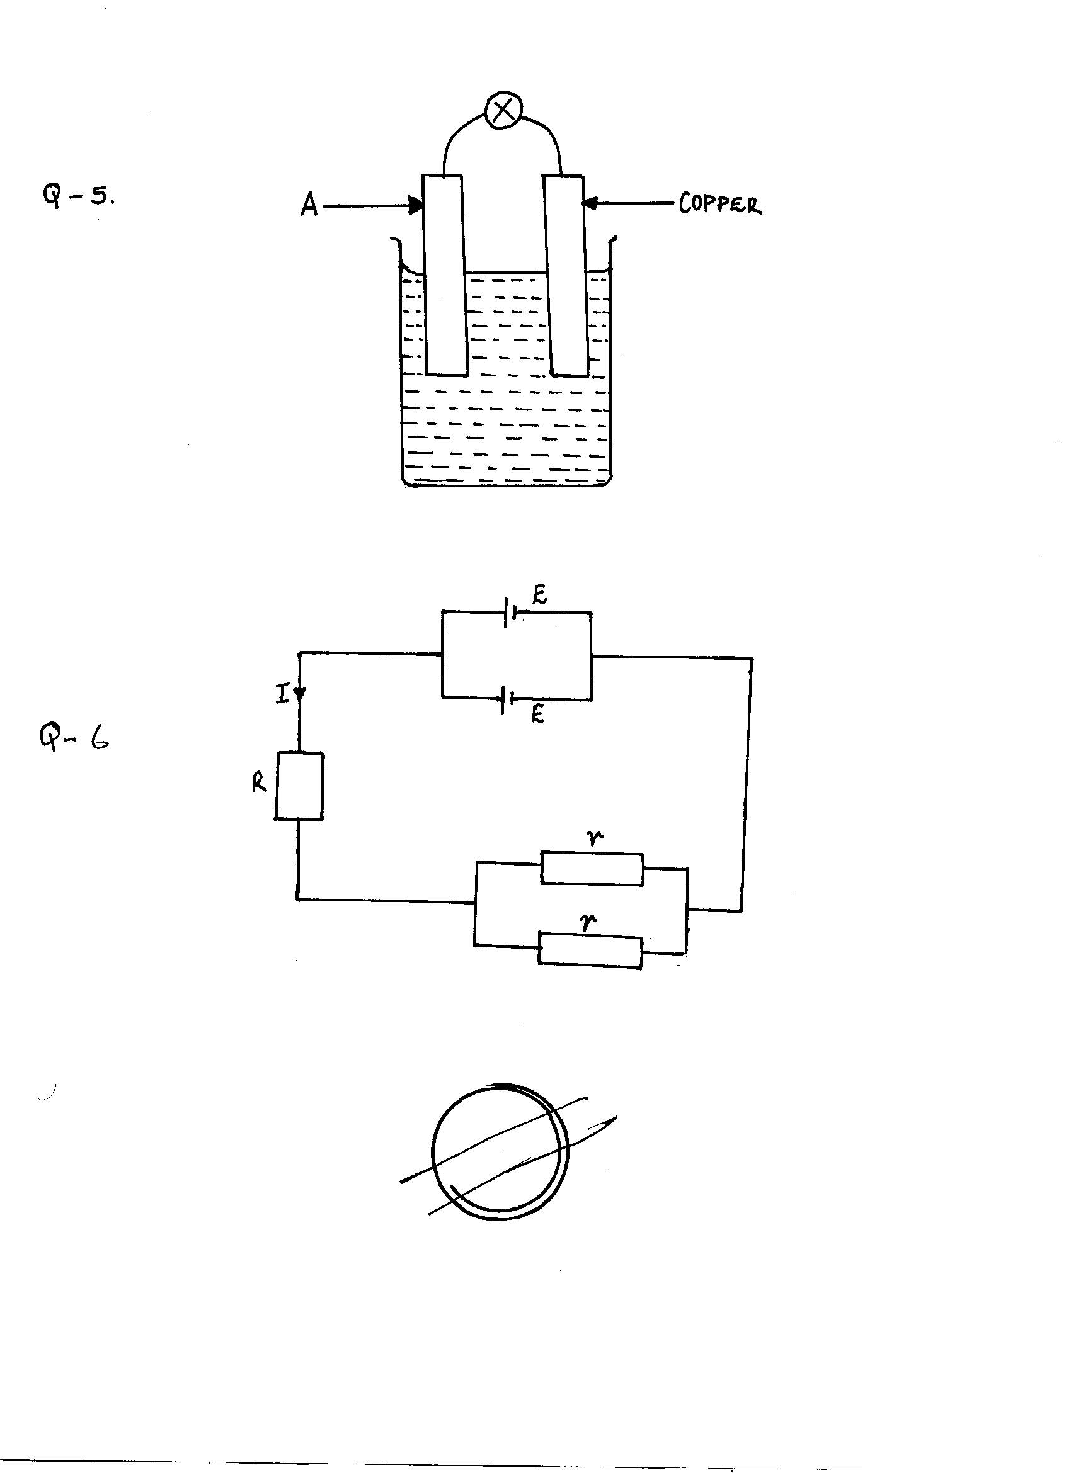

(i) Name the electrode A. (1 mk)

(ii) Explain why the bulb goes off after only a short time. (1 mk)

(iii) How can the problem stated above be corrected. (1mk)

6.



Using the circuit diagram above write formula relating E, I, R and r. (2 mks)

7. A thick sheet of plastic, n = 1.5, is used as the side of an aquarium tank. Light reflected from a fish in the water has an angle of incidence of 350. At what angle does the light enter the air. (3 mks)

8. In a pin – hole camera, what is the effect of making the pin – hole small but square in shape? (1 mk)

9. Suggest a reason why it is not possible to increase the strength of a magnet indefinitely. (1 mk)

10. Two heaters A and B are connected in parallel across 240V mains supply. Heater A is rated 1000W and B is rated 2500W. Calculate the ratio of their resistance. (2 mks)

11. Two mirrors are inclined at an angle of 740 to each other. Calculate the numbers of images formed (2 Marks)

**SECTION II (55 Marks)**

**Answer ALL questions in the spaces provided**

12. (a) State two advantages of a lead – acid accumulator over a nickel – iron accumulator

(2 Marks)

(b) State three maintenance practices for lead-acid accumulators (3mks)

(c) Figure 7 below shows a highly negatively charged rod being brought **slowly** near the cap of a positively charged electroscope.



 Cap

+

+

+ +

+

Figure 7

State and explain what will be observed happening to the leaf of the electroscope

(3 Marks)

13. Figure 8 below shows how keepers are used to store magnets A and B. Polarity of magnet A is given.

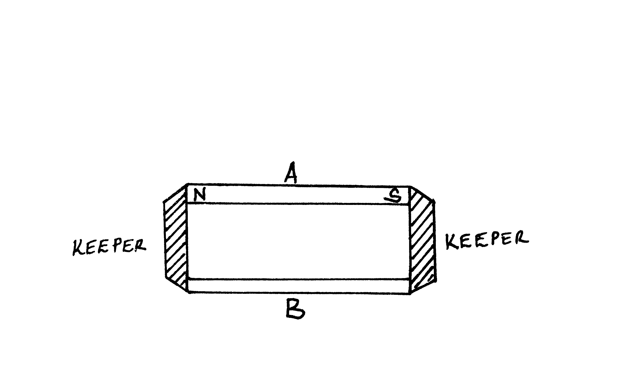

Figure 8

(i) Mark on the diagram the polarity of magnet B for correct storage habbit. (2 Marks)

(ii) Briefly explain how the keepers assist in storing the magnets (3mks)

14. a) State any two factor that determines the capacitance of a parallel plate capacitor

(2 Mark)

b) You are provided with the following A 500μf capacitor which is uncharged, a 6.0 V power source, a rheostat of range 100 – 10,000, a voltmeter, a milliameter, a switch, connecting wires and a stopwatch.

(i). Draw a circuit diagram using above approaches given, that can be used to show how the charging of the capacitor can be done. (2 Marks)

(ii) In the axes provided below sketch a graph showing how charging current varies with

time. (1 Mark)

I (mA)

t (s)

(iii) Briefly explain the use of stopwatch in this experiment (1 Mark)

c) Three capacitors of capacitance 3μf, 4μf and 5μf are arranged as in figure 9 below with a 10V battery across it.

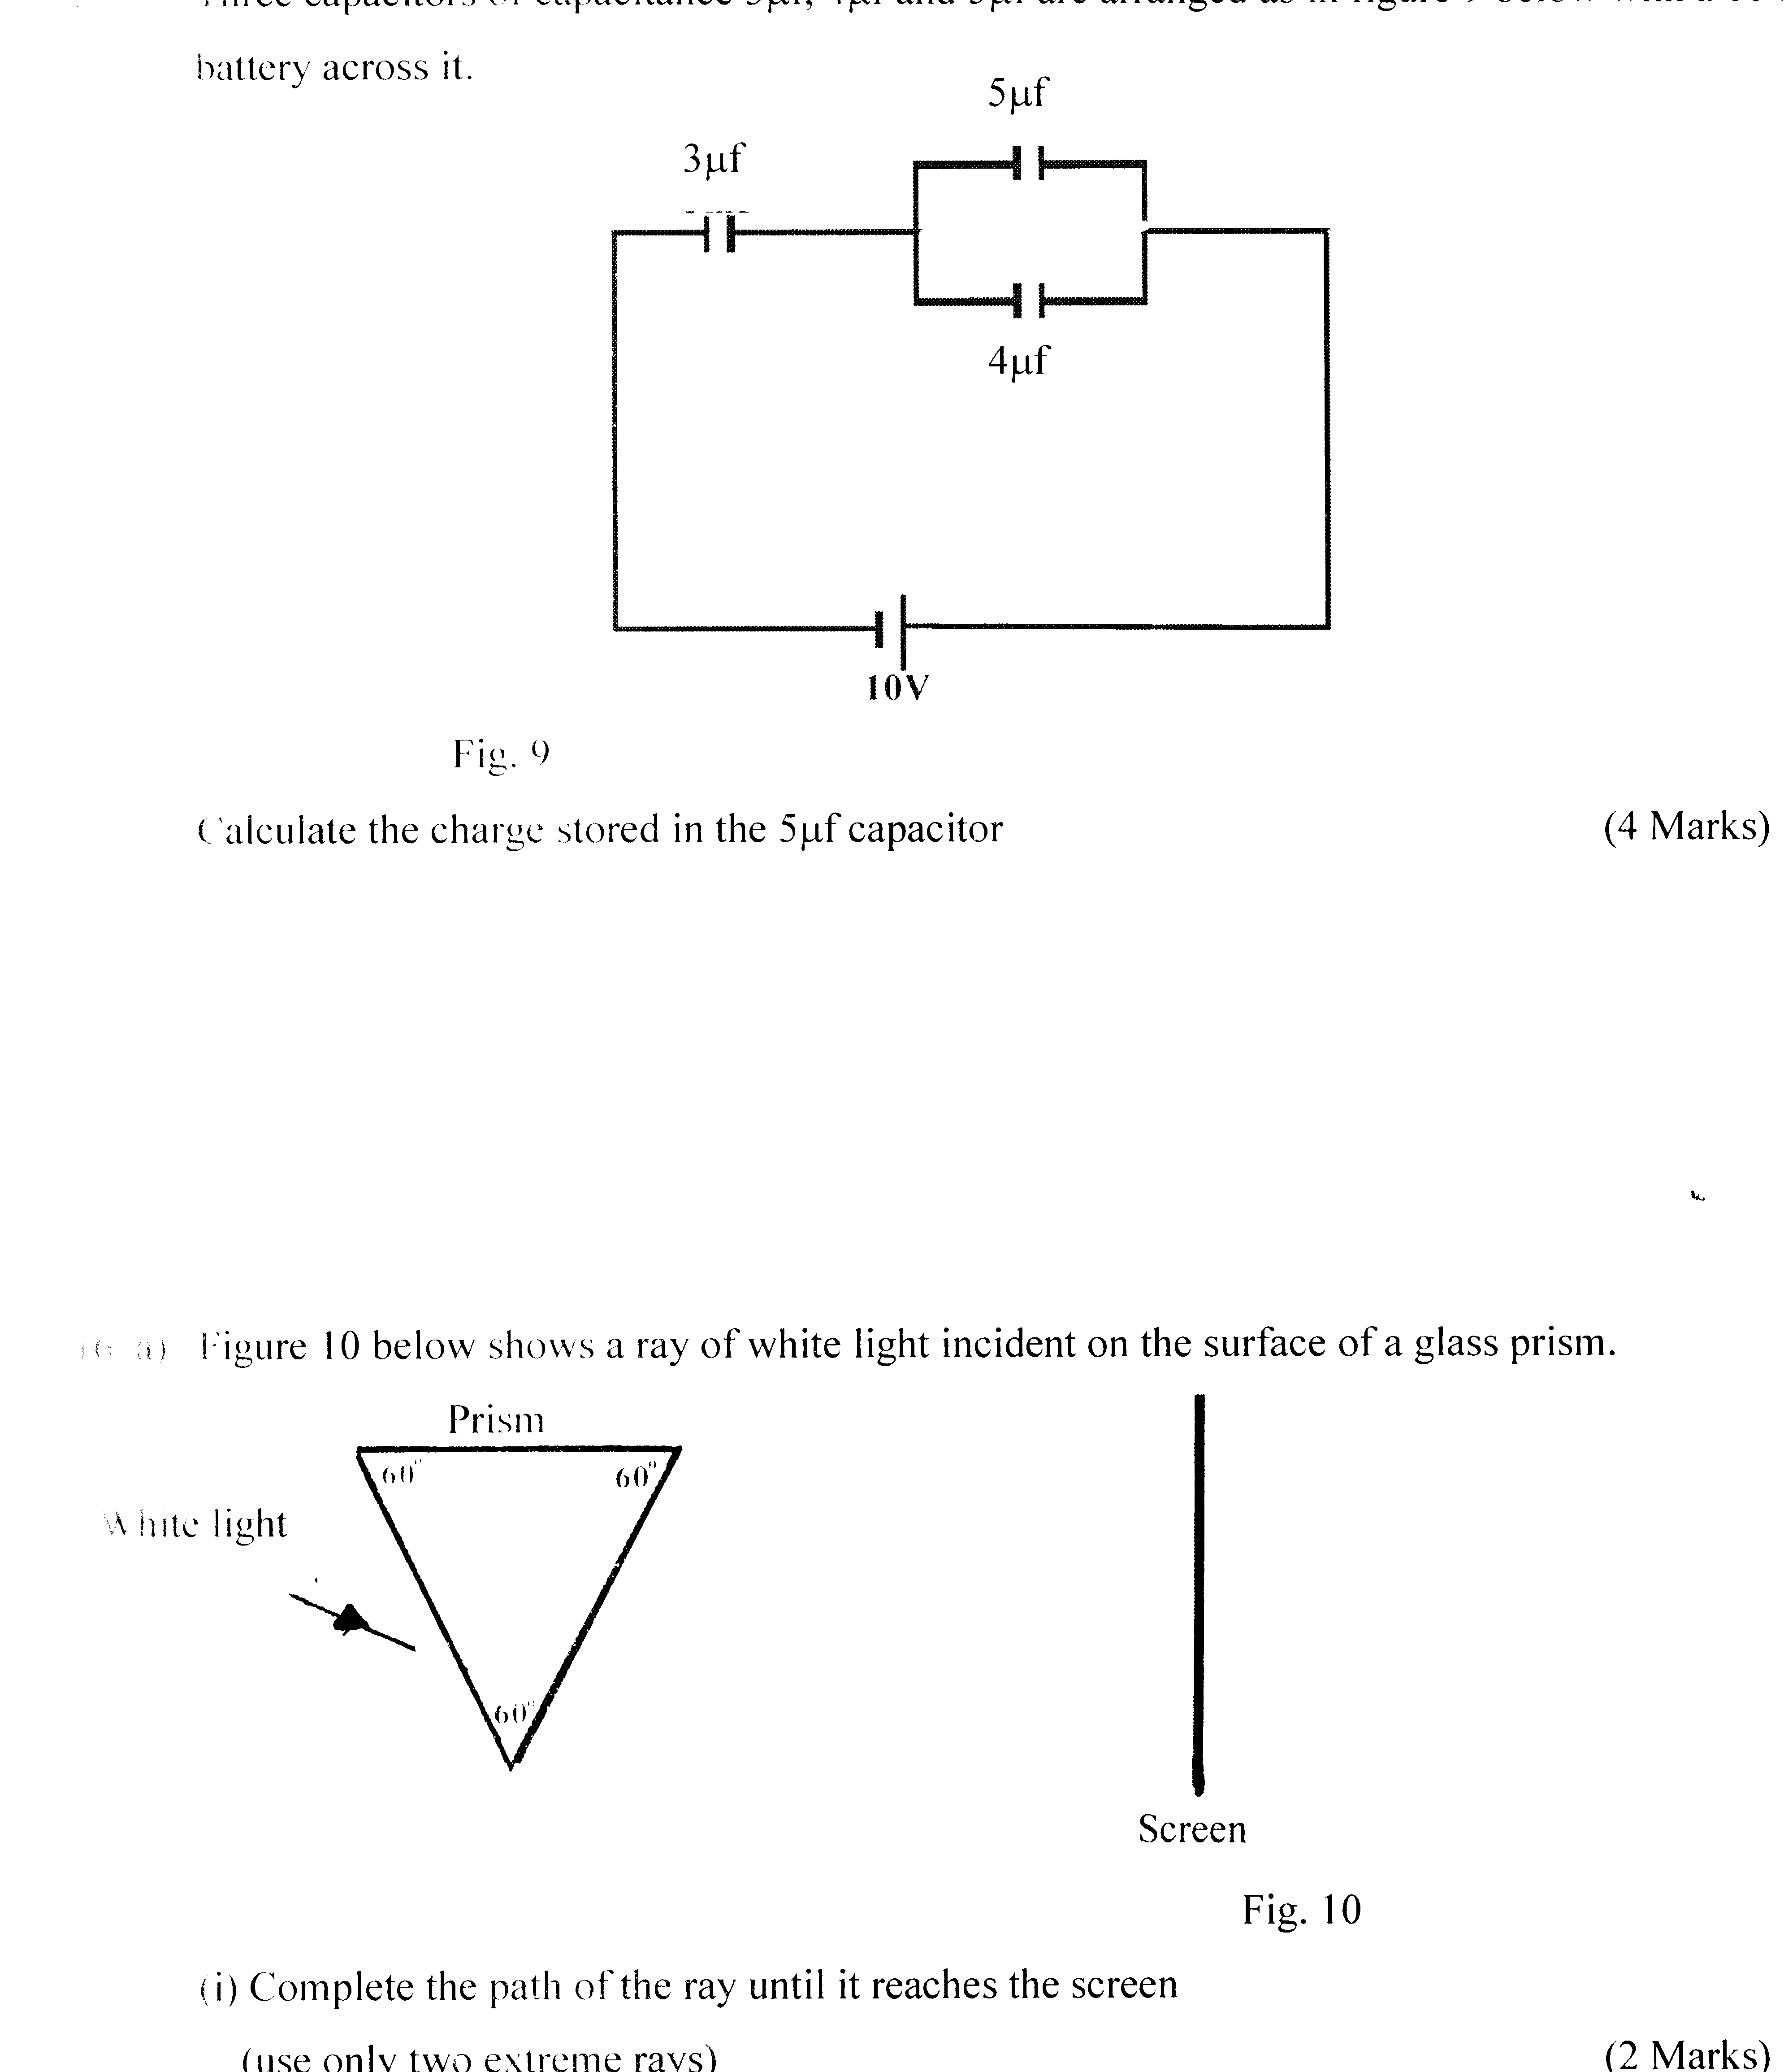

Fig. 9

Calculate the charge stored in the 5μf capacitor (4 Marks)

15. a) Figure 10 below shows a ray of white light incident on the surface of a glass prism.



Fig. 10

(i) Complete the path of the ray until it reaches the screen

(use only two extreme rays) (2 Marks)

(ii) Mark on the diagram the two rays as they appear on the screen (1 Mark)

(iii) What colours will be observed on the screen if white light was replaced by

yellow light? (1 Mark)

**END**

16. Figure 1 below shows two rays p and q entering a semi circular glass block whose critical angle is 440 the rays are incident at an air glass boundary at point O.

****Fig 1

Air

Glass

a) Complete the path of the two rays from point O. Label P’ and q’ the corresponding rays (2 Marks)

b) Calculate the refractive index of the material of the glass used above (3 Marks)

17. The following table shows some electrical appliances to be used in a house. The electrical ratings for each appliance are shown. The following fuses are available, 5A, 15A, 30A and 45A.

**Appliances Voltage (v) Power (w)**

TV 250 300

Iron Box 250 750

Electric Kettle 250 2000

a) Determine the resistance of the coil of the electric kettle (3 Marks)

b) Determine which one of the fuses is suitable for the house (2 Marks)

18. Figure 3 below shows a negatively charged conductor resting on an insulator

**A**



Insulator

Figure 3

a) Show the distribution of charge on the conductor (1 Mark)

b) A proof plane is made to touch the part marked A and then transferred to the cap of a negatively charged electroscope. State and explain what you will observe in the leaf of the electroscope. (2 Marks)

19. (a) A car battery is used to light a 12V lamp A constant current of 3 A passes round the circuit.

1. **Explain** what happens to the energy of the electron as they flow through the lamp wire. (3mks)

1. **How** much energy is transferred by the lamp in 20 seconds? (2mks)

1. For a particular specimen of wire, a series of readings of the current through the wire for different potential differences across it is taken and plotted as shown.

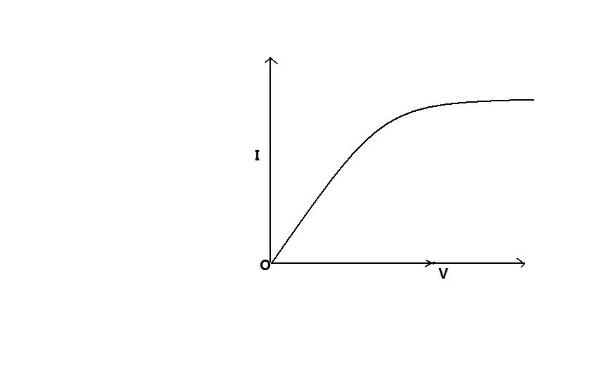

(i) **Explain** how the resistance of the wire changes (3mks)

1. **How** would the resistance of a piece of wire change if

(I) The length were doubled (2mks)

(II) The diameter were doubled (2mks)

1. A soldier standing between 2 cliffs fires a gun. He hears the first echo after 2s and the next after 5s. **Determine** the distance, between the two cliffs *(Take speed of sound as 340 m/s.)* (3mks)