ELERAI MCK GIRLS’ SECONDARY SCHOOL
P. O. BOX 435
SULTAN HAMUD
Motto “Discipline and Hard Work for Excellence”

FORM 2
AGRICULTURE
END OF TERM II 2016
Attempt all the questions
- State four reasons why farmers herd livestock (2mks

2. List four ways of controlling water pollution in the farm. (2mks)

3. State the three forms of water found in the soil. (1¹/₂mks)

4. State four practices carried out in minimum tillage. (2mks)

5State four methods used in preparing planting material in maize production. 2mks)

- State four characteristics of nitrogenous fertilizers. (2mks)

7. State one crop propagated using the following planting materials. (2mks)
a) Bulbils ………………..………………………………………………………………………………………………………
b) Splits………………………………………………………………………………………………………………………..
c) Cuttings…………………………………………………………………………………………………………………………
d)crown ……………………………………………………………………………………………………………………………
8) .State four characteristics of fertile soils. (2mks)

9. Differentiate between Olericulture and pomoculture as used in crop production (1 mk)

10. State FOUR physical agents of weathering (2 mk)

11.State four advantages of drip irrigation ( 2 mks)

12. Give four reasons for using certified seeds for planting ( 2 mks)

13Describe five factors that influence crop rotation. (4mks)

14 Diagrams M, N, P and Q represent some farm tools. Study them carefully and answer questions that follow.
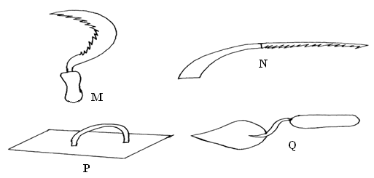

a. Identify the tools M, N, P and Q (2 marks)

b. Give one use of each of the tools names above (4 markS)

c. State two maintenance practices that should be carried out on tool M (2 mark

15.The following illustration shows a method of preparing compost manure.
Heap A
Heap C
Heap B
Heap D

- Identify the method. (1mk)

- State two factors that should be considered when siting a compost pit. (2mark)

c.State two factors that determine the time manure is ready for use on the field. (1mark

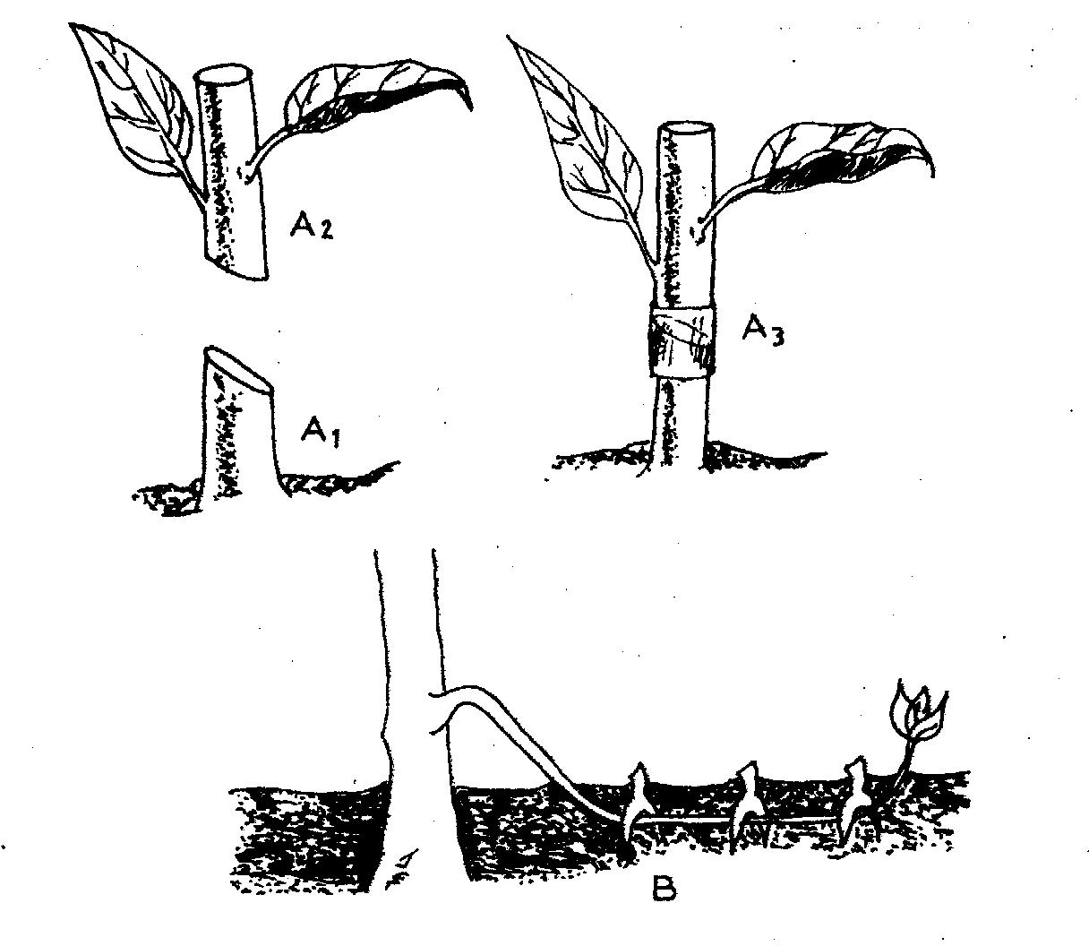
16. The diagrams labeled A_{1,} A₂, A_{3,} and B below illustrate materials and methods of vegetative propagation. Study them and answer the questions that follow.

(a) Name the parts labeled A₁, and A₂ ( 2 mks)
A₁
A₂………………………………………………………………………………………………………
(b) Name the methods of propagation illustrated in diagrams A₃ and B ( 2 mks)
A₃………………………………………………………………………………………………………………
B …………………………………………………………………………………………………………………

