NAME……………………………………………INDEX NUMBER………………………
AGRICULTURE

2HOURS

ELERAI MCK GIRLS SECONDARY
FORM THREE
END OF TERM II EXAM 2014

INSTRUCTIONS
Write your name and index number in the spaces provided above.
This paper consists of three section A,B and C.
Answer ALL the questions in section A and B and any TWO questions from section C.
Answer all questions in the spaces provided .
SECTION | QUESTION | MAXIMUM  SCORE | CANDIDATES  SCORE
A | 1 -14 | 30
B | 15 - 18 | 20
C |  | 20
 |  | 20
TOTAL |  | 90

SECTION A (30MKS)
Answer all questions in this section.
Q1. Name four breeds of rabbit . (2mks)

Q2 (a) Give two types of breeding systems. (1mk)

(b) State four disadvantages of artificial insemination. (2mks)

Q3. State three factors that would determine the effectiveness of an acaricide. (1 ½ mks)

Q4. Give the appropriate use of each of the following tools.
(i) burdizzo ( ½ mks)

(ii) garden trowel ( ½mks )

(iii) marking gauge ( ½ mks)

(iv) stock and die ( ½mks )

Q5. Differentiate between flushing and steaming and steaming up in livestock production(2mks )
Q6. (a) State four breeds of cattle kept for meat (2mks).

(b) State four ways of controlling livestock diseases (2mks)

Q7. State four features of a good piggery unit . (2mks)

Q8. (a) What is an apiary ? ( ½mks )

(b) State two factors to consider when sitting an apiary (1mk)

c) State two diseases that affect bees (1mk)

d) Give four reasons why bees swarm (2mks)

Q9. State four factors that affect the digestibility of feeds . (2mks)

Q10. (a) Name the casual agents for each of the following
(i) East coast fever. ( ½ mks)

(ii) Fowl typhoid. ( ½mks )

(b) Give two animals attacked by anthrax. (1mk)

Q11. (a) What do you understand by the term “cropping” in fish farming. (1mk)

(b) Give two methods of harvesting fish from a fish pond. (1mk)

c) Give four ways of preserving fish (2mks)

Q12. Give two reasons for docking in sheep production. (1mk)

SECTION B (20MKS)
Q 13. The illustration below represent the different states of development of a three host tick.
Study it carefully and then answer the questions that follow:

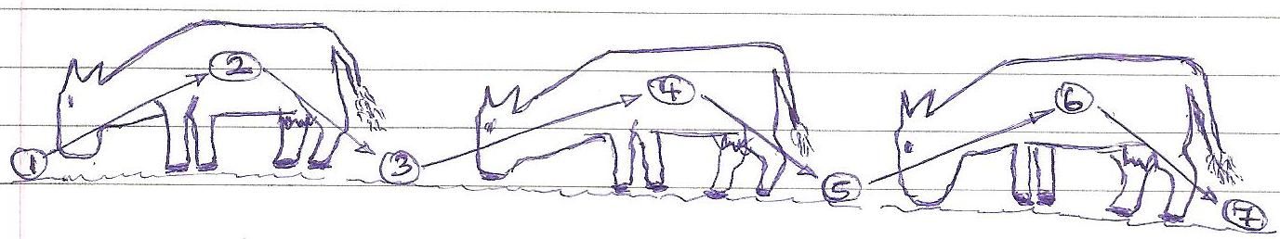
(a) Briefly explain what is happening in the following stages: (2mks)
1
……..
4
5
7

(b) Why do you think this tick is difficult to control using acarides? (1mk)

(c) Name two common sites the tick can be found on the body of an animal . (1mk)

(d) Give two examples of three – host ticks. (1mk)

(e) Give one off-host method of a tick control. (1mk)
14. (a) The diagram below represents roof of a building.
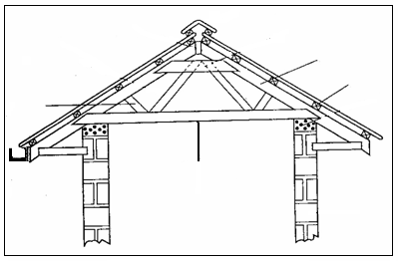
A
D
C
B

(i) Identify the parts labeled A, B, C. (3mks)

(ii) state the uses of A and B (2mks)

15.Study the diagram below carefully and answer the questions that follow. The number on the right ear represents litter number while the left ear number represents the individual number.

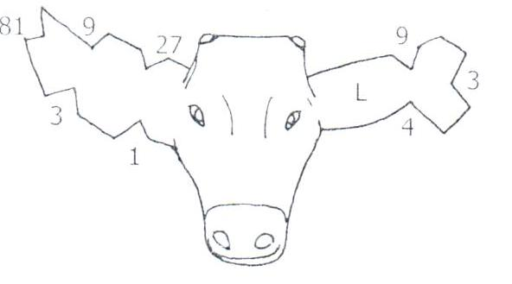

- Name the routine livestock production practice shown above. (1mk)

- State two reasons why farmers carry out the routine livestock production practice shown in the diagram above. (1mk)

16. a) . The diagram below shows the reproductive system of a cow. Study it and answer the questions
that follow:-
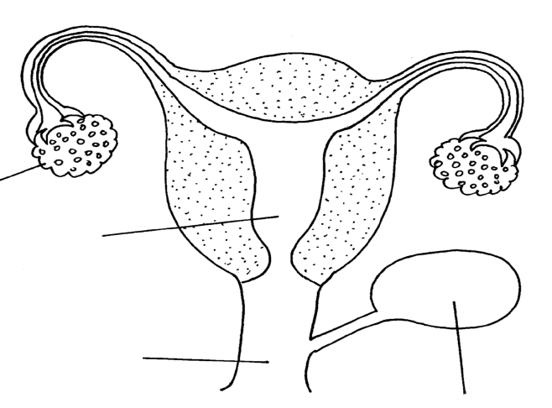

K
J

M
L
(a) Name the parts labeled (2mks)
K……………………………………………………………
L……………………………………………………………
M…………………………………………………………..
J…………………………………………………………….
(b) Name the three signs of heat in cows (3mks)
………………………………………………………………………………………………………….
………………………………………………………………………………………………………….
Q17.(a) Differentiate between roughages and concentrates. (2mks)

(b) A farmer wanted to prepare a 200kg of calf rearing ration containing 18% DCP. Using
the person’s square method , calculate the amount of maize containing 12% DCP and
sunflower containing 32% DCP that the farmer would need to prepare the ration.
(show your working) (3MKS)

SECTION C (40MKS)
Answer any TWO questions in this section.
Q 19. (a) State any five disadvantages of live fences . (5mks)

(b) Describe five factors which are considered when sitting a fish pond. (5mks)

(c) State five signs of parturition in a sow . (5mks)

(d) Describe 5 causes of swarming in bees. (5mks)

Q 20. (a) Discuss the factors considered when selecting materials for construction of farm structures. (12mks)

(b) Discuss the uses of the parts of apludge dip (8mks)

Q 21 . (a) Outline ten factors to consider when selecting livestock for breeding. (10mks).

(b) (i) Name two types of animals attacked by mastitis. (2mks)

(ii) Discuss four predisposing factors in livestock diseases (8mks)

