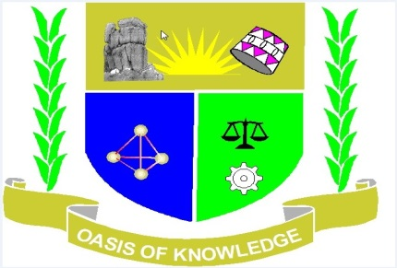
JARAMOGI OGINGA ODINGA UNIVERSITY OF SCIENCE AND
TECHNOLOGY
SCHOOL OF HUMANITIES AND SOCIAL SCIENCES
UNIVERSITY EXAMINATION FOR THE DEGREE OF BACHELOR OF
EDUCATION ARTS WITH IT
3rd YEAR 1ST SEMESTER 2017/2018 ACADEMIC YEAR
MAIN CAMPUS SCHOOL- BASED
______________________________________________________________________________
COURSE CODE: DPS 401
COURSE TITLE: POLITICS AND GOVERNMENT IN EAST AFRICA
EXAM VENUE: STREAM:
DATE: EXAM SESSION:
TIME:
Instructions
1. Answer question 1 (COMPULSORY) any other 2 questions
2. Candidates are advised not to write on the question paper
3. Candidates must hand in their answer booklet to the invigilator while in the exam

1. (a) Discuss the decentralized political system as was practiced in East
African (14mks)
(b) Explain the factors that contributed to the colonization process (16mks)
2. Discuss the reasons for rapid decolonization process in East Africa in the early 1960s (20mks)
3. Discuss the instruments that were used to maintain One Party State in East Africa (20mks)
4. Explain the factors that contributed to the militarization of politics in East Africa (20mks)
5. What are the challenges of multiparty political systems in East Africa?(20mks)

