BIOLOGY
FORM 1
END TERM EXAM - OCT. 2015
TIME: 2 HRS

NAME ....................................................................................CLASS.......ADM. NO. ........

- Read the text below that shows the synthesis of proteins and answer the questions that follow.

Amino cid Q + Amino acid R B + water

- Amino acids Q and R are made of the same elements. What differs in the two amino acids. (1 mk)

………………………………………………………………………………………………
………………………………………………………………………………………………
- What name is given to the molecule B? (1 mk)
………………………………………………………………………………………………
- Name the type of bonding found in molecule B. (1 mk)
………………………………………………………………………………………………
- Name the process T in the equation. (1 mk)
………………………………………………………………………………………………
- Many amino acids join to form a long protein chain called ……………………………….
(1 mk)
- What is holozoic nutrition? (1 mk)
….………………………………………………………………………………………………
….………………………………………………………………………………………………
….………………………………………………………………………………………………
- (a) What is dentition? (1 mk)

….………………………………………………………………………………………………
….………………………………………………………………………………………………
(b) Below is a drawing of a transverse section of a tooth.

- Identify the type of tooth above. (1 mk)
….………………………………………………………………………………………………
….………………………………………………………………………………………………
- Name the parts labeled: (4 mks)

A……………………………………………………………………
B……………………………………………………………………
C……………………………………………………………………
D……………………………………………………………………
- Study the dental formulae given below and answer the questions that follow.

Animal A Animal B

$$i \frac{3}{3} c \frac{1}{1} Pm \frac{4}{4} n \frac{2}{3} i \frac{0}{3} c\frac{0}{0} pm\frac{3}{2} m\frac{3}{3}$$

- Determine the number of teeth for each animal. (2 mks)

Animal A……………………………………………………………………………………
………………………………………………………………………………………………
Animal B……………………………………………………………………………………
………………………………………………………………………………………………
- Identify the mode of feeding for animal A and B. (2 mks)
A……………………………………………………………………………………………
B……………………………………………………………………………………………

- A part from dental formula, state two other adaptations of animal B to its mode of feeding. (2 mks)

….………………………………………………………………………………………………
….………………………………………………………………………………………………
….………………………………………………………………………………………………
….………………………………………………………………………………………………
- Define the following terms: (3 mks)
- Digestion
….………………………………………………………………………………………………
….………………………………………………………………………………………………
….………………………………………………………………………………………………
- Ingestion
….………………………………………………………………………………………………
….………………………………………………………………………………………………
….………………………………………………………………………………………………
- Egestion
….………………………………………………………………………………………………
….………………………………………………………………………………………………
….………………………………………………………………………………………………
- State the components of saliva and the function of each component. (6 mks)

Component | Function

- State two reasons why the study of biology is important. (2 mks)
….………………………………………………………………………………………………
….………………………………………………………………………………………………
….………………………………………………………………………………………………
….………………………………………………………………………………………………
….………………………………………………………………………………………………
- Mention any three characteristics of living things. (3 mks)

….………………………………………………………………………………………………
….………………………………………………………………………………………………
….………………………………………………………………………………………………
- Members of kingdom monena & protoctista are single celled: What differentiates them? (2 mks)

….………………………………………………………………………………………………
….………………………………………………………………………………………………
….………………………………………………………………………………………………
- Briefly explain the meaning of the terms basic, structural and functional in reference to a cell. (3 mks)

….………………………………………………………………………………………………
….………………………………………………………………………………………………
….………………………………………………………………………………………………
….………………………………………………………………………………………………
….………………………………………………………………………………………………
….………………………………………………………………………………………………
….………………………………………………………………………………………………
….………………………………………………………………………………………………
….………………………………………………………………………………………………
- List three physiological processes involved in the movement of substances in cells. (3 mks)

….………………………………………………………………………………………………
….………………………………………………………………………………………………
….………………………………………………………………………………………………
….………………………………………………………………………………………………
….………………………………………………………………………………………………
….………………………………………………………………………………………………

SECTION B (40 MARKS)
- A gas that stimulated coughing was passed through two tubes of equal but different lengths. The tubes were placed at different positions from two students as follows.

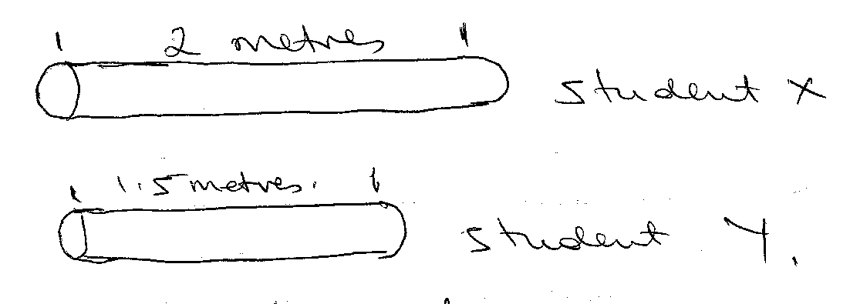
- Which of the two students started coughing earlier? (1 mk)

….………………………………………………………………………………………………
- Account for your results above. (2 mks)

….………………………………………………………………………………………………
….………………………………………………………………………………………………
….………………………………………………………………………………………………
….………………………………………………………………………………………………
….………………………………………………………………………………………………
- (a) Below is a transparent section of a leaf as seen under the onicroscope. Identify the parts
labelled A – E. (8 mks)

A………………………………………………………………………………………………
B.………………………………………………………………………………………………
C.………………………………………………………………………………………………
D.………………………………………………………………………………………………
E.………………………………………………………………………………………………
- The organelle below is important in the process of photosynthesis.

- Identify the organelle. (1 mk)
….………………………………………………………………………………………………
- Name the parts labelled A – E. (5 mks)
A……………………………………………………………………………………………
B……………………………………………………………………………………………
C…………………………………………………………………..…..……………………
D……………………………………………………………………………………………
E…………………………………………………………………….………………………
- Study the diagram below and answer the questions that follow.

- Name the parts labelled: (6 mks)

M…………………………………………………………………………………………..
N……………………………………………………………………………………………
P……………………………………………………………………………………………
U……………………………………………………………………………………………
r…………………………………………………………………………………………….
V……………………………………………………………………………………………
- The presence of food in the structure labelled N causes secretion of a certain juice and hormone. Name them. (2 mks)

- Juice ……………………………………
- Hormone ……………………………….
- State the components of the juice state in b. (i) above. (4 mks)

….………………………………………………………………………………………………
….………………………………………………………………………………………………
….………………………………………………………………………………………………
….………………………………………………………………………………………………
….………………………………………………………………………………………………
….………………………………………………………………………………………………
….………………………………………………………………………………………………
….………………………………………………………………………………………………
….………………………………………………………………………………………………
- A group of students using a light microscope observed 20 cells across the field of view as shown below.
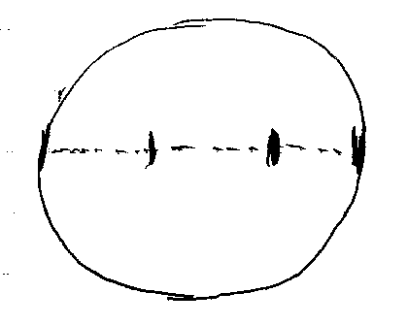
Calculate the size of each cell.

What is the diameter of the field of view in:
- Millimeters? (1 mk)
….………………………………………………………………………………………………
….………………………………………………………………………………………………
….………………………………………………………………………………………………
- Micrometres? (1 mk)
….………………………………………………………………………………………………
….………………………………………………………………………………………………
….………………………………………………………………………………………………
….………………………………………………………………………………………………

- Calculate the size of each cell in micrometer. (3 mks)
….………………………………………………………………………………………………
….………………………………………………………………………………………………
….………………………………………………………………………………………………
….………………………………………………………………………………………………
….………………………………………………………………………………………………
….………………………………………………………………………………………………
- Two slides were observed under two different microscopes and the images below were obtained.

- Identify the type of cells above. (2 mks)
….………………………………………………………………………………………………
….………………………………………………………………………………………………
- Identify the parts labelled C –G in diagram B. (5 mks)
C…………………………………………………………………………………………
D…………………………………………………………………………………………
E…………………………………………………………………………………………
F…………………………………………………………………………………………
G…………………………………………………………………………………………
SECTION C (20 MARKS)

- (a) Draw a well labelled diagram to show the external features of a simple dicot leaf. (8 mks)

(b) The leaf is thin, broad and flat. Explain how these features adopt the leaf to its photosynthetic function. (4 mks)

….………………………………………………………………………………………………
….………………………………………………………………………………………………
….………………………………………………………………………………………………
….………………………………………………………………………………………………
….………………………………………………………………………………………………
….………………………………………………………………………………………………
….………………………………………………………………………………………………
….………………………………………………………………………………………………
….………………………………………………………………………………………………
….………………………………………………………………………………………………
….………………………………………………………………………………………………
- You are provided with a food substance that contains glucose, proteins and lipids. Use the table below to explain how you would confirm the presence of the three food substances.
(8 mks)

Test | Procedure | Observation
Glucose

Protein

Lipids

