SUNSHINE SCHOOL
CHEMISTRY FORM ONE
END OF YEAR EXAM
TIME: 2HRS
NAME CLASS ADM NO.
INSTRUCTIONS
- ANSWER ALL QUESTIONS
- DO NOT LEAVE ANY BLANC SPACE

- Give two reasons why chemistry is studied as a subject in high school (2mks)

- a)State two commonly abused drugs by students (1mk)

b) Suggest two ways to reduce drug abuse among students (1mk)

- Explain why most apparatus are made of glass in the laboratory (2mks)

- State two apparatus used to measure liquids in the laboratory approximately (2mks)

- State two applications of solvent extraction as a method of separating mixtures (2mks)

- Name the most suitable method of separating the following mixtures in the laboratory;
- Oil from cashew nuts (1mk)

- Red colour from flower petals (1mk)

- Describe how you can obtain crystals of sodium chloride from a mixture of sodium chloride , iodine and sand (3mks)

- State two industrial applications of fractional distillation (2mks)

- State two differences between temporary and permanent changes (2mks)

- Complete the table below

Element | Symbol
Copper
 | Pb
Silver
 | K
Manganese
 | C

- Complete the following word equations
- Carbon + Oxygen
(excess)

- Zinc + dilute hydrochloric acid

- Sodium + Water

- Magnesium + steam

- a)Define the following terms (3mks)
- An acid

- A base

- An indicator

b) Name the commercial indicators and state their colour in acid and base
Indicators | Acid | Base
c) List the use of acids (2mks)

- List the uses of bases (2mks)

e) Name the acid used in;
i) Car batteries (1mk)

ii) Vinegar (1mk)

f Name two acidic oxides (2mks)

- Sodium metal reacts with cold water ,
- Write a word equation for the reaction which takes place (1mk)

- How would you show that one of the products is basic (1mk)

- The diagram below shows the effect of heat on hydrated cobalt (II) chloride
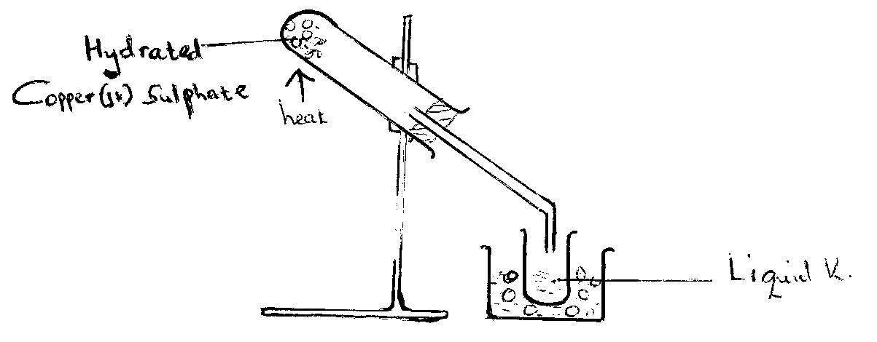
- Name liquid Q (1mk)

- Write a word equation for the reaction in the heated tube (1mk)

- What observations are made in the heated tube (1mk)

- Anhydrous copper (II) sulphate is heated in the test tube then liquid Q is added. State the observations made (1mk)

- The diagram below shows preparation of oxygen gas
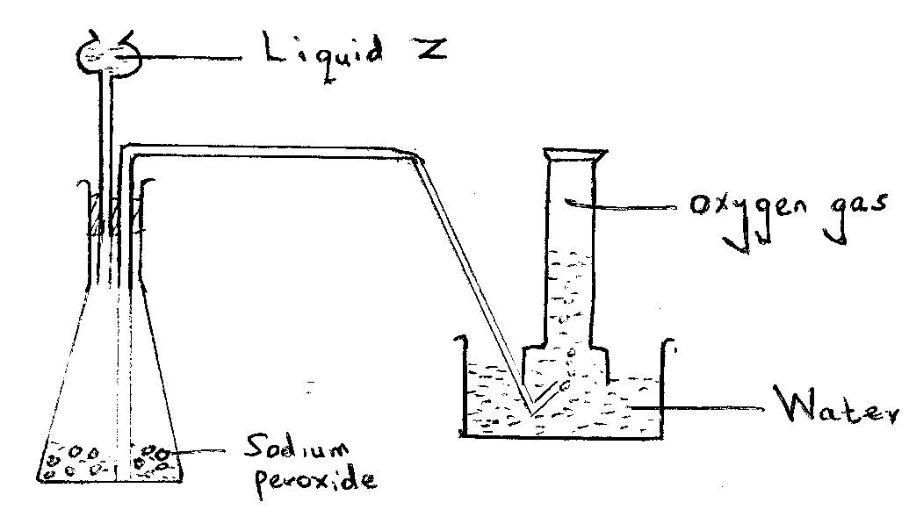

- Name liquid Z (1mk)

- State two mistakes in the above diagram (2mks)

- Write an equation for the reaction which takes place (1mk)

- When sodium is burnt in oxygen a yellow solid is formed. When the yellow solid is dissolved in water a gas is evolved and a colourless solution formed.
- Name the yellow solid (1mk)

- What would be the effect of the colourless solution on blue litmus paper (1mk)

- State the confirmatory test for the gas (1mk)

- Explain why potassium is stored in kerosene while phosphorus under water (2mks)

- A cooling curve shows how the temperatures of a substance changes with time as the substance is cooled from a gas to a solid. The cooling curve of a substance is X shown below.
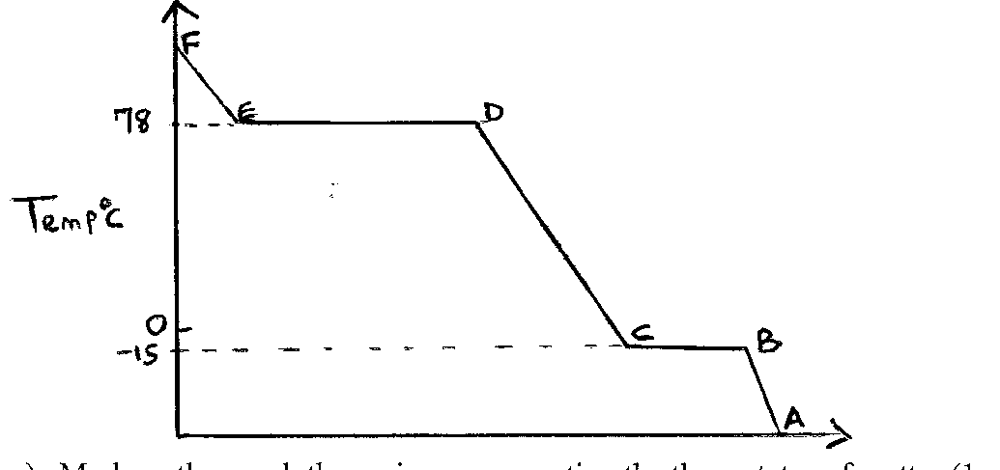
- Mark on the graph the regions representing the three states of matter (1mk)

- What is the state of X at 25ºC (1mk)

- In terms of kinetic theory, explain the difference between particles in regions AB and CD (2mks)

- A candle was burnt in the laboratory to produce water and carbon (IV) oxide,
- Name the two elements present in the candle (1mk)

- Name the general name for such compounds (1mk)

- a) Define the following terms
Reduction (1mk)

Oxidation (1mk)

- Identify the reducing and oxidizing agents in each of the following
- Iron (II) oxide + Carbon (II) oxide Iron + Carbon (IV) oxide (1mk)

- Hydrogen + Copper (II) oxide Copper + Water (1mk)

- Explain why the following cannot be used to prepare hydrogen gas using sulphuric acid;
- Lithium (1mk)

- Lead (1mk)

- Copper (1mk)

- Define the following terms
- Rusting (1mk)

- Galvanization (1mk)

- Alloying (1mk)

- The set up below was used to investigate the products of burning dry hydrogen gas.
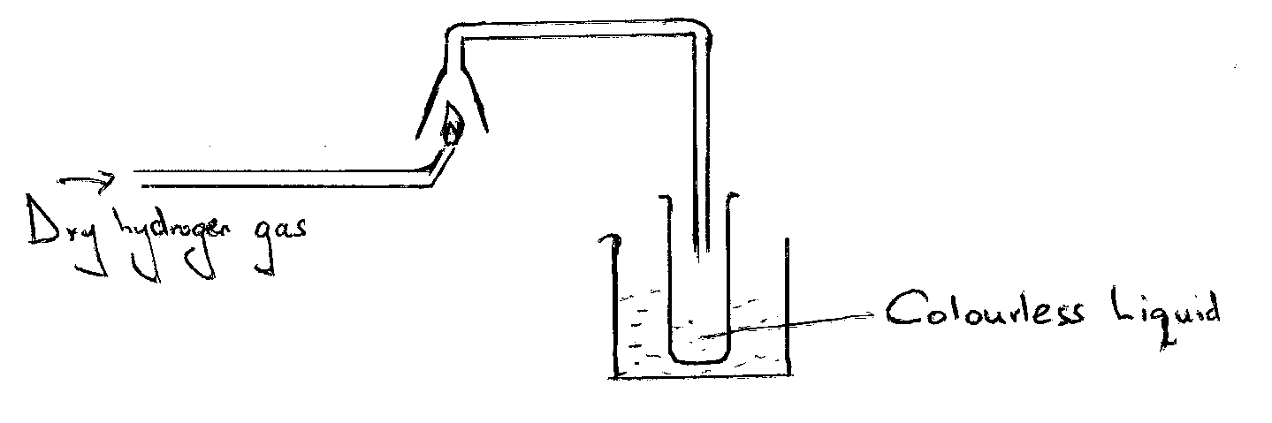

- Name the colourless liquid (1mk)

- Write an equation for the burning of hydrogen in air (1mk)

- Define the following terms (3mks)
- Atomic number

- Mass number

- Isotopes

- Complete the following table (7mks)

No. of protons | No. of electrons | No. of neutrons | Mass no
 | 11 |  | 23
17 |  | 18
 | 17 |  | 35
 |  | 20 | 40

*****END SUCCESS, BLESSED HOLIDAY*****

