SUNSHINE SCHOOL

FORM 1
GEOGRAPHY
END TERM EXAM – OCT. 2015
TIME: 2 ½ HRS

NAME: …………………………………………………CLASS:………..ADM. NO:…………

Q1
2
3
4
TOTAL

SECTION A

- (a) (i) Distinguish meteors from meteorites. (2 mks)
…………………………………………………………………………………………….
…………………………………………………………………………………………….
…………………………………………………………………………………………….
(ii) State three characteristics of comets. (3 mks)

…………………………………………………………………………………………….
…………………………………………………………………………………………….
…………………………………………………………………………………………….
…………………………………………………………………………………………….
(b) (i) Give four proofs that the earth is spherical. (4mks)

…………………………………………………………………………………………….
…………………………………………………………………………………………….
…………………………………………………………………………………………….
…………………………………………………………………………………………….
…………………………………………………………………………………………….
…………………………………………………………………………………………….
…………………………………………………………………………………………….
…………………………………………………………………………………………….
(ii) State four effects of the rotation of the earth. (4 mks)

…………………………………………………………………………………………….
…………………………………………………………………………………………….
…………………………………………………………………………………………….
…………………………………………………………………………………………….
…………………………………………………………………………………………….
…………………………………………………………………………………………….
…………………………………………………………………………………………….
…………………………………………………………………………………………….

(c) (i) When the local time at station X (15⁰E) is noon, what is the local time at Y
(45⁰E)? (2 mks)

…………………………………………………………………………………………….
…………………………………………………………………………………………….
…………………………………………………………………………………………….
…………………………………………………………………………………………….
(ii) When it is noon (0⁰) what is the East African Standard Time? (2 mks)

…………………………………………………………………………………………….
…………………………………………………………………………………………….
…………………………………………………………………………………………….
(d) The diagram below represents the structure of the earth. Use it to answer questions.
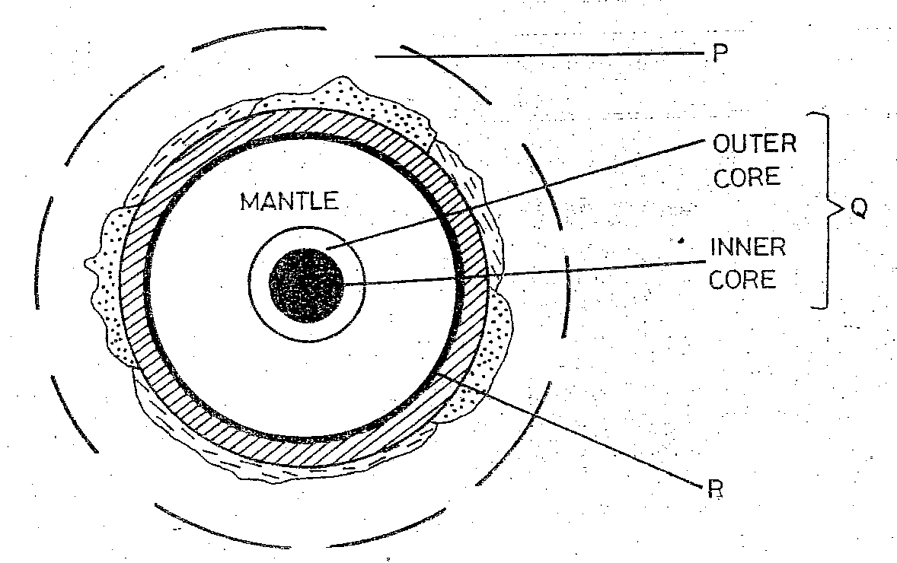

- Name the parts marked.

P …………………………………………… (1 mk)

Q …………………………………………… (1 mk)
- The discontinuity marked R. (1 mk)

…………………………………………………………………………………………….

- State five characteristics of the mantle. (5 mks)

…………………………………………………………………………………………….
…………………………………………………………………………………………….
…………………………………………………………………………………………….
…………………………………………………………………………………………….
…………………………………………………………………………………………….
…………………………………………………………………………………………….
…………………………………………………………………………………………….
…………………………………………………………………………………………….
…………………………………………………………………………………………….
…………………………………………………………………………………………….
- (a) State three characteristics of Troposphere. (3 mks)

…………………………………………………………………………………………….
…………………………………………………………………………………………….
…………………………………………………………………………………………….
…………………………………………………………………………………………….
…………………………………………………………………………………………….
…………………………………………………………………………………………….
…………………………………………………………………………………………….
(b) (i) Identify three different types of fog. (3 mks)

…………………………………………………………………………………………….
…………………………………………………………………………………………….
…………………………………………………………………………………………….
(ii) Explain three conditions ideal / necessary for the formation of dew. (6 mks)

…………………………………………………………………………………………….
…………………………………………………………………………………………….
…………………………………………………………………………………………….
…………………………………………………………………………………………….
…………………………………………………………………………………………….
…………………………………………………………………………………………….
…………………………………………………………………………………………….
…………………………………………………………………………………………….
(c) With the aid of a well-labelled diagram, describe how relief rainfall is formed. (6 mks)

…………………………………………………………………………………………….
…………………………………………………………………………………………….
…………………………………………………………………………………………….
…………………………………………………………………………………………….
…………………………………………………………………………………………….
…………………………………………………………………………………………….
…………………………………………………………………………………………….
…………………………………………………………………………………………….
…………………………………………………………………………………………….
…………………………………………………………………………………………….
…………………………………………………………………………………………….
…………………………………………………………………………………………….
(d) Give reasons why a Stevenson’s screen is:

- Painted white (2 mks)

…………………………………………………………………………………………….
…………………………………………………………………………………………….
…………………………………………………………………………………………….
- Has louvers (2 mks)

…………………………………………………………………………………………….
…………………………………………………………………………………………….
…………………………………………………………………………………………….
(e) Name the instruments used to measure: (3 mks)

- Speed of wind ……………………………………………………

- Sunshine………………………………………………………….

- Relative humidity………………………………………………….

- (a) (i) What is statistics? (2 mks)
………………………………………………………………………………………………
………………………………………………………………………………………………
(ii) State 5 significance of statistics. (10mks)
………………………………………………………………………………………………
………………………………………………………………………………………………
………………………………………………………………………………………………
………………………………………………………………………………………………
………………………………………………………………………………………………
………………………………………………………………………………………………
………………………………………………………………………………………………
………………………………………………………………………………………………
………………………………………………………………………………………………
………………………………………………………………………………………………
…………………………………………………………………………………………….
…………………………………………………………………………………………….
…………………………………………………………………………………………….
…………………………………………………………………………………………….
(b) (i) Give 2 types of statistical data. (2 mks)

………………………………………………………………………………………………
………………………………………………………………………………………………
(ii) Define the following terms:

I. discrete data (2 mks)

………………………………………………………………………………………………
………………………………………………………………………………………………
II. continuous data (2 mks)
………………………………………………………………………………………………
………………………………………………………………………………………………
III. individual data (2 mks)
………………………………………………………………………………………………
………………………………………………………………………………………………
(c) Name four methods of presenting statistical data. (4 mks)
………………………………………………………………………………………………
………………………………………………………………………………………………
………………………………………………………………………………………………
………………………………………………………………………………………………
(d) The table below shows a rainfall and temperature for Nairobi.

Month | J | F | M | A | M | J | J | A | S | O | N | D
Temp(⁰c) | 18 | 19 | 20 | 19 | 18 | 17 | 16 | 16 | 17 | 19 | 18 | 18
Rainfall(Mm) | 62 | 55 | 95 | 227 | 185 | 35 | 18 | 23 | 32 | 54 | 148 | 102
Source: Certificate Geo by Paul Kibuuka

- Using a scale of 1cm rep 20mm, draw a combined line and bar graph to show the above statistics. (5 mks)

- State two advantages of the above method. (2 mks)

………………………………………………………………………………………………
………………………………………………………………………………………………
………………………………………………………………………………………………
………………………………………………………………………………………………

- (a) (i) What is a map? (2 mks)
………………………………………………………………………………………………
………………………………………………………………………………………………
(ii) Apart from sketch map, name two other types of maps. (2 mks)

………………………………………………………………………………………………
………………………………………………………………………………………………
- Give four characteristics of a sketch map. (4 mks)

………………………………………………………………………………………………
………………………………………………………………………………………………
………………………………………………………………………………………………
………………………………………………………………………………………………
(b) (i) Define a scale. (2 mks)

………………………………………………………………………………………………
………………………………………………………………………………………………
………………………………………………………………………………………………
(ii) Name three groups of scale sizes.

………………………………………………………………………………………………
………………………………………………………………………………………………
………………………………………………………………………………………………
- Arrange the following scales in a descending order (2 mks)

$\frac{1}{100,000}$, 1:50,000, 1 cm represents 2 km, $\frac{1}{15,000}$
………………………………………………………………………………………………
………………………………………………………………………………………………
(c) Convert the following scales.
(i) 1cm represent 4 km into representative fraction scale. (3 mks)
………………………………………………………………………………………………
………………………………………………………………………………………………
………………………………………………………………………………………………
………………………………………………………………………………………………
(ii) 1:250,000 into a statement scale (2 mks)
………………………………………………………………………………………………
………………………………………………………………………………………………
………………………………………………………………………………………………
(d) Use the map extract, Machakos sheet 162/2 provided to answer the following questions.

(i) What type of map is this? (1 mk)

………………………………………………………………………………………………
(ii) Using marginal information, when was the map published. (1 mk)

………………………………………………………………………………………………
(iii) Measure the distance of the all weather bound surface road C97 between Easting
09 and Easting 14. (2 mks)

………………………………………………………………………………………………
(iv) Calculate the area of Kaani on the north East and enclosed by the municipality boundary and the bound surface road. (2 mks)

………………………………………………………………………………………………
………………………………………………………………………………………………
………………………………………………………………………………………………
………………………………………………………………………………………………
………………………………………………………………………………………………
(e) (i) Name features found in grid square 1030. (3 mks)

………………………………………………………………………………………………
………………………………………………………………………………………………
………………………………………………………………………………………………
(ii) Name three types of vegetation found in the area shown. (3 mks)

………………………………………………………………………………………………
………………………………………………………………………………………………
………………………………………………………………………………………………
(iii) Give the grid square where Kitutu dam is found. (1 mk)

………………………………………………………………………………………………

