SUNSHINE SCHOOL

FORM 1
MATHS
END TERM EXAM – OCT. 2015
TIME: 2 ½ HRS

NAME………………..………………………………………CLASS………ADM NO:……….

INSTRUCTIONS
- Write our name, admission number and class in the spaces above.
- Answer all questions in section A and section B.
- All calculations should be done in the spaces provided.
- Silent / electronic calculators must not be used.

For examiners’ use only
Section A
1 | 2 | 3 | 4 | 5 | 6 | 7 | 8 | 9 | 10 | 11 | 12 | 13 | 14 | 15 | 16 | TOTAL

Section B
17 | 18 | 19 | 20 | 21 | TOTAL

- The sum of four consecutive even numbers is 420, find the numbers. Hence express the largest number as a product of its prime factors in power form. (3 mks)

- Simplify: (2 mks)

7 of 13 – (18 ÷ 6 + 3) ÷ (9 x 3 – 25)

- Giving reasons, test the divisibility of 34, 700 by 4. (3 mks)

- A sector of a circle, radius = 7 cm, has an angle of 80⁰ at the centre. Find its perimeter. (3 mks)

- Mwisa, Otieno and Kamau divided 500 eggs among themselves in the ratio 14 : 5 : 6 respectively. Later Mwisa gave 20 eggs to Otieno and 20 eggs to Kamau. Find the percentage eggs that Otieno finally had to that of Kamau. (3 mks)

- Evaluate: (3 mks)

$$\frac{0.032 + 0.608}{0.0016 x 0.25}$$

- Kamau divided a certain number by 10, 15 and 18 and he realized the remainder was always 7. What was the possible number? (3 mks)

- (a) Simplify the expression $\frac{x-1}{x} - \frac{2x +1}{3x}$: (2 mks)

(b) Hence or otherwise solve the equation $\frac{x-1}{x} - \frac{2x +1}{3x} = \frac{2}{3}$ (2 mks)

- A bus left town A at 2045 hrs and arrived at town B at 0320h, where it stayed for 3 hours. It then set off to town C and took 6 hours from B to C.
- How long did the journey take from A to B. (1 mk)

- At what time in the 12 hour clock did the bus arrive at C.? (2 mks)

- Evaluate: (3 mks)

$$\frac{1}{2} of \frac{1}{4} ÷ \frac{1}{8} + 3/4- \frac{1}{8}$$

- Calculate the volume of 4000 kg of methylated spirit in m³ if the density of the methylated spirit is 0.8 g/cm³. (3 mks)

- Solve the following simultaneous equations by elimination method. (3 mks)

$$\frac{x}{3}- \frac{y}{2}+ 1=0$$

$${6x +y+8= 0}^{}$$

- A Kenyan bank buys and sells foreign currencies as shown below.
 | Buying (Ksh) | Selling (Ksh)
1 Euro | 84.15 | 84.26
100 Japanese Yen | 65.37 | 65.45

A Japanese traveling from France arrives in Kenya with 5000 Euros. He converts all the 5000 Euros to Kenya shillings at the bank. While in Kenya he spends a total of Ksh 289,850 and then converts the remaining Kenya shillings to Japanese Yen at the bank. Calculate the amount in Japanese Yen he receives. (4 mks)

- Use square and square root tables to evaluate to 4 significant figures the expression;
(4 mks)
$$\sqrt{{0.0465}^{2} +4.346}$$

- A cylindrical container of diameter 42 cm and height 30 cm is one-third full of water. The container is filled using a smaller cylindrical can of radius 4.2 cm and height 10 cm. determine the number of full cans required to fill the container. Use ( π = ²²/₇) (3 mks)

- The angle of elevation of a stationery hot air balloon 50m above the ground from a man on the ground is 17⁰. The balloon moves vertically upwards so that the angle o elevation from the man is 30⁰. Find by scale drawing, how far above the ground the balloon is. (3 mks)

- (a) Find the number of sides of a regular polygon whose interior angles are:

(i) 90⁰ (1 mk)

(ii) 108⁰ (1 mk)

(iii) 135⁰ (1 mk)

(vi) 156⁰ (1 mk)

(b) Find the number of sides of:

- A polygon having the sum of interior angles 1080⁰. (2 mks)

- A regular polygon if:

- Each exterior angle is 24⁰ (2 mks)

- Each interior angle is 150⁰ (2 mks)

- Complete the table for:

- x – 2y = -1

x | 0 | 1 | 3
y |  | 1

- 2x – y = 4 (3 mks)

x | 0 | 1 | -
y | -4 | -2 | 0

Hence or otherwise solve graphically the simultaneous equation above. (5 mks)

x – 2y = -1 and 2x – y = 4

State the coordinates of point of intersection. (2 mks)

- A surveyor followed the route PQRS. Q is 250 km on a bearing of 075⁰ from P. R is on a bearing of S 70⁰E from P and 275 km from Q. S is 300 km on a bearing of 100⁰ from Q. using a scale of 1 cm to represent 50 km:

- Show the relative position of PQRS. (4 mks)

- Determine:

- The distance PR in km. (2 mks)

- Bearing of Q from R. (1 mk)

- Distance PS in km. (2 mks)

- The bearing of R from S. (1 mk)

- (a) Using a ruler and a pair of compass only, construct a triangle ABC in which AB = 4.6 cm,
BC = 5.4 cm and <ABC = 75⁰ (4 mks)

(b) (i) Measure AC. (1 mk)

(ii) Drop a perpendicular from B to meet AC at N. (2 mks)

(iii) Measure BN. (1 mk)

(iv) Hence calculate the area of triangle ABC. (2 mks)

- The diagram below represents a steel girder used in construction work. The cross-section consists of a rectangle measuring 20 cm by 14 cm form which two similar semi-circles have been removed. The girder is 5 m long and is made of steel whose density is 8.5 g/cm³
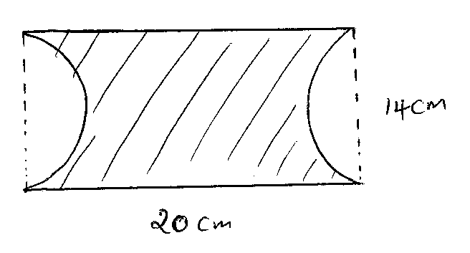
- Calculate:

- The cross-sectional area of the girder. (3 mks)

- The mass of the girder in kilograms. (4 mks)

- The removed semi-circular toughs are filled with concrete whose density s 5. g/cm³. Calculate the mass of concrete used to fill the removed parts of the girder. (Take π = ²²/₇)
(3 mks)

