SUNSHINE SCHOOL

FORM 1
PHYSICS
END TERM EXAM – OCT. 2015

NAME:…………………………………………………….CLASS:……..ADM NO:………

INSTRUCTIONS TO CANDIDATES

- Write your name, class and admission number in the spaces provided above.
- Answer ALL the questions in the spaces provided.
- Workings must be clearly shown.
- Non programmable silent calculators may be used.

FOR EXAMINER’S USE ONLY

STUDENT’S SCORE
MAXIMUM SCORE | 80

- (a) Give a reason why the weight of an object varies from one planet to another. (1 mk)
……………………………………………………………………………………………..
……………………………………………………………………………………………..
(b) A boy in sunshine was heard saying that “the mass of a body on earth is equal to the mass on the moon.” Gravitational field strengths on the earth and moon are different. State whether the boy is correct or wrong. (1 mk)

……………………………………………………………………………………………..
……………………………………………………………………………………………..
(c) The weight of a body on the surface of the earth is 30N where g = 10 N/kg. Determine the weight of the same body on the moon where g = 1.67 N/kg. (2 mks)

……………………………………………………………………………………………..
……………………………………………………………………………………………..
……………………………………………………………………………………………..
……………………………………………………………………………………………..
……………………………………………………………………………………………..
……………………………………………………………………………………………..
- (a) What do you understand by the term rectilinear propagation of light? (1 mk)

……………………………………………………………………………………………..
……………………………………………………………………………………………..
(b) Give any one difference between an image formed by a plane mirror and the one formed by a pin-hole camera. (1 mk)

……………………………………………………………………………………………..
……………………………………………………………………………………………..
(c) An object of height 10cm is placed 8 cm infront of a pin-hole camera of length 15cm. determine the height of the image formed. (2 mks)

……………………………………………………………………………………………..
……………………………………………………………………………………………..
……………………………………………………………………………………………..
……………………………………………………………………………………………..
……………………………………………………………………………………………..
……………………………………………………………………………………………..
(d) Explain why image formed on a pin-hole camera becomes brighter and blurred when the
size of the pin-hole is increased. (2 mks)

……………………………………………………………………………………………..
……………………………………………………………………………………………..
……………………………………………………………………………………………..
……………………………………………………………………………………………..
……………………………………………………………………………………………..
(e) Two plane mirrors are inclined such that 6 images are formed. Determine the angle of inclination. (2 mks)

……………………………………………………………………………………………..
……………………………………………………………………………………………..
……………………………………………………………………………………………..
……………………………………………………………………………………………..
……………………………………………………………………………………………..
(f) Use ……….diagram to locate the image of the object placed infront of a plane mirror as
shown. (2 mks)

(g) Draw a diagram to show to another eclipse. (2 mks)

- (a) Distinguish between cohesive and adhesive forces. (2 mks)

……………………………………………………………………………………………..
……………………………………………………………………………………………..
……………………………………………………………………………………………..
……………………………………………………………………………………………..
(b) Below shows the shape of water drops on a clean glass surface, and waxed one. Explain
clearly the differences.
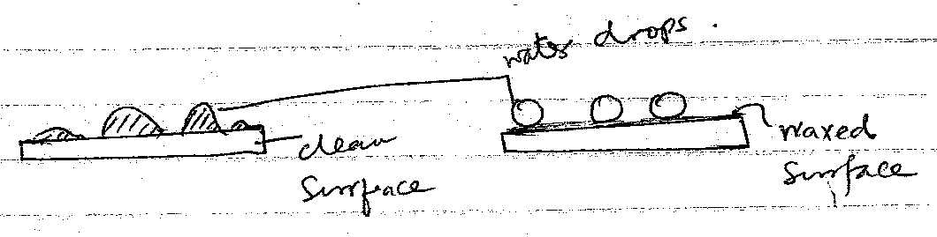
……………………………………………………………………………………………..
……………………………………………………………………………………………..
……………………………………………………………………………………………..
……………………………………………………………………………………………..
……………………………………………………………………………………………..
- (a) Define the following terms stating their SI units.
- Area (2 mks)
……………………………………………………………………………………………..
……………………………………………………………………………………………..
- Time (2 mks)
……………………………………………………………………………………………..
……………………………………………………………………………………………..
(b) Below shows a diagram of an experiment performed by a student to determine the thickness of a thread. Use it to answer the questions that follow.
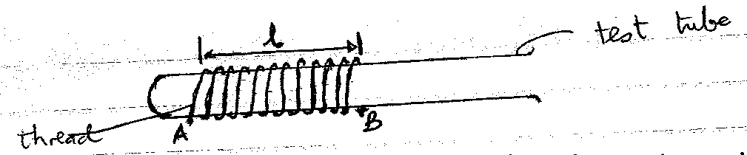

(i) Given that l = 9 cm, calculate the thickness, t, of the thread. (2 mks)

……………………………………………………………………………………………..
……………………………………………………………………………………………..
……………………………………………………………………………………………..
……………………………………………………………………………………………..
(ii) Length A to B of thread is 252 cm. Determine the diameter of the test-tube. (3 mks)

……………………………………………………………………………………………..
……………………………………………………………………………………………..
……………………………………………………………………………………………..
……………………………………………………………………………………………..
……………………………………………………………………………………………..
……………………………………………………………………………………………..
(c) A stone of mass 20g was placed in a beaker graduated in cm³ as shown below. Use the diagram to answer the questions that follows
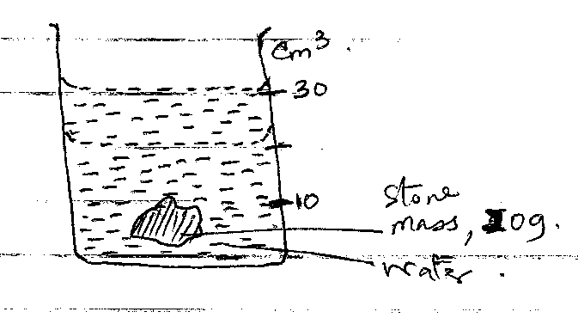
Determine:
- the volume of the stone. (1 mk)
……………………………………………………………………………………………..
……………………………………………………………………………………………..
……………………………………………………………………………………………..
- the density of the stone in SI units. (2 mks)

……………………………………………………………………………………………..
……………………………………………………………………………………………..
……………………………………………………………………………………………..
……………………………………………………………………………………………..
……………………………………………………………………………………………..
- In an experiment to investigate the unusual expansion of eater, a fixed mass of water at 0⁰C was heated until its temperature reached 20⁰C. On the axis provided, sketch a graph of density against temperature of the water from 0⁰C to 20⁰C. (2 mks)

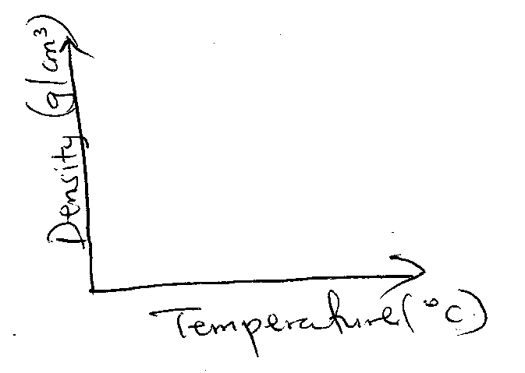
- Give two reasons why water is not suitable for use in a thermometer. (2 mks)
…..……………………………………………………………………………………………..
…..……………………………………………………………………………………………..
…..……………………………………………………………………………………………..
…..……………………………………………………………………………………………..
- Convert the following to ⁰C. (2 mks)

- 373K

- 0K

- The flask in the figure below is fitted with a cork through which a tube is inserted. When the flask is cooled, the water level rises slightly, and then falls steadily. Explain this observation.
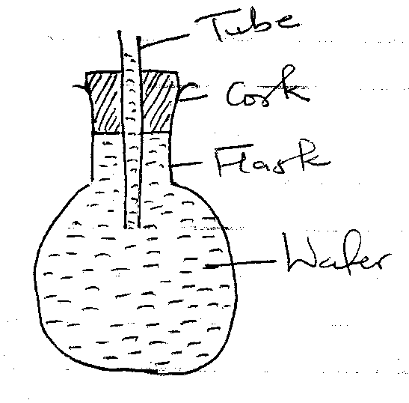
…..……………………………………………………………………………………………..
…..……………………………………………………………………………………………..
…..……………………………………………………………………………………………..
- A clinical thermometer has a constriction in the bore just above the bulb. State the use of this constriction. (1 mk)

…..……………………………………………………………………………………………..
…..……………………………………………………………………………………………..
- The figure below shows a bimetallic strip at room temperature. Brass expands more than invar when heated equally. Sketch the bimetallic strip after being cooled several degrees below room temperature. (1 mk)

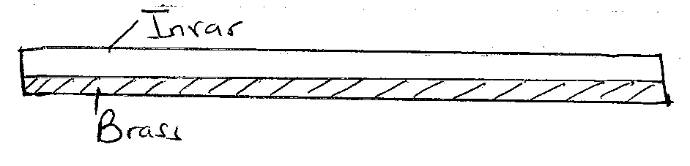
- Give a reason why a concrete beam reinforced with steel does not crack when subjected to changes in temperature. (1 mk)

…..……………………………………………………………………………………………..
…..……………………………………………………………………………………………..
- (a) Define surface tension. (1 mk)

…..……………………………………………………………………………………………..
…..……………………………………………………………………………………………..
(b) A metal pin was observed to float on the surface of pure water. However the pin sank when a few drops f soap solution were carefully added to the water. Explain this observation. (2 mks)

…..……………………………………………………………………………………………..
…..……………………………………………………………………………………………..
…..……………………………………………………………………………………………..
…..……………………………………………………………………………………………..
(c) Give one consequence of surface tension. (1 mk)

…..……………………………………………………………………………………………..
…..……………………………………………………………………………………………..
- (a) State three modes of heat transfer. (3 mks)

…..……………………………………………………………………………………………..
…..……………………………………………………………………………………………..
…..……………………………………………………………………………………………..
…..……………………………………………………………………………………………..
(b) State four factors that determine thermal conductivity of a metal. (4 mks)

…..……………………………………………………………………………………………..
…..……………………………………………………………………………………………..
…..……………………………………………………………………………………………..
…..……………………………………………………………………………………………..
…..……………………………………………………………………………………………..
(c) Explain why feet feel colder when a person stands on a cemented floor than when on a
wooden floor. (1 mk)

…..……………………………………………………………………………………………..
…..……………………………………………………………………………………………..
(d) The figure below shows corks fixed on dull and polished surface respectively.

State and explain the observation made after sometime. (2 mks)

…..……………………………………………………………………………………………..
…..……………………………………………………………………………………………..
…..……………………………………………………………………………………………..
…..……………………………………………………………………………………………..
…..……………………………………………………………………………………………..
(e) Explain why ventilations for a room are put near the roof and how near the floor. (1 mk)

…..……………………………………………………………………………………………..
…..……………………………………………………………………………………………..
(f) metals are generally good conductors of heat than non-metals. Explain. (1 mk)

…..……………………………………………………………………………………………..
…..……………………………………………………………………………………………..
- (a) State two factors determining the rate of diffusion. (2 mks)

…..……………………………………………………………………………………………..
…..……………………………………………………………………………………………..
…..……………………………………………………………………………………………..
…..……………………………………………………………………………………………..
(b) Two samples of bronure vapour are allowed to diffuse separately under different conductors, one in a vacuum and the other in air. State with reason the conductor in which bromine will diffuse faster. (2 mks)

…..……………………………………………………………………………………………..
…..……………………………………………………………………………………………..
…..……………………………………………………………………………………………..
…..……………………………………………………………………………………………..
- (i) What is Brownian motion? (2 mks)
…..……………………………………………………………………………………………..
…..……………………………………………………………………………………………..
…..……………………………………………………………………………………………..
…..……………………………………………………………………………………………..
(ii) In an experiment the diameter of the patch was measured to be 200mm for an oil drop of radius 0.25 mm. Determine the diameter of the molecule of the oil. (2 mks)

…..……………………………………………………………………………………………..
…..……………………………………………………………………………………………..
…..……………………………………………………………………………………………..
…..……………………………………………………………………………………………..
…..……………………………………………………………………………………………..

- Study the diagram below of a hydraulic brake.
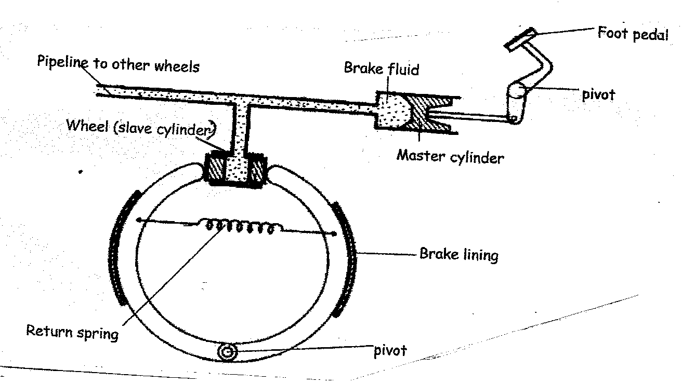

- How does the force applied on the foot pedal affect:

- Pressure of the brake fluid. (1 mk)
…..……………………………………………………………………………………………..
…..……………………………………………………………………………………………..
- The return spring. (1 mk)
…..……………………………………………………………………………………………..
…..……………………………………………………………………………………………..
- Brake lining. (1 mk)
…..……………………………………………………………………………………………..
…..……………………………………………………………………………………………..
- (i) Compare the diameter of the master cylinder and wheel cylinder. (2 mks)

…..……………………………………………………………………………………………..
…..……………………………………………………………………………………………..
…..……………………………………………………………………………………………..
…..……………………………………………………………………………………………..
…..……………………………………………………………………………………………..
…..……………………………………………………………………………………………..
(ii) The figure below shows a manometer closed at one end and the other end connected to a gas cylinder.
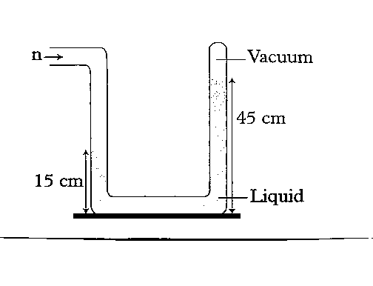
The liquid has a density of 1.2 g/cm³. Calculate the pressure due to the gas. (3 mks)

…..……………………………………………………………………………………………..
…..……………………………………………………………………………………………..
…..……………………………………………………………………………………………..
…..……………………………………………………………………………………………..
…..……………………………………………………………………………………………..
…..……………………………………………………………………………………………..

