END YEAR EXAM
OCTOBER 2014
BIOLOGY FORM 1

Name ……………………………………………………….…class ……….adm. no. ………

BIOLOGY FORM 1

Answer ALL questions in the spaces in this paper

- State the difference between photosynthesis and chemosynthesis. (2mks)
............................................................................................................................................................ .............................................................................................................................................................
- What is meant by the term binomial nomenclature? (1mk)
............................................................................................................................................................. .............................................................................................................................................................
b) A dog is called Canis familiairis. Name the taxonomic unit represented by canis. (1mk)
............................................................................................................................................................. .............................................................................................................................................................
- Name the cell organelles responsible for : (2mks)
Protein synthesis
.............................................................................................................................................................
Destroying worn – out organells and cells
............................................................................................................................................................
- Lietego school biology student used a microscope with x40 objective lens and x5 eyepiece lens which had 2mm radius. Calculate the area of the field of view in micrometers.(2mks)

b) What is the average size of the cell in micrometers (2mks)
............................................................................................................................................................. .............................................................................................................................................................
.............................................................................................................................................................
- Below is a diagrammatic summary of the main biochemical events in photosynthesis.Study it carefully and answer the questions that follow.
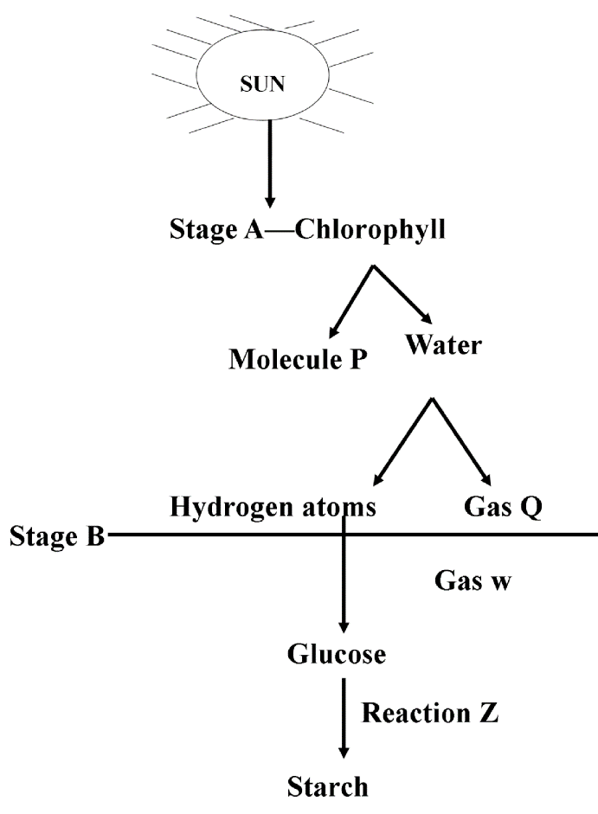
a) Suggest the identify of molecule P. (1mk)
............................................................................................................................................................
b) Name the gases represented by the letters (2mks)
Q
.................................................................................................................................................................
W
................................................................................................................................................................
c) Name the specific site for the reactions in stage B
....................................................................................................................................................................
d) Name reaction Z. (1mk)
Z ..................................................................................................................................................
- Explain the following terms.
  - Cell specialization (1mrk)
………………………………………………………………………………………………………………………………………………………………………………………………………………………………………………………………………………………………………………………
b) Species (1mrk)
………………………………………………………………………………………………………………………………………………………………………………………………………………………………………………………………………………………………………………………
- State the functions of the following organelles.
a).Lysosomes (1mrk)
…………………………………………………………………………………………………………………………………………………………………………………………………………..…
b).Golgi apparatus (1mrk)
…………………………………………………………………………………………………………………………………………………………………………………………………………….
- Name the form in which carbohydrates are stored in. (2mrks)
i). Plants tissues …………………………………………………………………………….
ii). Animal tissues ………………………………………………………………………………….
- The diagram below shows chemical reaction I and II which are controlled by enzyme A and B.
Glucose + fructose
Sucrose + water
Reaction I in presence
Of enzyme A
Reaction II presence
Of enzyme B

- Name the reaction I and enzyme B (2mrks)
Reaction I……………………………………………………………………………..
Reacction II ……………………………………………………………………….
- State two main functions of a microscope. (2mrks)
………………………………………………………………………………………………………………………………………………………………………………………………………………………………………………………………………………………………………………………
- Some form one students wanted to collect the following animals for study in the laboratory. State the suitable apparatus they should use.
i)Flying insects (1 mark)
……………………………………………………………………………………………………………………………………………………………………………………………………
ii) Crawling stinging insects (1mark) ……………………………………………………………………………………………………………………………………………………………………………………………………
iii) Small animals from tree barks (1 mark)
…………………………………………………………………………………………………………………………………………………………………………………………………..
- State the transport and synthetic roles of endoplasmic reticulum
i) Transport role (1 mark)
……………………………………………………………………………………………………………………………………………………………………………………………………
ii) Synthetic role (1 mark)
…………………………………………………………………………………………………………………………………………………………………………………………………
- Study the diagram below and answer the questions that follows (1 mark)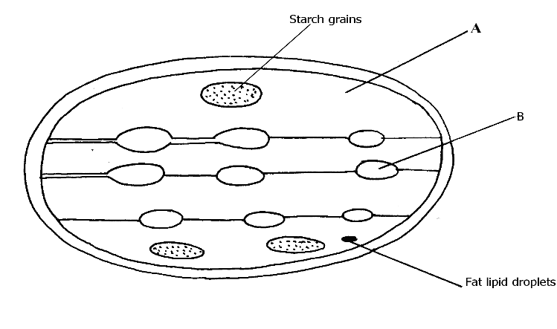
a) Identify the structures labeled A and B (2 mark)
    - A……………………………………………………………………………..
    - B…………………………………………………………………………….
- What process takes place in the parts labeled A and B (2 mark)
………………………………………………………………………………………………………
…………………………………………………………………………………………
- Define the term active transport (1 mark)
……………………………………………………………………………………………………………………………………………………………………………………………………
…………………………………………………………………………………………………
b)Name two environmental factors that influence the rate of active transport. (2 mark)
…………………………………………………………………………………………………………………………………………………………………………………………………………………………
- What is a cell (1mk)
……………………………………………………………………………………………………..
……………………………………………………………………………………………………..
- Define the meaning of the following terms
Entomology (1mk)
……………………………………………………………………………………………………..
……………………………………………………………………………………………………..
Genetics (1mks)
……………………………………………………………………………………………………..
- State the organelles that would be abundant in
Palisade cell (2mks)
……………………………………………………………………………………………………..
……………………………………………………………………………………………………..
Skeletal muscle cell
……………………………………………………………………………………………………..
……………………………………………………………………………………………………..
- State the functions of;
- nucleus (1mk)
……………………………………………………………………………………………………..
………………………………………………………………………………………………..
- cell wall (1mk)
……………………………………………………………………………………………………..
……………………………………………………………………………………………………..
- Distinguish between taxon and taxonomy (2mks)
……………………………………………………………………………………………………..
…………………………………………………………………………………………………….

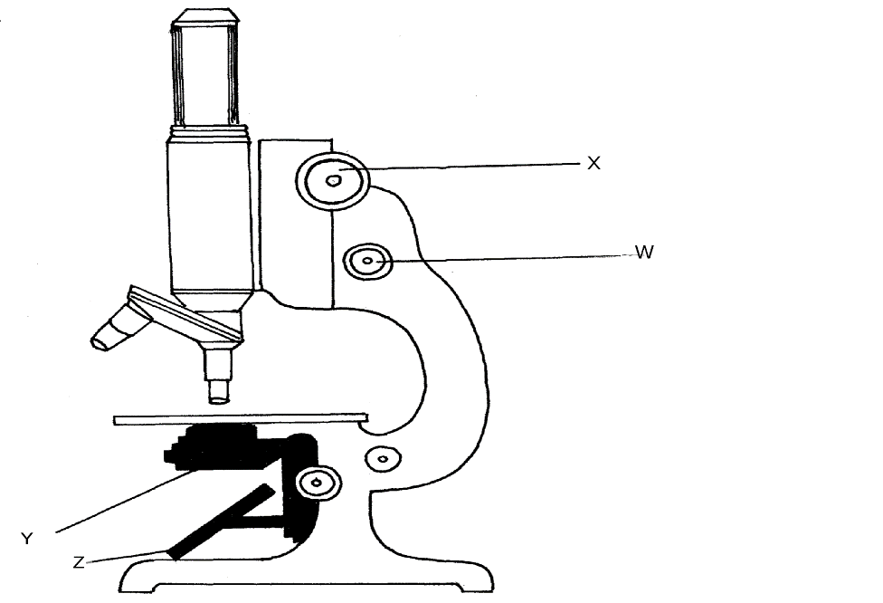
- Label the parts labeled X and Y. (2mks)
X ………………………………………………………..
Y……………………………………………………….
Using arrows show how the object is illuminated. (2mks)
- State the functions of the following organelles. (2mks)
- mitochondria (1mk)
.....................................................................................................................................................................................................................................................................................................................
- Cytoplasm ………………………………………………………………………………………………………………………………………………………………………………………………..……
- Explain the role of oxygen in Active transport (1mk)
........................................................................................................................................................
........................................................................................................................................................
- Name two processes that depend on Active transport in animals (2mks)
........................................................................................................................................................
........................................................................................................................................................
- A mango tree is known as mangifera Indica. Identify two mistakes made in the writing of the name (2mks)
........................................................................................................................................................
........................................................................................................................................................
........................................................................................................................................................
- State two ways in which chloroplasts are adapted for photosynthesis. (2mks)
....................................................................................................................................................................................................................................................................................................................................................................................................................................................................................
- State the role of the following chemicals in a test for non-reducing sugar.
- Hydrochloric acid (1mk)
......................................................................................................................................................
………………………………………………………………………………………………....
- Sodium hydrogen carbonate (1mk)
.......................................................................................................................................................
………………………………………………………………………………………………...
- Name two chemical compounds that are protein in nature that regulate metabolicactivities in the body. (2mks)
..............................................................................................................................................................................................................................................................................................................
- Distinguish between plasmolysis and Haemolysis. (2mks)
.......................................................................................................................................................
............................................................................................................................................................................................................................................................................................................................................................................................................................................................................................
- Explain the role of water in photosynthesis (2mk)
.......................................................................................................................................................
.......................................................................................................................................................
- Name the part of a chloroplast where the following proceses occur. (2mks)
  - Photolysis
………………………………………………………………………………………………
b) Carbon (iv) oxide fixation.
…………………………………………………………………………………………………
b) State how the part named in a (i) is suited to its function. (lmk)
………………………………………………………………………………………………………………………………………………………………………………………………………………………
- (a) State the function of co-factors in cell metabolism. (Imk)
………………………………………………………………………………………………………………………………………………………………………………………………………………………..
- Give one example of a metallic co-factor. (lmk)
……………………………………………………………………………………………………………………………………………………………………………………………………
- State three differences between light microscope and electron microscope. (3mks)
Light microscope | Electron microscope
- State two advantages of using low power magnification over high power magnification whenviewing specimen under a light microscope. (2mks)
……………………………………………………………………………………………………………………………………………………………………………………………………………………………………………………………………………………………………………………………………..
- Name the field of science that specializes in the study of chemical changes in an organism. (1mrk)
……………………………………………………………………………………………………… 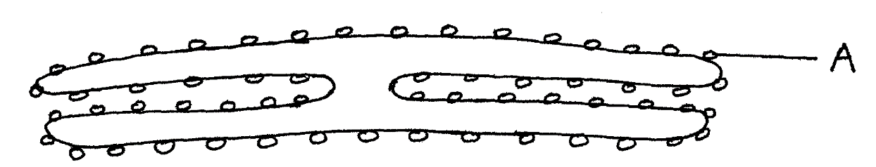
- (a) Name the organelle drawn above (1mk)
…………………………………………………………………………………………………
(b) State function of the structure labeled A (1mk)
………………………………………………………………………………………………………………………………………………………………………………………………………………………
- The diagram below represent a set up that was used to investigate a certain process in a plant.
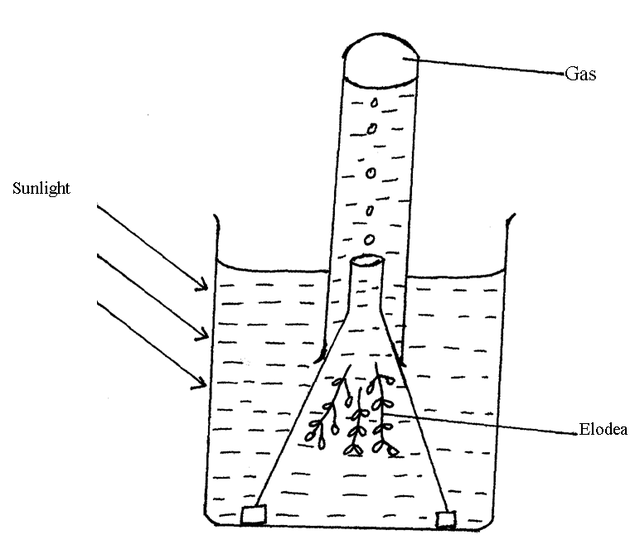
(a) State the process that was being investigated (1mk)
…………………………………………………………………………………………………
…………………………………………………………………………………………………
(b) Name the gas collected in the gas jar (1mk)
…………………………………………………………………………………………………
(c) State the factor that would affect the process (1mk)
…………………………………………………………………………………………………
…………………………………………………………………………………………………
28. State two functions of a chloroplast. (2mks)
…………………………………………………………………………………………………
…………………………………………………………………………………………………
29. State three differences between osmosis and active transport. (3mks)
…………………………………………………………………………………………………………………………………………………………………………………………………………………………………………………………………………………………………………………………………………………………………………………………………………………………………………………………………………………………………………………………………………………………………………………………………………………………………………………………………………………………………………………………………………………………………………………

