ELERAI MCK GIRLS SECONDARY SCHOOL

BIOLOGY FORM 1

END OF TERM II EXAM 2014

Answer all the questions

- Name two structure present in plant cell but absent in animal cell (2mks)

- Study the equation below
A
Glucose + galactose lactose + water
B

Name the process (2mks)

A…………………………………..

B…………………………………

- State the function of the cristae in mitochondria (1mk)

- Define the following terms as used in biology (3mks
- Ecology

- Taxonomy

- Binomial nomenclature

- State two environment problems that are solved by studying biology as a subject (2mks)

- State three characteristics of living organisms (3mks)

- a) Distinguish between diffusion and active transport (2mks)

b) State two roles of diffusion in the body of a human being (2mks)

c) State three factors that affect the rate of diffusion (3mks)

- During a practical lesson students observed an onion epidermis under light microscope. They counted 20 cells across the diameter of the field of view. if the diameter of the field of view measured 3mm.
Calculate the size of each cell in micrometers. Show your working (3mks)

- Describe the changes that will occur in an animal cell when placed in hypertonic solution (3mks)

- State three precautions to be put into consideration when collecting specimen (3mks)

- Study the equation below

6Co₂ + 6H₂ O C₆H₂O₆ + 6O₂

- Name the process shown above (1mk)

- State the conditions necessary for the process to take place (2mks)

- Name two environment factors that increase the rate of the process above (3mks)

- A given food substance name K is suspected to have starch.
- What chemical would you use to confirm the presence of starch (1mk)

- Describe the procedure you would use (2mks)

- If starch was present, what observation would be made (1mk)

- State the three types of carbohydrates and give two examples in each case (6mks)

- study the flow chart below and fill the gaps shown (3mks)

Organelle R tissue S T organism

R……………………….
S…………………………….
T………………………………..
- Form one students set an experiment shown below to investigate a certain physiological process. The set up was left for 30mins
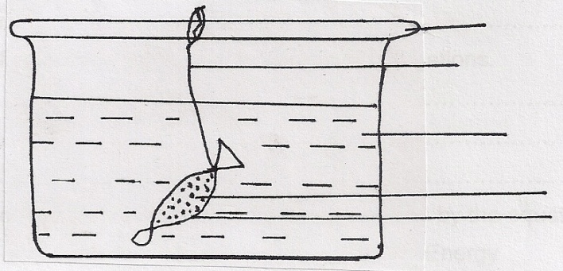

Glass rod
Thread

Distilled water

Sucrose solution
Visking Tubing

- Name the process under study (1mk)

- State the expected results (1mk)

- Explain your answer in (b) above (3mks)

- What does the same function as visking tubing in animal body (1mk

- State any two properties of the cell organelle mention in (d) above (2mks)

- State the function of each of the following parts of a micro-scope (3mks)
- Arm

- Diaphragm

- Eye piece

- a) Differentiate between multicellular and unicellular organism (2mks)

b)Give an example of
i) Unicellular organism (1mk)

ii) Multicellular organism

- Give three reasons why scientific names are used in classification instead of common names (3mks)

b) Give two differences between the kingdom plantae and animalia (2mks)

- explain why the absorption of mineral salt from the soil by roots require energy (2mks)
- Explain why a goat and a sheep cannot interbreed and give rise to a fertile offspring (2mks)

- Give a reason why during investigating the presence of starch in a leaf, the following is done.
- boiling the leaf in methylated spirit (1mk)

- dipping the leaf in boiling water (1mk)

- Give two differences between an electron microscope and light microscope (2mk)

- State the use of each of the following apparatus when collecting specimen
- bait trap (1mk)

- pitfall trap (1mk)

