ELERAI MCK GIRLS SECONDARY SCHOOL

AGRICULTURE FORM 1

Answer all the questions

Section A (50mks)

- Define the following terms as used in agriculture (5mks)
- Soil structure

- Pomology

- Aquaculture

- Soil texture

- Agro-forestry

- State four factors that favour shifting cultivation (4mks)

- List four biotic factor that are useful in agriculture production (4mks)

- Give three reasons why agriculture is referred to be a science (3mks)

- State the three forms of water found in the soil (3mks)

- State two disadvantage of using in bush clearing (2mks)

- State the use of each of the following tools as used in the form (5mks)

- Give five aspects of rainfall that affect crop production in Kenya (5mks)

- State four physical agents of weathering (4mks)

- State four ways of modifying soil PH (4mks)

- Give three tertiary operations carried out during crop production (3mks)

- . The diagram below illustrate a feature observed after digging the soil several meters
deep study the diagram carefully and answer the questions that follows.

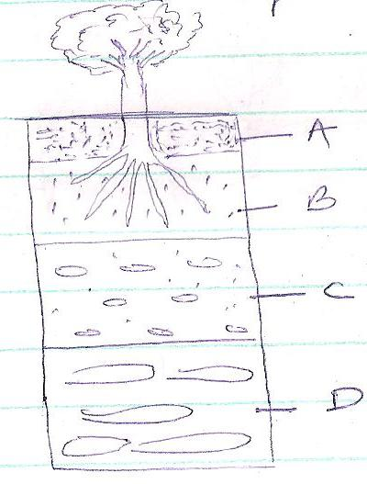
(a). Identify the features that the diagram above represent in the study of the soil. (1mks)

(b) Name the parts of the diagram labeled A, B, C, and D. (4mks)

A ………………………………………………………………….

B ………………………………………………………………….

C …………………………………………………………………..

D ………………………………………………………………….

- State the three sources of water in the farm (3mks)

Section B (50mks)

- State four use of water in the farm (4mks)

b) Give four reasons why water should be treated in the farm (4mks)

c) Describe the process of chemical water treatment (12mks)

- Explain why a farmer should carefully maintain farm tools and equipment (10mks)

- Give five farming practices carried out in minimum tillage (5mks)

b) Give five reasons why land preparation is carried out in farm (5mks)

c) Explain the reasons why minimum tillage is carried out in crop production (10mks)

