ELERAI MCK GIRLS SECONDARY SCHOOL

PHYSIC FORM 3

END TERM EXAM 2014

Answer all the questions

- (a) The diagram below shows a burette being used to determine the volume of a spherical lead shot. If the volume of a lead shot is 1.5 cm³ indicate on the diagram the new reading on the burette when 4 lead shots are dropped into the burette. (1mk)
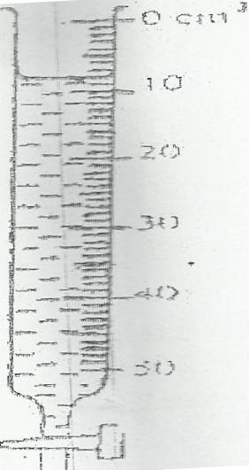

(b) State the advantage of using the density bottle in determining the density of a liquid. (1mk)

2.The set up below was used by a student to investigate Brownian motion in air.

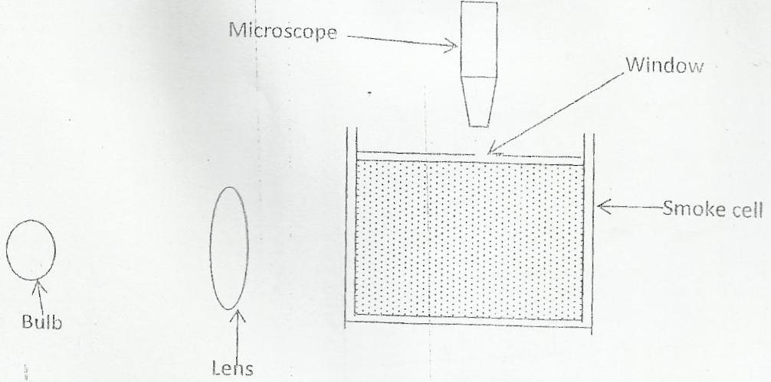

(i) State the purpose of the lens (1mk)

(ii) State and explain the observation make by the student. (2mks)

(c) State the danger of floating masses of ice in seas and oceans (1mk

3.The volume of a given mass of water varies as shown in the diagram below.
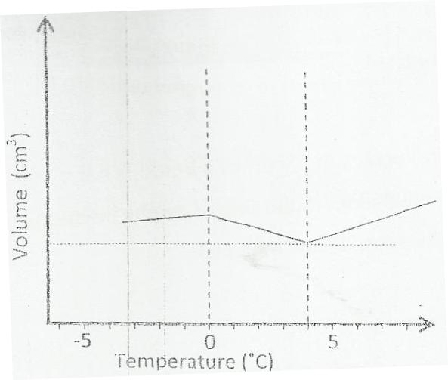

(a) What is the name given to this phenomenon? (1mk)

(b) Using the diagram above, explain why ice floats in water (1mk)

4.Figure, show bar magnets draw the pattern of the magnetic field around the bar magnets.
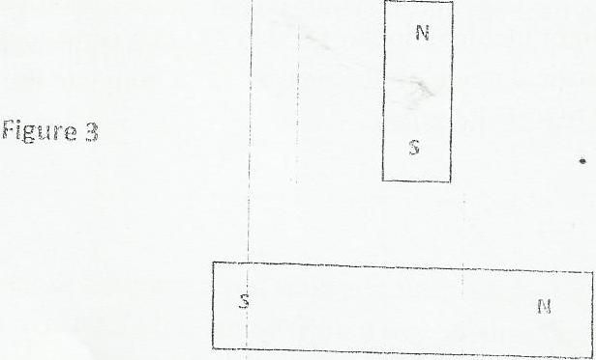

5.Figure 2 shows a ray of light incident on the surface AC of a right –angled glass prism ABC at right angle. The critical angle of the glass is 42⁰. Complete the diagram to show the path of the ray until it leaves the prism. (3mks)

6. A soldier standing between two cliffs fires a gun. He hears the first echo after 2 seconds and the next after 5 seconds. Determine the distance between two cliffs. (Take velocity of sound in Air=340m/s) (4mks)

7. State two advantages and one disadvantage of a convex mirror when used as a driving mirror. (2marks)

8. Figure 1 below shows a U-tube containing oil of light density in equilibrium.

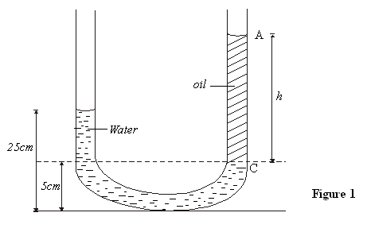
Determine the height h of the oil column AC (density of oil is 600kg/m3) (3marks)

9. (a) (i) what is capacitance of a capacitor. 1 mark)

(ii) State two factors that affects the capacitance of a parallel plate capacitor(2 marks)

(iii)Figure shows 4 capacitors connected as shown in the setup.

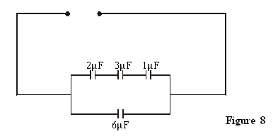

Calculate the effective capacitance of the setup shown in the diagram above. (3 mark

(b) A 10µF capacitor is charged to a potential of 240V and then disconnected. The charged capacitor is then connected to a 20µF capacitor. Calculate;
(i) The resultant potential difference. (3 marks)

(ii)The energy stored by the10µF capacitor before connection to the 20µF capacitor. (2 mrk)

(iii)State one application of capacitors. (1 mark)

15. a) State two factors that affect the efficiency of a pulley system. (2 marks)

b) Sketch a labeled diagram to show how arrangement of a single pulley may be used to provide a velocity ratio of 2. (2 marks)
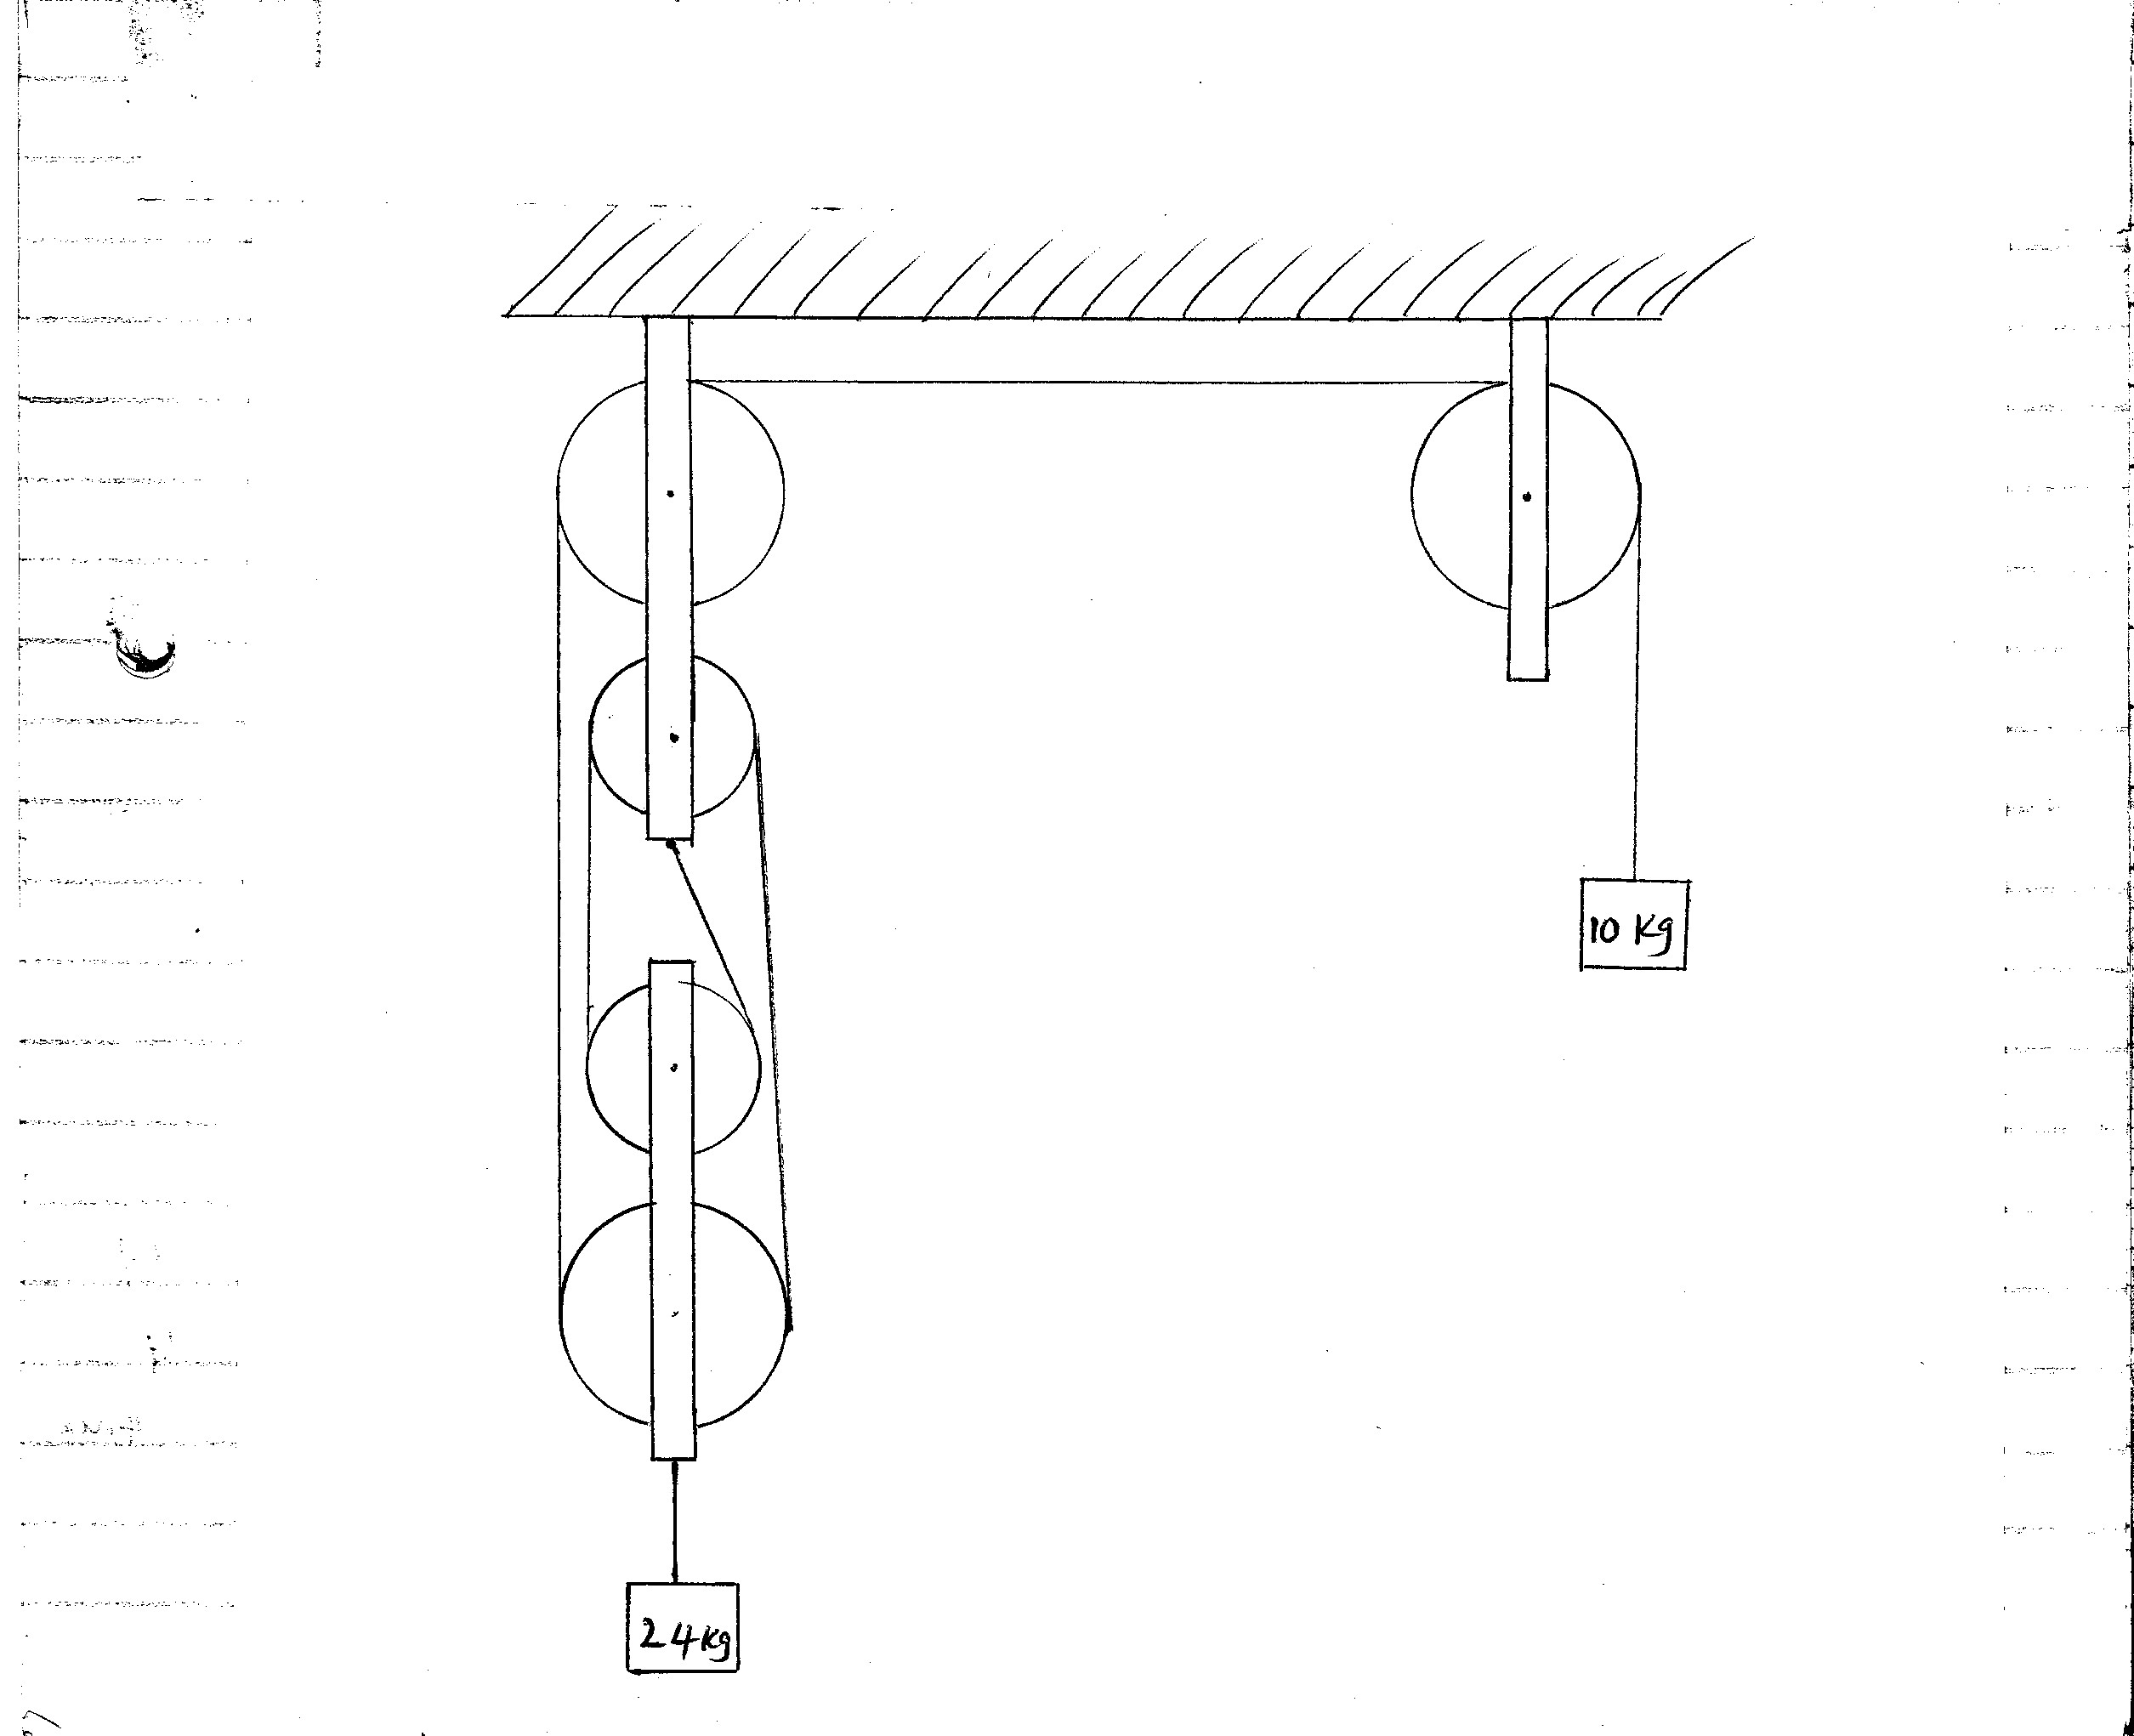

c) The figure above shows a pulley system with the load rising at uniform speed
From the information given calculate;
i) Velocity ratio of the machine (1 mark)

ii) Mechanical advantage of the machine. (2 marks)

iii) Efficiency of the machine. (2 marks)

d) The handle of the screw- jack in the figure below is 42cm long and the pitch of the screw is 0.5cm.
What force must be applied at the end of the handle when lifting a load of 1188N if the efficiency of the jack is 50%? (4 marks)

16. Define the term critical angle as used in refraction. (1 mk)

17. A bulb is rated (1000w, 240v) determine its resistances. (3 mks)

18. A curved mirror is used to monitor customers in a supermarket. The mirror has a radius of curvature of 10cm. With the aid of a ray diagram, locate and describe the image of a customer 10cm from the mirror. (3 mks)

19 Explain briefly how the defect of polarization is minimized in a dry cell. (2 mks)

20. The internal resistance of the cell in the figure below is 0.5 . Determine the ammeter reading when switch is closed. (3 mks)

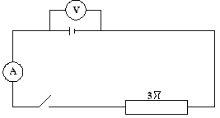

21. Sounds are much clearer at night than during daytime. Explain this phenomenon.(3 mks)

22. The figure below represents a part of a tape pulled through a ticker-timer by trolley moving down an initial place. If the frequency of the ticker-timer is 50Hz, calculate the acceleration of the trolley. (3marks)

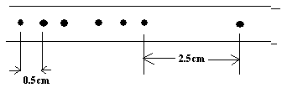

23. Explain your observation when air is blown in the diagram below. (2 marks)
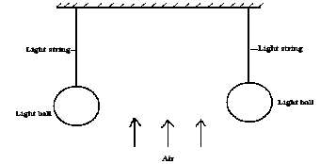

24. a) Define principal focus as used in curved surfaces. (1 mk)

b) An object OB is placed in front of a convex mirror as shown below drawn to scale.

i) Draw a ray diagram to show the position of the image formed. (3 mks)

ii) Determine the magnification produced by the mirror. (2 mks)

25. a) A ray of light makes a glacing angle of incidence i = 600 with the flat glass surface as shown below.
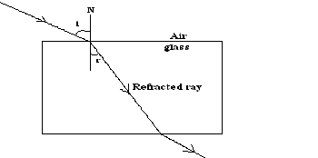

Given that the critical angle for glass is 420. Determine:
i) The refractive index of glass. (2 mks)

ii) The angle of refraction r. (2 mks)

iii) Given that the speed of light in air is 3.0 x 108m/s, find the speed of light in glass. (2 mks)

b) State the conditions necessary for total internal reflection to occur. (2 mks)

c) A microscope is focused on a mark on a horizontal surface. A rectangular glass block 3.0mm thick is placed on the mark. The microscope is then adjusted 10mm upwards to bring the mark to focus. Determine the refractive index of the glass. (3 mks)

- An Eskimo walking along an iceland observed an inverted image in the sky of a polar bear standing some distance away. Explain (2 mks)

