ELERAI MCK GIRLS SECONDARY SCHOOL
BIOLOGY PAPER
END OF TERM TWO 2014
FORM 2

SECTION A (40 MARKS)
Answer all the Questions by filling in the spaces provided.

1 a) Define the following
(i) Photosynthesis (1mk)

(ii) Chemosynthesis. (1mk)

b) Study the diagram below and answer the questions that follow.
Leaf B
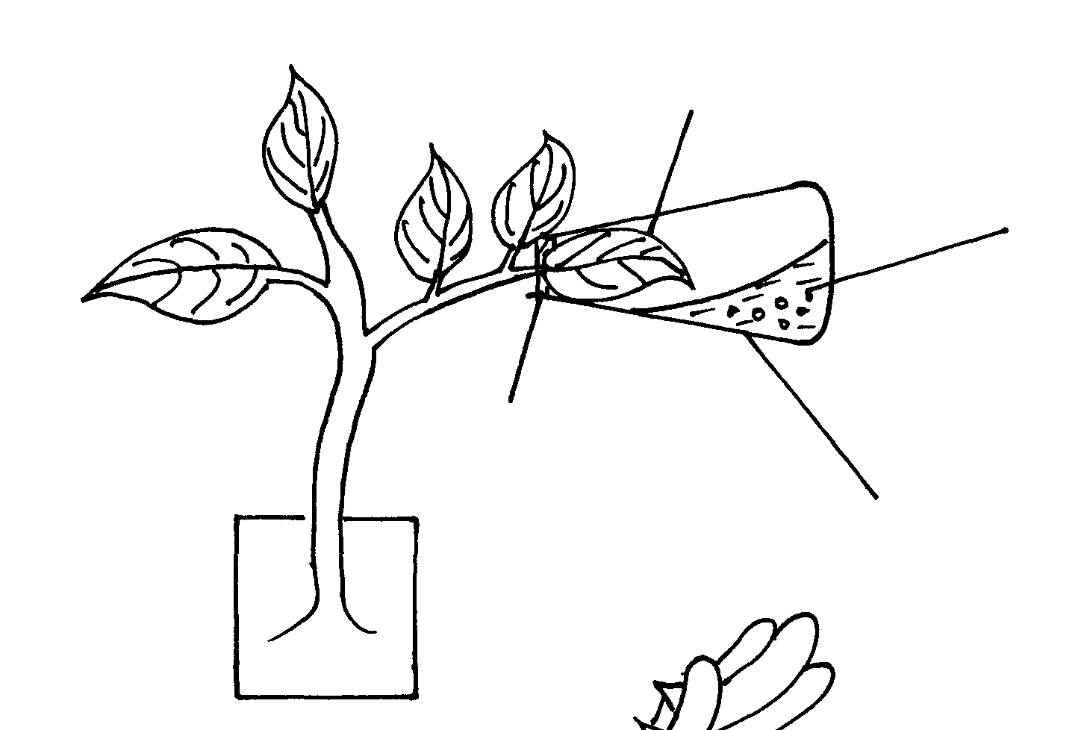

Leaf A
Sodium hydroxide pellets

Cork
Flask

Giving reasons state the expected results when leaf A and Leaf B are tested for starch.

Leaf A ……………………………………………… (1mk)

Reason (1mk)

Leaf B…………………………………………………. (1mk)

Reason (1mk)

2. The diagram below show a respiratory structure of a bony fish
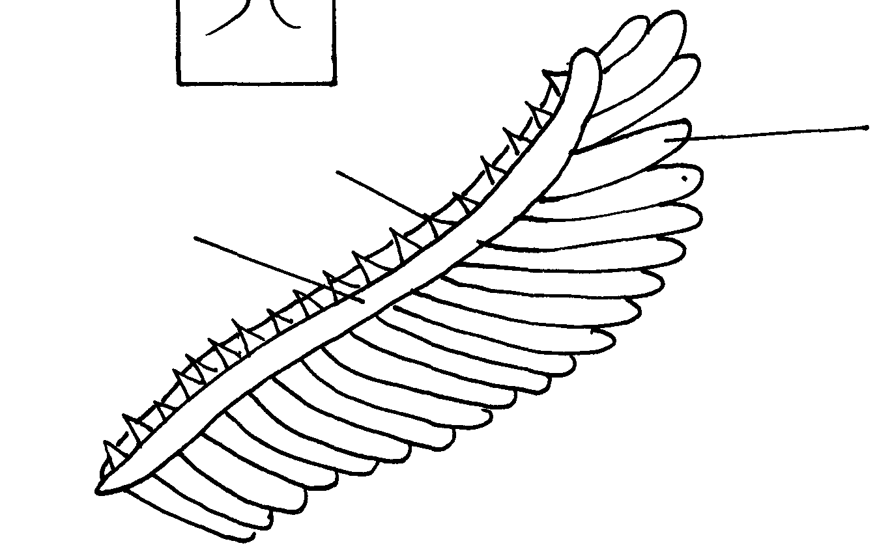

A
B
C

a) Name the parts labeled A,B and C (3mks)
A …………………………………………
B …………………………………………
C ………………………………………
b) How is the part labeled A adapted to its function. (2mks)

3. a) Distinguish between a vein and artery blood vessel (4mks)

Vein | Artery

b) Distinguish between closed and open circulatory system (2mks)

c) A girl has blood group A name the antigens and antibodies in her blood

Antigens…………………………………………………………. (1mks)

Antibodies………………………………………………………… (1mks)

d) Explain why blood clot does not occur in the blood vessels (2mks)

4.The diagram below represents part of a gaseous system in a grasshopper.
P Q
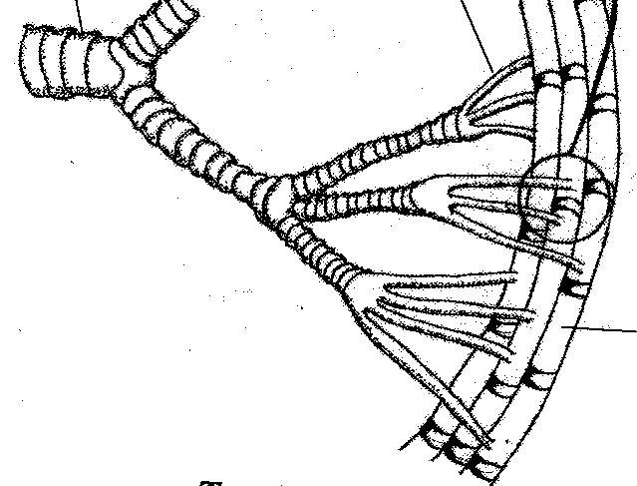
a) Name the structures labeled P and Q (1mk)

b) State the function of the structure labeled P (1mk)

c) Describe the path taken by carbon (IV) oxide from the tissues of the insect the atmosphere (3mks)

d) How is the structure labeled Q adapted to its functions (2mks)

5. a) name a process that occur in the glomerulus and loop of henle (2mks)
Glomerulus…………………………………………………..

Loop of henle…………………………………………………

b) Explain why human being produces more urine during cold weather than warm weather. (3mks)

6.The oxidation of a certain food substance is represented by the chemical equation shown below.
2C₅₁H₉₈O₆ + 145O₂ 102CO₂ + 9H₂O + 38.4KJ.
- What is meant by the term respiratory quotient (1mk)

- Calculate the respiratory quotient of the above equation (2mks)

- Name the class of food being oxidized (1mk)

d) in what form of energy stored in muscles (1mk)

e)State the economic importance of anaerobic respiration in plants (2mks)

SECTION B (40MARKS)
Answer all the question in the spaces provided.
7.a)explain how the mammalian heart is adapted to perform its functions (10mks)

b)describe the process of inspiration and expiration in mammals (10mks)

8 a) How is the mammalian skin modified to enable it perform its functions? (l0mks)

- Discuss the adaption of the small intestine to their functions (10mks)

