Name……………………………………………………………. Index No……………………………..
School…………………………………………………………… Candidate’s sign…………………….
Date………………………………….

231/2
BIOLOGY
PAPER 2
(THEORY)
TIME: 2 hrs

ELERAI MCK GIRLS SECONDRY SCHOOL

INSTRUCTION TO CANDIDATES

1. This paper has two sections; A and B.
2. Answer all the questions in section A in the spaces provided on the question paper.
3. From section B, answer questions 6 (Compulsory) any other question in the spaces provided after question 8.

For Examiner’s Use Only.
SECTION | QUESTION | MAXIMUM SCORE | CANDIDATE’S SCORE
A | 1 | 8
 | 2 | 8
 | 3 | 8
 | 4 | 8
 | 5 | 8
B | 6 | 20
 | 7 | 20
 | 8 | 20
TOTAL |  | 100

This paper consists of 12 printed pages. Candidates should check the question paper to
Ensure that all the pages are printed as indicated and no questions are missing.

1. The diagram below represents recycling of nutrients in a certain ecosystem.
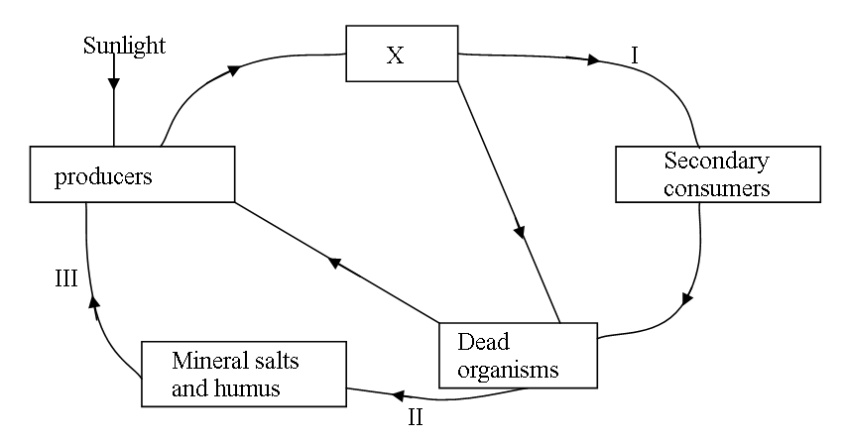
a) Name the trophic level represented by X (1mk)
………………………………………………………………………………………………………………………………………………………………………………………………………………
b) Name the processes represented by: (3mks)
I ……………………………………………………………
II ……………………………………………………………
III ……………………………………………………………
c) Name the organisms involved in process II (1mk)
………………………………………………………………………………………………………………………………………………………………………………………………………………
d) What would happen within the ecosystem if all the secondary consumers were eliminated? (3mks)
………………………………………………………………………………………………………………………………………………………………………………………………………………
………………………………………………………………………………………………………………………………………………………………………………………………………………
………………………………………………………………………………………………………………………………………………………………………………………………………………

2. In an experiment to investigate an aspect of digestion, two test tubes P and Q were set up as show in the diagram below.
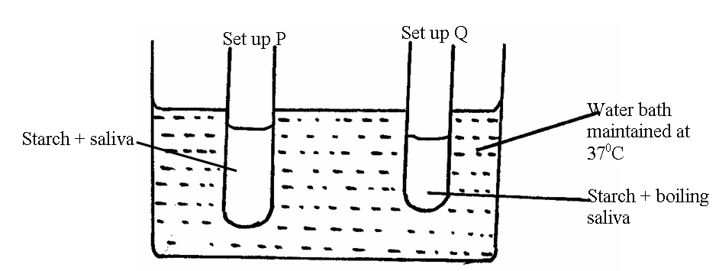
The test tubes were left in the bath for 30 minutes. The content of each test tube was then tested for starch using iodine solution.
a) What was the aim of experiment? (1mk)
………………………………………………………………………………………………………………………………………………………………………………………………………………
b) What results were expected in test tube P and Q (2mks)
P
………………………………………………………………………………………………………………………………………………………………………………………………………………
Q
………………………………………………………………………………………………………………………………………………………………………………………………………………
c) Account for the results you have given in b above in test tube P and Q (2mks)
………………………………………………………………………………………………………………………………………………………………………………………………………………
………………………………………………………………………………………………………………………………………………………………………………………………………………
d) Why was the set up left at 37⁰C (1mk)
………………………………………………………………………………………………………………………………………………………………………………………………………………
e) Name the carbohydrate stored in (2mk)
(i) Mammalian liver
………………………………………………………………………………………………………………………………………………………………………………………………………………

(ii) Potato tuber
………………………………………………………………………………………………………………………………………………………………………………………………………………
3. a) State one difference between closed and open circulatory systems (2mks)
………………………………………………………………………………………………………………………………………………………………………………………………………………
b) Give an example of a phylum where all members have
(i) Open circulatory system: (1mk)
………………………………………………………………………………………………………………………………………………………………………………………………………………
(ii) Closed circulatory system: (1mk)
………………………………………………………………………………………………………………………………………………………………………………………………………………
c) Explain how the following adaptation will reduce the rate of transpiration.
(i) Sunken Stomata: (2mks)
………………………………………………………………………………………………………………………………………………………………………………………………………………
……………………………………………………………………………………………………………………………………………………………………………………………………………
(ii) Leaf folding: (2mks)
………………………………………………………………………………………………………………………………………………………………………………………………………………
………………………………………………………………………………………………………………………………………………………………………………………………………………

- The diagram below represents a process in a given special of organisms;

- (i) Name the organism. 1 mark
………………………………………………………………………………………………………………

(ii) Identify the process that is shown to be taking place. 1 mark
………………………………………………………………………………………………………………
(iii) State the economic importance of organisms found in the kingdom which the organisms shown
above belong. 2 marks
………………………………………………………………………………………………………………
………………………………………………………………………………………………………………
………………………………………………………………………………………………………………
………………………………………………………………………………………………………………
- (i) Define the term species. 2 marks
………………………………………………………………………………………………………………
………………………………………………………………………………………………………………
………………………………………………………………………………………………………………
5.(a) Apart from avoiding overcrowding give two other benefits of seed dispersal. 1 mark
………………………………………………………………………………………………………………
………………………………………………………………………………………………………………
(b) State one way through which overcrowding disadvantages plants process of photosynthesis. 1 marks
………………………………………………………………………………………………………………
………………………………………………………………………………………………………………
(c) List two mineral elements necessary for chlorophyll formation. 2 marks
……………………………………………………………………………………………………………

(ii) State two principals of binomial nomenclature. 2 marks

5.The equation below shows a chemical reaction that takes place in green plants under certain conditions.
Carbon (IV) oxide + Water Glucose + X
- What is the name of substance X ? 1 mark
………………………………………………………………………………………………………………

- Other than the reagents, state two conditions necessary for this reaction 2 marks
………………………………………………………………………………………………………………
………………………………………………………………………………………………………………
- Name the process represented by the equation given above 1 mark
………………………………………………………………………………………………………………

SECTION B (40 Marks)
Answer question 6 (compulsory) and either 7 or 8 in the spaces provided after question 8
6. A hungry person had a meal, after which the concentrations of glucose and amino acids in the blood were determined. This was measured hourly as the blood passed through the hepatic portal vein and iliac vein in the leg. The results were as shown below.

TIME ( Hours) | Concentration of contents in hepatic portal vein ( mg/ 100ml) |  | Concentration of contents in iliac vein of leg ( mg / 100 ml)
0  1  2  3  4  5  6  7 | Glucose | Amino Acid | Glucose | Amino Acids
 | 85 | 1.0 | 85 | 1.0
 | 85 | 1.0 | 85 | 1.0
 | 140 | 1.0 | 125 | 1.0
 | 130 | 1.5 | 110 | 1.5
 | 110 | 3.0 | 90 | 3.0
 | 90 | 2.0 | 90 | 2.0
 | 90 | 1.0 | 90 | 1.0
 | 90 | 1.0 | 90 | 1.0

a) Using the same axes draw graphs of the concentration of glucose in the hepatic portal vein and
the iliac vein in the leg against time (7mks)
b) Account for the concentration of glucose in the hepatic portal vein from
(i) 0 – 1 hour (2mks)
………………………………………………………………………………………………………………………………………………………………………………………………………………
………………………………………………………………………………………………………………………………………………………………………………………………………………
(ii) 1 – 2 hours (3mks)
………………………………………………………………………………………………………………………………………………………………………………………………………………
………………………………………………………………………………………………………

(iii) 2 – 4 hours (3mks)
………………………………………………………………………………………………………………………………………………………………………………………………………………
………………………………………………………………………………………………………………………………………………………………………………………………………………

(iv) 5 – 7 hours (2mks)
………………………………………………………………………………………………………………………………………………………………………………………………………………
………………………………………………………………………………………………………………………………………………………………………………………………………………
c) Account for the difference in the concentration of glucose in hepatic portal vein and iliac vein
between 2 and 4 hours. (2mks)
………………………………………………………………………………………………………………………………………………………………………………………………………………
………………………………………………………………………………………………………………………………………………………………………………………………………………
d) Using the data provided in the table explain why the concentration of amino acids in the
hepatic portal vein took longer to increase. (1mk)

……………………………………………………………………………………………………………………………………………………………………………………………………………
7. Discuss the various factors that affect transpiration. (20mks)
8. Discuss the adaptations of the mammalian skin to its functions. (20mks)
END

