SUNSHINE SECONDARY SCHOOL

FORM 1
CHEMISTRY
END TERM EXAM –MAY/JUNE 2014
TIME: 2 HOURS

NAME:………………………………………….….CLASS:………..ADM NO:……….

INSTRUCTION:
- Answer all questions in the spaces provided.
- Writ your name, class and Adm no. in the space above.

STUDENTS’ MARKS

80

- The diagram below shows a set up of apparatus used in separation of a mixture of ethanol and water.

- Name the method of separation shown above. (1 mk)
……………………………………………………………………………………………….
- Why is it possible to separate water and ethanol using the above mentioned method? (1mk)
………………………………………………………………………………………………
……………………………………………………………………………………………….
- State the name and function of the part labeled x. (2 mks)

Name…………………………………………………………………………………….
Function:…..…………………………………………………………………………….
………………………………………………………………………………………….
………………………………………………………………………………………….
- On the diagram above indicate the water inlet and water outlet. (2 mks)

- During separation which liquid will be collected first? Explain. (2 mks)

……………………………………………………………………………………………….
……………………………………………………………………………………………….
……………………………………………………………………………………………….
- Give 2 industrial applications of the above method of separation. (2 mks)

……………………………………………………………………………………………….
……………………………………………………………………………………………….
- Identify one mistake in the above set up. (1 mk)

……………………………………………………………………………………………….
……………………………………………………………………………………………….
- Explain why solids have a definite shape. (2 mks)

……………………………………………………………………………………………….
……………………………………………………………………………………………….
……………………………………………………………………………………………….
……………………………………………………………………………………………….
- (a) Using diagrams, state 4 types of flasks commonly used as apparatus. (4 mks)

(b) Name 3 apparatus for measuring approximate volumes of liquids in the laboratory. (3 mks)

……………………………………………………………………………………………….
……………………………………………………………………………………………….
……………………………………………………………………………………………….
- (a) State the use of the following apparatus in the lab. (3 mks)
- deflating spoon
……………………………………………………………………………………………….
……………………………………………………………………………………………….
- crucible
……………………………………………………………………………………………….
……………………………………………………………………………………………….
- a pair of tongs
……………………………………………………………………………………………….
……………………………………………………………………………………………….
(b) Give 3 reasons why most laboratory apparatus are made of glass. (3 mks)

……………………………………………………………………………………………….
……………………………………………………………………………………………….
……………………………………………………………………………………………….
- The diagram below represents a non-luminous flame produced by a Bunsen burner.

- Name the parts labeled A, B and C. (3 mks)

A………………………………………………………………………………….
B…………………………………………………………………………………
C………………………………………………………………………………….
- Explain why the above flame is preferred for heating in the laboratory. (1 mk)

……………………………………………………………………………………………….
……………………………………………………………………………………………….
- A Bunsen burner also produces a luminous flame. Explain under what conditions does the burner produce luminous flame. (1 mk)

……………………………………………………………………………………………….
……………………………………………………………………………………………….
- Explain why luminous flame is basically bright yellow in colour. (1 mk)

……………………………………………………………………………………………….
……………………………………………………………………………………………….
- Luminous flame makes the apparatus dirty with soot when used for heating. Explain. (2 mks)

……………………………………………………………………………………………….
……………………………………………………………………………………………….
……………………………………………………………………………………………….
……………………………………………………………………………………………….
- What is a flame? (1 mk)

……………………………………………………………………………………………….
……………………………………………………………………………………………….
- (a) Define the following terms: (4 mks)
- Chemistry…………………………………………………………………………
- Drug abuse…………………………………………………………………………
- Mixture…………………………………………………………………………….
- Drug ……………………………………………………………………………….
(b) State 3 drugs commonly abused in Kenya apart from alcohol. (3 mks)

……………………………………………………………………………………………….
……………………………………………………………………………………………….
……………………………………………………………………………………………….
(c) State 4 negative effects of drug abuse. (4 mks)

……………………………………………………………………………………………….
……………………………………………………………………………………………….
……………………………………………………………………………………………….
……………………………………………………………………………………………….
(d) Explain two reasons why we study chemistry as a subject. (2 mks)

……………………………………………………………………………………………….
……………………………………………………………………………………………….
……………………………………………………………………………………………….
……………………………………………………………………………………………….
- The diagram below shows changes of state that matter undergoes.

F
Solids
Liquids
Gases
A C

B D

E

- Give two properties of matter. (2 mks)

……………………………………………………………………………………………….
……………………………………………………………………………………………….
……………………………………………………………………………………………….

- Which of the above processes A, B, C D and E involves cooling? (1 mk)

……………………………………………………………………………………………….
- Give 3 examples of substances that undergo process E. (3 mks)

……………………………………………………………………………………………….
……………………………………………………………………………………………….
……………………………………………………………………………………………….
- Name the physical processes. (4 mks)

A………………………………………………………………………………………….
B………………………………………………………………………………………….
C………………………………………………………………………………………….
D………………………………………………………………………………………….

- Four athletes A, B , C and D were suspected of using NSAID and EPO drugs as blood boosters to enhance their performance. Their blood samples were taken and analysed using chromatography. The results obtained were recorded in the chromatogram below.

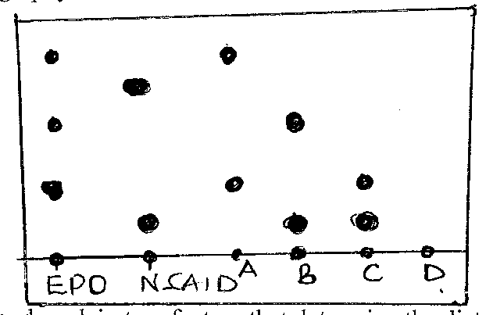

- State and explain two factors that determine the distance travelled by a sample along the filter paper. (4 mks)

……………………………………………………………………………………………….
……………………………………………………………………………………………….
……………………………………………………………………………………………….
……………………………………………………………………………………………….
……………………………………………………………………………………………….
……………………………………………………………………………………………….
……………………………………………………………………………………………….
……………………………………………………………………………………………….

- On the diagram above indicate the baseline and the solvent front. (2 mks)

- Which athlete(s) tested positive of the use of EPO drug only? (2 mks)
……………………………………………………………………………………………….
- Which athlete(s) tested positive of use both EPO and NSAID drugs. (2 mks)
……………………………………………………………………………………………….
- Which athlete had his blood sample negative of EPO and NSAID drugs? (1 mk)
……………………………………………………………………………………………….
- Name a suitable solvent used in papers chromatography. (1 mk)
……………………………………………………………………………………………….
- Briefly describe how a mixture iron fillings and sulphurs can be separated in the laboratory. (3 mks)

……………………………………………………………………………………………….
……………………………………………………………………………………………….
……………………………………………………………………………………………….
……………………………………………………………………………………………….
……………………………………………………………………………………………….
……………………………………………………………………………………………….
- (a) Name a suitable method of extracting oils from nuts and seeds. (1 mk)

……………………………………………………………………………………………….
(b) Apart from extraction of oil, state two other applications of the method named in (a)
above. (2 mks)

……………………………………………………………………………………………….
……………………………………………………………………………………………….
- Give the meaning of the following safety symbol. (2 mks)

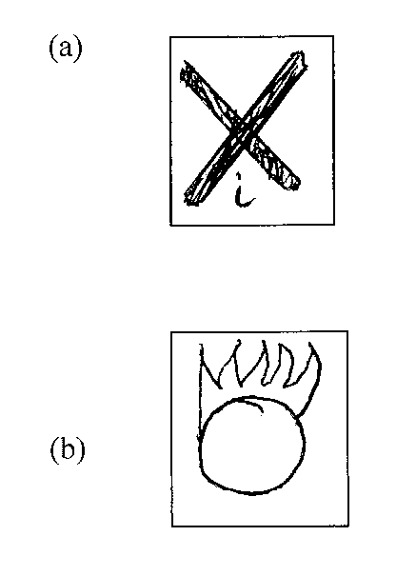
- Explain 2 major causes of most accidents in the lab. (2 mks)

……………………………………………………………………………………………….
……………………………………………………………………………………………….
……………………………………………………………………………………………….
……………………………………………………………………………………………….

