FORM 2
MID TERM EXAM – JUNE 2016
TIME: 2 HOURS

NAME:…………………………………………………..CLASS:………ADM NO:………..

Instructions
Answer ALL questions in the spaces provided.

Examiners use only

90

- Explain how caboxyhaemoglobin leads to death. (3 mks)

- The figure below shows two types of cells, not drawn to scale.

- What is the name of cell A? (1 mk)

- (i) B is a xylem vessels state two function in plants. (2 mks)

(ii) The cells forming the xylem vessel have no chloroplasts or vacuoles. In what other way is this type of cell different from a typical plant cell. (2 mks)

(iii) Explain how this difference helps this type of cell to perform its function. (2 mks)

- (a) Complete the table below showing Blood transfusion, tick () means no agglutination, cross (x)
means agglutination. (4 mks)

DONOR
Recipient |  | Ab | Ba | ABo | Oab
 | Ab |  |  | X
 | Ba | X |  | X
 | ABo
 | Oab | X | X

(b) The type of circulatory system found in member of the class insect is? (1 mk)

- Name the blood vessel that transports blood
- From the small intestines to the liver (1 mk)

- With the highest concentration of carbon (IV) oxide (1 mk)

- State the functions of the following structures in a mammalian tooth. (2 mks)
- Pulp cavity

- Enamel

- (a) State three adaptations of plants which enables them reduce water loss. (3 mks)

(b) Suggest two factors that my lead to increased rate of transpiration. (2 mks)

- The diagram below represents a specialized plant structure
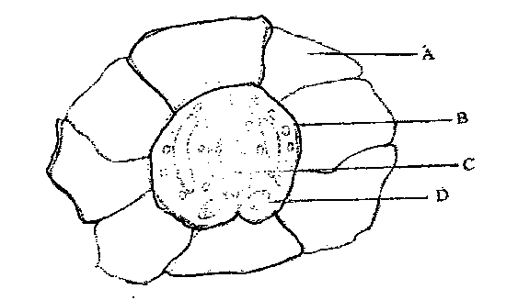

- Name the cells labeled A and B. (2 mks)

A

B

- State the functions of structures C and D. (2 mks)

C

D

- (a) Define the term Denature. (1 mk)

(b) In an experiment to investigate the action of pepsin on egg albumen, equal amount of pepsin were added to equal amounts of egg albumen in different test-tube. The test tubes were placed in water baths at different temperatures. The graph below shows time taken for the enzyme to digest protein in each
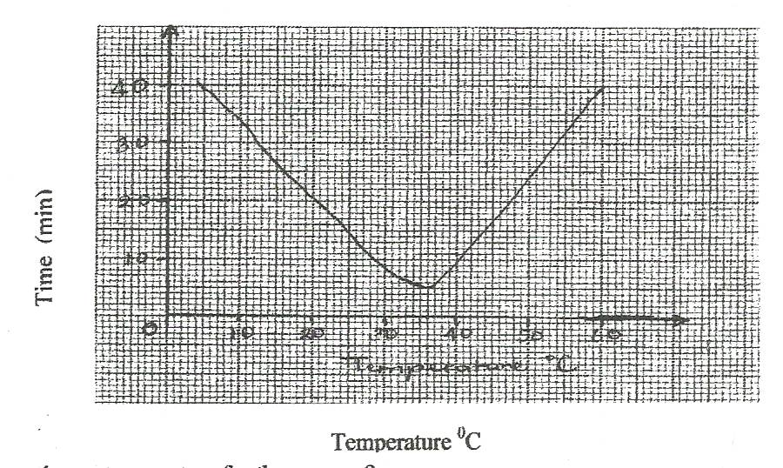
What is the optimum temperature for the enzyme? (1 mk)

- Account for the time taken to digest egg albumen at 45⁰c. (1 mk)

- (i) In which form is the enzyme pepsin secreted. (1 mk)

(ii) Give a reason for your answer in c (i) above. (1 mk)

- Name four plant tissues which lack chloroplast. (2 mks)

- State the function of the pad of gum in herbivorous feeding. (1 mk)

- The following are characteristics of a certain animal dentition; large curved and sharply pointed canines, small closely fitting incisors, narrow molars and premolars with cusps.
- Identify the likely mode of feeding in this animal. (1 mk)

- State three adaptations of the three types of teeth to the mode of feeding identified in (i) above. (3 mks)

- (a) Distinguish between the terms transpiration and Guttation (2 mks)

(b) State the structures through which each of the process named in (a0 above occurs (2 mks)

- (a) State two structural adaptations of capillaries to their functions. (2 mks)

- Below is a diagram of a mammalian heart. The diagram does not represent the central size of the organ.
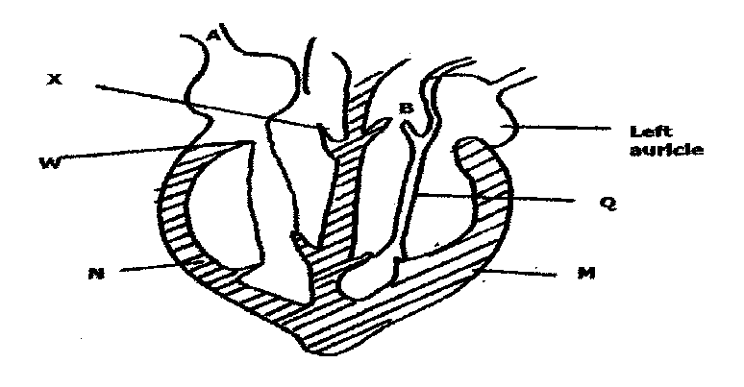

(a) Name the valves X, W and Q and the function of each. (3 mks)

(b) (i) Name the muscle type M. (1 mk)

(ii) What is the significance in the difference between thickness of muscle M and N. (2 mks)

- How does blood in vessel A differ from that in vessel B. (2 mks)

- Why is the muscle named in b(i) above considered special than thee other body muscles.

- The diagram below shows the treatment given to stripes of dandelion stem which were cut lengthwise from the main stem.
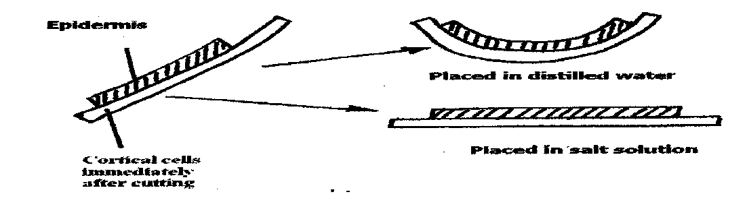
- Account for the result obtained when the stripes were put in;
- Distilled water (2 mks)

- Strong salt solution (2 mks)

- Name the physiological process being investigated. (1 mk)

- Why did the strips curl slightly towards the epidermis after being cut. (1 mk)

- The data below shows the rate of photosynthesis at different temperature in attached leaves of three East African plants. (Crotolaria, Gynandropsis and Amaranthus species) respectively which were grown outside with the same illustration while water and carbon (IV) oxide are not limiting factors in this experiment.

Rate of photosynthesis was expressed interms of carbon (IV) oxide uptake in mg/mm²/hr at various temperatures as tabulated below.

Temperature ⁰C | Rate of photosynthesis (mg/mm²/hr)
 | Gynandropsis sp | Crotolaris sp | Amaranthus sp
5 | - | 20 | -
10 | 22 | 40 | 10
15 | 50 | 49 | 27
20 | 60 | 64 | 42
25 | 80 | 48 | 55
30 | 85 | 45 | 54
35 | 80 | 42 | 50
40 | 73 | 31 | 45
45 | 66 | 15 | 40
50 | 2 | - | 11

- Represent the results graphically (rate of photosynthesis against temperature) (8 mks)

- Using the graph in (a) above indicate optimum temperature for the Gynandropsis and Amaranthus species. (2 mks)

- Give a reason why Gynandropsis and Amaranthus could not function photosynthetically at 5⁰C.
(1 mk)

- At what temperature was the amount of carbon (IV) oxide around the leaf of Gynandropsis highest? (1 mk)

- What raw material is required in the light stage of photosynthesis? (1 mk)

- Name the pars of chloroplasts in which the following stages of photosynthesis take place. (2 mks)

- Light stage

- Dark stage

- Explain how the various components of the mammalian blood are adapted to their functions?
(14 mks)

