FORM 2
CHEMISTRY
MID TERM EXAM – JUNE 2016
TIME: 2 HOURS

NAME:…………………………………………………….….CLASS:……..ADM NO:……….

INSTRUCTIONS TO CANDIDATES
- Write your name and admission number in the spaces provided.
- Answer all the questions in the spaces provided.
- All workings must be clearly shown where necessary.
- Mathematical tables and silent calculators may be used.

For examiners use only

80
- Use the grid below to answer the questions that follow. The letters do not represent the actual symbol of elements.
 |  |  |  |  | M |  | O
F | J |  | K | L |  | N | P | Q
G
H

a) Give the family name of the group in which elements G and H are member (1mk)
________________________________________________________________________
b) State and explain the difference in atomic radius between: (4mks)
i) F and J
________________________________________________________________________________________________________________________________________________________________________________________________________________________
ii) O and P
________________________________________________________________________________________________________________________________________________
c) Between F and G which is more reactive ? Explain. (2mks)
________________________________________________________________________________________________________________________________________________________________________________________________________________________________________________________________________________________________
________________________________________________________________________

d) Element R forms an oxide of formula RO₂ and belongs to period two. Indicate the grid the position of R. (1 mk)

e) Explain the trend in the melting points in the group of elements to which F belong to? (2mks)
________________________________________________________________________________________________________________________________________________________________________________________________________________________
f) Give the formula of the compound formed between K and P? ( 1 mk)

g) Name the type of bond formed when F reacts with O. Explain. (2mks)
________________________________________________________________________________________________________________________________________________________________________________________________________________________
h) Give one use of element P? (1mk)
________________________________________________________________________
i)Give the electron arrangement of ion of;
N- (1mk)

M (1mk)

2. The following set up shows the heating of a mixture of equal amounts of Sodium chloride and ammonium chloride.
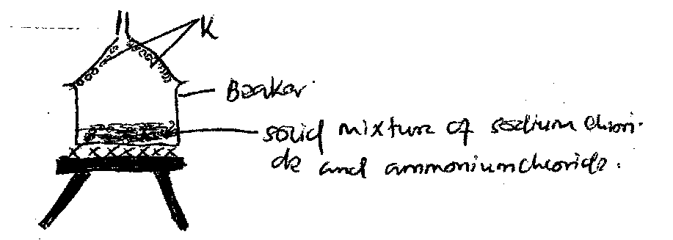
a)What is substance K- (1mk)
________________________________________________________________________
b)What is the name of the process by which substance K is formed. (1mk)
_______________________________________________________________________
3. The set up below shows simple distillation of salt solution pieces of broken porcelain were added into the solution and the apparatus set up as shown below.
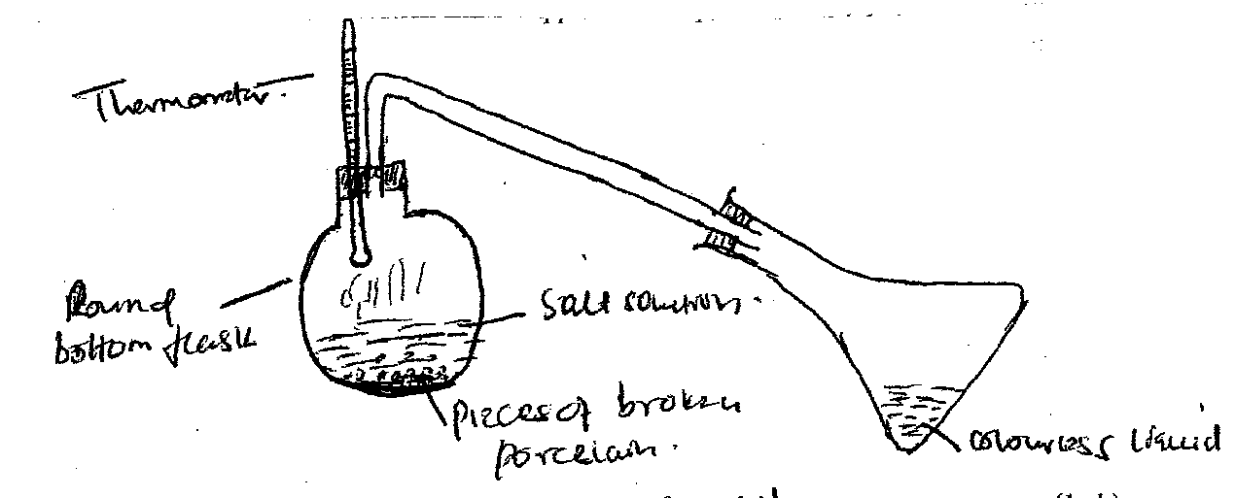
a)What is the purpose of adding broken pieces of porcelain. (1mk)
________________________________________________________________________
b) What is the use of the thermometer. (1mk)
________________________________________________________________________

c) i)Name the apparatus that can b e used for better / efficient coding. (1mk)
________________________________________________________________________
ii) Draw the apparatus named above to show how condensation is achieved. (1mk)

4. A group of form 1 students from Sunshine Secondary School decided to investigate the different components present in a shown extract used by Nunguni woman to colour sisal threads for making baskets.
i) Name the method used to investigate the different components of the extract. (1mk)
________________________________________________________________________
ii) Give a suitable solvent used in this experiment. (1mk)
________________________________________________________________________
iii) Give two applications for the process mentioned in (i) above. (2mks)
________________________________________________________________________
iv) At the end of the experiment, violet colour was noted near the top of the filter paper, a red band near the centre. What properties cause the components to separate (2mks)
________________________________________________________________________________________________________________________________________________________________________________________________________________________
5. Hydrogen can be prepared by reacting Zinc with dilute hydrochloride acid .
a) Write a chemical equation for the reactions (1mk)

b) Name one appropriate drying agent for hydrogen gas (1mk)
________________________________________________________________________
c) Explain why copper cannot be used to prepare hydrogen gas. (1mk)
________________________________________________________________________________________________________________________________________________________________________________________________________________________
d) Give 2 uses of hydrogen gas (2mks)
_______________________________________________________________________________________________________________________________________________________________________________________________________________________
6. James set up the experiment as shown below
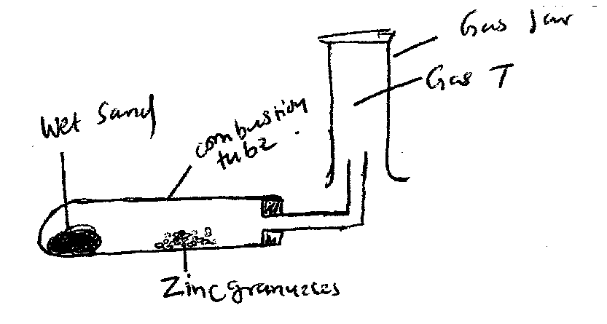
- State one conditions missing in the set up (1mk)
________________________________________________________________________
- Why is it necessary to heat wet sand before heating Zinc granules. (1mk)
______________________________________________________________________________________________________________________________________________________________________________________________________
- Write a chemical equation of the reaction taking place in combustion tube. (1mk)

7. Name the intermolecular forces labeled below A and B. (2mks)
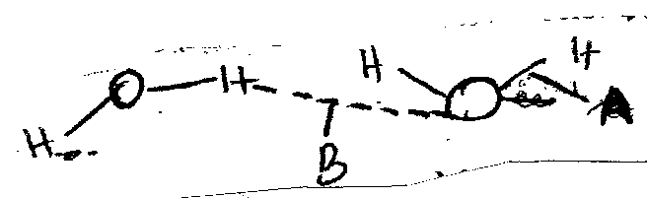
A-
B-
b) What is a hydrogen bond. (1mk)

8.State the type of bond in each of the following compounds and using dots( ) and cross(x) diagram show how the following compounds are formed.
a) Magnesium chloride (MgCl₂) (2mks)

Type of bond_____________________________________

b) H₃0 ⁺ (2mks)

Type of bonds __________________________________
c)Ammonia gas (NH₃) (2mks)

Type of bond___________________________________

d) Why is ammonia molecule able to bond with hydrogen ion(H⁺) to form ammonium ion (NH₄⁺) (2mks)
________________________________________________________________________________________________________________________________________________________________________________________________________________________
9.
 |  |  | Electrical conductivity
Substance | Melting point ($℃$) | Solubility in water | Solid state | Mo state
C | 650 | soluble | good | Good
D | 1610 | Insoluble | Poor | Poor
E | 801 | Soluble | Poor | Good

Select a substance with (3mks)
- Giant ionic structure-

- Giant atomic structure-

- Giant metallic structure-
10. With reference to iodine distinguish between covalent bonds and van der waal.(3mks)
________________________________________________________________________________________________________________________________________________________________________________________________________________________________________________________________________________________________
11. Ammonium ion has the following structure
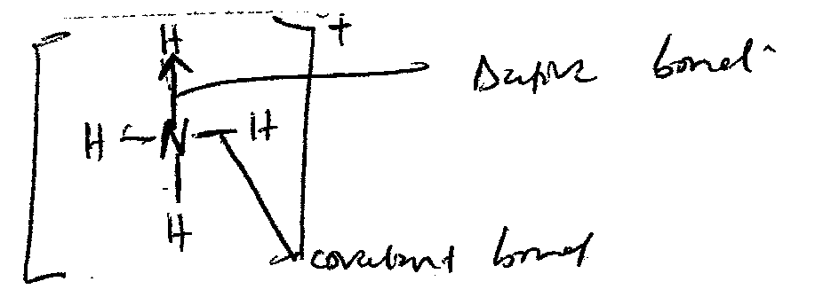
a) Label on the structure (2mks)
i) Covalent bond
ii) Dative bond
b) How many electrons are used in bonding in the molecule. (1mk)

12. Below is an experiment set-up to determine the percentage of oxygen in air. Use it to answer the questions that follow.
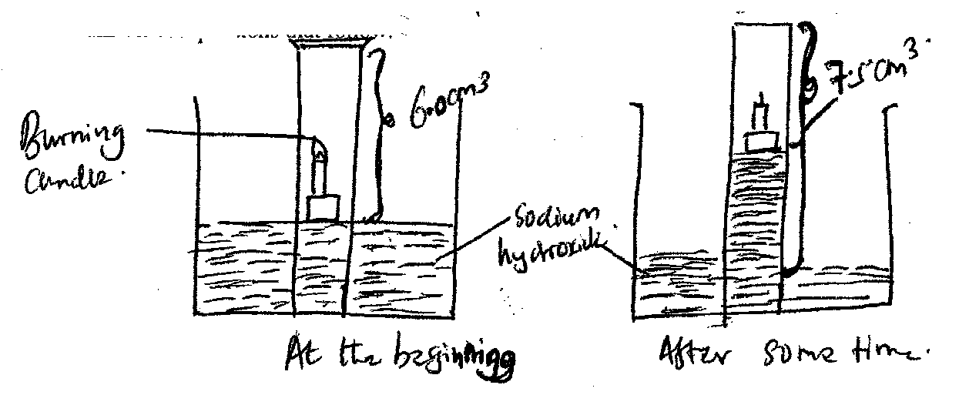
- Explain two observations made when burning candle is covered with gas jar. (2mks)
____________________________________________________________________________________________________________________________________________________________________________________________________________________________________________________________________________________________________________________________________________________________________________________________________________
- Explain why level of dilute sodium hydroxide rises in the gas jar. (1mk)
______________________________________________________________________________________________________________________________________________________________________________________________________
- Calculate the percentage composition of air used in burning candle. (2mks)

- Why is sodium hydroxide preferred over water in the set-up. (1mk)
______________________________________________________________________________________________________________________________________________________________________________________________________
- Name another substance that can be used in place of sodium hydroxide. (1mk)
__________________________________________________________________
13. A mixture of magnesium powder and lead (II) oxide reacts vigorously when heated but no reaction occurs when a mixture of magnesium oxide and lead powder are heated.
a) Explain the observation above. (2mks)
________________________________________________________________________________________________________________________________________________________________________________________________________________________________________________________________________________________________
b) Write the chemical equation for the reaction between magnesium and lead (II) oxide.(1mk)
________________________________________________________________________
c) Identify from the above reaction the; (1mk)
i) Oxidizing agent-
________________________________________________________________________
ii) Reducing agent-
________________________________________________________________________
- What name is give to the above type of reaction. Explain. (1mk)
______________________________________________________________________________________________________________________________________________________________________________________________________
14. solutions may be classified as strong base, weak base, neutral, strong acid, or weak aid. The information below gives some solution and their pH values. Study it and answer the questions that follow.
Solution pH
A 2
B 7
C 14
D 9
E 5
a) Classify the solutions as strong base, weak base, neutral ,strong acid, weak acid(4mks)
A-
B-
C-
D-
E-
b) A student tested soil in the school garden and found that its pH was below 7. His chemistry teacher advised him to add calcium oxide to the soil. What was the purpose of adding the calcium oxide? (2mks)
________________________________________________________________________________________________________________________________________________________________________________________________________________________________________________________________________________________________
15. Differentiate between luminous and non-luminous flame. (2mks)
__________________________________________________________________________________________________________________________________________________________________________________________________________________________________________
16. State the functions of the following parts of the Bunsen burner
i) Rubber tubing (1mk)
______________________________________________________________________________
ii) Collar (1mk)
______________________________________________________________________________
17. A form one student in sunshine secondary school was told to measure exact 25cm³ of sodium hydroxide solution during chemistry practical lesson, which apparatus will he use to measure the exact volume? (1mk)
______________________________________________________________________________
ii) Name two other apparatus used to measure accurate volume of liquids in the lab. (1mk)
______________________________________________________________________________
iii) What is the use of the following apparatus? (2mks)
- Separating funnel
________________________________________________________________________
________________________________________________________________________
b) Pipe clay triangle
____________________________________________________________________________________________________________________________________________________________
18. Define the following terms (2mks)
i) Mixture
__________________________________________________________________________________________________________________________________________________________________________________________________________________________________________
ii) Drug
__________________________________________________________________________________________________________________________________________________________________________________________________________________________________________
19. Write balanced chemical equation for the reaction of the following reaction.(4mks)
i) Calcium + water
________________________________________________________________________________________________________________________________________________
ii) Magnesium + dilute nitric(V)acid
________________________________________________________________________________________________________________________________________________
iii) Iron +steam

iv) Ammonium hydroxide +dilute sulphuric(VI) acid
________________________________________________________________________________________________________________________________________________
20. Below is a table of 1st ionization energies for elements A, B, C and D which are
metals.

Elements | A | B | C | D
Ionization energies Kjmol⁻¹ | 494 | 418 | 519 | 376

(a) What is meant by 1st ionization energy? (1 mk)

________________________________________________________________________
________________________________________________________________________
(b) With an explanation, arrange the elements in order to increasing
reactivities. (2 mks)

________________________________________________________________________
________________________________________________________________________
________________________________________________________________________
________________________________________________________________________
21. The following table gives the melting points of oxides of elements in period 3. Study it and answer the questions that follow.

Formula of oxide | Na₂O | MgO | Al₂O₃ | SiO₂ | P₄O₁₀ | SO₃
Melting point (C⁰) | 1190 | 3080 | 2050 | 1730 | 560 | -73
- Explain the difference in letting points of MgO and P₄O₁₀. (2 mks)

________________________________________________________________________
________________________________________________________________________
________________________________________________________________________
________________________________________________________________________
________________________________________________________________________
________________________________________________________________________
- Name the compound in the above table that will dissolve both in dilute hydrochloride acid and dilute sodium hydroxide. (1 mk)

________________________________________________________________________
22. The table below shows the atomic numbers of some elements represented by letter J to Q (letters not their actual symbols). Study and answer the questions that follow.

Element | J | K | L | M | N | P | Q
Atomic number | 11 | 17 | 15 | 14 | 12 | 20 | 19

- Write the electronic configuration of:
- M ……………………………….. (1 mk)
- P²⁺ ……………………………….. (1 mk)
- Write the formula of the compound formed when L combines with N. (1 mk)

- How would reactivities of element N and P with chlorine compare? Explain. (2 mks)

________________________________________________________________________
________________________________________________________________________
________________________________________________________________________
________________________________________________________________________
________________________________________________________________________
- Element J combines with oxygen to form an oxide. Using dots (.) and crosses (x) to represent the outermost electrons show how the two elements combine.
(2 mks)

- Select the most reactive metal and non-metal and give reason for your answer. (2 mks)

Metal ____________________________________________________________
Reasons___________________________________________________________
Non metal ________________________________________________________
Reason ___________________________________________________________
_________________________________________________________________

- State one physical and one chemical property that elements J and Q have in common. (2 mks)

________________________________________________________________________
________________________________________________________________________
________________________________________________________________________
________________________________________________________________________
- What name is given to the group of elements to which element M belong? (1 mk)

________________________________________________________________________
- Element K consists of two isotopes with relative abundances 75% and 25% and mass number 35 and 37 respectively find the relative atomic mass of K. (2 mks)

