FORM 2
ENGLISH
MID TERM EXAM – JUNE 2016
TIME: 2 ½ HOURS

NAME:………………………………………….……….CLASS:………….ADM NO:………..

QUESTION | SKILLS | MAX SCORE | CANDIDATE SCORE
 | FUNCTIONAL WRITING | 20
 | POETRY | 20
 | COMPREHENSION | 20
 | GRAMMAR | 20
 | TOTAL SCORE | 80

FUNCTIONAL WRITING (20 MARKS)

Your school is holding a prize giving day and several guests are to be invited. You are a member of a committee organizing the function. Design an invitation card that will be used for the said purpose.

………………………………………………………………………………………………………………………………………………………………………………………………………………
………………………………………………………………………………………………………………………………………………………………………………………………………………
………………………………………………………………………………………………………………………………………………………………………………………………………………
………………………………………………………………………………………………………………………………………………………………………………………………………………
………………………………………………………………………………………………………………………………………………………………………………………………………………
………………………………………………………………………………………………………………………………………………………………………………………………………………
………………………………………………………………………………………………………………………………………………………………………………………………………………
………………………………………………………………………………………………………………………………………………………………………………………………………………
………………………………………………………………………………………………………………………………………………………………………………………………………………
………………………………………………………………………………………………………………………………………………………………………………………………………………
………………………………………………………………………………………………………………………………………………………………………………………………………………
………………………………………………………………………………………………………………………………………………………………………………………………………………
………………………………………………………………………………………………………………………………………………………………………………………………………………
………………………………………………………………………………………………………………………………………………………………………………………………………………
………………………………………………………………………………………………………………………………………………………………………………………………………………
………………………………………………………………………………………………………………………………………………………………………………………………………………
………………………………………………………………………………………………………………………………………………………………………………………………………………
………………………………………………………………………………………………………………………………………………………………………………………………………………
………………………………………………………………………………………………………………………………………………………………………………………………………………
………………………………………………………………………………………………………………………………………………………………………………………………………………
………………………………………………………………………………………………………………………………………………………………………………………………………………
………………………………………………………………………………………………………………………………………………………………………………………………………………
………………………………………………………………………………………………………………………………………………………………………………………………………………
………………………………………………………………………………………………………………………………………………………………………………………………………………
………………………………………………………………………………………………………………………………………………………………………………………………………………
………………………………………………………………………………………………………………………………………………………………………………………………………………
………………………………………………………………………………………………………………………………………………………………………………………………………………
………………………………………………………………………………………………………………………………………………………………………………………………………………
………………………………………………………………………………………………………………………………………………………………………………………………………………
………………………………………………………………………………………………………………………………………………………………………………………………………………
………………………………………………………………………………………………………
POETRY (20 MARKS)

A Mother So Kind

How fortunate we are that you are the one to give us life
Before us, Dad knew he had a great wife.

You continued to give us life by the care you gave,
With a gentle smile, your love poured out like a wave.

You enriched our lives by the things you said,
Bit it was through your action that you lead.

You were always there with a word of praise,
And rarely did your voice ever rise.

You gave a helping hand to those and us in need,
A note, a word, a call, or meal to feed.

You are passing through this journey and leaving us all,
With words, ‘goodbye’ I love you sweetie,’ for us to recall.

Questions

- Who is the speaker in the poem? (2 mks)
………………………………………………………………………………………………..
………………………………………………………………………………………………..
- What is the poem about? (2 mks)

………………………………………………………………………………………………..
………………………………………………………………………………………………..
………………………………………………………………………………………………..
………………………………………………………………………………………………..

- Mention four good things that the persona remembers the ‘you’ of the poem for.(4 mks)

………………………………………………………………………………………………..
………………………………………………………………………………………………..
………………………………………………………………………………………………..
………………………………………………………………………………………………..
………………………………………………………………………………………………..
………………………………………………………………………………………………..
- Identify and illustrate any three poetic devices in the poem. (6 mks)

………………………………………………………………………………………………..
………………………………………………………………………………………………..
………………………………………………………………………………………………..
………………………………………………………………………………………………..
………………………………………………………………………………………………..
………………………………………………………………………………………………..
………………………………………………………………………………………………..
- What does the word ‘us’ represent in the poem? (1 mk)

………………………………………………………………………………………………..
………………………………………………………………………………………………..
- Explain the meaning of the last stanza. (2 mks)

………………………………………………………………………………………………..
………………………………………………………………………………………………..
………………………………………………………………………………………………..
………………………………………………………………………………………………..
………………………………………………………………………………………………..
- What are the feelings of the ‘us’ to the ‘you’ in the poem. (2 mks)

………………………………………………………………………………………………..
………………………………………………………………………………………………..
………………………………………………………………………………………………..
………………………………………………………………………………………………..
………………………………………………………………………………………………..
- And rarely did your voice ever rise. Add a question tag. (1 mk)

………………………………………………………………………………………………..
………………………………………………………………………………………………..

3. COMPREHENSION

Read the following passage and answer the questions that follow. (20 marks)

DRUG USAGE, PUSHING AND ABUSE
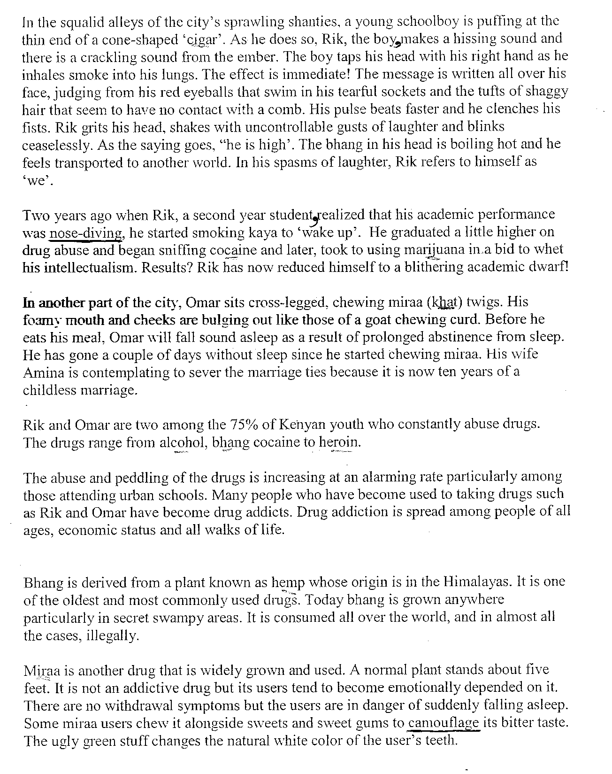

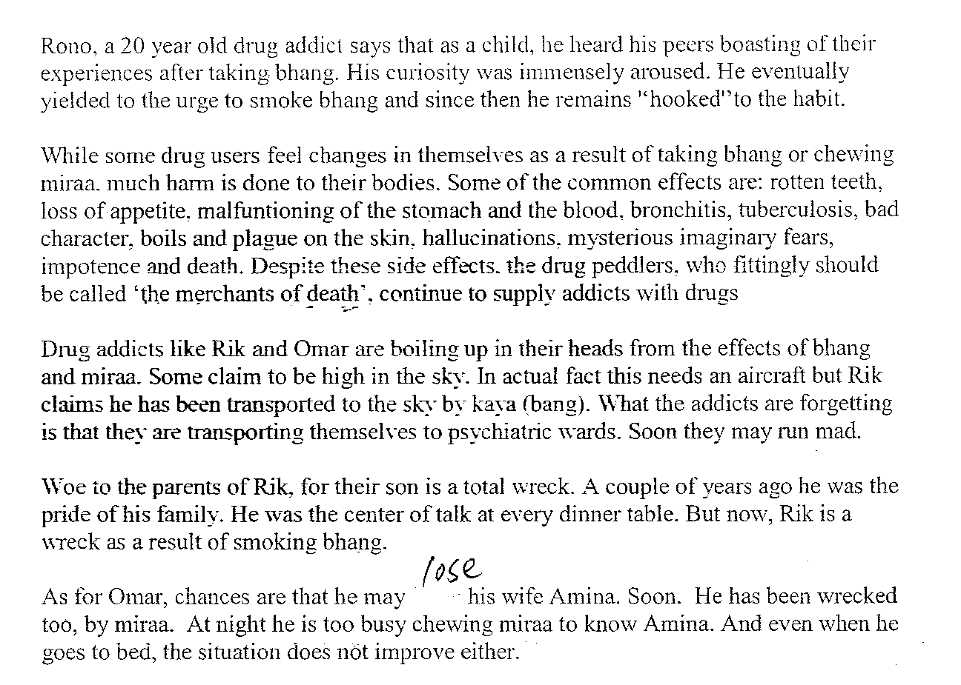

Questions.

- What evidence is there in the first paragraph to show that Rik does not care about grooming? (1 mk)

…………………………………………………………………………………………………..
…………………………………………………………………………………………………..
- Why is the word ‘cigar’ in quotation marks? (2 mks)
…………………………………………………………………………………………………..
…………………………………………………………………………………………………..
…………………………………………………………………………………………………..
…………………………………………………………………………………………………..
- Explain how the writer makes use of irony in the second paragraph. (2 mks)
…………………………………………………………………………………………………..
…………………………………………………………………………………………………..
…………………………………………………………………………………………………..
…………………………………………………………………………………………………..

- List the types of drugs mentioned in this passage. (2 mks)
…………………………………………………………………………………………………..
…………………………………………………………………………………………………..
…………………………………………………………………………………………………..
…………………………………………………………………………………………………..
…………………………………………………………………………………………………..
- Referring to paragraph nine, explain the writer’s attitude towards drug peddlers. (2 mks)
…………………………………………………………………………………………………..
…………………………………………………………………………………………………..
…………………………………………………………………………………………………..
…………………………………………………………………………………………………..
…………………………………………………………………………………………………..
- Make notes on how Rik and Omar’s lives have changed since they started taking drugs. (6 mks)
Rough copy
…………………………………………………………………………………………………..
…………………………………………………………………………………………………..
…………………………………………………………………………………………………..
…………………………………………………………………………………………………..
…………………………………………………………………………………………………..
…………………………………………………………………………………………………..
…………………………………………………………………………………………………..
…………………………………………………………………………………………………..
Final copy
…………………………………………………………………………………………………..
…………………………………………………………………………………………………..
…………………………………………………………………………………………………..
…………………………………………………………………………………………………..
…………………………………………………………………………………………………..
…………………………………………………………………………………………………..
…………………………………………………………………………………………………..
…………………………………………………………………………………………………..

- Explain the meanings of the following words as used in the passage. (4 mks)
nose-diving ……………………..……………………………………………………………..
camouflage ...…………………………………………………………………………………..
hooked…..……………………………………………………………………………………..
psychiatric wards..……………………………………………………………………………..
- It is not an addictive drug but its users tent to become emotionally dependent on it.
(Rewrite beginning. Though…)
…………………………………………………………………………………………………..
…………………………………………………………………………………………………..

GRAMMAR (20 MARKS)
- Fill in the blank spaces in the following sentences using the appropriate prepositions.
(2 mks)
- The man was robbed ……………………….his wallet.
- I am very disappointed …………………………you, Jane.

- Supply the most suitable adverb of degree to fill the blanks in the following sentence.
(2 mks)
- Njeri can ………………………..believe me.
- The fruits in the vineyard were ripe ………………….for harvest.

- Fill in the blanks with the adjectives given in brackets in their correct order.(4 mks)
- Wanjohi bought a …………………………………..suit. (shapeless, brown, second-hand)
- The carpenter made ………………………..………..tables. (rectangular, wooden, huge)
- We saw some …………………………..….spoons. (serving, Chinese, large)
- He was driving a ………………………………..car. (red, new, beautiful)

- Complete each of the following sentences with the past perfect form of the verbs in brackets. (3 mks)

- Before he joined the national team, he ………………………(swim) in many competitions.
- Write …………………………..(hang) the clothes out there to try.
- The children………………………(pray) before they started eating.

- Rewrite each of the following sentences according to the instructions given after each. (3 mks)
- They were so exhausted that they could not stay awake. (Rewrite using “too”)
…………………………………………………………………………………………………..
- She forbids the boys to throw stones. (Rewrite in the past tense).
…………………………………………………………………………………………………..
- The players and the coach did not appear on the pitch. (Rewrite beginning: Neither….)
…………………………………………………………………………………………………..

- Use the most appropriate form of the word in brackets to fill in the blanks. (3 mks)
- Sunset can bean ……………………….sight. (awe)
- We learnt a great deal from the speech; it was very ………………..(inform)
- It is against our culture to treat older people ……………………… (respect)

- Replace the underlined phrasal verb with one word that means the same. (2 mks)
- They made up for the last time.
………………………………………………………………………………………………
- I wished to meet him after classes yesterday but he did not show up.
……………………………………………………………………………………………….
………………………………………………………………………………………………..

- Fill the blank with the most suitable verb in the present continuous. (1 mk)
- I ………………….to college these days.

