KARATASI 102/2
KIDATO CHA PILI
MUHULA WA PILI
JUNI 2016

JINA----------------------------------------------------------------------------- DARASA ----------------
NAMBARI YA USAJIRI -------------

UFAHAMU | 15
SARUFI | 40
ISIMU | 10
FASIHI SIMULIZI | 15
JUMLA | 80

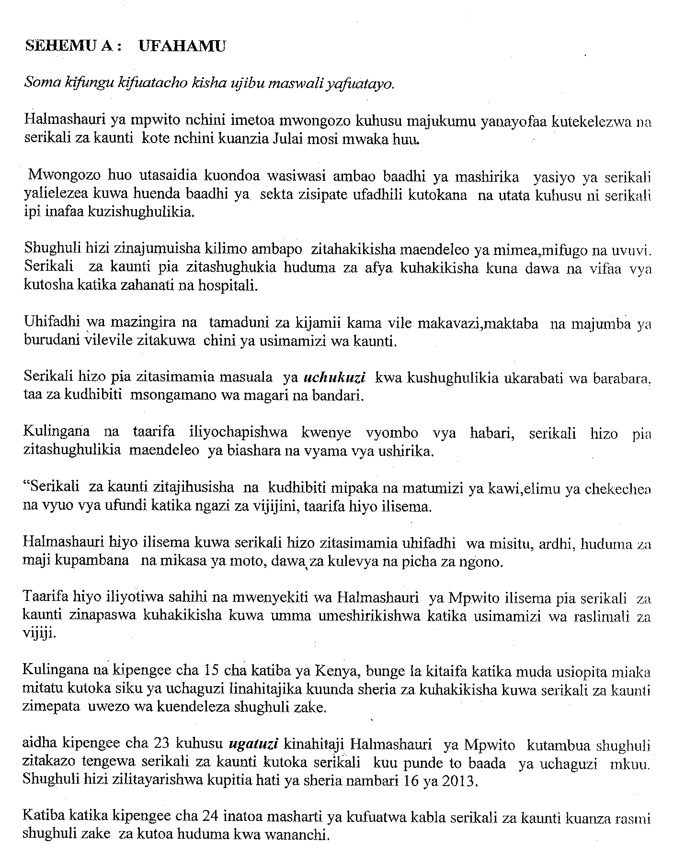
Maswali
- Ipe makala haya kichawa mwafaka. (al 1)
--------------------------------------------------------------------------------------------------------------

- Je, kaunti inawajibikaje katika kuwahudumia wananchi? (alama2)
--------------------------------------------------------------------------------------------------------------
--------------------------------------------------------------------------------------------------------------
--------------------------------------------------------------------------------------------------------------
--------------------------------------------------------------------------------------------------------------
- Utawala wa kaunti unaweza kupunguza vipi maafa yanayotokea kutokana na mapuuza ya mwanadamu? (alama 3)

--------------------------------------------------------------------------------------------------------------
--------------------------------------------------------------------------------------------------------------
--------------------------------------------------------------------------------------------------------------
--------------------------------------------------------------------------------------------------------------
--------------------------------------------------------------------------------------------------------------
--------------------------------------------------------------------------------------------------------------
- Bunge la kitaifa lina wajibu gani katika serikali ya kaunti? (alama 2)
--------------------------------------------------------------------------------------------------------------
--------------------------------------------------------------------------------------------------------------
- Ni changamoto zipi zinazoweza kukabili suala la ugatuzi nchini? (alama 3)
--------------------------------------------------------------------------------------------------------------
--------------------------------------------------------------------------------------------------------------
--------------------------------------------------------------------------------------------------------------
--------------------------------------------------------------------------------------------------------------
--------------------------------------------------------------------------------------------------------------
--------------------------------------------------------------------------------------------------------------
- Ni kwa njia gani serikali ya kaunti inaweza kufufua uchumi wan chi na kuinua kiwango cha maisha ili kufika ruwazw ya 2030. (alama 2)

--------------------------------------------------------------------------------------------------------------
--------------------------------------------------------------------------------------------------------------
--------------------------------------------------------------------------------------------------------------
--------------------------------------------------------------------------------------------------------------

- Eleza maana ya maneno yafuatayo kama yalivyotumika katika ufahamu.

(a) Uchukuzi--------------------------------------------------------------------------------------------
(b) Ugatuzi ----------------------------------------------------------------------------------------------

SARUFI AL 40
- Andika maneno yenye miundo ifuatayo ( al 2)

- KIKKI ------------------------------------------------------------------------------------------------------------------------------------------------------------------------------------------------------------------------------------------------------------------------------------------------------------------------
- II----------------------------------------------------------------------------------------------------------------------------------------------------------------------------------------------------------------------------------------------------------------------------------------------------------------------------------
- Onyesha matumizi ya kiimbo (al 3)
----------------------------------------------------------------------------------------------------------------------------------------------------------------------------------------------------------------------------------------------------------------------------------------------------------------------------------------------------------------------------------------------------------------------------------------------------------------
- Tunga sentensi moja ukitumia kitenzi – jina (al 2)
------------------------------------------------------------------------------------------------------------------------------------------------------------------------------------------------------------------------------------------------------------------------------------------------------------------------------------------------

- Eleza tofauti ya kimaana katika sentensi hizi
Nisimamapo huchekwa ( al 3)
--------------------------------------------------------------------------------------------------------------------------------------------------------------------------------------------------------------------------------
Ninaposimama huchekwa
----------------------------------------------------------------------------------------------------------------------------------------------------------------------------------------------------------------------------------------------------------------------------------------------------------------------------------------------
- Tunga sentensi moja kutofautisha maana ya maneno haya
Mkembe ; mkebe (al 2)
----------------------------------------------------------------------------------------------------------------------------------------------------------------------------------------------------------------------------------------------------------------------------------------------------------------------------------------------------------------------------------------------------------------------------------------------------------------
- Bainisha aina za vitenzi katika sentensi ifuatayo kwa kutuma T₁ T₂
Mwakijana alikuwa akivaa polepole ( al 2)
------------------------------------------------------------------------------------------------------------------------------------------------------------------------------------------------------------------------
- Bainisha mofimu (al 3)
Kilichosomeka
------------------------------------------------------------------------------------------------------------------------------------------------------------------------------------------------------------------------------------------------------------------------------------------------------------------------------------------------------------------------------------------------------------------------------------------------------------------------------------------------------------------------------------------------------------------------------------------------------------------------------------------------------------------------------------------------------------------------------

- Andika katika hali ya wingi ( al 2)
Ua wake una ua zuri na kubwa
---------------------------------------------------------------------------------------------------------------------------------------------------------------------------------------------------------------------------------------------------------------------------------------------------------------------------------------------------------------
- Sahihisha
Amina anaoga mikono akule ( al 2)
------------------------------------------------------------------------------------------------------------------------------------------------------------------------------------------------------------------------------------------
- Bainisha sifa za sauti / sh / na / ch / (al 3)
-----------------------------------------------------------------------------------------------------------------------------------------------------------------------------------------------------------------------------------------------------------------------------------------------------------------------------------------------------------------------------------------------------------------------------------------------------------------------------------
- Eleza matumizi ya alama mshazari ( al 3)
--------------------------------------------------------------------------------------------------------------------------------------------------------------------------------------------------------------------------------------------------------------------------------------------------------------------------------------------------------------------------------------------------------------------------------------------------------------------------------------------------------------------------------------------------------------------------------
- Andika kwa usemi halisi
Mwanafunzi alishangaa jinsi alivyoweza kusoma kitau hicho peke yake. ( al 3)
----------------------------------------------------------------------------------------------------------------------------------------------------------------------------------------------------------------------------------------------------------------------------------------------------------------------------------------------------------------------------------------------------------------------------------------------------------------

- Ni nini maana ya kivumishi. (al 2)
------------------------------------------------------------------------------------------------------------------------------------------------------------------------------------------------------------------------------------------------------------------------------------------------------------------------------------------------
Ii) Toa mfano wa kivumishi kisisitizi katika sentensi. (al 2)
------------------------------------------------------------------------------------------------------------------------------------------------------------------------------------------------------------------------------------------------------------------------------------------------------------------------------------------------
- Eleza matumizi matatu ya kiambishi Ji ( al 3)
---------------------------------------------------------------------------------------------------------------------------------------------------------------------------------------------------------------------------------------------------------------------------------------------------------------------------------------------------------------------------------------------------------------------------------------------------------------
- Tambulisha viwakilishi nafsi viambata katika sentensi hizi kwa wingi ( al 3)
- Niliomba kitabu jana
- Umemwona wapi
- Aliongea vizuri
FASIHI SIMULIZI ( AL 10)
- Taja aina mbili za wahusika katika fasihi simulizi. (al 2)
---------------------------------------------------------------------------------------------------------------------------------------------------------------------------------------------------------------------------------------------------------------------------------------------------------------------------------------------------------------------------------------------------------------------------------------------------------------
- Eleza majukumu mawili nyimbo katika jamii. (al 2 )
----------------------------------------------------------------------------------------------------------------------------------------------------------------------------------------------------------------------------------------------------------------------------------------------------------------------------------------------------------------------------------------------------------------------------------------------------------------
- Toa mifano miwili miwili ya methali zinazozingatia tamathali zifuatazo:
- Balagha (al 2 )
------------------------------------------------------------------------------------------------------------------------------------------------------------------------------------------------------------------------------------------------------------------------------------------------------------------------------------
- Takriri ( al 2)
-----------------------------------------------------------------------------------------------------------------------------------------------------------------------------------------------------------------------------------------------------------------------------------------------------------------------------------

- Eleza aina zifuatazo za ngano
- Khurafa ( al 1)
---------------------------------------------------------------------------------------------------------------------------------------------------------------------------------------------------------------------------------------------------------------------------------------------------------------------
- Hekaya (al 1)
------------------------------------------------------------------------------------------------------------------------------------------------------------------------------------------------------------------------------------------------------------------------------------------------------------------------------------
ISIMU JAMII
- Fafanua dhana zifuatazo
a)Lugha rasmi (al1)
-------------------------------------------------------------------------------------------------------------------------------------------------------------------------------------------------------------------------------------------------------------------------------------------------------------------------------------------------------------
b)Lugha ya taifa (al 1)

- Fafanua sifa mbili za sajili ya hotelini (al 2)
------------------------------------------------------------------------------------------------------------------------------------------------------------------------------------------------------------------------------------------------------------------------------------------------------------------------------------------------------------------------------------------------------------------------------------------------------------------------------------
- Tofautisha istilahi zifuatazo (al 2)
Isimu na Isimu jamii
------------------------------------------------------------------------------------------------------------------------------------------------------------------------------------------------------------------------------------------------------------------------------------------------------------------------------------------------------------------------------------------------------------------------------------------------------------------------------------
- Tambua sajili zifuatazo (al 4)
a)Kutokana na ushahidi uliotolewa, na kulingana na kifungu cha 44A cha sheria, ni wazi kuwa una mashtaka ya kujibu
-------------------------------------------------------------------------------------------------------------------
b)Mbili mara tatu kwa siku. Usizidishe wala kupunguza
-----------------------------------------------------------------------------------------------------------------
c)Zote hizi zimepita uzani unaohitajika. Itakubidi ununue bahasha na stempu
-----------------------------------------------------------------------------------------------------------------
d)Beba leo! Beba leo! Bei ni bure.
------------------------------------------------------------------------------------------------------------

