FORM 2
MID TERM EXAM – JUNE 2016
MATHEMATIC
TIME 2 ½ HOURS

Name……………………………...................…………....Class………..Adm No. ………...

Instructions:

- Write your name, class and adm no. in the space provided.
- This paper consist of section I and II
- Answer all questions in section I and II
- Show all your workings giving answers of each stage in the spaces provided below each question.
- Marks may be given for correct working even if the answer is wrong
- Mathematical tables maybe used except when stated otherwise
- Calculator should NOT be used.

SECTION I
1 | 2 | 3 | 4 | 5 | 6 | 7 | 8 | 9 | 10 | 11 | 12 | 13 | 14 | 15 | 16 | TOTAL

SECTION II
17 | 18 | 19 | 20 | 21 | TOTAL

GRAND TOTAL

SECTION I (50MKS)
- Evaluate the following $\frac{\frac{1}{2} of \frac{2}{5} ÷ + \frac{3}{15} x \frac{7}{10 } x \frac{6}{7} \left[1 \frac{1}{2} x \frac{1}{3}\right]}{\frac{5}{3} x \frac{6}{10} ÷ \frac{5}{4}- \frac{1}{4}}$ (3 mks)

- Solve the equation $\frac{1}{4x}= \frac{5}{6x}- \frac{7}{1}$ (3 mks)

- Use the tables of reciprocals and square roots to solve for y. (3 mks)
$$\frac{3}{0.63486}+ \sqrt{0.008576}= \frac{1}{y}$$

- Evaluate without using tables or calculators (4 mks)
$$\sqrt[3]{\frac{0.125 x \sqrt{64}}{0.064 x \sqrt{629}}}$$

- Use logarithms to evaluate (4 mks)
$$\sqrt{\frac{\tan{{77.23}^{0} x\sin{{2.34}^{0}}}}{\cos{{34.45}^{0}}}}$$

- The figure below shows the shape of Kamau’s farm with dimensions shown in meters.
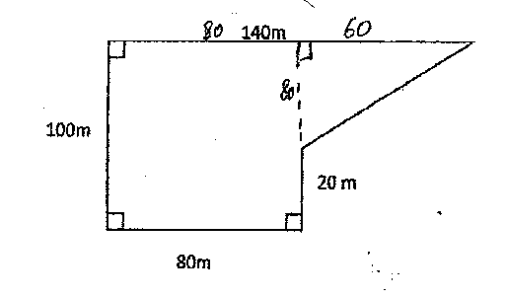
Find the area of Kamau’s farm in hectares. (3 mks)

- The length of a rectangle is increased by 20% while the width is decreased by 10%. Find the percentage change in area. (2 mks)

- Given the ratio x : y = 2 : 3, find the ratio (7x – 3y) : (2x + 3y) (3 mks)

- The figure below is a rhombus ABCD of sides 4cm. BD is an arc of circle centre C. given that <ABC = 138⁰. Find the area of shaded region. (4 mks)
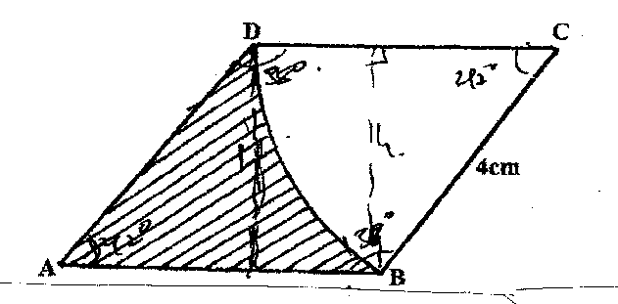

- 2.5 litres of water density 1 g/cm³ is added to 8 litres alcohol density 0.8 g/cm³. Calculate the density of the mixture. (3 mks)

- Find the equation of a line which passes through (-1,-4) and is perpendicular to the line:
y + 2x – 4 =0 (3 mks)

- Two consecutive odd number are such that the difference of twice the larger number and the smaller number is 21. Find the product of the numbers. (3 mks)

- Solve the simultaneous equation. (3 mks)
2x – y = 3
x² – xy = -4

- .
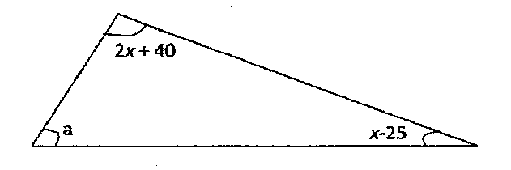
In the figure above, angle a is half the sum of the other angles. Evaluate the angles of the triangle. (3 mks)

- Simplify $\frac{3^{n+3}- 3 x 3^{n}}{4 x 3^{n+3}}$ (3 mks)

- Hamisi arrived in Nairobi from USA with 40 travelers cheques each with 75 US dollar. How much does she receive in Kshs from the bank on a day when 1 US dollar was equivalent to Kshs 81.40 and the bank charges commission at the rate of Kshs 100 per travelers cheque?
(3 mks)

- Two circles of radii 13cm and 16cm intersect such that they share a common chord of length 20cm. calculate the area of the shaded part ($π= \frac{22}{7}$) (10 mks)
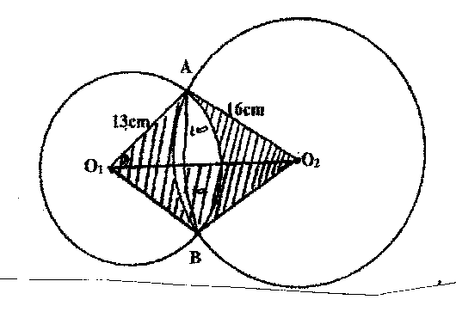

- The figure below shows a solid frustum if pyramid with a square top of side 8 cm and a square base of side 12 cm. the slant edge of the frustum is 9 cm.

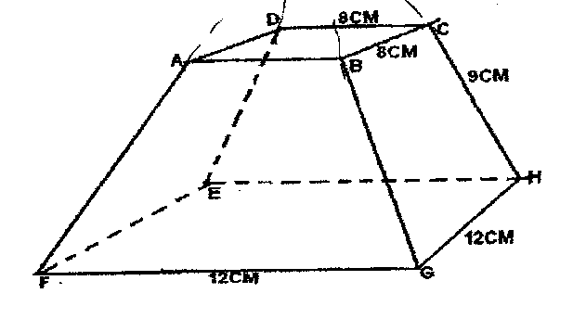
- The slant edge of the solid pyramid from which the frustrum was cut. (3 mks)

- The surface area of the frustrum. (7 mks)

- (a) In the triangle XYZ below, find the angle ZXY. (5 mks)
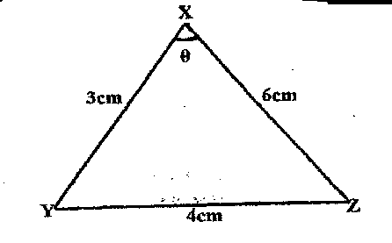

(b) The diagram shows a right glass prism ABCDEF with dimensions as shown.
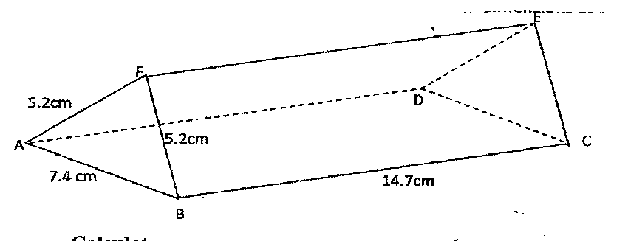

Calculate:
- The perimeter of the prism (2 mks)

- The volume of the prism. (3 mks)

- The angle of depression of a point A on the ground from the top of a post is 18⁰ and that of another point 8 on the same line as A nearer to the foot of the post is 25⁻. If A and B are 70m apart.
- Draw a sketch to represent positions of A and B. (2 mks)

- Using your sketch calculate
- The height of the post from the ground level. Write your answer to 4 s.f.
(6 mks)

- The distance of point A from the foot of the post. (2 mks)

