HOLA SECONDARY SCHOOL
FORM ONE
CHEMISTRY
END OF YEAR EXAM
2011
TIME:

NAME:…………………………………………..CLASS………….ADM/NO………………

- Study the following chart for laboratory preparation of dry nitrogen
Step I step II step III
AIR

liquid air
Carbon IV oxide free air
Water free air

- Name the compound which can be used in step I. (1mk)

- Describe briefly what happens in step III (2mks)

- What is the name given to process that is used in step II (1mk)

2. Some Copper (II) sulphate crystals were gently heated in a test tube until no more water was given off.
i) Draw a diagram of the apparatus that could be used to heat the crystals and collect the water given off. (3mks)

Ii) State and explain what would be observed if the residue in the test tube is cooled and few drops of water is added to it. (2mks)

(iii) write a word equation for the reaction in ii above(1mk)

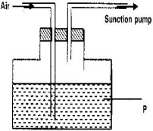
3. The following diagram is used to show that air contains Carbon (IV) Oxide.

a) Name liquid “p” (1mk)

b) State the observation made on liquid “p” which will indicate the presence of carbon (IV) Oxide. (1mk)

4. Explain why phosphorous is kept under water. (2mks)

5. The PH of a sample of soil was found to be 5.0. An agricultural officer recommended the addition of calcium oxide in the soil. State two functions of calcium oxide in the soil.(2mks)

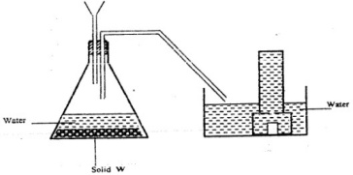
6. The diagram below shows a set up used by a student in an attempt to prepare collect oxygen gas

a)i)Complete the diagram by correcting the mistakes in it. (1mk)

ii) Identify solid w. (1mk)

7. A piece of phosphorous was burnt in excess air. Some amount of hot water was added to the product to make a solution.
i) Write a word equation for the burning of phosphorous in excess air.(1mk)

ii)The solution obtained in (b) above was found to have a PH of 2.0. Give reasons for this observation. (2mks)

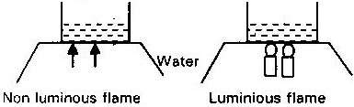
8.The diagram below shows an experiment to compare the heating effect of luminous and non luminous flame.

- What was observed at the bottom of each beaker at the end of experiment? Explain(2mks)

b) Which sample of water boils first? Give a reason for your answer. (2mks

c) Besides the amount of heat produced by the two flames, state other differences between the two flames. (3mks)

9. A student was supplied with a colorless liquid suspected to be water.
i) Describe one chemical test that could have been used to show that the liquid was water. (1mk)

ii) How it could have been shown that the liquid was pure water. (1mk)

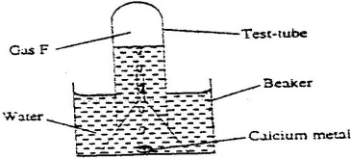
10. The set up was used to collect gas F, produced by the reaction between water and calcium metal.

i) Name gas F. (1mk)

ii) At the end of the experiment, the solution in the solution is a weak base. Explain (2mks)

iii) Give one laboratory use of the solution formed in the beaker. (1mk)

11. A piece of sodium was put into a beaker containing water.
a) State and explain three observations made in the above reaction. (3mks)

- What would be the pH for the resulting solution (1mk)

c) Give the test for hydrogen (1mk)
(1mk)

d) List three uses of hydrogen (3mks)

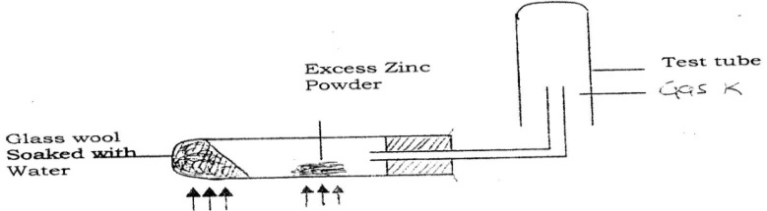
12.The following observations were made during the investigation of the
reaction of metal with water.

a) Why was it necessary to heat the moist glass wool before heating zinc powder? (1mk)
b) What would happen if the zinc powder was heated before heating the glass wool? (1mk)

c) What property of gas K made it possible for it to be collected as shown in the diagram? (1mk)

- Write an equation for the reaction that would take place if zinc was replaced by magnesium (1mk)
13. Complete the following equations (2mks)
i) Copper (ii) oxide +Magnesium
ii) Carbon+ oxygen
14. What is oxidation? (1mk)

15. Cars in Mombasa rust faster than cars in kisumu. What is the chemical name for rust (1mk)

- State the condition necessary for rusting to occur (3mks)

- Mention three ways by which rusting can be prevented(3mks)

16. Chemistry is one of the subjects offered in the Kenyan schools. State TWO reasons why the Government of Kenya allows the subject to be taught. (2mks)

17. A drug is a substance which is used as medicine or in medicine. Why must care be taken on the use of any drugs? (1mk)

18. The figure below shows same changes in state for a substance X .Study the diagram and answer the question.

- Name the process (2mks)
- I
- IV
- V
- III
(II) State one examples of substances that undergoes process IV. ( 1mk)

- Air is a mixture of gases. Comments on this statement. ( 1mk)

- Briefly describe how oil is obtained from macadamia nuts. ( 3mks)

0
- Write the chemical symbols of the following elements ( 2mks)
- Lead

- Potassium

- Magnesium

- Chlorine

- Define the following terms. ( 1mk)

- Atom

- Element

- State laboratory one rule concerning use of Bunsen burner.(1mk)

