EAST AFRICAN SCHOOL OF AVIATION EXAMINATION
MOCK EXAMS
DIPLOMA IN AERONAUTICAL ENGINEERING
ENGINEERING DRAWING
STREAM: Y1 (A&E &Avionics) Duration: 3 hrs
DAY/DATE: TIME
INSTRUCTION TO CANDIDATES
- You should have the following for this examination:
    - Drawing paper
    - Drawing pencils and eraser
- Question ONE is compulsory answer ANY other THREE.
- Maximum marks for each part of a question are as shown.
- All dimensions in millimeters
- Candidates should answer the questions in English.
This paper consists of Seven (7) printed pages.
Candidates should check the question paper to ascertain that
all the pages are printed as indicated and that no questions are missing.

© East African School of Aviation Examination 2015
QUESTION ONE (40 MARKS)
Figure 1 shows a pictorial detail of a machine bracket. Draw to full scale, the following views in First Angle orthographic projection with all hidden details.
- A front elevation obtained by viewing the bracket in the direction of arrow F.
(12 marks)
- A plan view projected from the front elevation. (10 marks)
- A suitable End view. (10 marks)
Include the following:
-at least 5 major dimensions (5 marks)
-a projection symbol according to drawing conventions (3 marks)
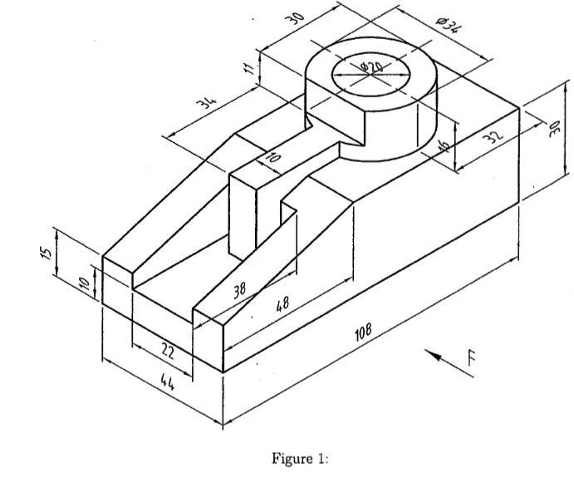

QUESTION TWO (20 MARKS)
Figure 2 shows two views of a machined casting. Draw the bracket in isometric projection with corner X as the lowest point.
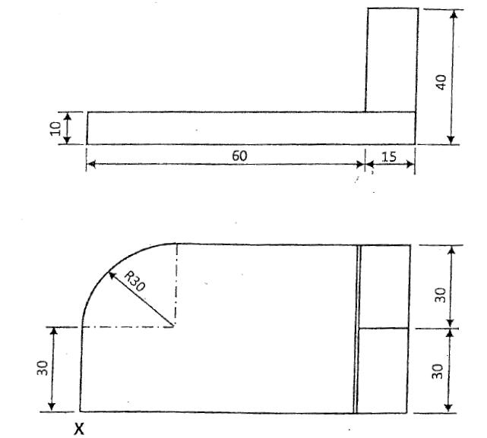
Fig. 2

QUESTION THREE (20 MARKS)
Figure 3 shows two unequal meeting each other as shown:
- Draw the given view full size;
- Draw the line of intersection between the two pipes;
- Develop the curved surface of the smaller pipe.

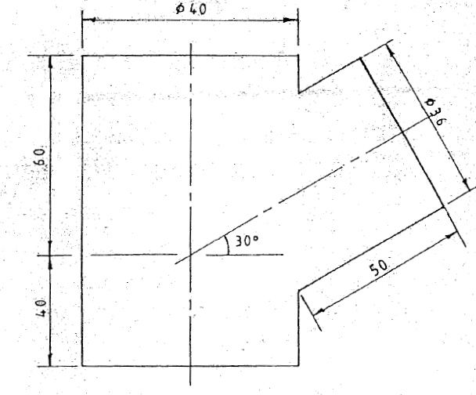
Fig. 3

QUESTION FOUR (20 MARKS)
- The view in Figure 4 represents a disc which rolls along a flat surface AB. Plot the locus of point P for one revolution of the disc. (11 marks)
- Figure 5 shows a slider crank mechanism with crank OA rotating in anti-clockwise direction.
Plot the locus traced by the mid-point P of the connecting rod AB, for complete revolution of crank OA. (9 marks) 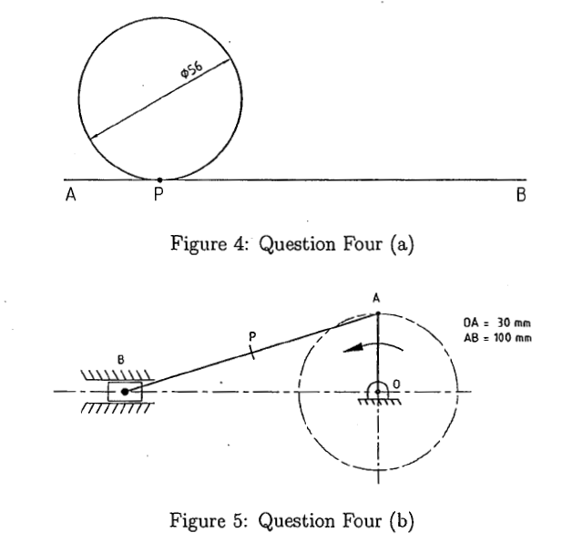

QUESTION FIVE (20 MARKS)
Figure 6 shows the handle of a jack plane. Construct the profile of the handle. Do Not erase the construction lines.
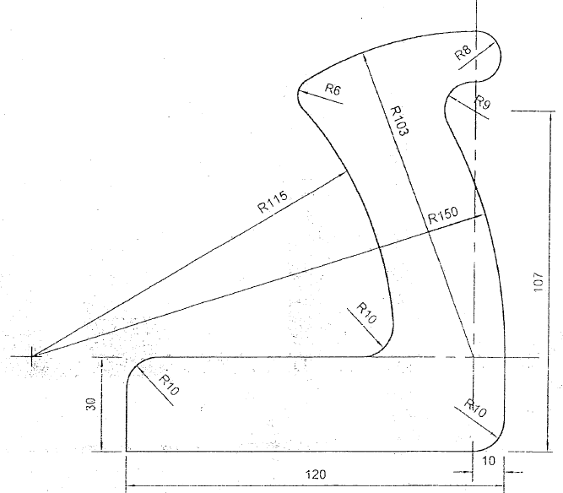
Fig. 6

QUESTION SIX (20 MARKS)

6. (a) Describe the stages in a design process. (10 marks)
(b) With the aid of sketches, design a wheelbarrow with an adjustment mechanism to allow the frame to be either lowered or raised at the wheel to vary the clearance between the frame and the ground. (10 marks)

