ENGLISH
FORM TWO END YEAR
TIME: 2 HOURS

FUNCTIONAL WRITING | 20
COMPREHENSION | 20
POETRY | 20
GRAMMAR | 20

FUNCTIONAL WRITING
Imagine that you are a member of the Environment Club of your school that executed a four day tour of the Coast. Write a personal Journal that you would have kept for personal reference. (20mks)
COMPREHENSION

The bloke to education
The universal Declaration of Human Rights clearly states that "Everyone has the right to education."Unfortunately, to many poor children in Kenya, this is a mere wish-washy dream. Though education plays a great role in enjoyment of human rights in addition to individual personality development, to many children in Lowly Developed Countries (L.D.C.s), accessing education is a nightmare.

In Kenya agriculture contributes over three-quarters to households incomes in rural areas. These incomes are directly used to finance education, consequently anything that affects agriculture also affects education. Quite unfortunately, market-distorting practices by developed members of World Trade Organization (W.T.O) are negatively affecting production and trade in agricultural products in Kenya, leaving an ineffaceable scar in the development and education of children.

Having liberalized its market mainly because of pressures from World Bank and International Monetary Fund through Structural Adjustment Program's (S.A.Ps), competition from well-established foreign organizations led to reduction in production and even the collapse of some factories. This has directly translated to loss of jobs and market for local produce. Poor farmers have to chase the ever-elusive market for their produce, get poor pay hence inadequate finances to cater for education expenses of their children. In addition, poorly paid workers in processing factories can't afford to provide adequate food for their children leave alone their education and clothing. More painfully the closure and reduced production of the local factories has rendered most of them jobless.

It is evidently clear that international trade particularly in agricultural products and agreements affecting it has impacted on the education of many children in Kenya. Practices that have denied Kenyan farmers, traders and workers a chance to fully exploit their resources have led to screaming poverty in the country. This poverty has hindered the struggle of Kenyans to achieve development goals particularly in providing education to all. Though there is some little impact by local factors, it can be concluded that unfair trade leads to poverty in Lowly Developed Countries which denies children their right to education.

The impacts of trade Liberalization are clearly mirrored in the education sector in Kenya. The first three successive decades after independence in 1963 saw impressive gains in access to education in Kenya. From the time Kenya joined the W.T.O., educational participation has not only retrogressed but also eroded the gains achieved in previous decades.

Questions
1. What according to the first paragraph are the main functions of education (2 Marks)
………………………………………………………………………………………………………………………………………………………………………………………………………………………………………………………………………………………………………………………………………………………………………………………………………………………………………………………………………………………………
………………………………………………………………………………………………………………………………………………………………………………………………………………………………………………………………………………………………………………………………………………………………………………………………………………………………………………………………………………………………
2. Provide another phrase that could replace the phrase "screaming poverty" (1 Mark)
………………………………………………………………………………………………………………………………………………………………………………………………………………………………………………………………………………………………………………………………………………………………………………………………………………………………………………………………………………………………
3. In not more than 100 words summarize the effects of trade liberalization on African Countries.
(5 Marks)
…………………………………………………………………………………………………………………………………………………………………………………………………………………………………………………………………………………………………………………………………………………………………………………………………………………………………………………………………………………………………………………………………………………………………………………………………………………………………………………………………………………………………………………………………………………………………………………………………………………………………………………………………………………………………………………………………………………………………………………………………………………………………………………………………………………………………………………………………………………………………………………………………………………………………………………………………………………………………………………………………………………………………………………………………………………………………………………………………………………………………………………………………………………………………………………………………………………………………………………………………………………………………………………………………………………………………………………………………………………………………………………………………………………………………………………………………………………………………………………………………………………………………………………………………………………………………………………………………………………………………………………………………………………………………………………………………………………………………………………………………………………………………………………………………………………………………………………………………………………………………………………………………………………………………………………………………………………………………………………………………………………………………………………………………………………………………………………………………………………………………………………………………………………………………………………………………………………………………………………………………………………………………………………………………………………………………………………………………………………………………………………………………………………………………………………………………………………………………………………………………………………………………………………………………………………………………………………………………………………………………………………………………………………
4. The impacts of trade liberalization are clearly mirrored in the education sector in Kenya.
(Rewrite this sentence showing possession) (1 Mark)
……………………………………………………………………………………………………………………………………………………………………………………………………………………………………………………………………………………………………………………………………………………………………………………………………………………………………………………………………………………………………
5. In Kenya agriculture accounts for over three-quarters of income for households in rural areas,
(add a question tag) (1 Mark)
…………………………………………………………………………………………………………………………………………………………………………………………………………………………………………….……………………………………………………………………………………..
6. Poor farmers have to chase the ever-elusive market for their produce. (Rewrite this sentence
in the passive voice) (2 Marks)
……………………………………………………………………………………………………………………………………………………………………………………………………………………………………………………………………………………………………………………………………………………………………………………………………………………………………………………………………………………………………….
7. What is ironical in this passage? (2Marks)
…………………………………………………………………………………………………………………………………………………………………………………………………………………………………………………………………………………………………………………………………………………………………………………………………………………………………………………………………………………………………….
8. What are the main negative effects of W.T.O on Kenya from the time it joined it.(2 Marks)
……………………………………………………………………………………………………………………………………………………………………………………………………………………………………………………………………………………………………………………………………………………………………………………………………………………………………………………………………………………………………..
……………………………………………………………………………………………………………………………………………………………..

9. Explain the meanings of the following words and phrases as used in the passage.(4 Marks)

a) wish-washy
………………………………………………………………………………………………………………………………………………..
...........................................................................................................
b) ineffaceable
…………………………………………………………………………………………………………………………………………………………………………………………………………………………………………………………………………………………………………………
c) mirrored in the education sector
…………………………………………………………………………………………………………………………………………………………………………………………………………………………………………………………………………………………………………………..
d)retrogressed
…………………………………………………………………................................................................................
………………………………………………………………………………………………………………………………………………………
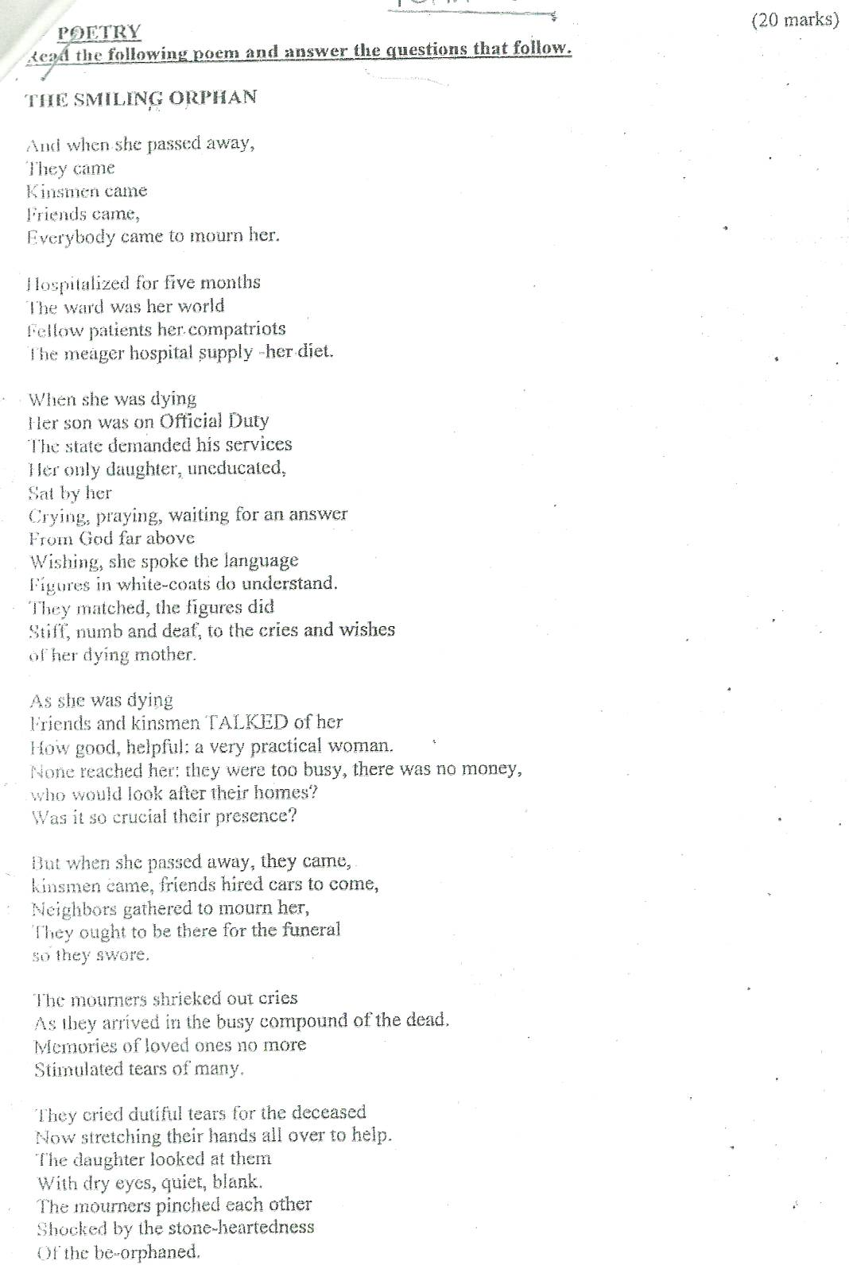
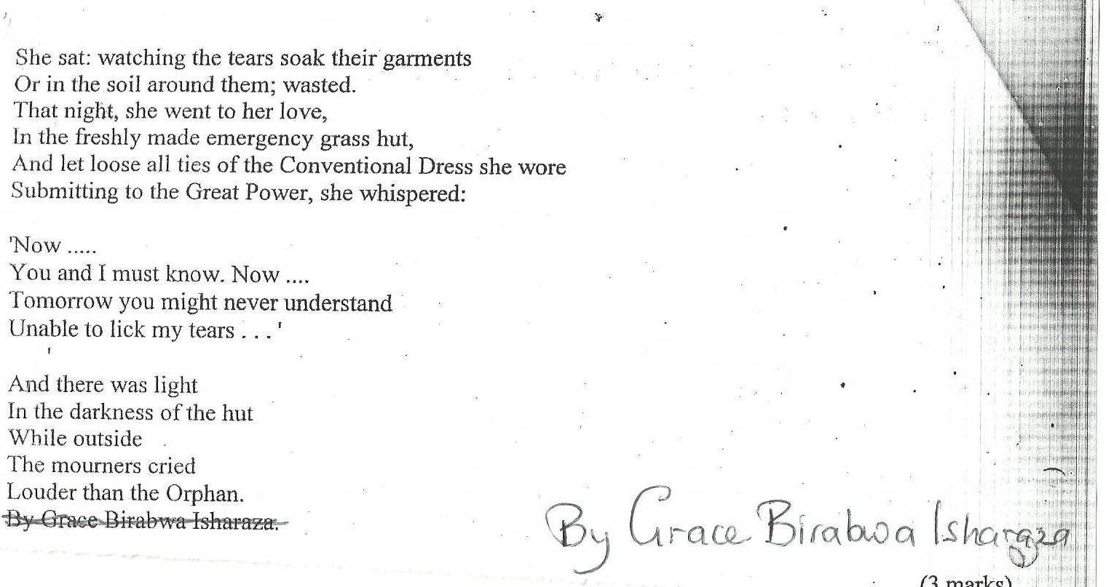

Questions
i)Explain what the poem is about? (3mks)
------------------------------------------------------------------------------------------------------------------------------------------------------------------------------------------------------------------------------------------------------------------------------------------------------------------------------------------------------------------------------------------------------------------------------------------------------------------------------------
ii)Who is the speaker of the poem? (2mks)
-----------------------------------------------------------------------------------------------------------------------------------------------------------------------------------------------------------------------------------------------------------------------------------------------------------------------------------------------------------------------------------------------------------------------------------------------------------------------------------
Iii)Explain why none of the sick mother’s friends and kinsmen visited her in hospital according to the poem. (3mks)
-------------------------------------------------------------------------------------------------------------------------------------------------------------------------------------------------------------------------------------------------------------------------------------------------------------------------------------------------------------------------------------------------------------------------------------------------------------------------------------------------------------------------------------------------------------------------------------------------------
iv)Identify an example of irony in the poem. (2mks)
-------------------------------------------------------------------------------------------------------------------------------------------------------------------------------------------------------------------------------------------------------------------------------------------------------------------------------------------------------------------------------------------------------------------------------------------------------------------------------------------------------------------------------------------------------------------------------------------------------
v)Other than irony, mention two aspects of style in the poem. (4mks)
------------------------------------------------------------------------------------------------------------------------------------------------------------------------------------------------------------------------------------------------------------------------------------------------------------------------------------------------------------------------------------------------------------------------------------------------------------------------------------------------------------------------------------------------------------------------------------------------------------------------------------------------------------------------------------------------------------------------------
vi)Mention one character trait of the girl as shown in the poem. (2mks)
---------------------------------------------------------------------------------------------------------------------------------------------------------------------------------------------------------------------------------------------------------------------------------------------------------------------------------------------------------------------------------------------------------------------------------------------------------------------------------------------------------------------------------------------------------------------------------------------------------
vii)”They cried dutiful ears for the deceased” ( add a question tag) (1mk)
--------------------------------------------------------------------------------------------------------------------------------------------------------------------------------------------------------------------------------------------------------------------------------------------------------------------------------------------------------------
viii)Explain the meaning of the line below “And there was light in the darkness of the hut. 1mk)
----------------------------------------------------------------------------------------------------------------------------------------------------------------------------------------------------------------------------------------------------------------------------------------------------------------------------------------------------------------------------------------------------------------------------------------------------------------
ix)Do you think the way the relative behaved to the girl is acceptance in society? Give reasons for your answer. (2mks)
-------------------------------------------------------------------------------------------------------------------------------------------------------------------------------------------------------------------------------------------------------------------------------------------------------------------------------------------------------------------------------------------------------------------------------------------------------------------------------------------------------------------------------------------------------------------------------
GRAMMAR
Identify the verb phrase in each of the following sentences.
a)The car may have been stolen

b)He appears surprised

Fill in the blank with the correct subordinating conjunction.
i)David passed his exams --------------------------------------------- he had been out of school most of the time.
ii)He was rewarded ----------------------------------------- he was the best in his class.
iii)-------------------------------------------- he honours the summon, a warrant of arrest will be issued against him.
Re-write the following sentences using the appropriate form of ‘do’ Do not change the tense of the sentence.
i)He teaches well

ii)He dared go there

Passivize the following sentences.
i) Someone sent me the letter

ii)They are repairing our roof at the moment.

iii)The police had apprehended the suspects

Re-write the following sentences in reported speech
i)James said he had been working here for a year
ii)She said that she couldn’t speak Italian very well

iii)Jane said that they wouldn’t be there

Choose the correct pronoun to complete the sentences below
i)(We/us) and the other members of the team are going to Ngong

ii)It was (she/her) who won the cup

iii)(it’s/its) tail was very long

Fill in each gap with the correct order of adjectives
i)My father bought ------------------------------------ tables. ( round, glass, huge, ten, beautiful)

ii)She is -------------------------------------------------lady. (intelligent, Israel, slim)

ii)It was ------------------------------------------------ match (interesting, domestic)

iv)I have finished reading a ----------------------------------------------- novel ( boring, long, Pakistani)

