IDARA YA KISWAHILI
MITHANI WA MWISHO WA MUHULA WA TATU
KIDATO CHA PILI, 2014

MAAGIZO
a)Jibu maswali yote kwa nafasi zilzoachwa
b) Andika kwa hati safi
c) Makosa yote ya sarufi yattadhibiwa

SEHEMU | UPEO | ALAMA
UFAHAMU | 15
SARUFI | 30
ISIMU JAMII | 10
FASIHI SIMULIZI | 15
RIWAYA | 10
JUMLA | 80

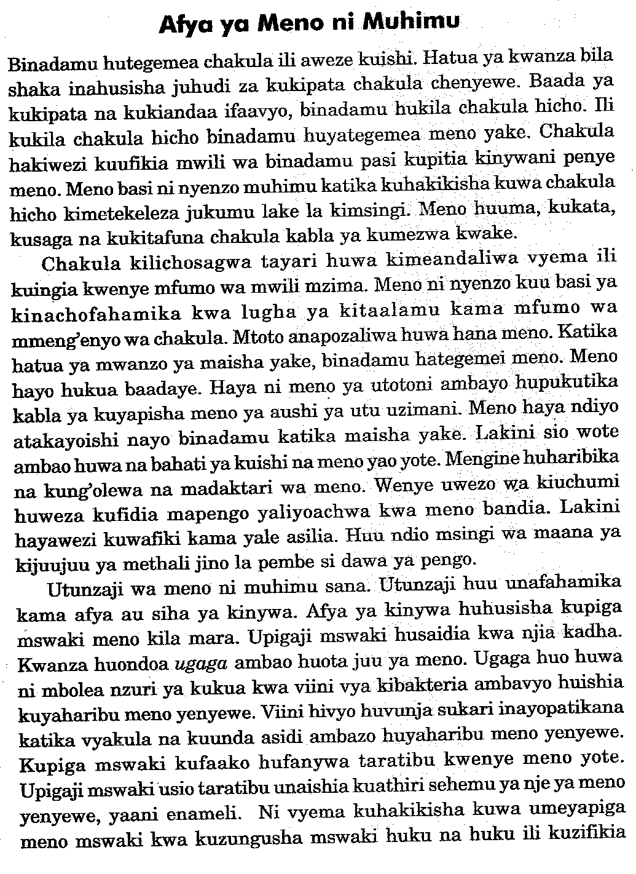

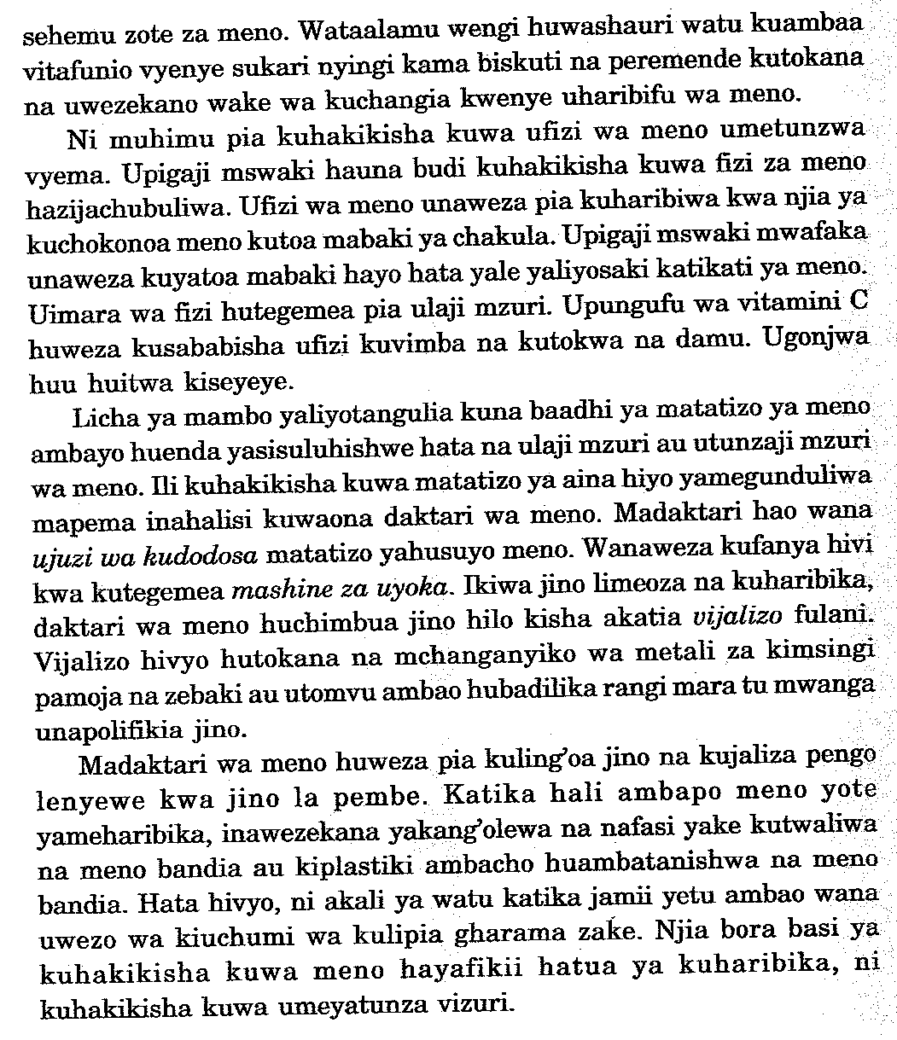

Maswali
1.Taja umuhimu wa meno (al 3)
------------------------------------------------------------------------------------------------------------------------------------------------------------------------------------------------------------------------------------------------------------------------------------------------------------------------------------------------------------------------------------------------------------------------------------------------------------------------------------
2.Kwa nini mtoto huzaliwa bila meno (al 1)
---------------------------------------------------------------------------------------------------------------------------------------------------------------------------------------------------------------------------------------------------------------------------------------------------------------------------------------------------------------
3.Mtoto anayezaliwa na jino huitwaje? (al 1)
------------------------------------------------------------------------------------------------------------------------------------------------------------------------------------------------------------------------------------------
4.Eleza sababu za kudumisha utunzaji wa meno. (al 3)
-------------------------------------------------------------------------------------------------------------------------------------------------------------------------------------------------------------------------------------------------------------------------------------------------------------------------------------------------------------------------------------------------------------------------------------------------------------------------------------------------------------------------------------------------------------------------------------------------------
5.Mwandishi anapendekeza njia gani ya kuyapiga meno mswaki? (al 1)
------------------------------------------------------------------------------------------------------------------------------------------------------------------------------------------------------------------------------------------

6.i)Je ni kweli kuwa si binadamu wote hubahatika kuishi na meno yao yote? (al 1)
----------------------------------------------------------------------------------------------------------------------------------------------------------------------------------------------------------------------------------------
ii)Toa sababu? ( al 1 )
--------------------------------------------------------------------------------------------------------------------------------------------------------------------------------------------------------------------------------------------------------------------------------------------------------------------------------------------------------------
7.Eleza maana ya maneno haya
i)Ugaga (al 1)
-----------------------------------------------------------------------------------------------------------------------------------------------------------------------------------------------------------------------------------------
ii)ujuzi wa kudodosa (al 1 )
------------------------------------------------------------------------------------------------------------------------------------------------------------------------------------------------------------------------------------------
iii)Mashine ya uyoka (al )
------------------------------------------------------------------------------------------------------------------------------------------------------------------------------------------------------------------------------------------
iv) Vijalizo (al 1 )
---------------------------------------------------------------------------------------------------------------------------------------------------------------------------------------------------------------------------------------

SARUFI NA MATUMIZI YA LUGHA (ALAMA 30 )
1.Taja sauti zenye sifa zifuatazo: (al 2)
i)Mbele, juu, tandazwa
-----------------------------------------------------------------------------------------------------------------------------------------------------------------------------------------------------------------------------------------
ii)Konsonanti ghuna ya kaakaa laini
----------------------------------------------------------------------------------------------------------------------------------------------------------------------------------------------------------------------------------------
2.Tunga sentensi yenye muundo ufuatao (al 2)
KN ( W + V) + KT ( T + E )
--------------------------------------------------------------------------------------------------------------------------------------------------------------------------------------------------------------------------------------3.Andika sentensi (al 4 )
Baba na mama walikuwa wanaimba jana
------------------------------------------------------------------------------------------------------------------------------------------------------------------------------------------------------------------------------------------
4.Yakinisha:
Yator hajakula wali kwa mchuzi wa pweza (al 2)

5.Eleza maana ya kiambishi (al 2 )

6.Andika katika usemi wa taarifa ( al 3)
“Waziri wa Israel atajiuzulu leo,” mtangazaji akasema

7.Kwa kutolea mifano eleza matumizi mawili ya parandesi (al 2)

8.Tumia neon haraka kama kielezi na nomino kwa kutunga sentensi mbili (al 2)

9.Andika kwa wingi (al 2)
Kiongozi wa taifa hili ni hodari

10.Kanusha
Mama alipoingia alilkuwa amefurahi sana

11.Eleza maana mbili za sentensi hii (al 2)
Baba ameniandikia barua

12.Kamilisha

Genge la (al 2)
Thureya ya

13.Tumnga sentensi moja kuonysha tofauti ya maan kati ya (al 2 )

Tepe

Debe

14Andika sentensi hii upya katika kauli ya kutendeana (al 1)

Kemunto anampikia Kimani chakula kizuri

ISIMU JAMII
MTU I: Wewe ! Sema yote ana utakula kalewa
MTU ii: Afande! Pole, usiniweke cell nitasema ukweli.
MTU II Good! Endelea kuonges haraka

a)Tambua sajili hii (al 2)

b)Tambua MTU I na MTU II (al 2)

c)Eleza sifa tatu za sajili hii zinazojitokeza katika dindoo (al 3)

d)Kwa kurejelea hoja tatu, eleza umuhimu wa Isimu Jamii (al 3 )

FASIHI SIMULIZI
1.Fafanua maan ya istilahi zifuatazo za fasihi simulizi (al 4 )
i)Ngano za mtanziko

ii)Hodiya

2.Tathmini umuhimu wa mighani katika jamii (al 5 )

5.Andika fani zilizounda methali zifuatazo (al 2 )
i)Maji ya kifuu bahari ya chungu

ii)Pambo la jeneza lamfaani mfu (al 1 )
4.Fafanua umuhimu wa
a)Michezo ya watoto (al 1 )

b)Vichekesho

KIDAGAA KIMEMWOZEA ( al 10 )
“Sitaki kelele hapa kwenye ikulu ya rais… Miye mtukufu Rais bado nalala na mwaniletea kelele.”
a)Ni nai aliyesema maneno haya? (1mk)

b)Msemewa ni nani? (1mk)

c)Walikuwa wapi? (1mk)

d)Ni lini? (al 1 )

e)Fafanua sifa za
Msemaji (al 2 )

Msemaji alitenda maajabu . Toa mifano miwili . (al 2 )

