ELERAI MCK GIRLS SECONDARY SCHOOL
P O BOX 435
SULTAN HAMUD
AGRICULTURE PAPER

EXAM 1 TERM1 2015

FORM 3

1. State four reasons for mulching as a nursery practice. (2mks)

2 List three breeds of goats kept for milk production. (11/2mks)

3. State four reasons for carrying out minimum tillage (2mks)

4. What is the function of each of the following ingredients in the preparation of compost manure?
(a) Wood ash (1 mk)

(b) Top soil (1 mk)

5. Define the following terms as used in pasture establishment.

(a) Seed inoculation (1mk)

(b) Over sowing (1mk)

6. State two factors that encourage forking in carrots. (1mk)

7. State three characteristics of dry concentrates (1½mks)

8. State four factors that favour shifting cultivation. (2mks)

9. (a) State two sources of water in an animal's body. (1½ mks)

(b) Give two functions of vitamins. (1 ½ mks)

10. State three factors that affect soil formation (1 ½ mks)

11 (a) Give four factors affecting maintenance ration required. (2mks)

(b) State two functions of the gizzard in birds digestive system (1mk)

12. Name two types of pruning carried out in tea (1 mk)

13 State three useful biotic facto that affect bean production (1 ½ mks)

14. Give four reasons for rearing livestock. (2mks)

15. List four general characteristics of dairy cattle breeds. (2mks)

16. State four effects of burning as a means of bush clearing. (2mks

17. Study the diagram below and answer the questions that follow.
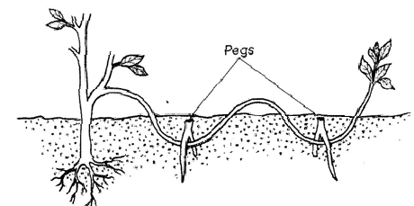

(a) Identify the practice illustrated. ( ½ mks)

(b) State three ways of initiating faster root development. (1 ½ mks)

(c) State two conditions that necessitate the use of the practice above. (2mks)

18 A crop was spaced at 90cm x 30cm. calculate the plant population of this crop in a hectare of land. (2mks)

19. Below are diagrams labeled A and B. study them carefully and answer the questions that follow.

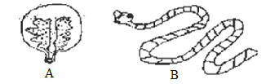

(a) Identify (1mk)

(b) Name the intermediate host of specimen A (1mk)

(c) Name the final host of specimen B. (1mk)

(d) State two control measures of the specimen A. (1mk)

20(a) State six reasons for carrying out proper crop rotation programme. (6mks)

(b) Discuss the characteristics of a good grain store (6mks)

(c) Outline four field practices carried out on beans. (4mks)

(d) State four way of preventing water pollution in the farm (4mk

