ELERAI MCK GIRLS SECONDARY SCHOOL

FORM 4 CHEMISTRY

PAPER 1 THEORY

TIME: 2 HOURS
- Chelule mixed wax and ammonium chloride accidentally. He found that it is not advisable to heat the mixture in order to separate them. Briefly explain how he would have separated them. (3marks)

- Potassium sulphite solution was prepared and divided into two portions. The first portion gave a white precipitate when reacted with barium nitrate. On addition of dilute hydrochloric acid, the white precipitate disappeared.
- Write the formula of the compound which formed as the white precipitate. (1mark)

- Write the equation for the reaction between dilute hydrochloric acid and the compound whose formula is written in (a) above. (1mark)

- What observation would be made if one drop of potassium dichromate solution was added to the second portion followed by dilute hydrochloric acid? (1mark)

- In ancient Greece, chewing chalk was used to combat excess stomach acid. A patient suffering from duodenal ulcer releases 30cm³ of 1M hydrochloric acid in the stomach. He chewed 5g of impure chalk to neutralize the acid released.
(Ca = 40, C = 12, O = 16).
- Write a well balanced chemical reaction that took place. (1mark)

- Calculate the number of moles of calcium carbonate used up. (2marks)

- Calculate the percentage impurity in calcium carbonate, chalk used. (2marks)

- A polymer has the following structure.

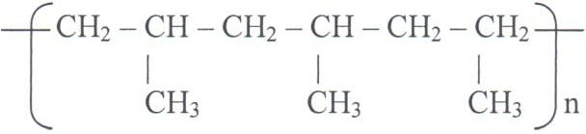

- Draw the structure of the monomer. (1mark)

- A sample of the polymer is found to have molecular mass of 6426. Determine the number monomers present (2marks)
(C = 12, H = 1).

- Below is a table of 1st ionization energies for elements A, B, C and D which are metals.
Elements | A | B | C | D
Ionization energies KJmol⁻¹ | 494 | 418 | 519 | 376
- What is meant by 1st ionization energy? (1mark)

- With an explanation, arrange the elements in order of increasing reactivities. (2marks)

- State the role of chlorine gas in:
  - Water treatment (1mark)

  - Paper manufacture (1mark)

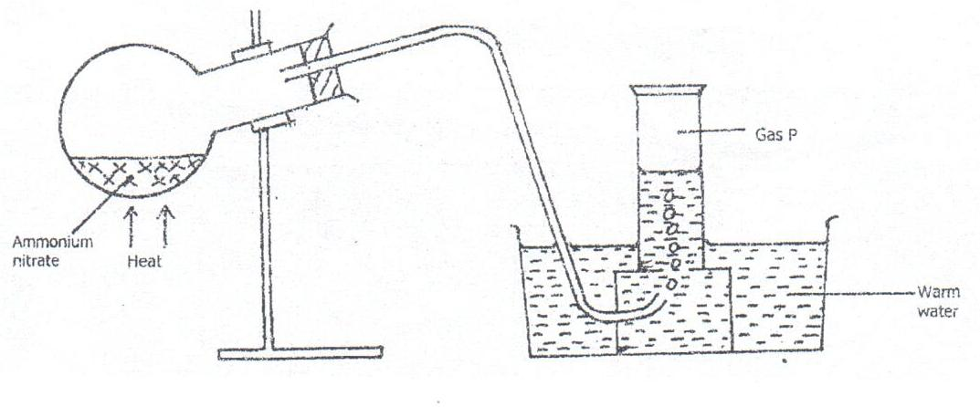
- The table below was used to prepare and collect gas P.

- Name gas P. (½mark)

- Write an equation for the reaction that takes place in the round bottomed flask. (1mark)

- State the property of gas P that makes it possible for its collection as shown in the diagram above. (½mark)

- State one precaution to observe while preparing gas P in the laboratory. (1mark)

- The electronic configuration of X²⁺ and Y⁻ are 2.8 and 2.8 respectively.
  - Write the electronic configuration of the atoms of X and Y. (1mark)

  - Using dots (•) and crosses (x) for electrons, show bonding in the compound formed by elements X and Y. (2marks)

- In an experiment, equal amounts of magnesium powder were placed into test-tube 1 and 2 as shown below.
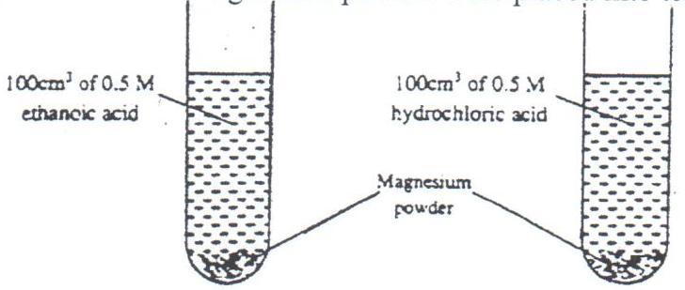

Test Tube 1 Test Tube 2
Explain why the amount of hydrogen gas liberated in test-tube 2 is greater than in test-tube 1 before the reaction is complete. (3marks)

- When excess dilute hydrochloric acid was added to sodium sulphite, 960cm³ of sulphur (IV) oxide gas was produced. Calculate the mass of sodium sulphite that was used. (Molar mass of sodium sulphite = 126g and molar gas volume = 24000cm³). (3marks)

- (a) State the observation made when excess pentene is reacted with bromine gas. (1mark)

(b) Draw and name the compound formed in (a) above. (2marks)

- Pieces of blue and red litmus papers were placed into a beaker containing water into which Aluminium Chloride had been dissolved.
- Is dissolving of aluminium chloride in water a physical or chemical process? Explain. (1mark)

- State the observations made on the papers. Explain your answer. (2marks)

- Use the information in the table below to answer the questions that follow. (The letters do not represent the actual symbols of the elements.
Element | P | Q | R | S | T
Atomic number | 20 | 8 | 18 | 8 | 19
Mass number | 40 | 16 | 40 | 18 | 39
  - Which two letters represent the same element? Give a reason. (2marks)

  - Give the number of neutrons in an atom of element T. (1mark)

- The table below shows physical properties of some substances. Use the information in the table to answer the questions that follow.
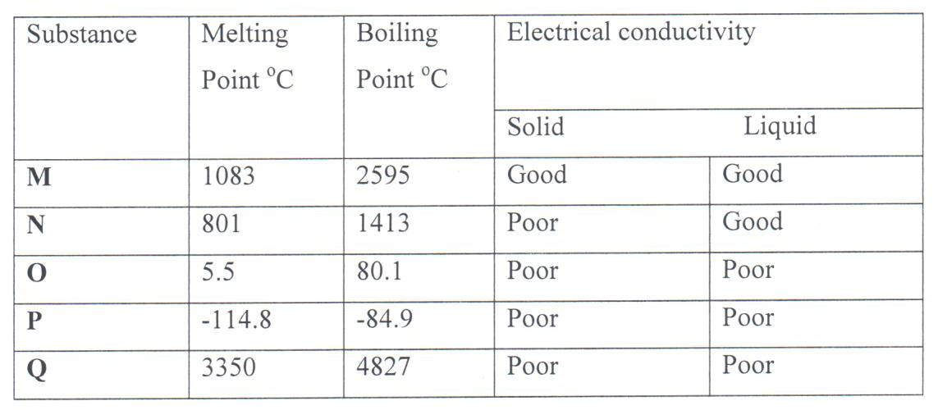
- Which substance is likely to be:
  - A metal (½mark)

  - A liquid at room temperature? (½mark)

- Which substance is likely to have the following structures: (1mark)
  - Simple molecular?

  - Giant atomic? (1mark)

- The diagram below represents a laboratory experiment to investigate the reaction between hydrogen sulphide gas and an aqueous iron (III) chloride.
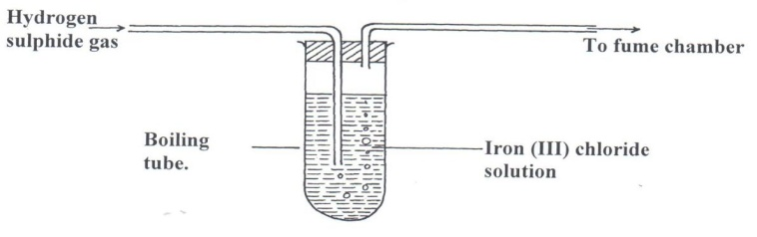

  - Write a chemical equation for the reaction which takes place in the boiling tube. (1mark)

  - What adjustment need to be made in the above set-up if the laboratory does not have a fume chamber. (1mark)

  - Describe a laboratory chemical test for a sample of hydrogen sulphide gas. (1mark)

- (a) Write a chemical equation for the combustion of laboratory gas, when the Bunsen burner produces a non-luminous flame.(1mark)

  - Describe two observable characteristics of a luminous flame. (1mark)

- The table below gives some elements in the periodic table. Use it to answer the questions that follow. The letters do not represent the actual symbols of the elements
Element | A | B | C | D | E
Atomic number | 12 | 13 | 14 | 15 | 16
Which of the above letters represent:
- A metallic element which forms ions with the smallest ionic radius? Explain. (1 mk)

- A non metallic element with the largest atomic size? Explain. (1mark)

18. Below is an illustration of the solvay process for manufacture of sodium carbonate. Use it to answer the questions that follow.

Solvay Tower
Carbonator
Chamber X
Roaster

Slaker
Kiln

NH_{3(g)}

NH₄Cl
Substance
D CO₂ gas

Na₂CO₃

      - Name two raw materials, in this process other than ammonia. (1mark)

      - The Solvay tower a lot of heat is produced. State how the heat produced is controlled. (1mark)

      - The carbonator is cooled regularly. What does this suggest about the type of reaction in the carbonator? (1mark)

      - Write the overall equation for the reaction in the carbonator. (1mark)

      - Identify the process taking place in chamber X. (1mark)
      - State the property of sodium hydrogen carbonate that enables it to be separated from ammonium chloride. (½mark)

      - Name two substances that can be recycled. (1mark)

      - Why is recycling important in this process? (1mark)

      - Identify substance D. (½mark)

      - In the roaster 2,400dm³ of carbon (IV) oxide is produced. Calculate the mass of sodium hydrogen carbonate that that was used. (MGV at rt.p 24000cm³, Na=23, H = 1, C = 12, 0=16) (2marks)

