NAME…………………………………………… INDEX No…………………CLASS……..
SCHOOL…………………………………………CANDIDATE’S SIGN……………………
443/1
AGRICULTURE
PAPER 1
TIME: 2 HOURS
TERM 2 2017

Kenya Certificate of Secondary Education
443/1
AGRICULTURE
PAPER 1
TIME: 2 HOURS

- Write your name and index number in the spaces provided above
- Sign and write the date of the examination in the spaces provided above
- This paper consists of three sections A, B and C
- Answer ALL the questions in section A and B
- Answer ANY two questions in section C
- Answers should be written in the spaces provided in this booklet

For Examiner’s Use Only:

SECTION | QUESTION | MAXIMUM SCORE | CANDIDATE’S SCORE
A | 1 – 20 | 30
B | 21 – 24 | 20
C |  | 20
 |  | 20
TOTAL SCORE 90
This paper consists of 12 printed pages.
Candidates should check the question paper to ascertain that all pages are printed as indicated.
And that no questions are missing.

SECTION A (30 MARKS)
Answer ALL questions in this section in the spaces provided.
- State two requirements of intensive farming system. (1mark)
……………………………………………………………………………………………………………………………………………………………………………………………
- State two reasons that entail why Agriculture as a science. (1mark)
……………………………………………………………………………………………………………………………………………………………………………………………………………………………………………………………………………………………..
- Give two farming practices that facilitate organic farming. (1mark)
………………………………………………………………………………………………………………………………………………………………………………………………………………………………………………………………………………………………
- Outline three effects of soil organisms which benefit crop growth. (1^{1/}₂mark)
……………………………………………………………………………………………………………………………………………………………………………………………………………………………………………………………………………………………..
- State four farming practices that can improve soil structure. (2marks)
………………………………………………………………………………………………………………………………………………………………………………………………………………………………………………………………………………………………………………………………………………………………………………………………………………………………………………………………………………………………
- Give three chemical processes of soil formation. (1^{1/}₂marks)
………………………………………………………………………………………………………………………………………………………………………………………………………………………………………………………………………………………………
- State four demerits of minimum tillage in crop production. (2marks)
……………………………………………………………………………………………………………………………………………………………………………………………
- Name two implements that can be used to break plough pans. (1mark)
………………………………………………………………………………………………
- State four conditions under which irrigation is carried out. (2marks)
………………………………………………………………………………………………………………………………………………………………………………………………………………………………………………………………………………………………………………………………………………………………………………………………
- Outline the first four stages of chemical water treatment. (2marks)
………………………………………………………………………………………………………………………………………………………………………………………………………………………………………………………………………………………………………………………………………………………………………………………………
- State four characteristics of a good crop for preparation of green manure. (2mark)
………………………………………………………………………………………………………………………………………………………………………………………………………………………………………………………………………………………………………………………………………………………………………………………………
- Give four disadvantages of planting seed using broadcasting method. (2marks)
………………………………………………………………………………………………………………………………………………………………………………………………………………………………………………………………………………………………………………………………………………………………………………………………
13 (a) Give one cause of blossom end rot in tomatoes (^{1/}₂mark)
……… …………………………………………………………………………………….
(b) State two methods of controlling blossom end rot in tomatoes. (1mark)
………………………………………………………………………………………………
14. Differentiate between land fragmentation and land consolidation. (1mark)
……………………………………………………………………………………………………………………………………………………………………………………………………………………………………………………………………………………………..

15. State two objectives of land redistribution. (1mark)
………………………………………………………………………………………………………………………………………………………………………………………………
16. Outline four factors that influence by solifluction on steep slopes. (2marks)
………………………………………………………………………………………………………………………………………………………………………………………………………………………………………………………………………………………………………………………………………………………………………………………………
17. Identify three bases on which herbicides are classified. (1^{1/}₂marks)
……………………………………………………………………………………………………………………………………………………………………………………………………………………………………………………………………………………………..
18. Name two improved sorghum varieties grown in Kenya (1mark)
………………………………………………………………………………………………………………………………………………………………………………………………
19. List four types of financial books farmers should keep. (2marks)
………………………………………………………………………………………………………………………………………………………………………………………………………………………………………………………………………………………………………………………………………………………………………………………………
20. Outline four methods of tree harvesting in an agricultural farm. (2marks)

SECTION B (20MARKS)
Answer ALL the questions in the spaces provided
21. Study the illustration below of farm records:- Use it to answer the questions that follow.
Name of cow | DAYS IN MONTH
 | 1 |  | 2 |  | 3 |  | 4 |  | 5 |  | 6
 | AM | PM | AM | PM | AM | PM | AM | PM | AM | PM | AM | PM

(a) Name the type of the farm record illustrated above. (1mark)
………………………………………………………………………………………………
(b) Give two reasons for keeping health records in a livestock production (2marks) ………………………………………………………………………………………………………………………………………………………………………………………………
(c) Give two pieces of information a dairy farm manager should collect from the record for planning purposes. (2marks)
………………………………………………………………………………………………………………………………………………………………………………………………
22. The diagram below illustrates the spacing which is used when planting beans. Study the diagram and answer the questions that follow:
15cm
30cm

(a) State the spacing illustrated above (1mark) ………………………………………………………………………………………
(b) Suppose the student is asked to use the illustrated spacing to plant in a plot 4m by 3m leaving 30cm distance from the edge; calculate;
(i) The number of rows on the wider side of the plot (2marks)

(ii) Calculate the plant population. (2marks)

23. The diagram below shows a system of grazing, use it to answer the questions that follow.

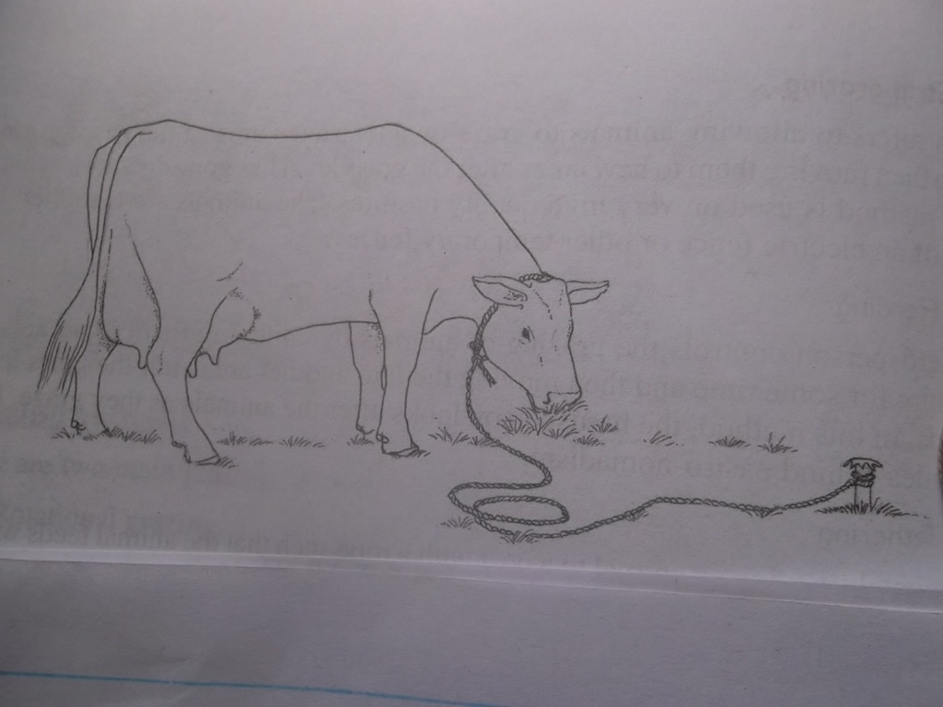
(a) Identify the method of grazing illustrated above. (1mark)
……………………………………………………………………………………………..
(b) State two advantages of the method identified in (a) above. (2marks)
………………………………………………………………………………………………………………………………………………………………………………………………
(c) Outline two reasons why a dairy farmer would prefer vegetative material to establish pasture. (2marks)
………………………………………………………………………………………………………………………………………………………………………………………………
24. (a) What is elasticity of demand for a commodity? (1mark)
……………………………………………………………………………………………...
(b) Given that at a price of shs.1000 per bag, 20 bags of maize are demanded but when the price changes to shs.800 per bag, 22 bags are demanded. Calculate the elasticity of demand.
Show your working. (2marks)

(c) Briefly explain two problems experienced by a floriculturist during marketing of his produce.
(2marks)………………………………………………………………………………………………………………………………………………………………………………………………………………
SECTION C (40MARKS)
Answer any TWO questions in this section in the spaces provided.
25. (a) Discuss the economic importance of water in crop production. (5marks)
(b) Explain five guidelines that a farmer should put into consideration while drawing a crop rotational program. (5marks)
(c) Describe six factors that influence the selectivity and effectiveness of herbicides.
(6marks)
(d) State four deficiency symptoms of nitrogen in a crop. (4marks)
26 (a) The table below represents the yield of maize in 90kg bags in response to application of different quantities of planting fertilizer
Input 50kg bag fertilizer | Output 90kg bag maize | Average product (AP) | Marginal product (MP)
0  1  2  3  4  5  6  7  8 | 6  10  24  31  36  40  43  43  40 | -  -  -  -  -  -  -  -  - | -  -  -  -  -  -  -  -  -
(i) Fill in the blank spaces. (7marks)

(ii) Suggest the best level of production in relation to the inputs and output. (1mark)
(b) State six advantages of propagating crops through grafting and budding. (6marks)
(c) Explain six cultural methods used to control crop diseases. (6marks)
27. (a) Describe the establishment of cabbages under the following sub – headings:
i) Importance of raising cabbage seedlings in the nursery (4marks)
ii) Varieties (3marks)
(b) Explain six structural measures used to conserve soil and water in steep areas. (6marks)
(c) Discuss the production of cotton under the following sub-headings:
  - Time of harvesting. (1mark)
  - Precautions during planting. (3marks)
(d) State how water control is done in rice production (3marks)
……………………………………………………………………………………………………………………………………………………………………………………………………………………………………………………………………………………………………………………………………………………………………………………………………………………………………………………………………………………………………………………………………………………………………………………………………………………………………………………………………………………………………………………………………………………
………………………………………………………………………………………………………………………………………………………………………………………………………………………………………………………………………………………………………………………………………………………………………………………………………………………………………………………………………………………………………………………………………………………………………………………………………………………………………………………………………………………………………………………………………………………
………………………………………………………………………………………………………………………………………………………………………………………………………………………………………………………………………………………………………………………………………………………………………………………………………………………………………………………………………………………………………………………………………………………………………………………………………………………………………………………………………………………………………………………………………………………
………………………………………………………………………………………………………………………………………………………………………………………………………………………………………………………………………………………………………………………………………………………………………………………………………………………………………………………………………………………………………………………………………………………………………………………………………………………………………………………………………………………………………………………………………………………
………………………………………………………………………………………………………………………………………………………………………………………………………………………………………………………………………………………………………………………………………………………………………………………………………………………………………………………………………………………………………………………………………………………………………………………………………………………………………………………………………………………………………………………………………………………
………………………………………………………………………………………………………………………………………………………………………………………………………………………………………………………………………………………………………………………………………………………………………………………………………………………………………………………………………………………………………………………………………………………………………………………………………………………………………………………………………………………………………………………………………………………
………………………………………………………………………………………………………………………………………………………………………………………………………………………………………………………………………………………………………………………………………………………………………………………………………………………………………………………………………………………………………………………………………………………………………………………………………………………………………………………………………………………………………………………………………………………
………………………………………………………………………………………………………………………………………………………………………………………………………………………………………………………………………………………………………………………………………………………………………………………………………………………………………………………………………………………………………………………………………………………………………………………………………………………………………………………………………………………………………………………………………………………
………………………………………………………………………………………………………………………………………………………………………………………………………………………………………………………………………………………………………………………………………………………………………………………………………………………………………………………………………………………………………………………………………………………………………………………………………………………………………………………………………………………………………………………………………………………
………………………………………………………………………………………………………………………………………………………………………………………………………………………………………………………………………………………………………………………………………………………………………………………………………………………………………………………………………………………………………………………………………………………………………………………………………………………………………………………………………………………………………………………………………………………
………………………………………………………………………………………………………………………………………………………………………………………………………………………………………………………………………………………………………………………………………………………………………………………………………………………………………………………………………………………………………………………………………………………………………………………………………………………………………………………………………………………………………………………………………………………………………………………………………………………………………………………………………………………………………………………………………………………………………………………………………………………………………………………………………………………………………………………………………………………………………………………
…………………………………………………………………………………………………………………………………………………………………………………………………………………………………………………………………………………………………………………………………………………………………………………………………………………………………………………………………………………………………………………………………………………………………………………………………………………………………………………………………………………………………………………………………………………………………………………………………………………………………………………………………………………………………………………………………………………………………………………………………………………………………………………………………………………………………………………………………………………………………………………………………………………………………………………………………………………………………………………………………………………………………………………………………………………………………………………………………………………………………………………………………………………………………………………………………………………………………………………………………………………………………………………………………………………………………………………………………………………………………………………………………………………………………………………………………………………………………………………………………………………………………………………………………………………………………………………………………………………………………………………………………………………………………………………………………………………………………………………………………………………………………………….
-END-

