Name ………………………………………………………….. Index No………………………..
443/2
AGRICULTURE
Paper 2
Time: 2 Hours
May/June 2017

INSTRUCTIONS TO CANDIDATES
- Write your name and index number in the spaces provided
- This paper consists of three sections; A,B and C.
- Answer all the questions in section A and B and any other two in section C
- All answers must be written in the spaces provided in this booklet

SECTION A (30 MARKS)
Answer all the questions in this section in the spaces provided
- Name a goat breed that can be used for the production of mohair. ( ½ Mark)
………………………………………………………………………………………………………..……………………………………………………………………………………………………………..
- State four factors that influence the quality of bricks. ( 2Marks)
…………………………………………………………………………………………………………...…………………………………………………………………………………………………………..…………………………………………………………………………………………………………..………………………………………………………………………………………………………….
- Give three problems associated with lambing. (1½Marks)
…………………………………………………………………………………………………………...…………………………………………………………………………………………………………..………………………………………………………………………………………………………….…………………………………………………………………………………………………………..
- Give two qualities of creep food. (1 Mark)
……………………………………………………………………………………………………….…..……………………………………………………………………………………………………….……………………………………………………………………………………………………………..
- Name two diseases that affect female animals only. ( 1 Mark)
…………………………………………………………………………………………………………..……………………………………………………………………………………………………….….…………………………………………………………………………………………………………..
- State four advantages of farm mechanization. ( 2 Marks)
…………………………………………………………………………………………………………………………………………………………………………………………………………………………………………………………………………………………………………………………………………………………………………………………………………………………………………
- State three management practices that would ensure maximum harvest of fish in a fish pond. (1½Marks) …………………………………………………………………………………………………………………………………………………………………………………………………………………………………………………………………………………………………………………………………………………………………………………………………………………………………………
- Name the four compartments of a ruminant stomach in a sequence. ( 2 Marks)
…………………………………………………………………………………………………………………………………………………………………………………………………………………………………………………………………………………………………………………………………………………………………………………………………………………………………………
- List two sources of farm power which are environmentally friendly. ( 1 Mark)
……………………………………………………………………………………………………………………………………………………………………………………………………………………………………………………………………………………………………………………………...
- State two uses of green houses. ( 1 Mark)
……………………………………………………………………………………………………………………………………………………………………………………………………………………………………………………………………………………………………………………………….
- Which hormone stimulates milk let-down? ( ½ Mark)
……………………………………………………………………………………………………………………………………………………………………………………………………………………
- Name four components of power transmission in a tractor. (2 Marks)
…………………………………………………………………………………………………………………………………………………………………………………………………………………………………………………………………………………………………………………………………………………………………………………………………………………………………………

- Give a reason as to why each of the following is important in the diet of young animals.
- Phosphorous (1Mark) ……………………………………………………………………………………………………………………………………………………………………………………………………………………………………………………………………………………………………….
- Vitamin C (1 Mark)
………………………………………………………………………………………………………………………………………………………………………………………………………………………………………………………………………………………………………
- State four reasons why a farmer would choose to use a disc plough rather than a mould plough.
- Marks)
………………………………………………………………………………………………………………………………………………………………………………………………………………………………………………………………………………………………………………………………………………………………………………………………………………………………………………………………………………………………………………………………………

- Name two type of grass mowers commonly used in Kenya. ( 1 Mark)
………………………………………………………………………………………………………………………………………………………………………………………………………………………………………………………………………………………………………………………………
- Name the appropriate saw used for carrying out each of the following operations.
- Cutting timber across the grains.
………………………………………………………………………………………………….
- Cutting timber along the grains.
………………………………………………………………………………………………….
- Cutting unwanted branches from a fruit tree.
………………………………………………………………………………………………….
(1½Marks)
- Outline four objectives of livestock breeders. ( 2 Marks)
…………………………………………………………………………………………………………………………………………………………………………………………………………………………………………………………………………………………………………………………………………………………………………………………………………………………………………

- Name two cattle diseases caused by a virus. (2 Marks)
………………………………………………………………………………………………………………………………………………………………………………………………………………………………………………………………………………………………………………………………………………
- State four ways of minimizing sediments in a plunge dip. (2 Marks)
…………………………………………………………………………………………………………………………………………………………………………………………………………………………………………………………………………………………………………………………………………………………………………………………………………………………………………………………………………………………………………………………………………………
- List four symptoms of parasitic attack on livestock. (2 Marks)
……………………………………………………………………………………………………………………………………………………………………………………………………………………………………………………………………………………………………………………………………………………………………………………………………………………………………………………………………………………………………………………………………………………

SECTION B: (20 MARKS)
Answer all the questions in this section in the spaces provided
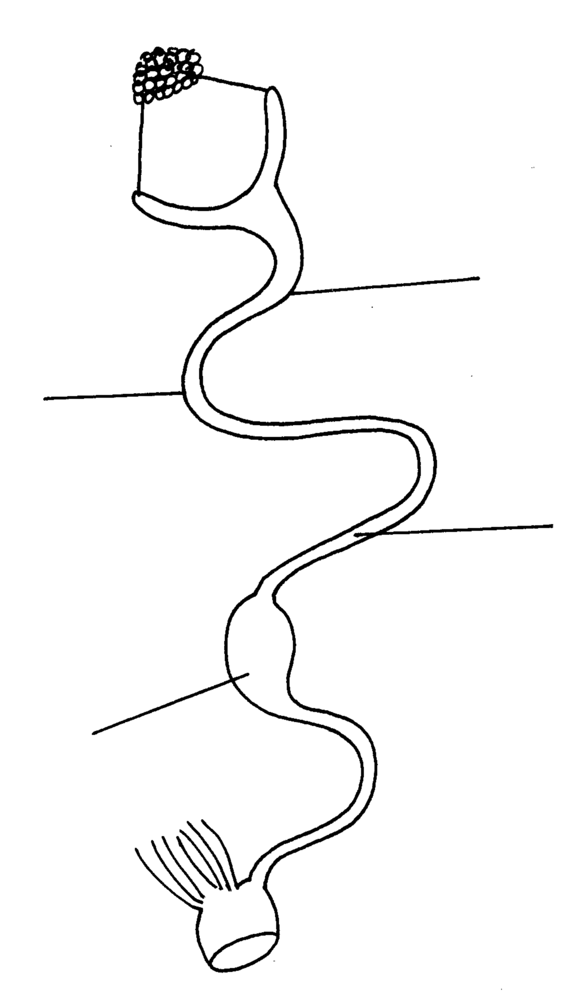21. Below is a diagram representing the reproductive system in poultry. Study it and answer the questions.
A
Y
X
B

(a) Name the parts labelled A and X, (2mks)
A………………………………………………………….
X………………………………………………………….
(b) Name two substances added to the egg at section labeled B. (2mk)
…………………………………………………………………………………………………………………………………………………………………………………………………………………………………………………………………………………………………………………………………………………………………………………………………………………………………………
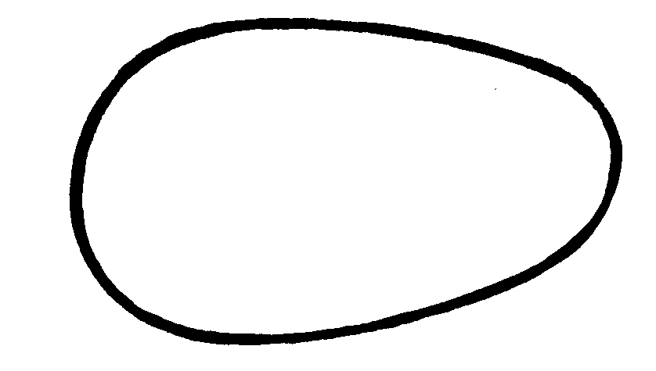 (C) Below is a diagram of an egg
Q
R
R
Q

Which part of the egg represented by the letters Q and R would come out first during the laying process.
………………………………………………………………………………………………………………………………………………..( 1 mk)

22. The diagram below shows the reproductive system of a cow. Study it and answer the questions
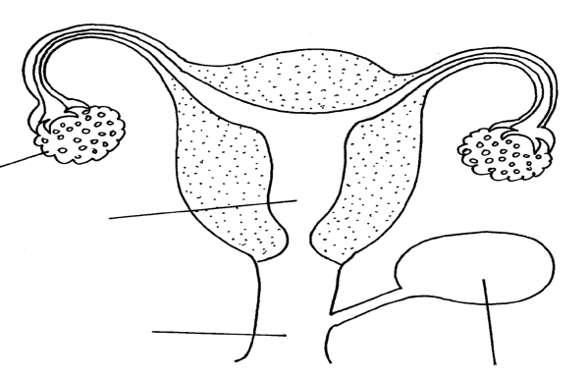
that follow:-

J
K
M
L

(a) Name the parts labeled (4mks)
K……………………………………………………………
L……………………………………………………………
M…………………………………………………………..
J…………………………………………………………….
(b)Define artificial insemination (1mk)
…………………………………………………………………………………………………………………………………………………………………………………………………………………………………………………………………………………………………………………………………………………………………………………………………………………………………………
23. The diagrams below illustrates the four cycle of a tractor engine. Study them carefully and answer the
questions that follow.
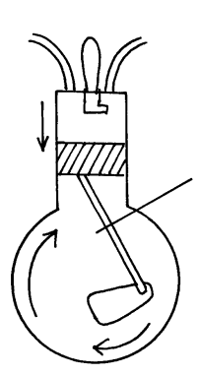
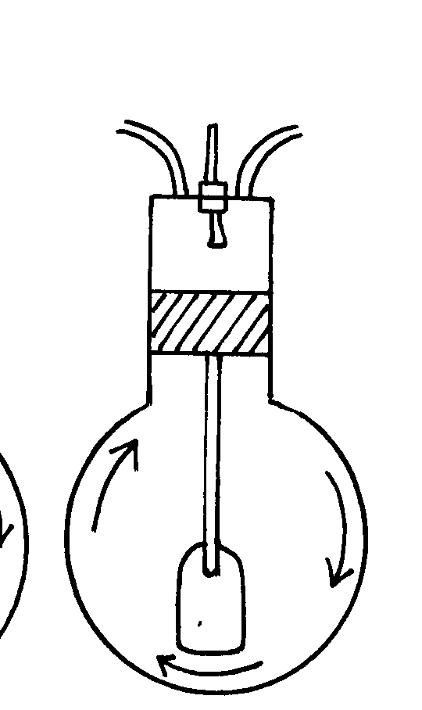
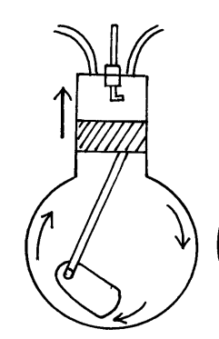
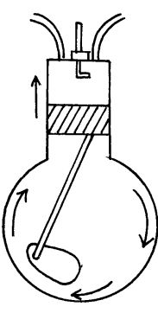
M
N
L
K
P

(a) Identify each of the four strokes illustrated in the diagrams. (4mks)
K……………………………………………………………
L……………………………………………………………
M……………………………………………………………
N……………………………………………………………
(b) Name the part labeled P. (1mk)
……………………………………………………………
24. (a) Give a reason for breeding bees. (1mk)
…………………………………………………………………………………………………………………………………………………………………………………………………………………………………………………………………………………………………………………………………………………………………………………………………………………………………………
b) State two reasons why bees swarm. (2mks)
…………………………………………………………………………………………………………………………………………………………………………………………………………………………………………………………………………………………………………………………………………………………………………………………………………………………………………
(c) List two tools/equipments used in harvesting honey. (2mks)
……………………………………………………………………………………………………………………………………………………………………………………………………………………

SECTION C
Answer any TWO questions in this section in the spaces provided
25. (a) Describe the procedure followed when using the hypodermic syringe and needle to administer drugs to cattle. (3 Marks)
(b) Outline six reasons for maintaining livestock in good health. (6 Marks)
(c) Discuss coccidiosis under the following headings.
(i) Casual organism (1 Mark)
(ii) Livestock species attacked. (2 Marks)
(iii) Symptoms of attack. (4 Marks)
(iv) Control measures. (4 Marks)
26. Describe the components of a plunge dip . (20 Marks)
- a) Describe the management practices that a poultry farmer should carry out to reduce stress in a flock of layers. (10 Marks)
- Distinguish between carrying capacity and stocking rate. (2 Marks)
- outline eight advantage of rotational grazing as a pasture management practice in livestock production (8 Marks)
....................................................................................................................................................................................................................................................................................................................................................................................................................................................................................................................................................................................................................................................................................................................................................................................................................................................................................................................................................................................................................................................................................................................................................................................................................................................................................................................................................................................................................................................................................................................................................................................................................................................................................................................................................................................................................................................................................................................................................................................................................................................................................................................................................................................................................................................................................................................................................................................................................................................................................................................................................................................................................................................................................................................................................................................................................................................................................................................................................................................................................................................................................................................................................................................................................................................................................................................................................................................................................................................................................................................................................................................................................................................................................................................................................................................................................................................................................................................................................................................................................................................................................................................................................................................................................................................................................................................................................................................................................................................................................................................................................................................................................................................................................................................................................................................................................................................................................................................................................................................................................................................................................................................................................................................................................................................................................................................................................................................................................................................................................................................................................................................................................................................................................................................................................................................................................................................................................................................................................................................................................................................................................................................................................................................................................................................................................................................................................................................................................................................................................................................................................................................................................................................................................................................................................................................................................................................................................................................................................................................................................................................................................................................................................................................................................................................................................................................................................................................................................................................................................................................................................................................................................................................................................................................................................................................................................................................................................................................................................................................................................................................................................................................................................................................................................................................................................................................................................................................................................................................................................................................................................................................................................................................................................................................................................................................................................................................................................................................................................................................................................................................................................................................................................................................................................................................................................................................................................................................................................................................................................................................................................................................................................................................................................................................................................................................................................................................................................................................................................................................................................................................................................................................................................................................................................................................................................................................................................................................................................................................................................................................................................................................................................................................................................................................................................................................................................................................................................................................................................................................................................................................................................................................................................................................................................................................................................................................................................................................................................................................................................................................................................................................................................................................................................................................................................................................................................................................................................................................................................................................................................................................................................................................................................................................................................................................................................................................................................................................................................................................................................................................................................................................................................................................................................................................................................................................................................................................................................................................................................................................................................................................................................................................................................................................................................................................................................................................................................................................................................................................................................................................................................................................................................................................................................................................................................................................................................................................................................................................................................................................................................................................................................................................................................................................................................................................................................................................................................................................................................................................................................................................................................................................................................................................................................................................................................................................................................................................................................................................................................................................................................................................................................................................................................................................................................................................................................................................................................................................................................................................................................................................................................................................................................................................................................................................................................................................................................................................................................................................................................................................................................................................................................................................................................................................................................................................................................................................................................................................................................................................................................................................................................................................................................................................................................................................................

